# Nitro Groundshaker

## Physical Setup

* Level Machine – about 1% steeper than factory recommendation
* Ear Plug Tilt Hack
* Verify Tilt Sensitivity – should be sensitive, but only one danger with each hard bump
* Check Flipper Strength, Consider Glo Balls if playing too slow or can’t hit upper playfield
* Clean/wax playfield
* Clean glass

## Switch or Software Setup

* 3-Ball Play (S31 ON).



* Disable Extra Balls, Special worth points (SW6 ON, SW7 ON)

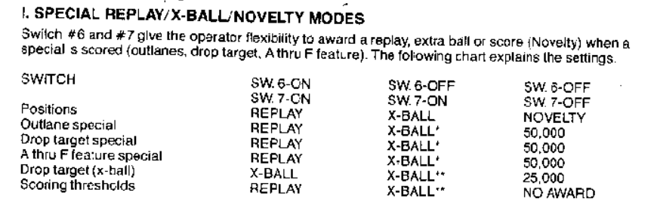

* Free Play if possible, else Max Credits per coin
  + Same as Mata Hari