# Paragon

## Physical Setup

* Level Machine
* Verify Tilt Sensitivity
* Check Flipper Strength
* Clean Playfield if necessary
* Clean Glass

## Switch or Software Setup

* 5-Ball Play (S16 ON)



* Disable Extra Balls, Special worth points (S14 OFF, S15 OFF)

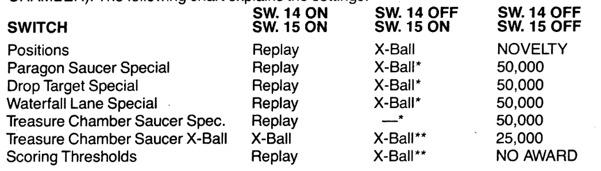

* To balance out inline-drops-all-day strategy, make that conservative, everything else liberal
* Paragon Saucer - Liberal (S23 ON, S24 ON)

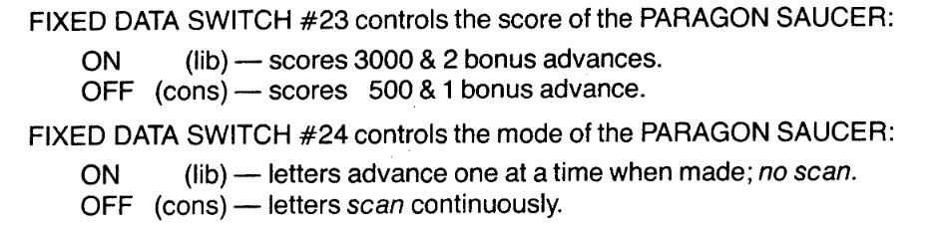

* Inline drops - Conservative (S30 OFF, S22 OFF)

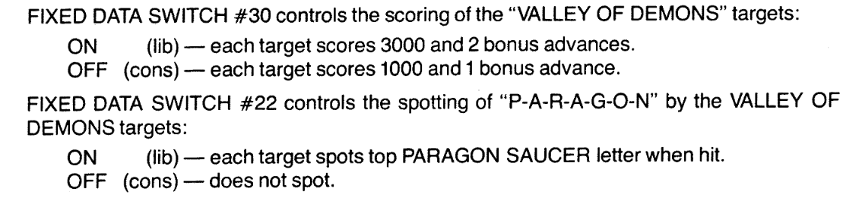

* 3-Bank drops – Liberal (SW31 OFF)



* Free Play if possible, else Max Credits per coin
  + Same as Mata Hari