# Bally Star trek

## Physical Setup

* Level Machine – about 1% steeper than factory recommendation
* Ear Plug Tilt Hack
* Verify Tilt Sensitivity – should be sensitive, but only one danger with each hard bump
* Check Flipper Strength, Consider Glo Balls if playing too slow or can’t hit upper playfield
* Clean playfield if necessary
* Clean glass

## Switch or Software Setup

* 5-Ball Play (S16 ON).



* Major Mode Fature: Novelty

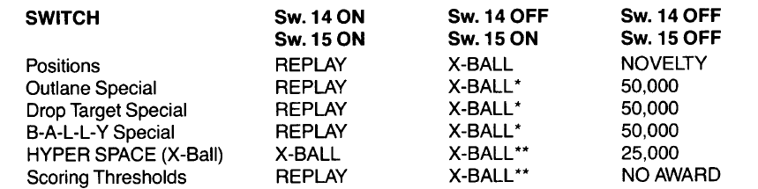

* Game features all to Conservative

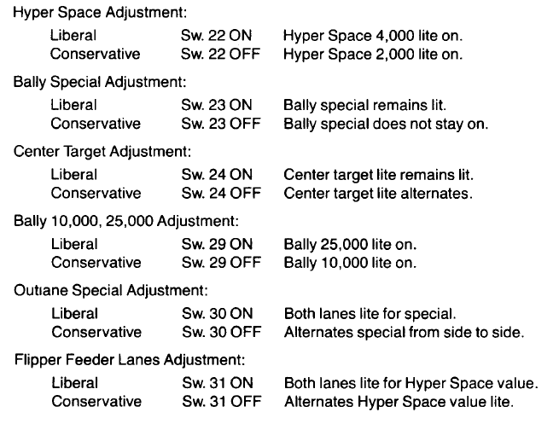

* Set Replay to 10K. Max 40 credits.

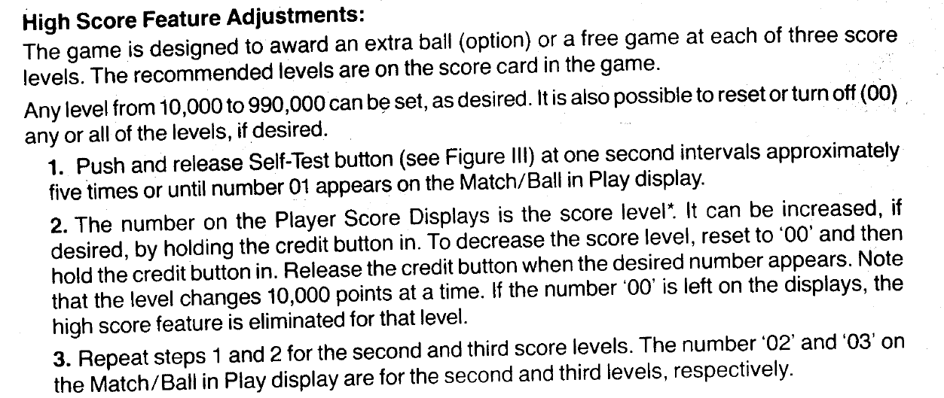 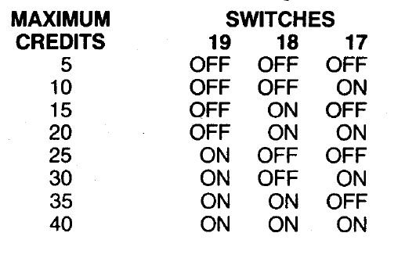

* Reset Bonus on Collect: SW 28 ON. (Custom ROM setting)