# Centaur

## Physical Setup

* Level Machine
* Outlane Posts on “Hard Settings”. I.e. most open.
* Verify Tilt Sensitivity
* Ear Plug Tilt Hack (see photo)
* Verify Volume
* Verify coin door ball save or no flipper disable when coin door opened.
* Clean Playfield if necessary
* Clean Glass
* Check Flipper Strength

## Switch Setup

* #1-5, #9-13 Free Play if possible. Otherwise, set to Max Credits for Minimum Coins 🡪
* 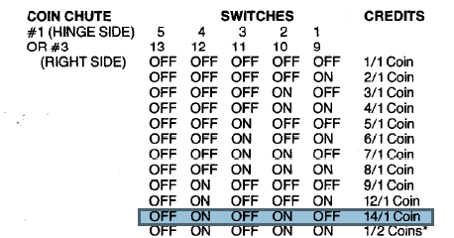#6 OFF Multipliers Reset
* #7 OFF Only 20-40-60 held
* #8 OFF Drop Conservative
* #14 OFF Feature lights reset
* #15 OFF Lit orbs are reset
* #16 OFF Guardians can only release one ball
* #21 OFF Release on last ball conservative
* #22 OFF Player must earn all orbs
* #23 ON Ball Tilt
* #24 OFF Target must be qualified on each ball
* #25,#26 ON ON, Max 40 credits
* #31, #32 OFF OFF, 3 Balls per game

## Front Door Game Adjustments

* Self-Test Position 16: Set to 03 for Replay on Everything
* 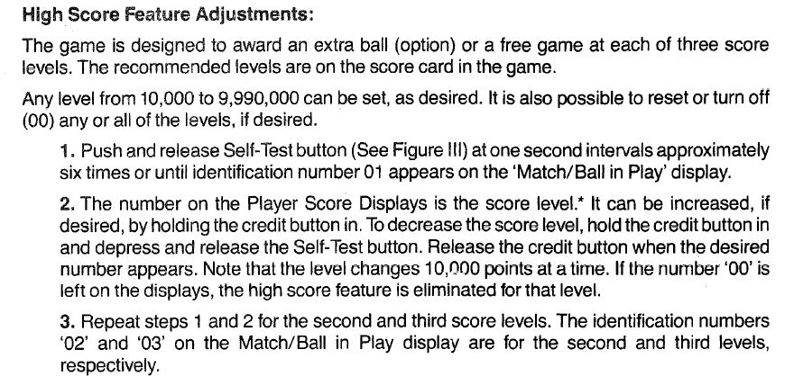Set all replay scores to 10K