# Eight Ball Deluxe

## Physical Setup

* Level Machine, per factory recommendation
* Outlane Posts on Medium settings.
* Ear Plug Tilt Hack
* Verify Tilt Sensitivity – should be sensitive, but only one danger with each hard bump
* Verify coin door ball save or no flipper disable when coin door opened.
* Check Flipper Strength, ensure ball can easily go to top of playfield.
* Clean Playfield if necessary
* Clean Glass
* Verify Volume

## Switch or Software Setup

* 5-Ball Play for PinGolf, 3-Ball for Round E and Rookie.
* Disable Extra Balls, Special worth points.

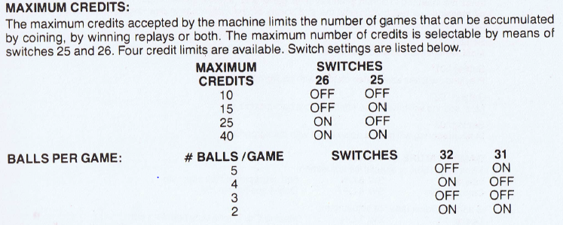

* Specials/EB worth points, set Self Test positions 16/17 to 01

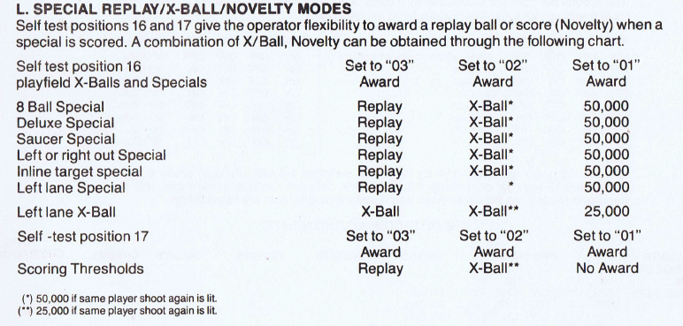

* Free Play possible? If not, 15 Credits per Coin,

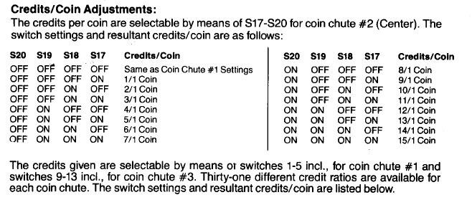 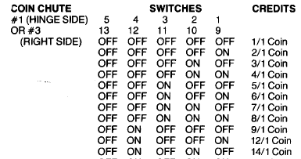

* SW16 Saucer has Bonus X: OFF