# Flash Gordon

## Physical Setup

* Level Machine, per factory recommendation
* Outlane Posts on Medium settings.
* Ear Plug Tilt Hack
* Verify Tilt Sensitivity – should be sensitive, but only one danger with each hard bump
* Verify no flipper disable when coin door opened.
* Check Flipper Strength, ensure ball can easily go up ramps from stopped ball.
* Clean Playfield if necessary
* Clean Glass
* Verify Volume

## Switch or Software Setup

* 5-Ball Play for PinGolf, 3-Ball for Round E and Rookie

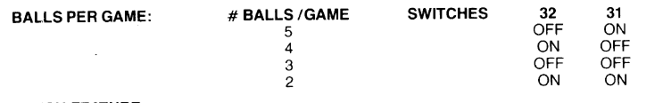

* Disable Extra Balls, Special worth points

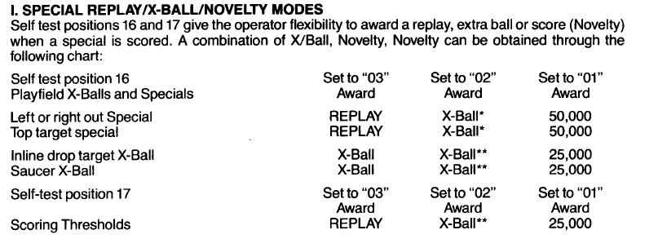

* Max Credits to 40: SW25 ON, SW26 ON
* 15 Credits per Coin,
* 