# Cybernaut

## Physical Setup

* Level Machine, normal steepness
* Remove Outlane Posts for “Hard Settings”. I.e. most open.
* Ear Plug Tilt Hack
* Verify Tilt Sensitivity – should be sensitive, but only one danger with each hard bump
* Verify coin door ball save or no flipper disable when coin door opened.
* Clean Playfield if necessary
* Clean Glass
* Ensure Glo Ball is installed
* Check Flipper Strength, ensure left ramp and right upper targets are easily hittable from ball at rest.
* Verify Volume

## Switch Adjustments

* 3 Balls per Game

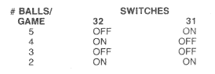

* Max Credits 40

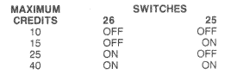

* 14 Credits per coin (unless you can put it on free play?)

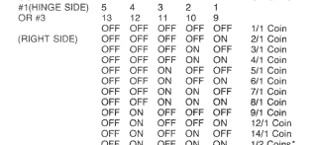 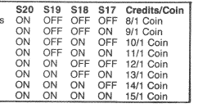

* Novelty (points for EB and Special)
* 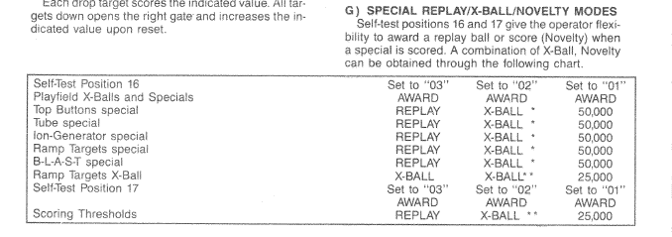
* No Bonus X on collect bonus
* 