# Gottlieb Pink Panther

* Level Machine
* Verify Tilt Sensitivity
* Verify Volume
* Check Flipper Strength. Consider Glo-ball if flippers weak or play is too slow
* Clean Playfield if necessary
* Clean Glass

## Switch or Software Setup (These settings are from Gottlieb Black Hole; could be wrong)

* 3-Ball Play (Switch 17 off)

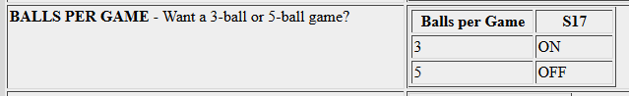

* Disable Extra Balls, Specials worth points instead of credits

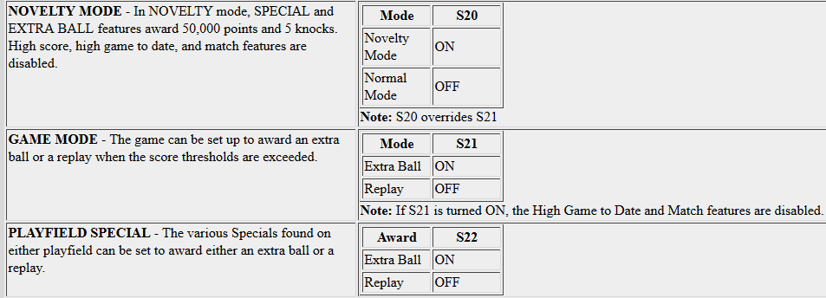

* Free Play if possible, else Max Credits per coin and minimum replay score



 