# Classic Bank: Mars Trek

## Physical Setup

* Level Machine
* Verify Tilt Sensitivity
* Check Flipper Strength
* Clean Playfield if necessary
* Clean Glass

## Switch or Software Setup

* 5-Ball Play.

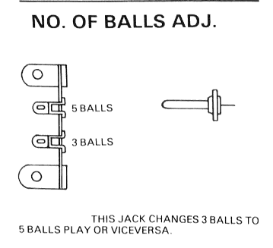

* Disable Extra Balls

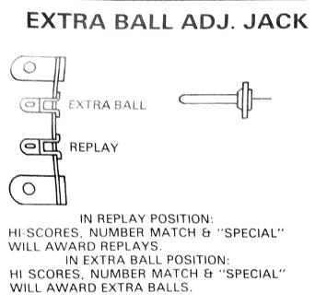

* Special worth points
* Free Play if possible, else Max Credits per coin and minimum replay score
* 