# Sonic Cherry Bell

* Level Machine
* Verify Tilt Sensitivity
* 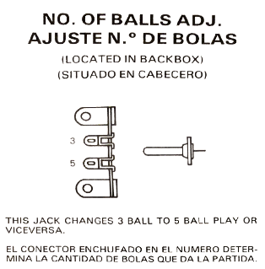Check Flipper Strength. Consider Glo-ball if flippers weak or play is too slow.
* Clean Playfield if necessary
* Clean Glass

## Switch or Software Setup

* 5-Ball Play. 🡪
* Free Play if possible, else Max Credits per coin and minimum replay score  
  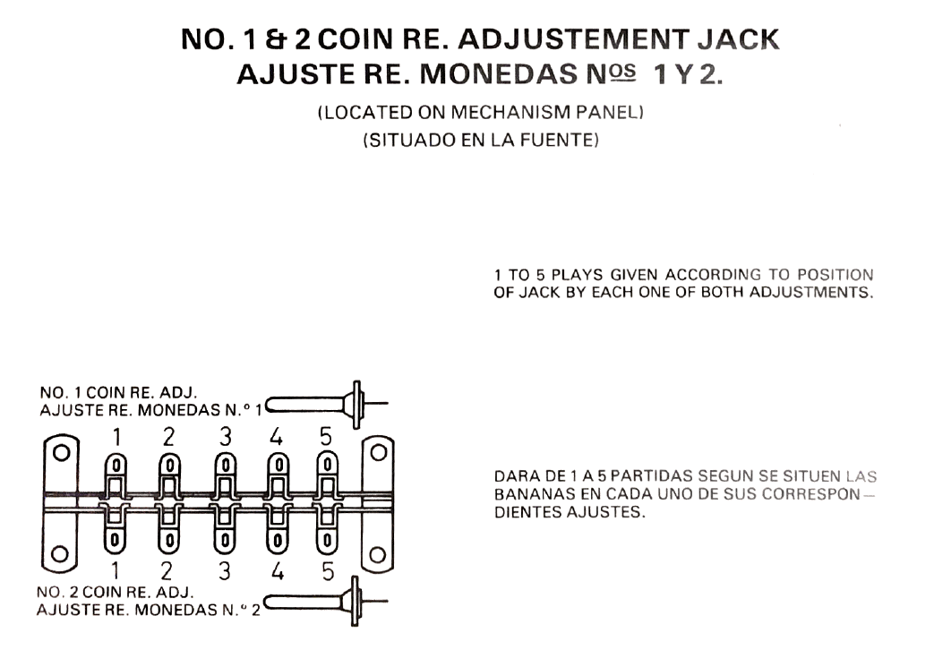 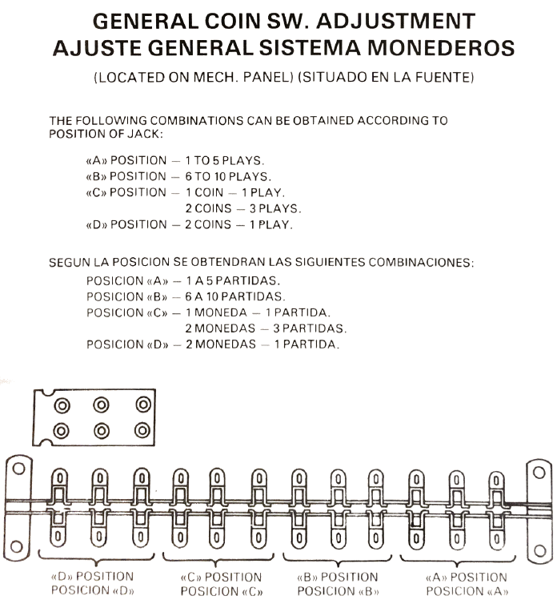
* Replay for Hi Scores, NOT Extra Ball

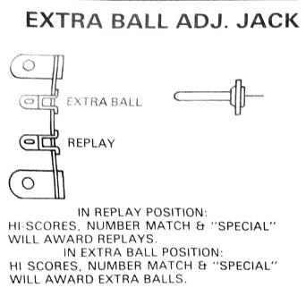There was an issue with this setting, I think near infinite extra balls. If using this machine, play-test the choices.