# Stern Big Game

* Level Machine
* Verify Tilt Sensitivity
* Verify Volume
* Check Flipper Strength. Consider Glo-ball if flippers weak or play is too slow.
* Clean Playfield if necessary
* Clean Glass

## Switch or Software Setup

* 3-Ball Play. SW7=OFF.

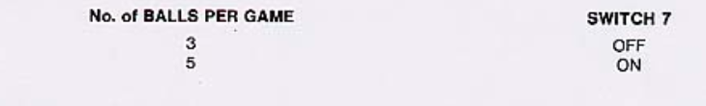

* Max Credits per coin (unless free play possible?).
  + S28-S25 ON, S2-5 ON, S1 OFF, S10-13 ON, S9 OFF. S17-S19 ON.
* Max Credits 40 (SW19=ON, SW18=ON). Credit Display = ?? (Off=Free Play?)  
  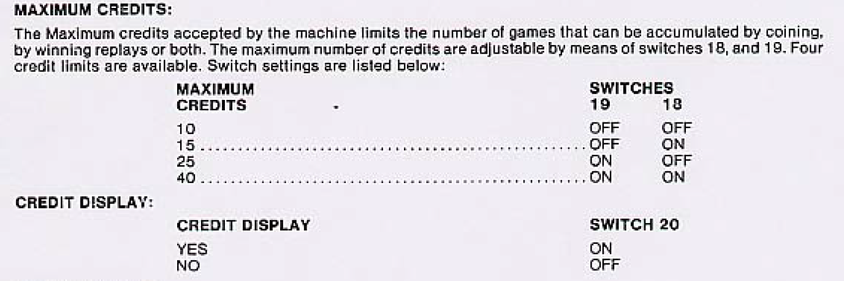
* No Extra Balls. SW17=OFF

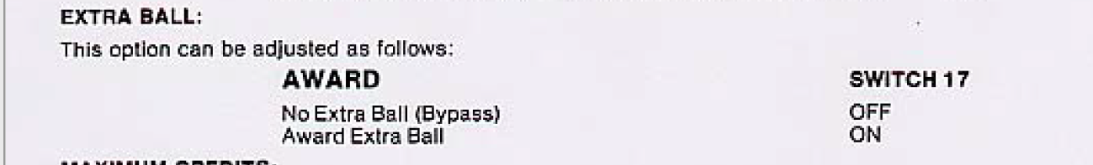

* Special is points SW31=ON, SW32=OFF.



* Card Selection Hard (SW23=ON). 5K per line = Ball 3 (SW25=ON,SW26=OFF).

