# Williams Grand Prix

## Physical Setup

* Level Machine – about 1% steeper than factory recommendation
* Ear Plug Tilt Hack
* Verify Tilt Sensitivity – should be sensitive, but only one danger with each hard bump
* Check Flipper Strength, Consider Glo Balls if playing too slow or can’t hit upper playfield
* Clean/wax playfield
* Clean glass

## Switch Setup

* 5-Ball Play

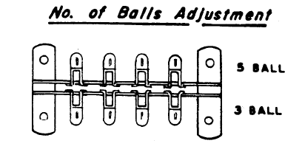

* 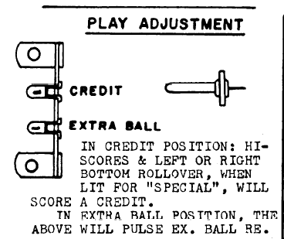Extra Balls – credits, not EB
* Hi Score Adjustment Plug: make it lowest score possible (10,000), to replenish credits

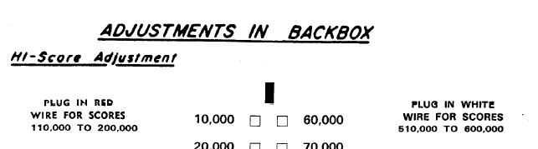

* Feature Adjustments: 2 and Conservative
* 