# Williams Space Mission

## Physical Setup

* Level Machine, per factory recommendation
* Ear Plug Tilt Hack
* Verify Tilt Sensitivity – should be sensitive, but only one danger with each hard bump
* Check Flipper Strength, Consider Glo Balls if playing too slow or can’t hit upper playfield
* Clean Playfield if necessary
* Clean Glass

## Switch Setup

* 5-Ball Play , Extra Balls🡪credits not EB

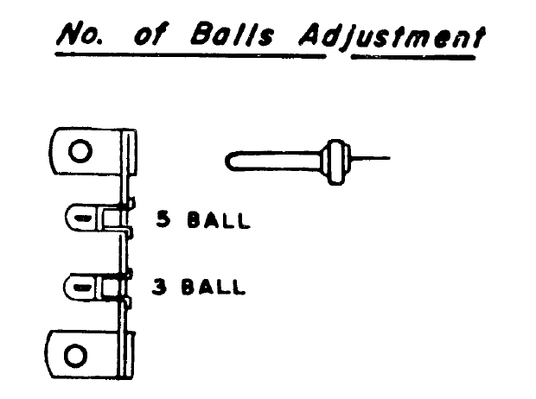 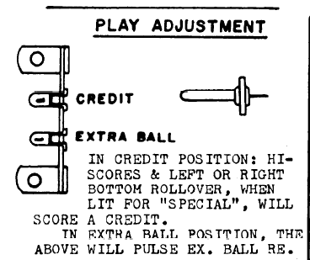

* Hi Score Adjustment Plug: make it lowest score possible (10,000), to replenish credits

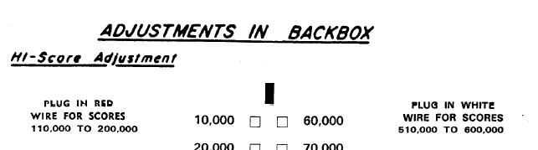

* Feature Adjustments: Conservative
* 