Project Sprint #1

The Solitaire game is described in CS449HomeworkOverview. You should read the description very carefully.

In this assignment, you aim to specify the requirements (i.e., user stories and acceptance criteria) of the target software that allows a human player to play a Solitaire game. These requirements will be fully implemented by the end of sprint 3. The minimum features include choosing the board size and type, starting a new game, making a move, determining if a game is over. The following is a sample GUI layout.

Board size
7
Board Type  - English  - Hexagon  - Diamond | 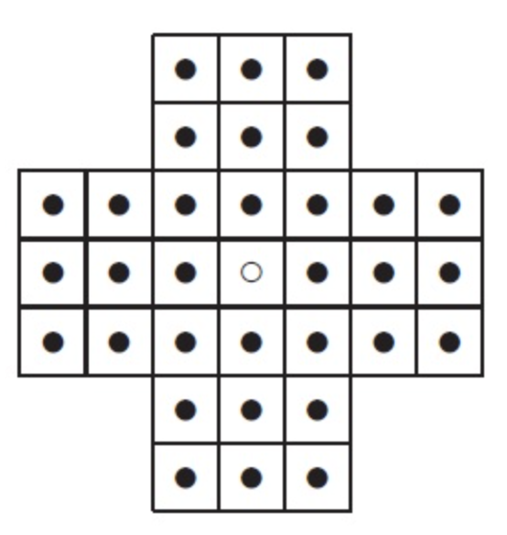 | New Game
Figure 1. Sample GUI layout of the first working program by the end of Sprint 3

Use the following tables to document your user stories and acceptance criteria.

You are required to use the free ChatGPT or another LLM to complete two user stories and two of their respective acceptance criteria. You must ensure that the generated user stories are correct and fix them if not. At the end of the submission, provide screenshots of your LLM prompts and answers, along with the description of errors the LLM made that you had to correct. Points will be deducted if no screenshots/description are provided.

For the other user stories and acceptance criteria, you are not required to use LLM.

- User Stories (3 points)

- User Story Template: As a <role>, I want <goal> [so that <benefit>]

ID | User Story Name | User Story Description | Priority | Estimated effort (hours)
1 | Choose a board size | As a player, I want to choose the size of the board before I start so that I can make the game bigger or smaller depending on how long I want to play. | High | 3
2 | Choose the board type | As a player, I want to pick between the English, Hexagon, and Diamond boards so that I can try different shapes instead of playing the same board every time. | High | 3
3 | Start a new game of the chosen board size and type | As a player, I want to start a new game using the size and type I picked so that I can start playing right away, or restart if I mess up. | High | 4
4 | Make a move in a game | As a player, I want to move a peg by jumping it over another peg into an empty hole so that the jumped peg gets removed and I can work toward clearing the board. | High | 6
5 | A game is over | As a player, I want the game to tell me when it's over and whether I won so that I know how I did without having to check the whole board myself. | Med | 4

- Acceptance Criteria (AC) (12 points): Add/delete rows as needed.

User Story ID and Name | AC  ID | Description of Acceptance Criterion | Status (completed, toDo, inPprogress)
1. Choose a board size | 1.1 | AC 1.1 Player enters a valid board size  Given the game window is open and no game is being played  When the player types a valid board size (like 7) into the board size box and starts a game  Then the board is drawn with that size | toDo
1. Choose a board size | 1.2 | AC 1.2 Player enters a board size that isn't allowed  Given the game window is open  When the player types a size that isn't allowed (like 2, an even number like 6, or letters like "abc")  Then the game shows a message saying the size isn't valid  And the board size stays the same as before | toDo
1. Choose a board size | 1.3 | AC 1.3 Player doesn't change the board size  Given the game window was just opened  When the player starts a game without changing the board size  Then the game uses the default size of 7 | toDo
2. Choose the board type | 2.1 | AC 2.1 Player picks the English board  Given the game window is open  When the player clicks the "English" option  Then English is selected and Hexagon and Diamond are not selected | toDo
2. Choose the board type | 2.2 | AC 2.2 Player switches to Hexagon or Diamond  Given English is currently selected  When the player clicks "Hexagon" (or "Diamond")  Then that option becomes selected and English is unselected, since only one type can be picked at a time | toDo
2. Choose the board type | 2.3 | AC 2.3 Default board type  Given the game window was just opened  When the player hasn't clicked any board type yet  Then English is already selected by default | toDo
3. Start a new game of the chosen board size and type | 3.1 | AC 3.1 Start a new English game  Given the player picked size 7 and the English board  When the player clicks "New Game"  Then a cross-shaped board is drawn with a peg in every hole except the center hole, which starts empty | toDo
3. Start a new game of the chosen board size and type | 3.2 | AC 3.2 Start a new Hexagon or Diamond game  Given the player picked a valid size and the Hexagon (or Diamond) board  When the player clicks "New Game"  Then the board is drawn in that shape at the chosen size, with a peg in every hole except the starting empty hole | toDo
3. Start a new game of the chosen board size and type | 3.3 | AC 3.3 Restart in the middle of a game  Given a game is in progress and some pegs have already been removed  When the player clicks "New Game"  Then the old game is cleared and a fresh board is drawn with all the pegs back in place | toDo
3. Start a new game of the chosen board size and type | 3.4 | AC 3.4 Change settings during a game  Given a game is in progress  When the player changes the board size or type but doesn't click "New Game"  Then the current game keeps going on the same board until the player clicks "New Game" | toDo
4. Make a move in a game | 4.1 | AC 4.1 Make a valid jump  Given a new English board of size 7 where the center hole (3,3) is empty  When the player selects the peg at (3,1) and then clicks the empty hole at (3,3)  Then the peg moves to (3,3), the peg it jumped over at (3,2) is removed, and (3,1) is now empty | toDo
4. Make a move in a game | 4.2 | AC 4.2 Try to land on a hole that already has a peg  Given a new English board of size 7  When the player selects the peg at (0,3) and clicks (2,3), which already has a peg in it  Then the move is not allowed and nothing on the board changes | toDo
4. Make a move in a game | 4.3 | AC 4.3 Try to jump when there's no peg in between  Given a game in progress where the hole between the selected peg and an empty hole two spaces away is also empty  When the player tries to move the peg into that empty hole  Then the move is not allowed because there is no peg to jump over, and the board stays the same | toDo
4. Make a move in a game | 4.4 | AC 4.4 Try a move that's the wrong distance or direction  Given a game in progress on the English board  When the player tries to move a peg only one space, more than two spaces, or diagonally  Then the move is not allowed and the board stays the same | toDo
4. Make a move in a game | 4.5 | AC 4.5 Click an empty hole first  Given a game in progress  When the player clicks an empty hole as the piece to move  Then nothing gets selected and the board doesn't change | toDo
5. A game is over | 5.1 | AC 5.1 Win with one peg left  Given a game in progress where there are two pegs left and one can jump the other  When the player makes that last jump  Then only one peg is left, the game ends, and a message says the player won | toDo
5. A game is over | 5.2 | AC 5.2 No moves left with more than one peg  Given a game in progress with more than one peg left  When the player makes a move and after it no peg can make a valid jump  Then the game ends and a message says there are no more moves and shows how many pegs are left | toDo
5. A game is over | 5.3 | AC 5.3 Board is locked after the game ends  Given the game is over  When the player clicks on a peg or a hole  Then nothing happens on the board until the player starts a new game | toDo

III. LLM Usage

User stories and acceptance criteria I used an LLM for: Claude.

Screenshots of my prompts and the LLM's answers:
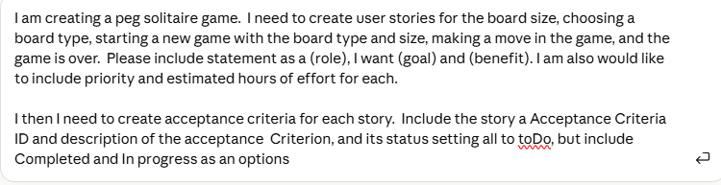
Mistakes the LLM made and how I fixed them:
N/A

