Finance & Risk Analysis Part 2- Market Risk Analysis

By Vinish Vincent

Great Learnings

PGP-DSBA - 23

# Table of content

**Problem Statement:**

The dataset contains 6 years of information (weekly stock information) on the stock prices of 10 different Indian Stocks. Calculate the mean and standard deviation on the stock returns and share insights. You are expected to do the Market Risk Analysis using Python.

* 1. Draw Stock Price Graph(Stock Price vs Time) for any 2 given stocks with inference.
  2. Calculate Returns for all stocks with inference
  3. Calculate Stock Means and Standard Deviation for all stocks with inference
  4. Draw a plot of Stock Means vs Standard Deviation and state your inference
  5. Conclusions and Recommendations

**List of Graphs**

Graph 1 – Infosys Stock Price Graph

Graph 2 – Mahindra & Mahindra Stock Price Graph

Graph 3 - Plot of Stock Means vs Standard Deviation

# Problem Statement Part 2 – Market Risk Analysis:

The dataset contains 6 years of information (weekly stock information) on the stock prices of 10 different Indian Stocks. Calculate the mean and standard deviation on the stock returns and share insights. You are expected to do the Market Risk Analysis using Python.

**Dataset Description**

Head of Dataset:

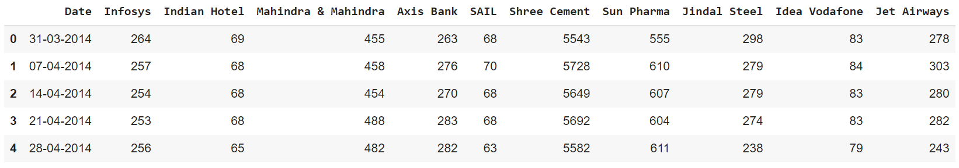

* We are changing the names for better approach

Head of dataset after alteration in columns headers:

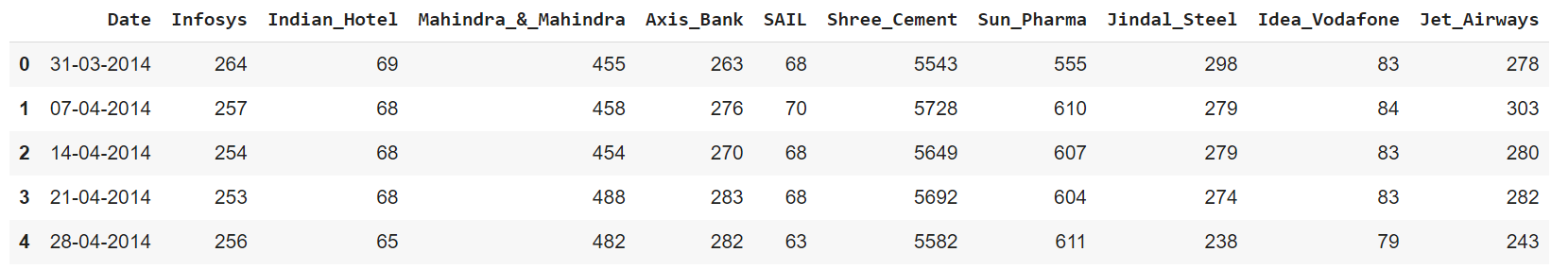

Shape of dataset:

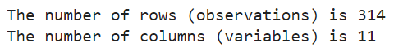

Dataset Information:

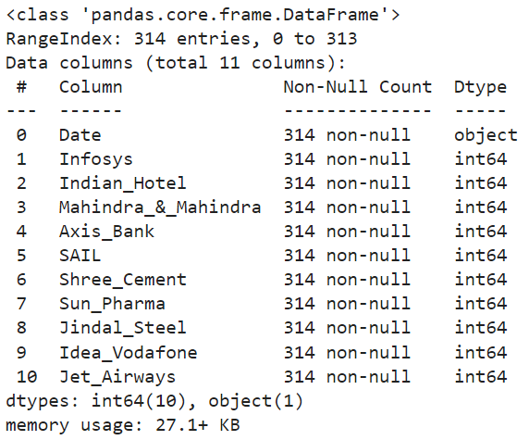

* There are no missing values in the dataset
* There are no duplicate values
* We have 11 variables, 1 object type data (Date) and 10 companies’ numerical values

Dataset Description:

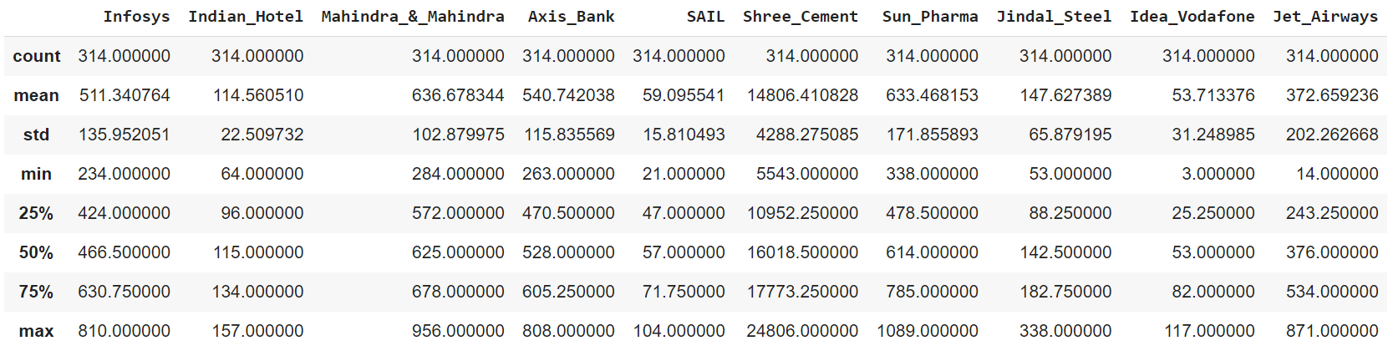

* Shree Cement, with an average market capitalization of 14,806.41, emerges as the most valuable company among the listed ones.
* SAIL and Idea Vodafone, with lower standard deviations, showcase relatively more stable stock prices in comparison.
  1. **Draw Stock Price Graph(Stock Price vs Time) for any 2 given stocks with inference**

**Solution**: Taken two stocks 'Infosys' and ‘Mahindra & Mahindra' to explain the stock price graph

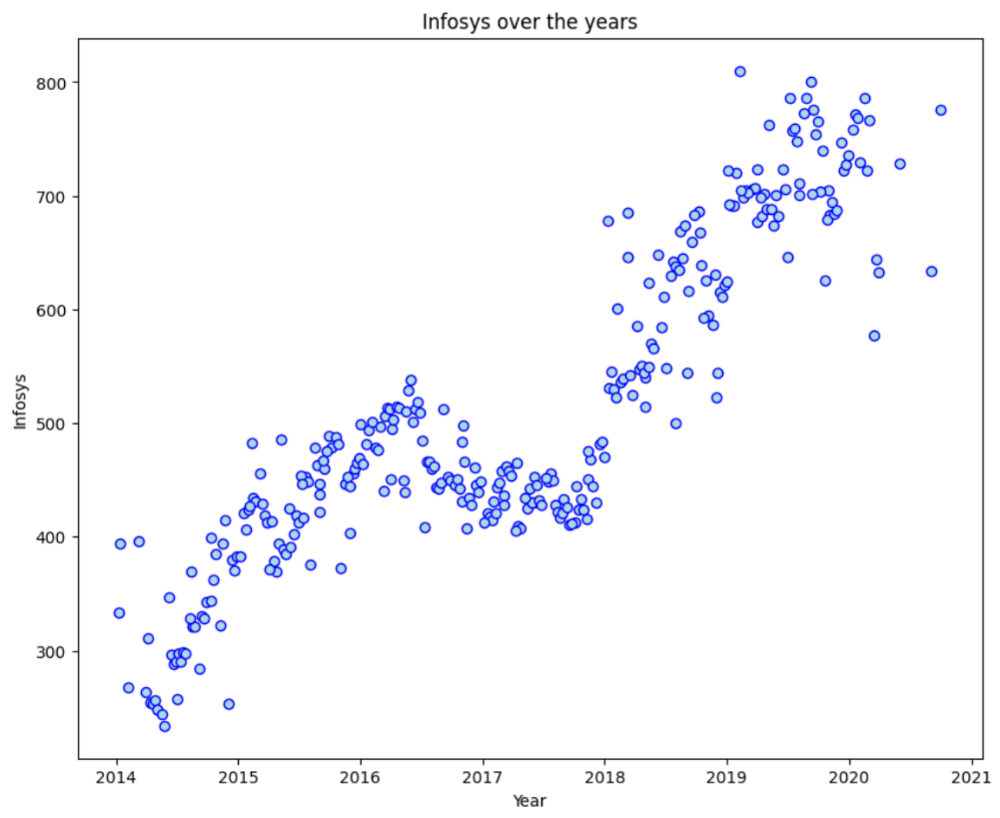**Infosys:**

Graph 1

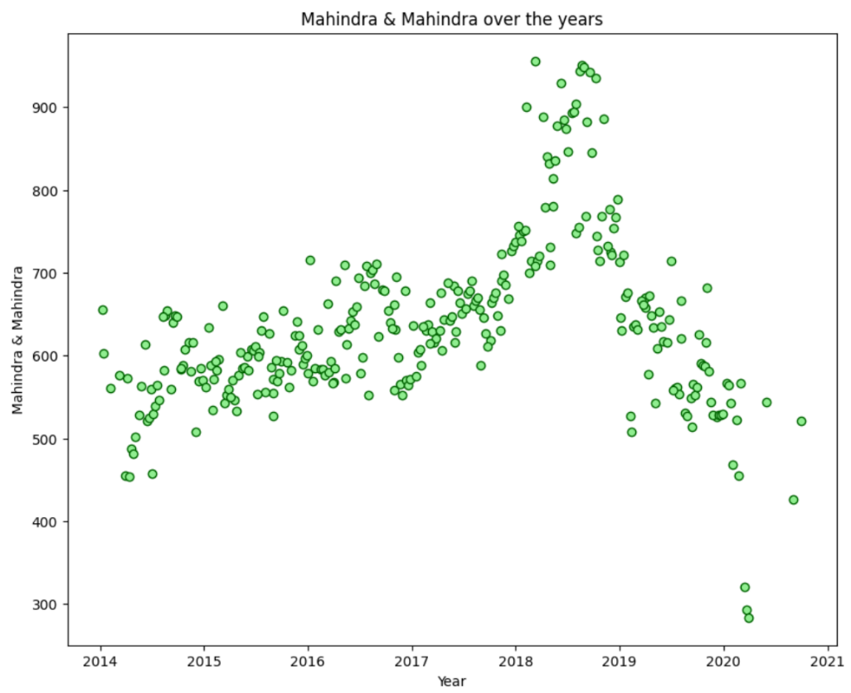**Mahindra & Mahindra:**

Graph 2

**Inferences:**

* The above scatterplot shows the trends of stocks 'Infosys' & Mahindra & Mahindra ' overtime
* For Infosys, We observe an increasing trend over years. Price was 200 during the year 2014 and it has increased to 800 during the year 2021
* For Mahindra & Mahindra, we observe a decline in trend starting from late-year 2018. Price was at 650 during the year 2014 and remained stable till 2018. Starting 2018, it showed a huge spike reaching above 900, and then started to decrease from late 2018, evening reaching below 300 in between 2020 and year 2021
  1. **Calculate Returns for all stocks with inference**

A financial return, also referred to as a return, is essentially the profit or loss incurred on an investment during a specific time frame. It is commonly represented as the monetary change in the value of an investment over time.

Calculating returns by taking the **log** is preferred when we look at multiple time period

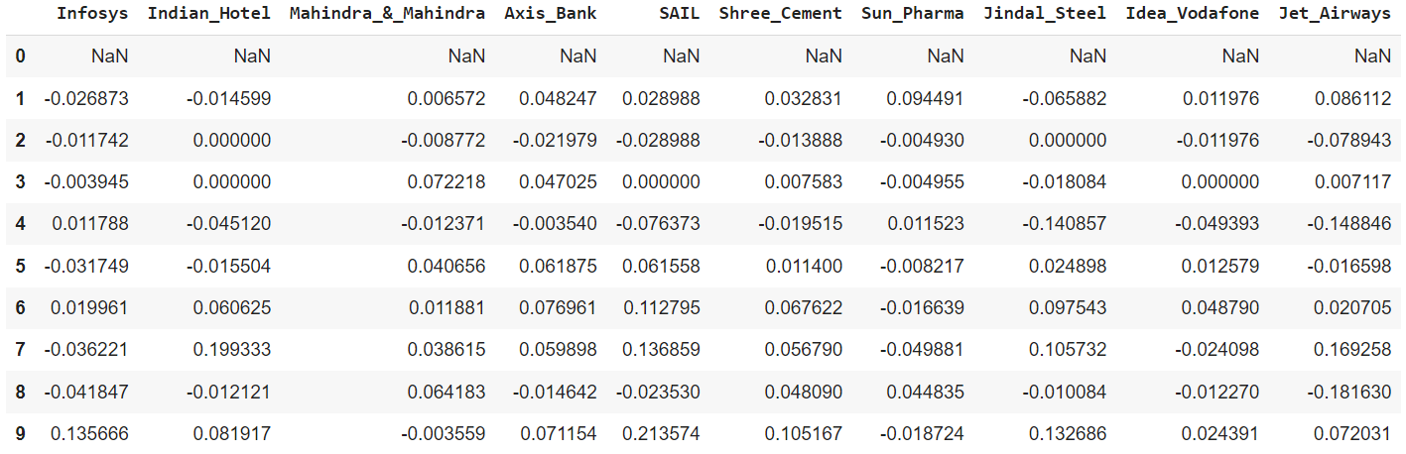

A positive return indicates the profit or earnings gained from the stock, while a negative return signifies the loss or money that has been lost on the stock. This metric is crucial for evaluating the performance of the stock.

Return dataset statistical summary:

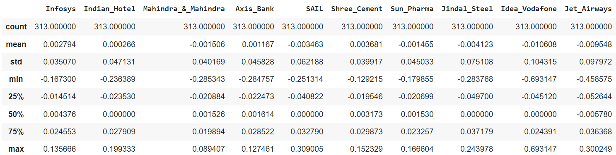

**Inferences:**

* The mean values indicate the average daily returns for each company
* Companies with positive mean returns, such as Infosys, Axis Bank, and Shree Cement, on average, experienced positive daily returns, suggesting potential profitability.
* Companies with higher standard deviations (e.g., SAIL, Jindal Steel) exhibit more significant day-to-day price fluctuations, indicating higher risk in their stock returns
* Jet Airways experienced the most negative daily return at -0.693147, highlighting a particularly challenging day for its investors. Meanwhile, Shree Cement had the highest daily return at 0.152329, suggesting a particularly positive day for the company's stock
  1. **Calculate Stock Means and Standard Deviation for all stocks with inference**

**Mean for all the stocks**:

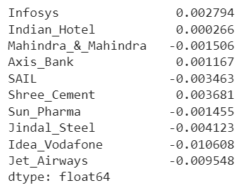

**Inferences:**

* Infosys and Axis Bank have positive mean returns (0.002794 and 0.001167, respectively), indicating, on average, positive daily returns. Investors in these stocks might have experienced slight gains
* On the other hand, Idea Vodafone and Jet Airways have negative mean returns (-0.010608 and -0.009548, respectively), suggesting, on average, daily losses. Investors in these stocks might have faced challenges during this period
* Shree Cement stands out with the highest positive mean return (0.003681), indicating potentially better performance compared to other stocks in the dataset. In contrast, Jindal Steel has a relatively lower negative mean return (-0.004123), suggesting a comparatively more stable performance

**Standard Deviation for all the stocks**:

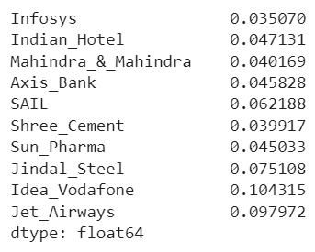

**Inferences:**

* Idea Vodafone and Jet Airways have the highest standard deviations (0.104315 and 0.097972, respectively), indicating greater volatility in their daily returns
* Jindal Steel stands out with a higher standard deviation (0.075108), suggesting a potentially riskier investment compared to other stocks in the dataset. In contrast, Mahindra & Mahindra and Shree Cement have relatively lower standard deviations, implying lower risk
  1. **Draw a plot of Stock Means vs Standard Deviation and state your inference**

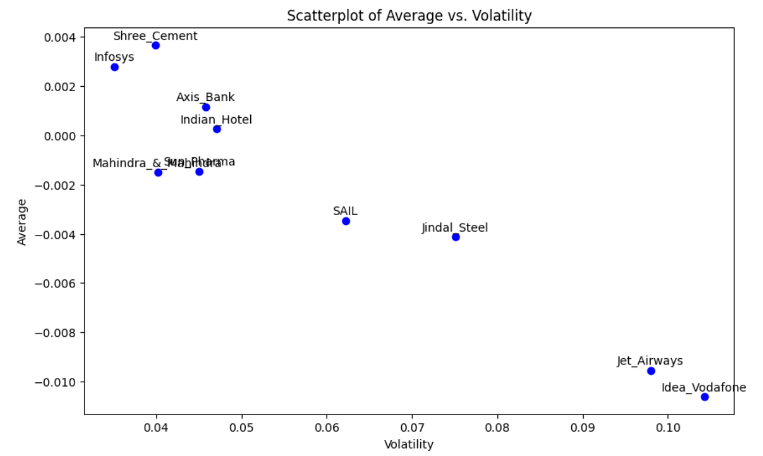

Graph 3

**Table:**

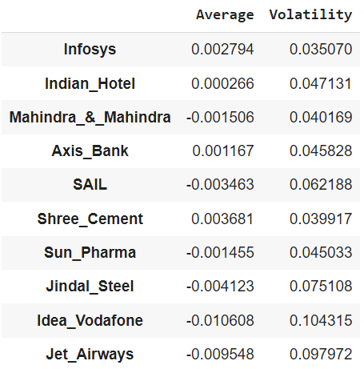

**Inferences:**

* By drawing plot against Average (Mean) and volatility (Standard Deviation), where Standard deviation is measure of risk and its used to measure the uncertainty of variables
* If the value of risk is high then the returns are more uncertain and if the value of risk is low then the returns are less certain and risky
* From the above plot we can see that the stocks of Idea Vodafone and Jet Airways have the highest standard deviation and low mean values which means these stocks are a risky investment since they are in the declining stage.
* The stocks of Shree Cement, Infosys, Axis Bank and Indian Hotel have positive means which means the stock prices are increasing and they have less standard deviation which represents that these stocks are less risky to invest in
* Comparing the stocks Shree Cement and Mahindra which has high standard deviation but the mean of Shree Cement are high than Mahindra. Now Mahindra is performing less compared to other stocks
* Comparing Mahindra and Sun Pharma having same average stock prices but the risk of Sun Pharma is high than Mahindra, hence, we can conclude that Sun Pharma is risky to invest in
  1. **Conclusions and Recommendations**
* Stocks with positive average returns (e.g., Infosys, Indian Hotel, Axis Bank, Shree Cement) may be considered for a "buy" or "hold" strategy. Positive average returns suggest potential profitability, and investors may want to explore these stocks further
* Stocks with negative average returns (e.g., Mahindra & Mahindra, SAIL, Sun Pharma, Jindal Steel, Idea Vodafone, and Jet Airways) may be candidates for a "hold" or "sell" strategy. Negative average returns indicate potential losses, and investors might want to carefully assess the reasons behind the negative performance
* Stocks with higher volatility (e.g., Idea Vodafone, Jet Airways, and Jindal Steel) may carry higher risk. Investors with a higher risk tolerance might consider these stocks for potential higher returns but should be cautious about the associated volatility
* Stocks with lower volatility (e.g., Infosys, Shree Cement) may be suitable for more risk-averse investors looking for stability in their investments

**Thank you**