**MAE 4710 Problem Set 2: Dynamic Simulation**

**Problem 1:**

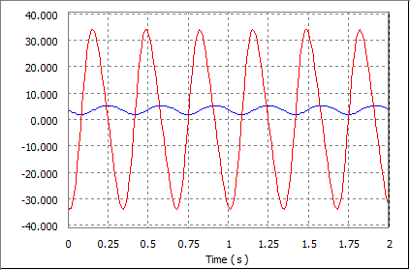

Figure : Pump without effects of gravity, friction, or spring force. Graph displays x-position

and velocity of the trace placed on the connecting rod-piston joint

Average Velocity (X): -0.16411

Maximum Velocity (X): 33.99770

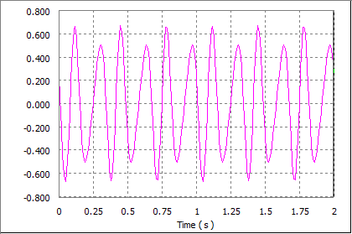

Figure : Pump without effects of gravity, friction, or spring force. Graph displays driving torque

required to rotate at a constant 180 RPM.

Average Driving Torque: 0.00131

Maximum Driving Torque: 0.67002

**Problem 2:**

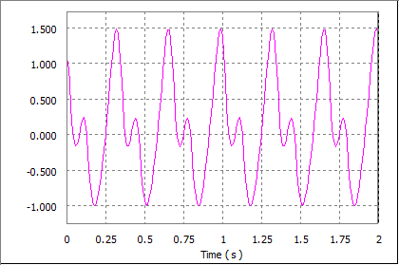

Figure : Pump with effects of gravity and friction but without effect of spring force. Graph displays driving torque

required to rotate at a constant 180 RPM.

Average Driving Torque: 0.10888

Maximum Driving Torque: 1.48335

**Problem 3:**

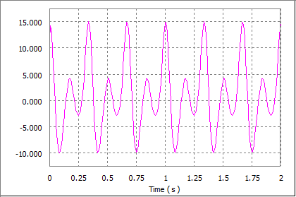

Figure : Pump with effects of gravity, friction, and spring force. Graph displays driving torque

required to rotate at a constant 180 RPM.

Average Driving Torque: 1.05600

Maximum Driving Torque: 15.00160

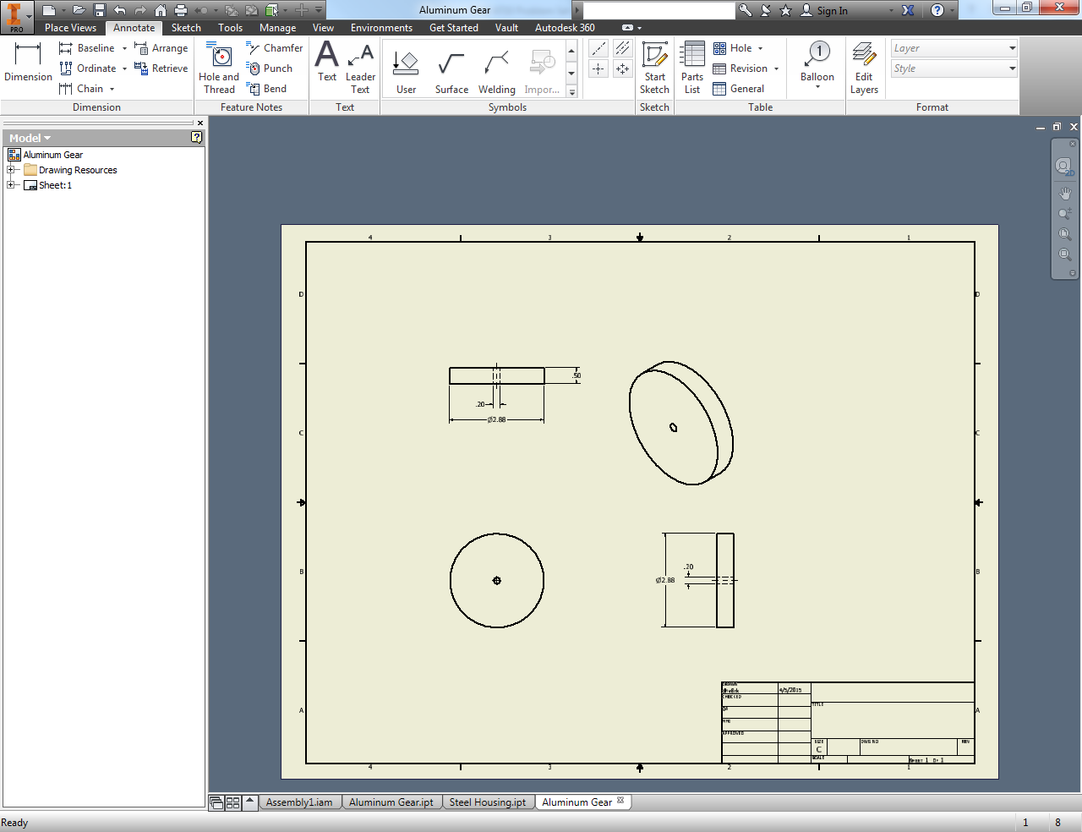

Figure : Aluminum Gear

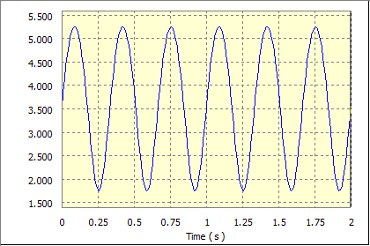

Figure : Pump with effects of gravity, friction, and spring force. Graph displays x-position

and velocity of the trace placed on the connecting rod-piston joint.

When the gear is added, the x-position of the trace is 90 degrees out of phase compared to the position of the trace in part 1e. This occurred because the added gear reverses the direction of rotation of the crank. In both configurations, the crank is spinning at a rate of 180 RPM, or a total of 6 rotations during the 2-second interval.

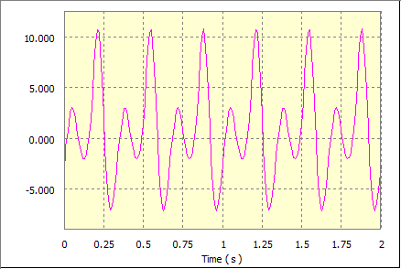

Figure : Pump being driven by 250 RPM motor and gear with effects of gravity, friction, and spring force. Graph displays driving torque required to rotate at a constant 180 RPM.

Average Driving Torque: 0.70308

Maximum Driving Torque: 10.80320

