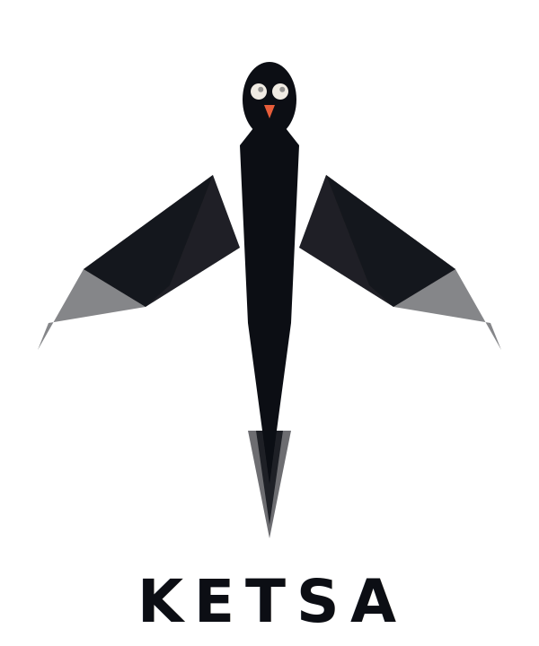
RESEARCH BRIEF

Product Research Brief
Market analysis, technical feasibility, legal landscape, and strategic recommendations

v1.0 — March 2026
Confidential — Internal Use Only

EXECUTIVE SUMMARY
This document presents deep research findings on the technical feasibility, legal landscape, competitive environment, and strategic recommendations for Ketsa — a mobile privacy protection platform. The product addresses a real and growing market need driven by evolving case law on biometric compulsion, increased police use of digital forensics during routine stops, and rising consumer awareness of smartphone privacy vulnerabilities.
Core Finding: The original product vision of a single button that toggles system-level privacy settings (Face ID, Location Services, AirDrop, etc.) is not technically feasible as a standard App Store application on either iOS or Android. However, multiple viable alternative architectures exist that accomplish the same user goal through different technical means, and the market opportunity is substantial.
Recommended Architecture: A hybrid app combining guided privacy configuration, automation triggers (Android Intents / iOS Shortcuts), active encounter protection features (audio/video recording, GPS pinning, emergency contact notification), and a legal education platform. Launch Android-first for broader system-level access, then adapt for iOS.
Business Model: Freemium with tiered subscription. Free tier provides legal education and basic privacy audit. Premium tier ($4.99–$6.99/month) provides active encounter protection, setting drift monitoring, state-specific legal updates, and cloud-secured recordings.

1. TECHNICAL FEASIBILITY ANALYSIS
This section addresses the primary research priority: what can a third-party app actually control on Android and iOS? The findings determine the product architecture.

1.1 Android Capabilities
Android provides significantly more system-level access to third-party developers than iOS, though important restrictions still apply.
Feature | Status | Technical Details
Disable Biometrics (Lockdown) | WORKAROUND | Android 9+ has built-in Lockdown Mode (power + volume). App cannot trigger programmatically but CAN guide users and remind via notification. Device Admin API can enforce PIN-only when activated.
Toggle Location Services | PARTIAL | Cannot toggle global switch. Can revoke own permissions, guide users to Settings via Intent, and on Android 10+ use Settings Panel API for floating toggle.
Toggle Bluetooth/NFC | PARTIAL | BluetoothAdapter.disable() deprecated in Android 13. NFC cannot be toggled by third-party apps. Both require directing users to system settings.
Audio/Video Recording | CAN BUILD | Full camera and microphone API access. Background recording via Foreground Service. Core buildable feature.
GPS Location Pinning | CAN BUILD | Full GPS access. Capture, timestamp, and transmit location. Geofencing for automated triggers.
Emergency Contact Notification | CAN BUILD | SMS and push notification to designated contacts with GPS coordinates and timestamp.
App Lock / Vault | CAN BUILD | Accessibility Service or Device Admin API overlay lock screens on protected apps.
Quick Settings Tile | CAN BUILD | Custom tile for one-tap activation of encounter protection from notification shade or lock screen.
Privacy Audit / Monitoring | CAN BUILD | Check all privacy-relevant settings and alert users when configurations drift from secure baseline.

1.2 iOS Capabilities
iOS is significantly more restrictive. Apple’s sandboxing prevents third-party apps from modifying system settings. Ketsa must take a fundamentally different approach on iOS.
Feature | Status | Technical Details
Disable Face ID / Touch ID | CANNOT BUILD | No API access. Users can disable by pressing power + volume for 1 second. Ketsa can educate on this shortcut and provide practice drills.
Toggle Location / Bluetooth / NFC | CANNOT BUILD | Entirely locked to system Settings. No API, no Shortcuts action. Ketsa can only instruct users.
Audio/Video Recording | PARTIAL | Foreground recording works. Background limited. Existing Siri Shortcut (“Hey Siri, I’m getting pulled over”) already handles basic recording.
GPS + Emergency Contacts | CAN BUILD | Full GPS access with permission. iOS Shortcuts can automate sending pre-written texts with location.
Siri Shortcuts Integration | CAN BUILD | Register custom Siri Shortcuts for voice-triggered encounter activation.

1.3 Architecture Recommendation
Hybrid approach with platform-specific implementations. Android serves as the primary platform with deeper system integration. iOS version adapts through Siri Shortcuts and guided manual configuration.

2. LEGAL LANDSCAPE ANALYSIS

2.1 Key Case Law
United States v. Brown (D.C. Circuit, 2025)
The D.C. Circuit held that compelling a suspect to unlock a phone with a fingerprint IS testimonial under the Fifth Amendment. The court reasoned that biometric unlocking implicitly communicates control, knowledge, and ownership. This directly contradicts other circuits, creating a fractured legal landscape.
Riley v. California (Supreme Court, 2014)
Police generally need a warrant to search a cell phone seized during arrest. However, Riley only applies to active searches, not features that passively broadcast information or biometric compulsion.
Carpenter v. United States (Supreme Court, 2018)
Historical cell-site location information requires a warrant. However, location data stored locally on a phone may be treated differently if officers obtain lawful device access.
Product Implication: State-specific legal guidance is not a nice-to-have. It’s a fundamental differentiator. No competitor currently offers jurisdiction-aware privacy protection that updates as case law evolves.

2.2 Liability Considerations
- Marketing Language: Never claim Ketsa “protects” users legally. Position as “education and tools.” Clear disclaimers that Ketsa does not constitute legal advice.
- App Store Compliance: Position as a “privacy and digital rights education tool.” Apple rejects apps perceived as encouraging obstruction.
- Recording Laws: 11 U.S. states require two-party consent. Ketsa MUST include state-specific recording guidance.

3. COMPETITIVE LANDSCAPE
The market is fragmented with no single player combining privacy hardening, encounter protection, and legal education. This is Ketsa’s white-space opportunity.
Competitor | Category | Price | Privacy | Encounter | Legal Ed
TurnSignl | Legal Guidance | $6.99/mo | LOW | HIGH | MEDIUM
ACLU Mobile Justice | Recording | Free | LOW | MEDIUM | LOW
D.O.P.E. App | Education / SOS | Free | LOW | MEDIUM | HIGH
Signal / Lockdown Privacy | Encryption | Free / Varied | HIGH | LOW | LOW
KETSA | All-in-One | $4.99–$6.99/mo | HIGH | HIGH | HIGH

3.1 Key Competitor: TurnSignl
TurnSignl connects drivers to live attorneys via video call during traffic stops at $6.99/month. Approximately 50,000 subscribers and 400 attorneys in all 50 states. Featured on PBS NewsHour and won ABA Techshow 2022.
Key Insight: TurnSignl validates market demand at this price point but requires human attorneys 24/7, creating scalability problems. Ketsa can offer recording, de-escalation guidance, and rights information without the human bottleneck and at lower operational cost. TurnSignl also does zero privacy hardening.

4. PRODUCT STRATEGY

4.1 Tiered Feature Set
Free Tier (Acquisition + Trust Building)
- Privacy audit: scans device settings, generates privacy score with recommendations
- Legal rights education: state-specific know-your-rights guides
- Interactive training: practice drills for disabling biometrics quickly
- Setting guide: step-by-step privacy configuration walkthrough
Premium Tier ($4.99–$6.99/month)
- Encounter Protection Mode: one-tap activation via Quick Settings tile
- Background audio/video recording with automatic cloud upload
- GPS pin + timestamp + emergency contact notification
- Setting drift monitoring with alerts on configuration changes
- State-specific legal updates as case law evolves
- App Lock Vault: protect sensitive apps behind separate PIN (Android)
Enterprise / Group Tier ($3.99/user/month, 10+ users)
- Organizational deployment for activist groups, delivery driver fleets, journalism outlets
- Admin dashboard for managing team privacy configurations

4.2 Go-to-Market Strategy
Phase 1: Beachhead (Months 1–3)
- Target: activists, protesters, delivery drivers, rideshare drivers
- Platform: Android only. Free tier to build user base and gather feedback
Phase 2: Monetization (Months 3–6)
- Launch premium tier. Encounter Protection Mode as flagship feature
- Partnership outreach: civil rights orgs, legal aid nonprofits for subsidized subscriptions
Phase 3: Platform Expansion (Months 6–12)
- iOS launch with Siri Shortcuts integration
- Enterprise tier. API partnerships with dashcam companies
Phase 4: Scale (Year 2+)
- Mass market. International expansion. AI-powered legal guidance

5. CRITICAL RISKS & OPEN QUESTIONS
Risk | Likelihood | Impact | Mitigation
App Store rejection (iOS) | MEDIUM | HIGH | Position as privacy education tool. Android as primary platform regardless.
Liability if app fails during encounter | MEDIUM | HIGH | Robust ToS. Never claim legal protection. Carry E&O insurance.
OS updates break functionality | HIGH | MEDIUM | Budget for rapid update cycles. Monitor beta releases.
Two-party consent recording laws | HIGH | HIGH | GPS-based state detection. Consent warnings in two-party states.
Subscription churn | HIGH | MEDIUM | Continuous value via legal updates, drift alerts, new features. Annual plan discount.
Google restricts Accessibility Service | MEDIUM | HIGH | Build vault using Device Admin API as fallback. Monitor Play Store policy.

6. RECOMMENDED NEXT STEPS
Immediate (Weeks 1–2)
- Finalize Ketsa brand identity and trademark registration
- Create detailed Android technical specification document
- Register domain, social media handles (@ketsa / @ketsaapp)
Short-Term (Weeks 3–6)
- Build Android MVP: Privacy Audit + Legal Education (free tier)
- Conduct user interviews with 15–20 people from beachhead segment
- Survey willingness-to-pay (n=200+)
Medium-Term (Weeks 7–12)
- Build Encounter Protection Mode. Beta test with 50–100 users
- Iterate. Prepare for Google Play Store submission
Long-Term (Months 4–6)
- Public launch. Begin iOS development. Pursue first B2B deals

End of Document — Ketsa Product Research Brief v1.0 — March 2026

