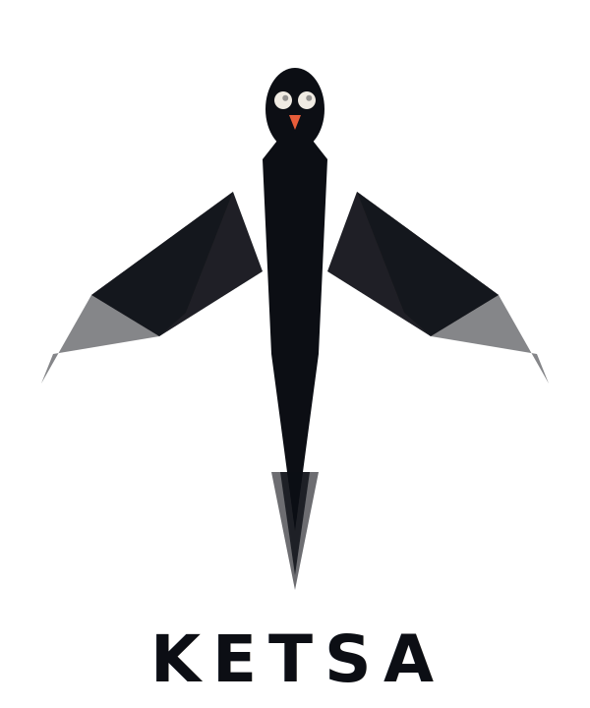
TECHNICAL SPEC

Android Technical Specification
Architecture, features, tech stack, and implementation guide for the Android-first MVP

v1.0 — March 2026
Confidential — Internal Use Only

1. TECHNOLOGY STACK
Core technology decisions for the Ketsa Android MVP. All choices prioritize modern best practices, long-term maintainability, and alignment with Google’s recommended architecture.
Layer | Technology | Rationale
Language | Kotlin 2.x | Google’s official. Required for Compose. Coroutines for async. Future KMP path for iOS code sharing.
UI Framework | Jetpack Compose + Material 3 | Declarative UI. Less code, faster iteration. Built-in theming, animation, adaptive layouts.
Architecture | MVVM + Clean Architecture | UI → ViewModel → UseCase → Repository → DataSource. Testable, modular, scalable.
Dependency Injection | Hilt (Dagger) | Google-recommended. Compile-time resolution. Native ViewModel, WorkManager, Service integration.
Async / Concurrency | Kotlin Coroutines + Flow | Structured concurrency. StateFlow/SharedFlow for reactive UI. Replaces RxJava.
Navigation | Navigation Compose | Type-safe navigation. Deep link support for Quick Settings tile and notifications.
Local Database | Room | SQLite with compile-time verification. Stores audits, encounters, settings, legal content.
Preferences | DataStore (Proto) | Type-safe, async. User config, emergency contacts, feature toggles.
Networking | Retrofit + OkHttp + Moshi | Industry standard REST. Moshi for fast JSON. OkHttp interceptors for auth.
Background Work | WorkManager + Foreground Services | WorkManager for periodic drift checks. Foreground Services for encounter mode.
Cloud / Auth | Firebase (Storage, Auth, Analytics) | Rapid MVP setup. Scales automatically. Generous free tier. Migrate to custom at scale.
Min SDK | API 28 (Android 9 Pie) | Required for Lockdown Mode. Covers 95%+ active devices.
Target SDK | API 35 (Android 15) | Latest stable. Play Store compliance. Latest foreground service requirements.

1.1 Why Native Kotlin
- Deep OS integration: Foreground Services, Quick Settings Tiles, Device Admin API, Accessibility Service — all need first-class native access.
- Zero-lag encounter activation: Camera, audio, GPS, and SMS must all fire within 1–2 seconds. No cross-platform bridge overhead.
- Future iOS via KMP: Kotlin Multiplatform shares business logic between platforms while keeping native UI. Build domain layer KMP-compatible from day one.

2. APPLICATION ARCHITECTURE

2.1 Module Structure
Module | Type | Contents
:app | Android Application | Entry point. Hilt setup, navigation graph, theme, MainActivity.
:feature:privacy-audit | Android Library | Privacy score, settings scanner, drift detection, audit UI, recommendations.
:feature:encounter | Android Library | Encounter Protection Mode. Recording service, GPS tracker, emergency SMS, Quick Settings tile.
:feature:legal | Android Library | Legal education, state-specific guides, rights cards, drills, legal update notifications.
:feature:vault | Android Library | App Lock. PIN management, protected apps list, lock overlay, Device Admin receiver.
:feature:onboarding | Android Library | First-run wizard. Permission requests, emergency contact setup, guided config.
:core:domain | Kotlin Library (KMP-ready) | Use cases, domain models, repository interfaces. No Android dependencies. Shareable with iOS.
:core:data | Android Library | Repository implementations, Room DB, DataStore, API services, data mappers.
:core:ui | Android Library | Shared Compose components, Ketsa design system, theme, typography, colors, animations.

3. FEATURE SPECIFICATIONS

3.1 Encounter Protection Mode (Premium)
Flagship feature. When activated, must execute all actions within 2 seconds of user tap.
Action | Implementation
Start audio recording | Foreground Service with MICROPHONE type. MediaRecorder with AudioSource.MIC. Encrypted local file. Continues with screen off. Requires RECORD_AUDIO + FOREGROUND_SERVICE_MICROPHONE.
Start video recording | Same service adds CAMERA type. CameraX API, front-facing camera. Encrypted local file. Toggle for audio-only mode.
Capture GPS location | FusedLocationProviderClient. Pins initial location, tracks every 10 seconds. Stores trail in Room. Requires ACCESS_FINE_LOCATION.
Notify emergency contacts | SmsManager to pre-configured contacts. Message: GPS link + timestamp + “Recording active.” Falls back to FCM if SMS fails.
Display legal rights card | Overlay or full-screen notification with state-specific rights. Auto-detected state via GPS reverse geocode.
Cloud upload (after encounter) | WorkManager queues AES-256 encrypted recording for chunked upload with retry.

Activation Methods
- Quick Settings Tile (fastest): Custom TileService. One tap from lock screen.
- Persistent notification button: Always visible “Activate” button. PendingIntent triggers service.
- In-app button: Large, prominent Ember-colored button on home screen.
- Voice: Google Assistant routine. “Hey Google, activate Ketsa.”
Critical: Foreground Service Restrictions
Android 12+ restricts Foreground Services from background. User MUST interact (tile, notification, widget) to start encounter mode. Geofence alone won’t work from background. Workaround: geofence → notification → user taps → service starts.
Two-Party Consent Detection
GPS coordinates → reverse geocode to state → check consent database. Two-party states: CA, CT, DE, FL, IL, MD, MA, MI, MT, NH, OR, PA, VT, WA. User must acknowledge consent notice before recording starts in these states.

3.2 Privacy Audit Dashboard (Free)
Scans device settings, generates privacy score (0–100), provides actionable recommendations. Primary free-tier value driver and premium conversion funnel.
Setting | API Access | Check
Location Services | LocationManager.isProviderEnabled() | GPS/network enabled. Recommends disabling when not navigating.
Bluetooth | BluetoothAdapter.isEnabled() | Flags risk if enabled unnecessarily.
NFC | NfcAdapter.isEnabled() | Flags if enabled without active use.
Biometric enrollment | BiometricManager.canAuthenticate() | Explains 5th Amendment risk. Recommends passcode-only for high-risk.
Screen lock type | KeyguardManager | Critical vulnerability if no lock screen.
Developer options | Settings.Global.getInt() | USB debugging enables data extraction. Recommends disabling.
Encryption status | DevicePolicyManager | Verifies device storage encrypted.

4. ANDROID PERMISSIONS
Every permission requested, with user-facing justification. Requested contextually (just-in-time), never all at once.
Permission | Type | Feature | User Justification
CAMERA | Runtime | Encounter | To record video during encounters.
RECORD_AUDIO | Runtime | Encounter | To record audio as documentation.
ACCESS_FINE_LOCATION | Runtime | Encounter / Audit | To pin location and detect state for legal guidance.
SEND_SMS | Runtime | Encounter | To notify emergency contacts with your location.
FOREGROUND_SERVICE_CAMERA | Install-time | Encounter | Camera access during background recording.
FOREGROUND_SERVICE_MICROPHONE | Install-time | Encounter | Microphone access during background recording.
POST_NOTIFICATIONS | Runtime (API 33+) | All | Privacy alerts, encounter status, legal updates.
SYSTEM_ALERT_WINDOW | Special | Vault / Encounter | Lock screen overlay and legal rights card.

5. DATA MODEL & SECURITY

5.1 Core Entities
Entity | Key Fields | Purpose
User | id, email, state, subscriptionTier, createdAt | Core profile. State for legal content targeting.
EmergencyContact | id, userId, name, phone, relationship, priority | Contacts notified during encounter.
Encounter | id, startTime, endTime, lat, lng, state, recordingPath, cloudUrl, status | Each encounter activation with linked recordings.
LocationPoint | id, encounterId, lat, lng, timestamp, accuracy | GPS breadcrumb trail. 10-second intervals.
PrivacyAudit | id, timestamp, overallScore, settingsSnapshot | Historical audits for drift detection and trending.
LegalContent | id, state, type, title, body, version, lastUpdated | Cached legal content. Synced from backend.
ProtectedApp | id, packageName, appName, isEnabled | Apps protected by vault.

5.2 Security Architecture
- Zero-knowledge recordings: Encrypted client-side (AES-256-GCM via Android Keystore) before upload. Server never has decryption key.
- Local-first: All core features work fully offline. Network only for cloud upload, legal sync, and subscription validation.
- No analytics on encounter data: Never send encounter metadata to analytics. Track aggregate usage only.
- Auto-delete: Local recordings auto-delete after 30 days. Location trails purged after encounter. Audit history 90 days.
- Certificate pinning: OkHttp CertificatePinner on all API calls to prevent MITM attacks.

6. MVP SCOPE & BUILD ORDER

6.1 Sprint Plan
Sprint | Focus | Deliverables
Week 1–2 | Project Setup + Core | Multi-module structure. Hilt DI. Navigation. Ketsa design system (Ember/Midnight/Bone theme). Room schema. Firebase. CI/CD.
Week 3–4 | Privacy Audit Dashboard | Settings scanner. Privacy score algorithm. Audit UI. Recommendations. Manual checklists.
Week 5–6 | Onboarding + Legal | Setup wizard. Permission flows. Emergency contacts. 5 core legal rights cards. State detection.
Week 7–9 | Encounter Protection | Foreground service (audio + GPS). Emergency SMS. Quick Settings tile. Encounter UI. Two-party consent. Video as secondary.
Week 10 | Drift Monitor + Premium | WorkManager drift checks. Google Play Billing. Subscription paywall. Feature gating.
Week 11–12 | Polish + Launch | Bug fixes. Performance. Play Store listing. Privacy policy. Beta test (50 users). Legal ToS review.

6.2 Critical Test
The single most important test: User taps Quick Settings tile → screen off → phone in pocket → 5 minutes → recording intact, GPS trail complete, SMS sent. If this fails on Samsung or Xiaomi (aggressive battery management), the product fails. Test obsessively on real devices.

End of Document — Ketsa Android Technical Specification v1.0 — March 2026

