Binary Classification of Chemically Treated and Natural Milled Rice Using E-Nose Features
Experiment report
This report summarizes the classification result obtained from the e-nose machine-learning application. The classifier was trained to distinguish chemically treated milled rice from natural milled rice using normalized resistance features and an SVM classifier.

1. Objective
The objective of this experiment was to evaluate whether the electronic nose system can classify two categories of milled rice based on their gas-sensor response patterns.
Class | Description
Class 1 | Milled rice that passed through a chemical protection process for shipping
Class 2 | Natural milled rice

2. Feature Extraction and Model Configuration
Raw ADC values were converted to sensor resistance and then normalized using the baseline resistance R0 estimated from the previous air phase. For each measurement phase, the normalized signal was computed as:
xM = (RM - R0) / R0

2.1 Feature extraction settings
Parameter | Value
R0 method | Median
R0 window | 5 s
Early window | 5 s
Late window | 5 s
A-M pair representation | Last A-M pair
Trim percent | 20%
Minimum samples | 5

2.2 PCA and SVM settings
Parameter | Value
Classifier | Support Vector Machine (SVM)
Kernel | RBF
C | 1.0
Gamma | Scale
Polynomial degree | 4 (not used for RBF kernel)
Class weight balanced | Disabled
PCA dimensions | 5
Zero-variance feature removal | Enabled
Time/slope/integration feature removal | Enabled

2.3 App configuration screenshot
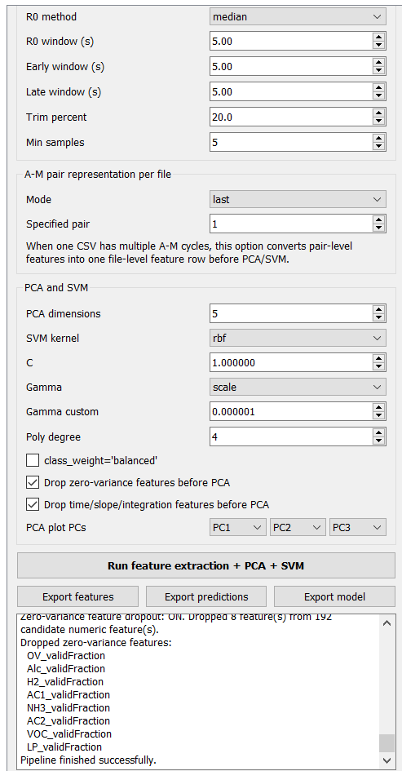
Figure 1. Training/model export settings used in the experiment.

3. Feature Selection
The app initially generated 192 candidate numeric sensor features. Time-related, slope-related, and integration-related features were intentionally removed before PCA. This removed 72 features, including timeToMax, timeToMin, timeToAbsPeak, areaTotal, areaAbs, initialSlope, lateSlope, R0Slope, and R0SlopeRelative features from all gas sensors.
In addition, eight zero-variance features were removed because they did not vary across the training dataset. These features were the validFraction features for all eight gas sensors.
Item | Value
Initial candidate numeric features | 192
Time/slope/integration features removed | 72
Zero-variance features removed | 8
Features used for PCA | 112
PCA dimensions used | 5
Explained variance by 5 PCs | 77.32%

4. Dataset Summary
The dataset was divided into 80% training data and 20% validation data. The total dataset contained 135 file-level samples.
Dataset | Total samples | Class 1 | Class 2
Training | 108 | 72 | 36
Validation | 27 | 18 | 9
Total | 135 | 90 | 45
The data were imbalanced, with Class 1 having twice as many samples as Class 2. This class imbalance should be considered when interpreting recall and overall accuracy.

5. Classification Results
Dataset | Accuracy
Training | 97.22%
Validation | 85.19%
The high training accuracy indicates that the SVM model fitted the training data well. The validation accuracy of 85.19% suggests that the model generalized reasonably well to unseen samples, although a decrease from training performance was observed.
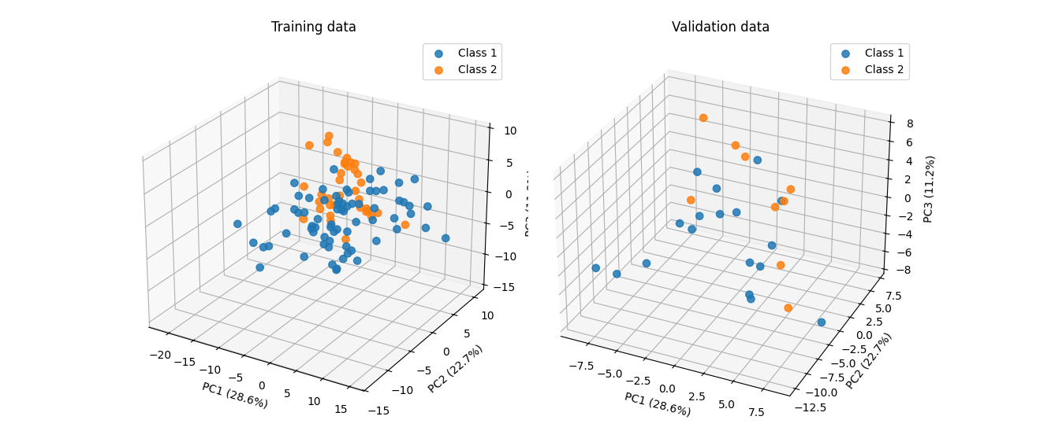
Figure 2. First three PCA components plot of training and validation data.

5.1 Training classification report
Class | Precision | Recall | F1-score | Support
Class 1 | 0.96 | 1.00 | 0.98 | 72
Class 2 | 1.00 | 0.92 | 0.96 | 36
Accuracy |  |  | 0.97 | 108
Macro average | 0.98 | 0.96 | 0.97 | 108
Weighted average | 0.97 | 0.97 | 0.97 | 108
For the training data, the classifier achieved strong performance for both classes. Class 1 achieved perfect recall, meaning that all chemically treated rice samples in the training set were correctly identified. Class 2 also showed strong performance, with an F1-score of 0.96.

5.2 Validation classification report
Class | Precision | Recall | F1-score | Support
Class 1 | 0.85 | 0.94 | 0.89 | 18
Class 2 | 0.86 | 0.67 | 0.75 | 9
Accuracy |  |  | 0.85 | 27
Macro average | 0.85 | 0.81 | 0.82 | 27
Weighted average | 0.85 | 0.85 | 0.85 | 27
The validation performance shows that Class 1 was detected more reliably than Class 2. Class 1 had recall of 0.94, whereas Class 2 had recall of 0.67. This means that some natural rice samples were misclassified as chemically treated rice.

5.3 Validation confusion matrix
True class | Predicted Class 1 | Predicted Class 2
True Class 1 | 17 | 1
True Class 2 | 3 | 6
From the validation results, 17 chemically treated samples were correctly classified, and 6 natural rice samples were correctly classified. One chemically treated sample was predicted as natural rice, while three natural rice samples were predicted as chemically treated rice.

6. Discussion
The result suggests that the e-nose system can distinguish between chemically treated milled rice and natural milled rice with good validation performance. The use of normalized resistance features allows the classifier to focus on relative sensor response rather than absolute resistance values.
The classifier achieved 85.19% validation accuracy even after removing time, slope, and integration features. This indicates that steady-state and amplitude-related features still contain meaningful information for separating the two rice categories.
The main weakness of the current model is the lower recall for Class 2. Class 2 corresponds to natural rice, and a recall of 0.67 means that three out of nine validation samples were misclassified as chemically treated rice. This may happen because some natural rice samples produced sensor response patterns similar to chemically treated rice.
The performance gap between training accuracy and validation accuracy suggests mild overfitting. Training accuracy was 97.22%, while validation accuracy was 85.19%. The model may still be sensitive to sample variation, environmental variation, or sensor drift.
The class imbalance is also important. Since Class 1 has twice as many samples as Class 2, and class_weight="balanced" was not enabled, the SVM may be slightly biased toward Class 1. This can contribute to the lower recall of Class 2.

7. Conclusion
The SVM classifier using PCA-reduced e-nose features achieved promising performance for binary classification of chemically treated and natural milled rice. With 5 PCA components from 112 selected features, the model achieved:
Metric | Value
Training accuracy | 97.22%
Validation accuracy | 85.19%
The classifier performed better for chemically treated rice than for natural rice. The main limitation is the lower recall of Class 2, where some natural rice samples were misclassified as chemically treated rice. Overall, the result supports the feasibility of using the e-nose system as a screening tool for detecting chemically treated milled rice.

8. Recommendations for Future Improvement
- Increase the number of Class 2 samples to reduce class imbalance and improve natural-rice recall.
- Test the SVM with class_weight="balanced" to reduce possible bias toward Class 1.
- Compare models with and without time/slope/integration features to determine whether the removed dynamic features improve Class 2 detection.
- Evaluate additional classifiers such as neural networks, random forest, and gradient boosting for comparison.
- Repeat measurements under controlled humidity and temperature to reduce environmental effects.
- Include independent testing data collected on a different day to better evaluate generalization.

