实验2：练习并熟练掌握交互式SQL语言
姓名 | 吴健 |  | 院系 | 软件学院 |  |  | 学号 |  | 1103710321
任课教师 |  | 邓胜春 |  |  | 指导教师 | 王帅
实验地点 |  | 软件学院三楼机房 |  |  | 实验时间 | 2012-5-22
实验课表现 |  | 出勤、表现得分10% |  |  | 实验报告  得分40% |  |  | 实验总分
 |  | 操作结果得分50%
实验学时：6学时
实验目的：
用已建立的数据库SCT与CAP, 练习并熟练掌握交互式SQL语言。
实验内容及要求：
练习并熟练掌握交互式SQL语言。
- 熟悉并练习交互式SQL语言的操作方式
- 录入并完成10条以上的SQL语句, 要求清晰记录下结果, 并检查是否与SQL语句要求的一致 [从课后练习题中选取]
- 写出另外10条以上的SQL语句并录入, 检查语句的正确性,无需记录结果[从课后练习题中选取]
考核方法：
- 检查给定语句的结果是否都记录下来
- 检查给定条件的SQL语句是否都已完成
实验报告要求：
完整的实验报告应包含：
- 给定SQL语句的结果描述与结果记录
- 给定条件的SQL语句
- 本实验的心得
上交文件要求：
1．文件命名：10本-DBS实验报告2-学号-姓名.doc
2．文件内包含：
（1）所有SQL语句；
（2）实验报告文件。
3．本实验要求在截至日期前提交，否则每迟交1天成绩扣20%。

实验过程及结果：
由于第一次试验建立的CAP数据库中的很多数据在本次试验中的SQL语句的查询结果都为空，故将CAP数据库的4个表重建，重新录入数据，使得SQL语句能够查询得到结果
重新录入的数据如下所示
use CAP

insert Customers values ('c0001','顾客一','Kyoto',20);
insert Customers values ('c0002','顾客二','Tokyo',25);
insert Customers values ('c0003','顾客三','Duluth',30);
insert Customers values ('c0004','顾客四','Dallas',35);
insert Customers values ('c0005','顾客五','Kyoto',40);
insert Customers values ('c0006','顾客六','Tokyo',45);
insert Customers values ('c0007','顾客七','New York',50);
insert Customers values ('c0008','顾客八','Duluth',55);
insert Customers values ('c0009','顾客九','Tokyo',60);
insert Customers values ('c0010','顾客十','Kyoto',65);
insert Customers values ('c0011','顾客十一','New York',70);
insert Customers values ('c0012','顾客十二','Dallas',75);
insert Customers values ('c0013','顾客十三','Duluth',80);
insert Customers values ('c0014','顾客十四','Dallas',85);
insert Customers values ('c0015','顾客十五','New York',90);

insert Agents values ('a0001','代理商一','New York',50);
insert Agents values ('a0002','代理商二','Duluth',30);
insert Agents values ('a0003','代理商三','Kyoto',10);
insert Agents values ('a0004','代理商四','New York',20);
insert Agents values ('a0005','代理商五','Tokyo',15);
insert Agents values ('a0006','代理商六','Kyoto',35);
insert Agents values ('a0007','代理商七','New York',45);
insert Agents values ('a0008','代理商八','Duluth',67);
insert Agents values ('a0009','代理商九','Dallas',60);
insert Agents values ('a0010','代理商十','Tokyo',80);
insert Agents values ('a0011','代理商十一','Tokyo',95);
insert Agents values ('a0012','代理商十二','Duluth',65);
insert Agents values ('a0013','代理商十三','Kyoto',70);
insert Agents values ('a0014','代理商十四','Duluth',53);
insert Agents values ('a0015','代理商十五','Dallas',22);

insert Products values ('p0001','产品一','Dallas',5000,0.1);
insert Products values ('p0002','产品二','Tokyo',8000,0.2);
insert Products values ('p0003','产品三','Kyoto',8500,0.3);
insert Products values ('p0004','产品四','New York',3000,0.4);
insert Products values ('p0005','产品五','Duluth',2000,0.5);
insert Products values ('p0006','产品六','Dallas',6000,0.6);
insert Products values ('p0007','产品七','Tokyo',7000,0.7);
insert Products values ('p0008','产品八','New York',6500,0.8);
insert Products values ('p0009','产品九','Kyoto',3200,0.9);
insert Products values ('p0010','产品十','Duluth',4000,1.0);
insert Products values ('p0011','产品十一','Kyoto',4600,1.1);
insert Products values ('p0012','产品十二','Dallas',6500,1.2);
insert Products values ('p0013','产品十三','New York',7200,1.3);
insert Products values ('p0014','产品十四','New York',8000,1.4);
insert Products values ('p0015','产品十五','Tokyo',1300,1.5);

insert Orders values ('o0001','March','c0001','a0001','p0001',3000,300);
insert Orders values ('o0002','March','c0002','a0001','p0002',4000,800);
insert Orders values ('o0003','April','c0003','a0003','p0003',2000,600);
insert Orders values ('o0004','March','c0004','a0004','p0004',2000,1000);
insert Orders values ('o0005','May','c0005','a0005','p0005',600,300);
insert Orders values ('o0006','March','c0006','a0006','p0006',2000,1200);
insert Orders values ('o0007','July','c0007','a0004','p0007',1000,700);
insert Orders values ('o0008','May','c0008','a0003','p0008',3000,2400);
insert Orders values ('o0009','March','c0004','a0008','p0002',1000,200);
insert Orders values ('o1000','April','c0007','a0006','p0006',3000,1800);
insert Orders values ('o0011','May','c0001','a0002','p0004',500,200);
insert Orders values ('o0012','June','c0006','a0002','p0003',2000,600);
insert Orders values ('o0013','September','c0001','a0004','p0002',1000,200);
insert Orders values ('o0014','March','c0002','a0007','p0004',1000,400);
insert Orders values ('o0015','September','c0003','a0006','p0001',2000,1200);
练习1：（SQL语句及其结果）
(1) 找出订单总价大于或者等于$1000的(ordno, pid)对
SELECT ordno, pid FROM Orders WHERE dollars>=1000
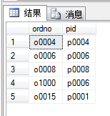

(2) 找出所有价格在$0.50和$1.00之间的商品名字，包括边界价格
SELECT pname FROM Products WHERE price>=0.5 AND price<=1.0
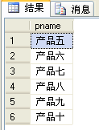

(3) 找出订单价格低于$500的(ordno, cname)对，使用一次连接
SELECT O.ordno, C.cname
FROM Orders O, Customers C
WHERE O.cid = C.cid AND O.dollars < 500
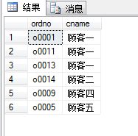

(4) 找出所有三月份接受的订单的(ordno, aname)对，使用一次连接
SELECT O.ordno, A.aname
FROM Orders O, Agents A
WHERE O.aid = A.aid AND O.[month] = 'March'
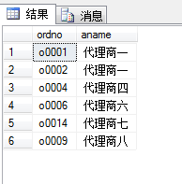

(5) 找出所有三月份接受的订单的(ordno, cname, aname)三元组，使用两次连接
SELECT O.ordno, C.cname, A.aname
FROM Orders O, Customers C, Agents A
WHERE O.aid = A.aid AND O.cid = C.cid AND O.month = 'March'
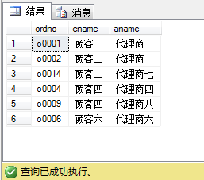

(6) 找出所有位于New York的代理商，并且要求这些代理商所接受的单个订单
SELECT A.aid, A.aname, A.city, A.apercent
FROM Agents A, Orders O
WHERE O.aid = A.aid AND O.dollars < 500 AND A.city='New York'
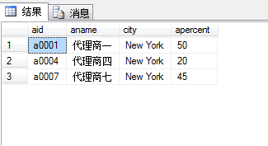
(11) 找出接受顾客c0002订单的代理商所在的城市
SELECT A.city FROM Agents A, Orders O
WHERE O.cid='c0002' AND O.aid = A.aid
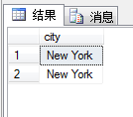
(12) 取出至少被一个在Dallas的顾客通过位于New York的代理商定购的商品的名字
SELECT P.pname
FROM Customers C, Agents A, Products P, Orders O
WHERE O.cid=C.cid AND O.aid=A.aid AND O.pid=P.pid
AND C.city='Dallas' AND A.city='New York'
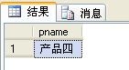

(13) 取出曾经收到Kyoto的顾客订单的代理商所销售的所有的商品的pid值。
SELECT pid FROM Orders WHERE aid IN
(SELECT aid FROM Orders O, Customers C
WHERE O.cid = C.cid AND C.city='Kyoto')
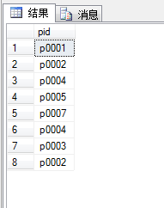

(14) 列出所有在同一个城市的代理商的aid对
SELECT A1.aid, A2.aid
FROM Agents A1, Agents A2
WHERE A1.city = A2.city AND A1.aid>A2.aid
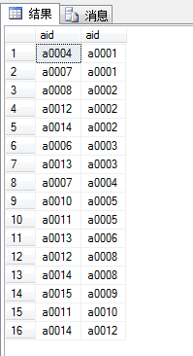

(15) 列出没有通过代理商a0003定购过商品的顾客的cid值
SELECT C.cid FROM Customers C WHERE C.cid NOT IN
(SELECT O.cid FROM Orders O WHERE aid = 'a0003')
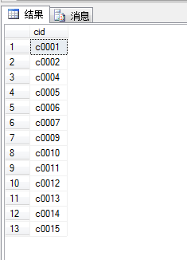

(18) 找出通过代理商a03而不通过代理商a06定购的商品的pid值
SELECT O1.pid FROM Orders O1 WHERE O1.aid = 'a0003' AND NOT EXISTS
(SELECT * FROM Orders O2 WHERE O2.pid = O1.pid AND O2.aid = 'a0006')
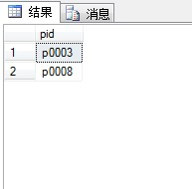

(19) 取出商品的pname和pid值，要求这些商品所在的城市和某个销售过该商品的代理商所在的城市相同
SELECT P.pname, P.pid FROM Products P, Agents A, Orders O
WHERE O.pid = P.pid AND O.aid = A.aid AND P.city = A.city
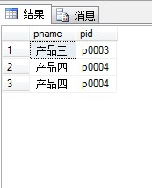
(22) 取出销售过所有曾被顾客c0002定购过的商品的代理商的名字
SELECT A.aname FROM Agents A WHERE Not Exists
(SELECT * FROM Orders O1 WHERE O1.cid='c0002' AND Not Exists
(SELECT * FROM Orders O2 WHERE O2.pid=O1.pid AND O2.aid=A.aid))
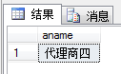

(25) 取出所有曾在代理商a03处定购商品的顾客定购过的商品的pid值
SELECT O1.pid FROM Orders O1, Orders O2
WHERE O1.cid = O2.cid AND O2.aid = 'a0003'
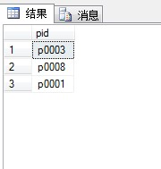

(27) 给出所有的(cname, aname)对，要求对应的顾客曾经在对应的代理商处 定购过商品
SELECT C.cname, A.aname FROM Customers C, Agents A, Orders O
WHERE O.cid = C.cid AND O.aid = A.aid
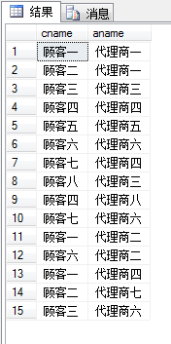

(28) 取出只从一家代理商定购过商品的顾客的cid值
SELECT O1.cid FROM Orders O1 WHERE NOT EXISTS
(SELECT * FROM Orders O2
WHERE O2.cid = O1.cid AND O2.aid <> O1.aid)
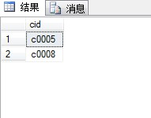

(29) 为每个有订货记录的代理商列出他所销售的每样产品的pid值以及所有通过该代理商订购该产品的顾客们所定购的总量
SELECT aid, pid, sum(qty)
FROM Orders
GROUP BY aid, pid
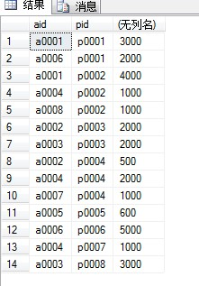

(30) 求出没有为任何住在Duluth的顾客订购任何在Dallas生产的产品的代理商aid值
SELECT A.aid FROM Agents A WHERE Not Exists
(SELECT * FROM Customers C, Products P, Orders O
WHERE O.aid=a.aid AND O.cid=C.cid AND O.pid=P.pid AND
C.city='Duluth' AND P.city='Dallas')
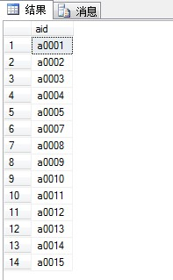

(32) 求出只通过代理商a0003或a0005订货的顾客的cid值
SELECT O1.cid FROM Orders O1 WHERE O1.aid in ('a0003','a0005') AND Not Exists
(SELECT * FROM Orders O2 WHERE O2.cid=O1.cid AND
O2.aid not in ('a0003','a0005') )
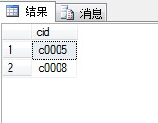

(34) 找出拥有最高Percent的代理商
SELECT A1.aid FROM Agents A1
WHERE A1.apercent >= all (SELECT A2.apercent FROM Agents A2)
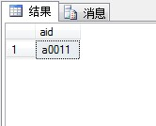

(36) 求出为住在Duluth的所有顾客订货的代理商的aid和percent值，并按percent值从大到小的顺序排列结果中的aid值
SELECT A.aid, A.apercent FROM Agents A
WHERE not Exists
(SELECT * FROM Customers C WHERE C.city = 'Dulluth' AND
not Exists
(SELECT * FROM Orders O
WHERE O.cid = C.cid AND O.aid = A.aid)
)
ORDER BY A.apercent DESC
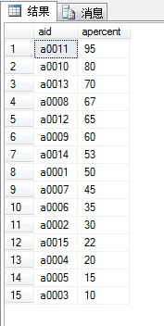

(37) 查询满足下列条件的产品的pid值：该产品至少被一个顾客订购，每个顾客与为他订购该产品的代理商住在同一城市
SELECT O.pid FROM Orders O, Agents A, Customers C
WHERE O.aid = A.aid AND O.cid = C.cid AND A.city = C.city
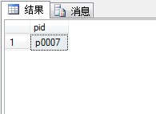

练习2：（正确写出SQL语句）

(7) 找出所有三月份定购的(位于)Duluth的商品的名字
SELECT P.pname FROM Products P, Orders O
WHERE P.pid = O.pid AND O.[month] = 'Marth' AND P.city = 'Duluth'

(8) 找出所有顾客、代理商和商品都在同一个城市的三元组(cid, aid, pid)
SELECT C.cid, A.aid, P.pid FROM Customers C, Agents A, Products P
WHERE C.city = A.city AND C.city = P.city

(9) 找出所有顾客、代理商和商品不都在同一个城市(可能有两个在同一城市)的三元组(cid, aid, pid)
SELECT C.cid, A.aid, P.pid FROM Customers C, Agents A, Products P
WHERE C.city <> A.city OR C.city <> P.city OR A.city <> P.city

(10) 找出所有顾客、代理商和商品两两不在同一个城市的三元组
SELECT C.cid, A.aid, P.pid FROM Customers C, Agents A, Products P
WHERE C.city <> A.city AND C.city <> P.city AND A.city <> P.city

(17) 找出定购了所有商品的顾客的cid值
SELECT C.cid FROM Customers C WHERE NOT EXISTS
(SELECT * FROM Products P WHERE NOT EXISTS
(SELECT * FROM Orders O WHERE O.pid = P.pid AND O.cid = C.cid) )

(21) 取出同时定购了商品p0001和p0007的顾客的cid值
SELECT O1.cid FROM Orders O1, Orders O2
WHERE O1.cid = O2.cid AND O1.pid = 'p0001' AND O2.pid = 'p0007'

(23) 取出销售过所有曾被某些顾客定购过的商品的代理商的名字
SELECT A.aname FROM Agents A WHERE Not Exists
(SELECT * FROM Orders O1 WHERE Not Exists
(SELECT * FROM Orders O2
WHERE O2.pid=O1.pid AND O2.aid=A.aid))

(24) 取出所有的三元组(cid, aid, pid)，要求对应的顾客，代理商和商品中至少有两者是位于同一座城市
SELECT C.cid, A.aid, P.pid FROM Customers C, Agents A, Products P
WHERE NOT EXISTS (SELECT * FROM Customers C1, Agents A1, Products P1
WHERE C1.city<>A1.city AND C1.city<>P1.city AND A1.city<>P1.city AND C.cid=C1.cid
AND A.aid=A1.aid AND P.pid=P1.pid)

(26) 取出接受过Kyoto的顾客一笔总额超过$500的订单的代理商的aid值
SELECT O.cid FROM Orders O, Customers C
WHERE O.cid = C.cid AND C.city = 'Kyoto' AND O.dollars>500

(31) 求出为住在Duluth或Kyoto的所有顾客订购了至少一样公共产品的代理商的aid值
SELECT O1.aid FROM Orders O1 WHERE Not Exists
(SELECT * FROM Customers C WHERE C.city='Duluth' AND Not Exists (SELECT * FROM Orders O2 WHERE O2.cid=C.cid AND O2.aid=O1.aid AND O2.pid=O1.pid))
UNION
SELECT O1.aid FROM Orders O1 WHERE Not Exists
(SELECT * FROM Customers C WHERE C.city='Kyoto' AND Not Exists (SELECT * FROM Orders O2 WHERE O2.cid=C.cid AND O2.aid=O1.aid AND O2.pid=O1.pid))

(33) 求出被所有住在Dallas的顾客都订购了的产品的pid值
SELECT O1.pid FROM Orders O1 WHERE Not Exists
(SELECT * FROM Customers C WHERE C.city='Dallas' AND Not Exists
(SELECT * FROM Orders O2
WHERE O2.pid=O1.pid AND O2.cid=C.cid))

(35) 检索订购了至少一样产品但所有产品都只通过代理商a0004来订购的顾客的 cid值，另外该查询还应在每个cid值所在的同一行上列出每个顾客的总订货金额
SELECT cid, SUM(dollars)
FROM Orders
WHERE aid='a0004' AND cid not in (SELECT cid FROM Orders WHERE aid <> 'a0004')
GROUP BY cid

实验心得（实验过程中遇到的问题如何解决的？本实验的收获？）
指导教师评语
签字：
日期：

