Evolutionary dynamics of indirect reciprocity with inertial reputation transitions
Indirect reciprocity is a fundamental mechanism for the evolution of cooperation, wherein individuals help others based on the others’ reputations rather than direct experience​. Classic models of indirect reciprocity typically assume binary reputations (good or bad) and deterministic, and publicly or privately evaluates each action under a shared social norm​. For example, a single antisocial behavior by a reputable individual can immediately damage their reputation, while one prosocial act by a disreputable individual can fully restore it. In practice, however, human assessments are often more nuanced – people may give second chances or require consistent good behavior to fully trust someone, depending on the player's reputation status prior to assessment. Here, we separate reputation labels from behavioral assessments and incorporate reputation inertia into the reputation transformation system, which is represented by two stages with multiple intermediate states. By adjusting the perception of the intermediate state in the two stages, it is possible to demonstrate tolerance toward "good" people and strictness toward "bad" people. Errors and disagreements are important factors that undermine the effectiveness of indirect reciprocity mechanisms. In our model, we verified the effectiveness of reputation inertia in maintaining and promoting cooperation under public and private assessment. Under second-order norms, if defecting against bad players is considered bad, increasing tolerance inertia can promote cooperation, while strict inertia will always cooperate. If defecting against bad players is considered good, the opposite is true.

Model description

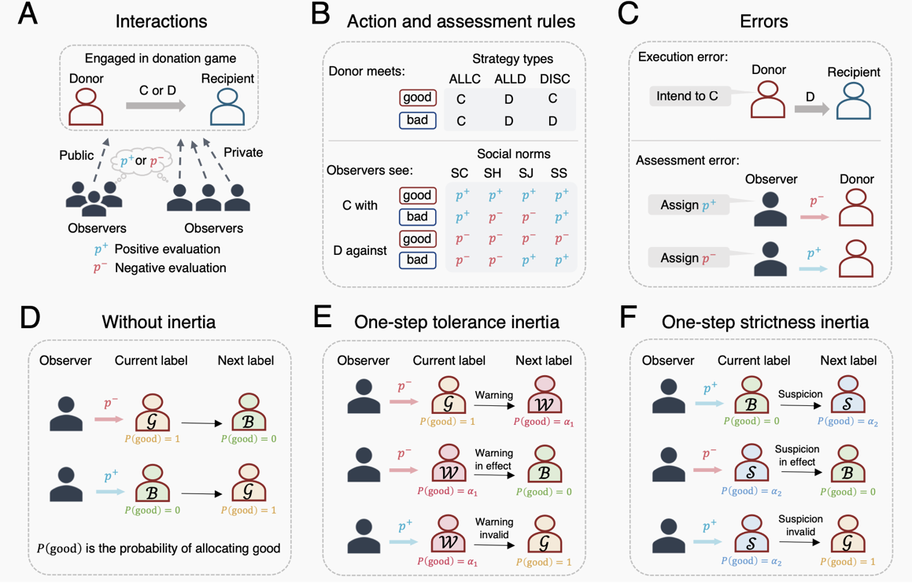
Interactions: We consider a well-mixed population of players engaged in pairwise, one-shot interactions that takes the form of donation games, also known as the simplified prisoner's dilemma. In each interaction, two players are randomly selected from the population to serve as the donor and recipient, respectively. The donor can choose to cooperate (C), incurring a cost $c$ ($c > 0$) and generating a benefit $b$ ($b > c$) for the recipient, or defect (D), incurring no cost and generating no benefit. The above donation game can be characterized by the payoff matrix
$$\left(\begin{matrix}b-c & -c \\ b & 0\end{matrix}\right).$$

Strategies: Individuals make decisions based on their behavior strategy, which prescribes an action conditioned on the reputation of the recipient. Here we describe the strategies by the tuples $s=(s^{G},s^{B})$, where $s^{G}$ and $s^{B}$ represent the probabilities of a donor cooperating with a "good" or "bad" recipient, respectively. As is common in the recent literature, we assume that both $s^{G}$ and $s^{B}$ are in {0,1}, and so we focus on three strategies: ALLC (always cooperate) with $s=(1,1)$, ALLD (always defect) with $s=(0,0)$ and DISC (discriminate, who cooperates only when recipient in good standing) with $s=(1,0)$.

Social norms: We consider second-order social norms, which depend on the actions of donors and the reputation of recipients. Such norms can be represented by a four-dimensional vector $d=\{d_{CG},d_{CB},d_{DG},d_{DB}\}$, where $d_{AR}$ represents the probability of receiving a positive evaluation when a donor takes action $A∈\{C,D\}$ toward a recipient with reputation $R∈\{G,B\}$. It should be noted that $R$ here represents the evaluation of the reputation label. Our model uses probability perception, that is, the probability that players with label $G$ are perceived as reputation G is $1$, and the probability that players with label $B$ are perceived as reputation G is $0$. We consider the general case where each reputation transition path has $k$ ($k≥0$) intermediate labels. For the assessment inertia in the path from “good” to “bad”, the probabilities that players with labels $W_{i}$ are perceived as reputation G are ${α_{1}}^{i}$, where $α_{1}$ ($0≤α_{1}≤1$) represents tolerance in reputation inertia, and the larger the value of $α_{1}$, the higher the tolerance. In contrast, players with reputation labels $S_{i}$ in the assessment inertia from “bad” to “good” are considered to have a probability of reputation G of $1-{α_{2}}^{i}$, where $α_{2}$ ($0≤α_{2}≤1$) represents strictness in reputation inertia, and the larger the value of $α_{2}$, the stricter it is. Table. 1 summarizes the relationship between reputation labels and the probability of good reputation perception.

Table: The relationship between reputation labels and good reputation.
Reputation Labels | $$G$$ | $$B$$ | $$W_{1}$$ | $$⋯$$ | $$W_{k}$$ | $$S_{1}$$ | $$⋯$$ | $$S_{k}$$
Probability of reputation G | $$1$$ | $$0$$ | $$α_{1}$$ | $$⋯$$ | $${α_{1}}^{k}$$ | $$1-α_{2}$$ | $$⋯$$ | $${1-α_{2}}^{k}$$
Probability of reputation B | $$0$$ | $$1$$ | $$1-α_{1}$$ | $$⋯$$ | $$1-{α_{1}}^{k}$$ | $$α_{2}$$ | $$⋯$$ | $${α_{2}}^{k}$$

In general, cooperating with "good" player is considered as good, while defecting with "good" player is considered as bad, i.e., $d_{CG}=1$ and $d_{DG}=0$. Four different norms arise from the evaluation of different behaviors toward "bad" player. Using parameters $p$ and $q$ to represent the probabilities of cooperating with and defecting from "bad" player to obtain positive evaluations, respectively, the social norms are expressed as $d=\{1,p,0,q\}$, where $p=1$ and $q=0$correspond to Scoring (SC); $p=0$ and $q=1$ correspond to Stern Judging (SJ); $p=1$ and $q=1$ correspond to Simple Standing (SS); and $p=0$ and $q=0$ correspond to Shunning (SH).

Errors: Our model also includes errors in strategy execution and in observation. With probability $e_{1}$ ($0<e_{1}<1/2$), a player who intends to cooperate can accidentally defect, whereas an intended defection is always executed correctly. With probability $e_{2}$ ($0<e_{2}<1/2$), an observer may erroneously assign a positive evaluation to a negative evaluation, and vice versa. The assignment of positive evaluations by social norms changes under two types of errors. An individual can obtain a "good" reputation in the following ways. They may be observed:
1. interacting with an individual with a good reputation and intending to cooperate.
$$d_{CG}=(1-e_{1})(1-e_{2})+e_{1}e_{2}=ϵ.$$
2. interacting with an individual with a bad reputation and intending to cooperate.
$$d_{CB}=p(ϵ-e_{2})+q(1-ϵ-e_{2})+e_{2}.$$
3. interacting with an individual with a good reputation and intending to defect.
$$d_{DG}=e_{2}.$$
4. interacting with an individual with a bad reputation and intending to defect.
$$d_{DB}=q\left(1-2e_{2}\right)+e_{2}.$$

Table. 2 summarizes the probability of observers assigning positive evaluations to donors under four social norms.

Table: The probability of observers assigning positive evaluations to donors.
Social norms | $$d_{CG}$$ | $$d_{CB}$$ | $$d_{DG}$$ | $$d_{DB}$$
Scoring | $$ϵ$$ | $$ϵ$$ | $$e_{2}$$ | $$e_{2}$$
Shunning | $$ϵ$$ | $$e_{2}$$ | $$e_{2}$$ | $$e_{2}$$
Stern Judging | $$ϵ$$ | $$1-ϵ$$ | $$e_{2}$$ | $$1-e_{2}$$
Simple Standing | $$ϵ$$ | $$1-e_{2}$$ | $$e_{2}$$ | $$1-e_{2}$$

Replicator dynamics:
Let $x,$ $y$, and $z$ represent strategies ALLC, ALLD, and DISC, respectively, and let $f_{x}$, $f_{y}$, and $f_{z}$represent their frequencies in the population, such that$f_{x}+f_{y}+f_{z}=1$. Denoting the average payoff of strategy $I∈\left\{x,y,z\right\}$ as $Π_{I}$, the strategy dynamics can be expressed as
$${\dot{f}}_{I}=f_{I}(Π_{I}-\overline{Π})$$
where $\overline{Π} =f_{x}Π_{x}+f_{y}Π_{y}+f_{z}Π_{z}$ represents the average payoff of the population.
The payoff of each player is determined by interactions in the donation game with all other players in the population. Let $g_{I}$ denote the average probability that strategy $I$ is regarded as good in the population. We can obtain the expected payoffs of the three strategies as
$$\begin{matrix}\begin{matrix}Π_{x}= \\ Π_{y}= \\ Π_{z}=\end{matrix} & \begin{matrix}(1-e_{1})b(f_{x}+g_{x}f_{z})-(1-e_{1})c, \\ (1-e_{1})b(f_{x}+g_{y}f_{z}), \\ (1-e_{1})b(f_{x}+g_{z}f_{z})-(1-e_{1})cg.\end{matrix}\end{matrix}$$
where $g=f_{x}g_{x}+f_{y}g_{y}+f_{z}g_{z}$ represents the average fraction of individuals with good reputations over the population.

Reputation dynamics:
We assume that reputation frequencies reach equilibrium before strategy frequency change- that is, we assume the timescale of reputation updating is fast compared to that of strategy update. First, we calculate the probability that strategy $I∈\left\{x, y, z\right\}$ will receive a positive evaluation $p_{\text{I}}^{+}$ under public assessment. For ALLC, observers gave positive evaluations in the following two ways:
1. interacting with an individual with a good reputation (probability $g$), intending to cooperate, which yields a positive evaluation with probability $d_{CG}$.
2. interacting with an individual with a bad reputation (probability $1-g$), intending to cooperate, which yields a positive evaluation with probability $d_{CB}$.

Similar reasoning applies to ALLD, who can earn positive evaluations in two ways:
1. interacting with an individual with a good reputation (probability $g$), intending to defect, which yields a positive evaluation with probability $d_{DG}$.
2. interacting with an individual with a bad reputation (probability $1-g$), intending to defect, which yields a positive evaluation with probability $d_{DB}$.

Finally, a DISC player ends up with positive evaluation in two ways:
1. interacting with an individual with a good reputation (probability $g$), intending to cooperate, which yields a positive evaluation with probability $d_{CG}$.
2. interacting with an individual with a bad reputation (probability $1-g$), intending to defect, which yields a positive evaluation with probability $d_{DB}$.

In summary, we can get
$$p_{\text{x}}^{+}=gd_{GC}+(1-g)d_{BC}$$
$$p_{\text{y}}^{+}=gd_{GD}+(1-g)d_{BD}$$
$$p_{\text{z}}^{+}=gd_{GC}+(1-g)d_{BD}$$

Under private assessment, reputations are tracked according to a solitary private monitoring system, whereby all individuals observe and update their views of others independently. The difference from public assessment occurs in DISC. Let $g_{2}$ denote the probability that two randomly selected players will see the same recipient as "good", that is $g_{2}=f_{x}{g_{x}}^{2}+f_{y}{g_{y}}^{2}+f_{z}{g_{z}}^{2}$. The probability that two players see the same recipient as "bad" is then $b_{2}=1-2g+g_{2}$, and they will disagree on the subjective reputation of the recipient with probability $d_{2}=g-g_{2}$. Then we can get the probability that strategy DISC will receive a positive evaluation under private assessment is
$$p_{\text{z}}^{+}=g_{2}d_{GC}+b_{2}d_{BD}+d_{2}(d_{GD}+d_{BC})$$

Regardless of the assessment method used, it is necessary to know the frequency of “good” reputation in various strategies. We let $g_{I}$ represents the probability that strategy $I$ is regarded as a “good” reputation and $π_{I}\left(X\right)$ represents the proportion of reputation labels $X$ in strategy $I$. Then we get:
$$g_{I}=π_{I}(G)+\sum_{i=1}^{k}{π_{I}(W_{i})α_{1}^{i}}+\sum_{j=1}^{k}{π_{I}(S_{j})(1-α_{2}^{j})}.$$

When $k=1$, we have
$$g_{I}=π_{I}(G)+α_{1}π_{I}(W)+(1-α_{2})π_{I}(S)$$

Calculation of stable distribution of reputation labels：
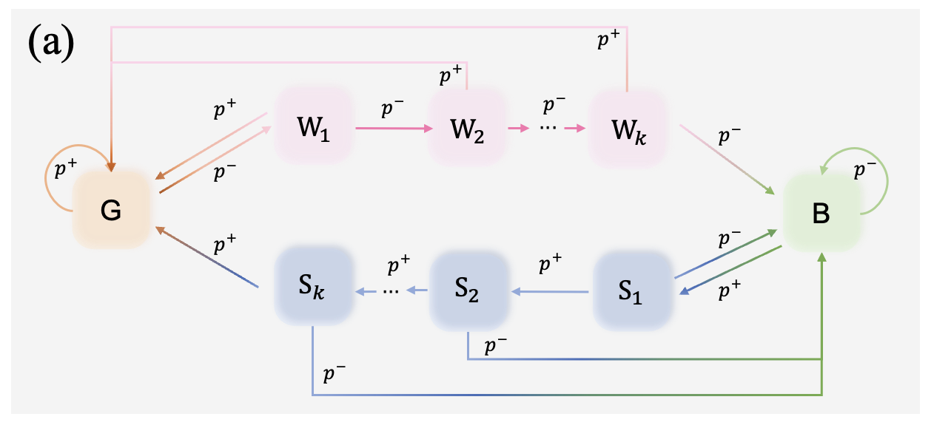
A skip change means that the warning for intermediate state $W_{i}$ is lifted after a positive evaluation $p^{+}$, and suspicion for intermediate state $S_{i}$ takes effect after a negative evaluation $p^{-}$.
The Markov system has a total of $2k+2$ states. For strategy $I$, let $p=p_{I}^{+}$ be the probability of obtaining a positive evaluation (see equation in the above).

For skip version, the reputation state transition follows the Markov chain below.
- from $G$: Stay in $G$ with probability $p$ and transition to $W_{1}$ with probability $1-p$.
- from $W_{i} (1≤i<k)$: With probability $p$, jump back to $G$, and with probability $1-p,$ transition to $W_{i+1}$.
- from $W_{k}$: With probability $p$, jump back to $G$, and with probability $1-p$, transition to $B$.
- from $B$: With probability $p$, transition to $S_{1}$, and with probability $1-p$, remain in $B$.
- from $S_{j}(1≤j<k)$: With probability $p$, transition to $S_{j+1}$, and with probability $1-p$, jump back to $B$.
- from $S_{k}$: With probability $p$, transition to $G$; with probability $1-p$, jump back to $B$.

Based on this, we can list the state transition matrix $T$ of $\left(2k+2\right)×\left(2k+2\right)$, whose non-zero elements are:
$$\begin{matrix}T_{G→G} & =p, & T_{G→W_{1}} & =1-p, \\ T_{W_{i}→G} & =p, & T_{W_{i}→W_{i+1}} & =1-p \left(i<k\right), \\ T_{W_{k}→G} & =p, & T_{W_{k}→B} & =1-p, \\ T_{B→S_{1}} & =p, & T_{B→B} & =1-p, \\ T_{S_{j}→S_{j+1}} & =p, & T_{S_{j}→B} & =1-p \left(j<k\right), \\ T_{S_{k}→G} & =p, & T_{S_{k}→B} & =1-p.\end{matrix}$$
From the above Markov chain solution, the steady-state distribution
$$π=\left(π_{I}\left(G\right),π_{I}\left(W_{1}\right),…,π_{I}\left(W_{k}\right),π_{I}\left(B\right),π_{I}\left(S_{1}\right),…,π_{I}\left(S_{k}\right)\right)$$
satisfies $π=πT$. The recursive relationship can be obtained as follows:
$π_{I}\left(W_{i}\right)={\left(1-p\right)}^{i}π_{I}\left(G\right)$ ($i=1,…,k$);
$π_{I}\left(S_{j}\right)=p^{j}π_{I}\left(B\right)$ ($j=1,…,k$).
Using the normalization condition $\sum{π}=1$, we can solve for
$$\begin{matrix}π_{I}\left(G\right) & =\frac{p^{k+1}}{p^{k}+{\left(1-p\right)}^{k}-{\left(p\left(1-p\right)\right)}^{k}}, \\ π_{I}\left(W_{i}\right) & ={\left(1-p\right)}^{i}π_{I}\left(G\right)=\frac{{\left(1-p\right)}^{i}p^{k+1}}{p^{k}+{\left(1-p\right)}^{k}-{\left(p\left(1-p\right)\right)}^{k}}, i=1,…,k, \\ π_{I}\left(B\right) & =\frac{{\left(1-p\right)}^{k+1}}{p^{k+1}}π_{I}\left(G\right)=\frac{{\left(1-p\right)}^{k+1}}{p^{k}+{\left(1-p\right)}^{k}-{\left(p\left(1-p\right)\right)}^{k}}, \\ π_{I}\left(S_{j}\right) & =p^{j}π_{I}\left(G\right)=\frac{p^{j}{\left(1-p\right)}^{k+1}}{p^{k}+{\left(1-p\right)}^{k}-{\left(p\left(1-p\right)\right)}^{k}}, j=1,…,k,\end{matrix}$$
Recall that $p$ is the positive evaluation probability of strategy $I$. When $k=1$, we get
$$\begin{matrix}π_{I}\left(G\right)=\frac{p^{2}}{1-p+p^{2}} \\ \begin{matrix}π_{I}\left(W_{1}\right)=\frac{\left(1-p\right)p^{2}}{1-p+p^{2}} \\ π_{I}\left(B\right)=\frac{{\left(1-p\right)}^{2}}{1-p+p^{2}} \\ π_{I}\left(S_{1}\right)=\frac{p{\left(1-p\right)}^{2}}{1-p+p^{2}}\end{matrix}\end{matrix}$$
Given strategy $I$, the probabilities that each state is considered “good” are: $1, 0, α_{1}^{i}, 1-α_{2}^{j}$(corresponding to $G,B,W_{i},S_{j}$). Therefore, the overall “good” probability of strategy $I$ (i.e., the average probability that observers consider $I$ to have reputation G) is
$$\boxed{g_{I}=\frac{p^{k+1}}{p^{k}+{\left(1-p\right)}^{k}-{\left(p\left(1-p\right)\right)}^{k}}[1+\sum_{i=1}^{k}{(1-p)^{i}α_{1}^{i}}]+\frac{(1-p)^{k+1}}{p^{k}+{\left(1-p\right)}^{k}-{\left(p\left(1-p\right)\right)}^{k}}\sum_{j=1}^{k}{p^{j}(1-α_{2}^{j}}),}$$
When $α_{1}=α_{2}=0$, we have $g_{I}=p$, which reverts to the original indirect reciprocity model.

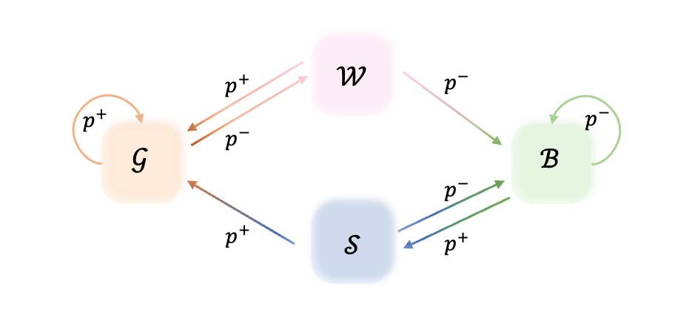
We will now mainly analyze the results when $k = 1.$
$$g_{I}=\frac{p^{k_{2}+1}+p^{k_{2}+1}\sum_{i=1}^{k_{1}}{1-p)^{i}α_{1}^{i}+(1-p)^{k_{1}+1}}(\sum_{j=1}^{k_{2}}{p^{j}(1-α_{2}^{j})})}{(1-p)^{k_{1}}+p^{k_{2}}-(1-p)^{k_{1}}p^{k_{2}}}$$

$$\begin{matrix}π_{l}\left(G\right) & =\frac{p^{k_{2}+1}}{{\left(1-p\right)}^{k_{1}}+p^{k_{2}}-{\left(1-p\right)}^{k_{1}}p^{k_{2}}} \\ π_{l}\left(W_{i}\right) & =\frac{{\left(1-p\right)}^{i}p^{k_{2}+1}}{{\left(1-p\right)}^{k_{1}}+p^{k_{2}}-{\left(1-p\right)}^{k_{1}}p^{k_{2}}} \\ π_{l}\left(B\right) & =\frac{{\left(1-p\right)}^{k_{1}+1}}{{\left(1-p\right)}^{k_{1}}+p^{k_{2}}-{\left(1-p\right)}^{k_{1}}p^{k_{2}}} \\ π_{l}\left(S_{j}\right) & =\frac{p^{j}{\left(1-p\right)}^{k_{1}+1}}{{\left(1-p\right)}^{k_{1}}+p^{k_{2}}-{\left(1-p\right)}^{k_{1}}p^{k_{2}}}\end{matrix}$$

