**Spike Sorting Steps**

1. Run Mapfile
2. Open, browse to data folder, open .lsx file
3. Options/Convert to Matlab format options 🡪 Align Channels by adding zeros 🡪 convert channels together
4. Options/Input Definitions 🡪 select channels 🡪 OK
5. File/Convert to Matlab format

**1) Multiple Stim Subtraction:**

* Load ‘multiple_stims_subtraction_v1.m’
* Change the data file folder if need be
* Change list of input channels
* Run file through
  + thresh (set threshold for detection)
  + SBAB (number of samples before artifact detection to be blanked)
    - E.g. thresh = 4000, then detection happens at the second crossing. In this case, if SBAB = 20, then it means that 20 time points before this cross is blanked

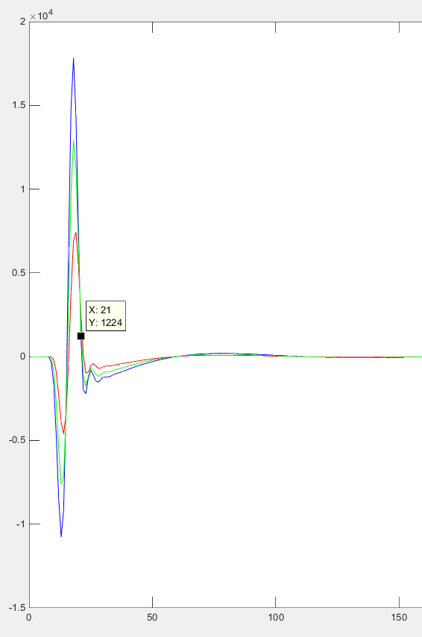

* + blanklength (number of samples to be blanked for each artifact)
    - note: (SBAB) samples is blanked before the crossing, and (blanklength – SBAB) is the number of samples to be blanked after the crossing
  + templ_length (number of artifacts to be averaged into a template)
  + SBAD (number of samples before the artifact crossing the threshold to be included in the artifact waveform)
    - E.g. thresh = 4000, then detection happens at the second crossing. In this case, if SBAD = 20, then it means that 20 time points before this cross is included in the spike waveform



* + artSegs (egment of the artifact waveform to compare)
  + F (Where the processed results are stored)
  + padNum – number of zeros to be padded to the very front of the data. This is normally set to zero (e,g. no padding).
    - If this code is not added, then the line ‘mask(m'*ones(1,blanklength+1)+ones(length(m),1)*[-SBAB:blanklength-SBAB])=0; might error, and it is because during a particular stim epoch, there may not be enough data points before the first detected artifact pulse that’s necessary to satisfy SBAB. The error will be : ‘subscript indices must be either real positive integers or logicals’. Therefore we must pad the data at the front in order to maintain the SBAB that we want.

**2) Offline Sorter:**

1. File/import/binary file with continuous digitized data

* Import the .2plx file (generated from multiple-stim-subtraction)

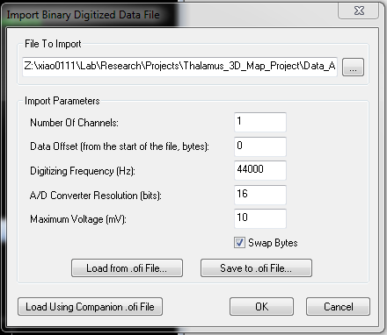

1. Select channel (e.g. 1)
2. Adjust zoom and get a clear picture of the spikes

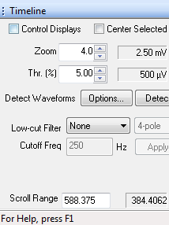

1. Detection view 🡪 adjust until 6 std above the mean



1. Manually invalidate waveforms that are obviously not spikes
2. Tools/Align waveform/Global maximum btw sort start and sort end (max alignment shift = 3-5)
3. Sort method🡪 usually valley seeking
4. Sort/Perform automatic sorting
5. Depending on the outcome, can adjust the fit number by the units screen, and then Sort/apply sorting with current templates
6. To check what a waveform looks like in the raw trace

* Select a point from the 2D cluster view that is in question

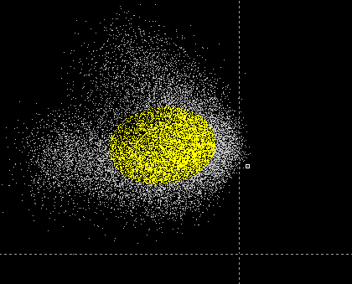

* Hold the left key and then right click on the point
* Then look at the point in the raw trace and zoom in on it

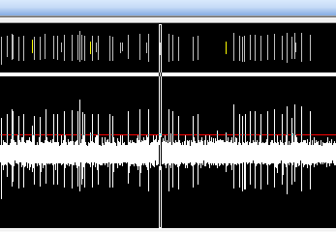

* Can right click on the selected unit 🡪 Use waveform as template for new unit and sort (find ones that are similar to the selected unit)

1. Export/New plx file
2. Export/Nex file

**3) Matlab: (export time stamps of stim)**

* Run the portion to export stim time stamps, select the corresponding ‘proc’ file.
* This will write a .nex file, which will be used in the next step

**4) Neuroexplorer:**

* First load in the data .nex file

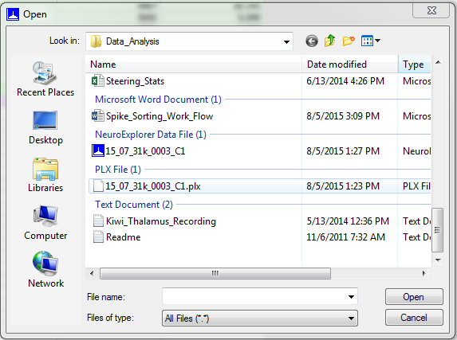

* Click only the first box: ‘Channel01a’.

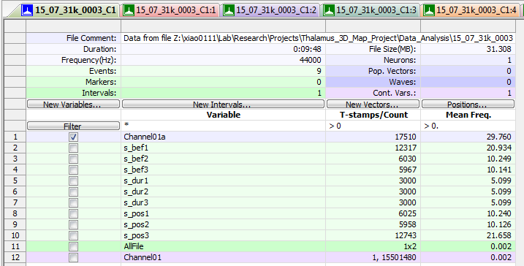

* + In this example above, under T-stamp/Count:
    - In ‘Channel01a’, 17510 🡪 total number of spikes that were recorded
    - In each of the categories below (e.g. s_bef1, s_bef2, etc) 🡪 those are the number of stim pulses.
* Perievent rasters/ref events/bring in on the pre, dur, post files

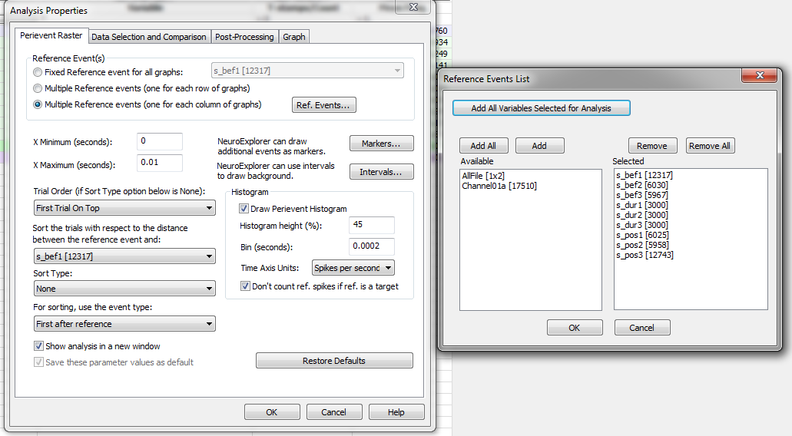

* + X Maximum = 1/(100) = 0.01s (because it’s 100Hz stim)
  + Bin (seconds) = 0.01/50 = 0.0001s (100 bins)
  + Check ‘show analysis in a new window’ so the plot is not overridden
  + Time axis units: Use ‘Spikes per second’ (count/bin size)
  + Smoothing: right click on graph 🡪 Analysis parameters 🡪 post-processing 🡪 Smooth with Gaussian filter (or Boxcar filter)
  + Make all plots have the same y-axis: right click on graph 🡪 Edit graphics 🡪 Y Axis Properties 🡪 use global max (global min)
  + Edit thickness of lines and rasters: right click on graph 🡪 Edit Graphics 🡪 Graph Properties 🡪
    - Perievent raster 🡪 Thickness 🡪 adjust
    - Histogram 🡪 Line 🡪 thickness 🡪 adjust
* If there is more than one cell, on the bottom right corner, move the cells around

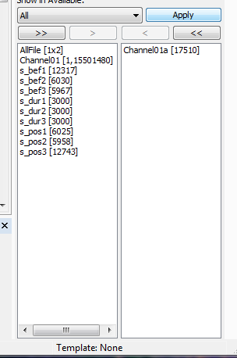

* Export to ppt
  + Graphics Option 🡪 Use bitmap to export graphics
  + Include in the title the number of spikes for that cell
* Other plots to look at:
  + Rate histograms
  + Interspike interval histogram
  + Interspike intervals vs. time
* Note: Confusion may arise when the pre-DBS, DBS-on and post-DBS recording periods are not the same length. E.g. in the figure below, the pre-DBS and DBS-on periods were 2mins long while the DBS-on period was only 30s long. This means that are more rows in the pre-DBS and post-DBS periods compared to the DBS-on period. This is why the raster is denser in the pre-DBS and post-DBS periods, while the average spike rate is not that different.

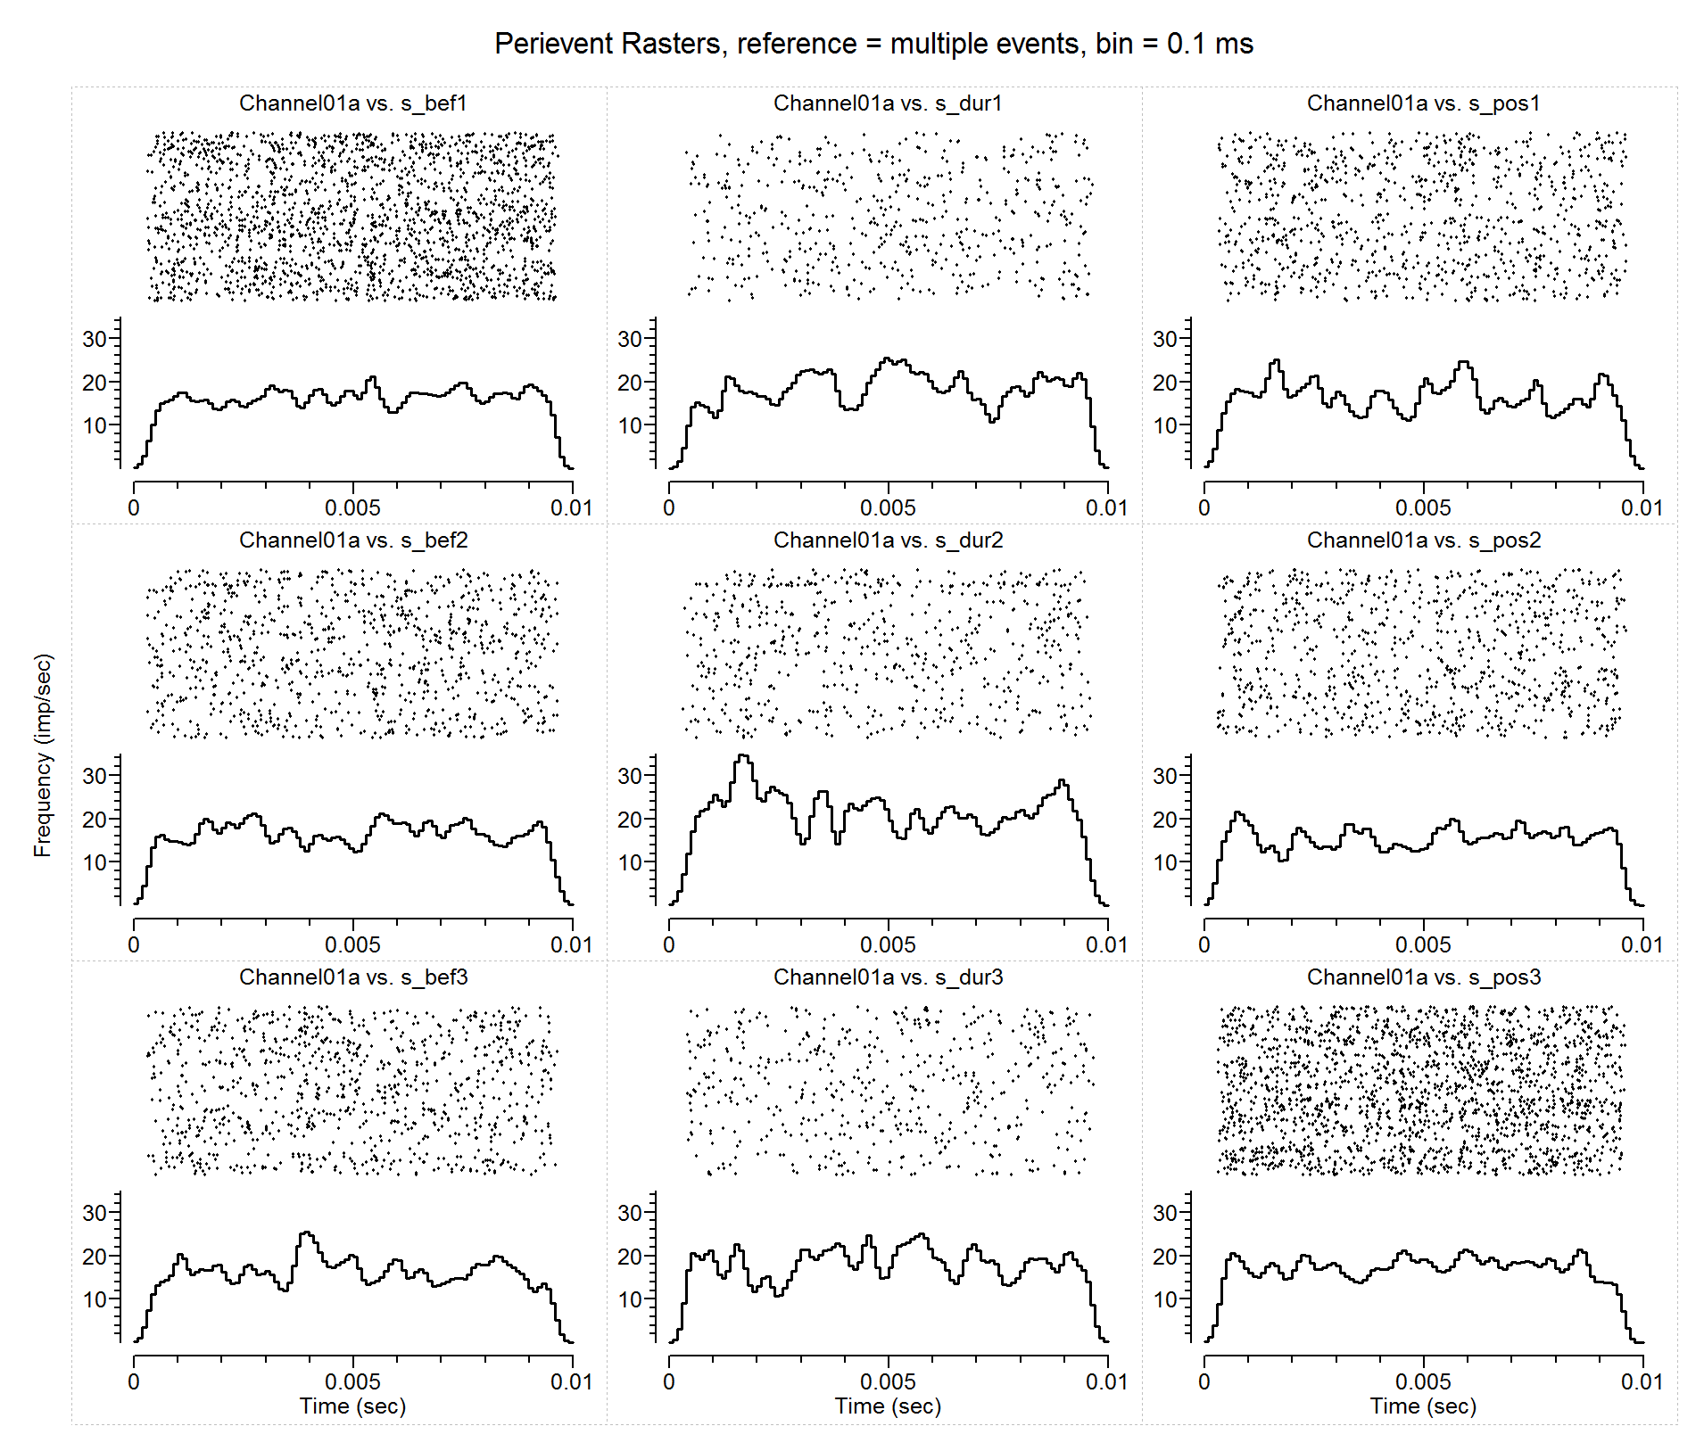

1. **PSTH Analysis in Matlab: (consistent with Agnesi et al. 2015)**

* Use the file ‘modulationStats.m’
* Bin = 0.1ms
* Excitatory entrainment: PSTH during stim showed an increase in spike activity for at least 2 consecutive bins that exceeded the mean + 6 std of the DBS-OFF baseline PSTH rate
* Inhibitory entrainment:
  + inhibitory phase (specific period within the inter-pulse interval) lower, for at least 5 consecutive bins, than the mean – 3 std of the DBS-OFF PSTH rate.
  + This was chosen so as not to go into the negative for most VLo and STN cells. (This is something that I need to measure in VPLo cells)
* rate increase: above mean + 2 std of pre-DBS period PSTH rate
* rate decrease: below mean – 2std of pre-DBS period PSTH rate
* Stim subtraction blanking period should be the same and not change
  + 15 samples before artifact detection: 15*1/44000 = 0.34ms
  + 15 samples after artifact detection: 15*1/44000 = 0.34ms
  + In all PSTH data (pre, during, post), remove spikes that fall within the first and last 0.5ms. This will cover the blanking period noted above.