Android app documentation
By Joe Coleman

Introduction 2
Purpose of the project 2
Target Audience 2
Project Requirements 3
Functional requirements 4
Non-functional requirements 5
User needs / goals 6
Research & Inspiration 8
What similar apps exist 8
Design trends followed 9
Why certain features were chosen 9
Wireframes & Initial Concepts 10
Early sketches 10
Layout planning 10
Explanation of navigation 11
Wireframe Fidelity Level 11
Testing 12
Device testing (emulator + phone) 12
UX testing (what people liked/disliked) 12
Fixes and bugs resolve 13
Screen-by-Screen Final product breakdown 14
Loading screen 14
Welcome Screen 15
Mood Selection Screen 16
Game Menu 17
Breathing Game 18
Drawing Game 19
Memory Game 20
Mood Slider 21
Congratulations screen 23
Sticker Book 24
User Flow & Navigation 25
App Lifecycle Considerations 26
Composites / Visual Design 26
App Icon Design 26
Colour Palette & Emotional Meaning 26
UI Asset Scaling 28
Bibliography 30

Introduction
This section will look at introducing the project and why it was chosen along with the requirements and user audience that was focused on.

Purpose of the project
The reason for planning and creating this app was to fill a gap in the market. When planning this project, the group identified that there were hundreds of mindfulness apps for adults but none for younger children. The group decided to aim and create an app for children around primary school age ranging from 5 to 16 and we decided that the app should be able to get non-verbal children to be able to effectively communicate their feelings and help improve their mood. We felt like this was extremely important as in studies show that non-verbal children need to have these human interactions and understanding of their emotions to help them as well as to help cognitive development. Our app aims to help bridge this issue by adding fun calming games to help with development whilst also calming the user to ensure that even if things get stressful at home or school, they have a place where they can go to calm down. The group also wanted to ensure that the communication and emotions side was not lost so there were features added for this such as a mood question before the games and a slider after so that the parent or teacher can observe improvements as well as this there is a text box where the user can type out how they are feeling or even use it as a diary. This allows for the parent or teacher to better understand the user and how they are feeling along with what effects their mood, Obretti (2024).

Target Audience
As previously stated, this apps target audience is children around the ages of 5 to 16. This target audience was chosen as it is looking at primary school aged children. Picking the target audience for this app was extremely critical as it allowed the group to focus on what was most important for the app for example a mindfulness app for adults or teenagers will not focus on the same kinds of features that could be seen as overwhelming for children and a child's app will not have the same level of complexity to make it easier for them to navigate along with colours for children having colours is extremely important to help them understand the emotion they are feeling without anyone telling them that it is bad and potentially causing more issues, Junell (2025).

Project Requirements
The project requirements were to ensure that we created an app that could be used easily by children of younger ages whilst also keeping it accessible for these same children. This was to ensure that the app was useable and not overly complicated to learn to use we wanted something that was self-explanatory and could be picked up by anyone that has used a tablet in the past and even if they hadn't the bright coloured buttons should make it easily useable.

Functional requirements
Below is a list of functional requirements the group had for the app's development:
Welcome Screen
- The app shall display a welcome page when first opened to greet the user.
- The welcome page should have a settings button and a start button to allow the user to the next page.
- The settings page must have an accessibility feature meaning that the user can change between light and dark mode.
Mood Selection
- The app should display a mood question after the welcome page where the user will be asked how they are feeling today and answers in coloured boxes will be how the user answers the questions.
Game Menu
- The app shall display a list of three games after the mood selection:
  - Breathing Game – used for relaxation
  - Drawing Game – used for creativity
  - Memory (Snap) Game – used for cognitive development
  - Play all – allows the user to play all the games
- The user shall be able to select any of the three games.
Breathing Game
- The app will guide the user through a breathing exercise to help calm them in stressful situations.
- The app will also include a visual representation of this being a circle that expands and retracts
- The game will complete after a fixed number of breathing cycles or if the user presses the next button or back button.
Drawing Game
- The app will provide a blank canvas with prompts at the top to help the user have an idea of what to draw.
- The app will allow the user to draw using touch input.
- The user should be able to clear the drawing and get new prompts.
Memory (Snap) Game
- The app will display a grid of 3 by 3 cards that are face-down.
- The app should allow the user to flip cards to reveal an image on the other side.
- The app will detect the matches that the user is able to find.
- The game will be won by the user once they have found all the pairs.
Final question slider
- The app should have a final question after all the games have been completed
- The question should be in the form of a slider that allows the user to slide to how they are feeling after the games. Once this has been completed a text box should pop up asking if the user wants to type out anything.
Sticker Reward System
- The app should give the user a sticker for each game they have played
- The app will show all the stickers earned once all the games have been completed and the final question has been answered.

Non-functional requirements
Usability
- The app should be extremely easy to use for children aged 5–16.
- The app will use large buttons and simple language to help make it accessible.
Performance
- The app should load screens within 2 seconds to ensure that the app can be used well without annoying wait times.
- The app will run smoothly without any performance issues during the games.
Reliability
- The app will not crash when being used normally.
- The app should be able to handle excessive user input effectively such as multiple presses of a button or multiple presses on screen.
Accessibility
- The app will use high-contrast colours to make it easy to read and use.
- The app should avoid small text and buttons to ensure it can be easily read and pressed.
- The app will not rely on reading ability alone it will use emojis where possible to help the user understand what is being asked.

Security & Privacy
- The app should not collect any personal data as in this form it is not needed.
- The app will not need internet access.

User needs / goals
- Emotional Regulation & Calmness
Need:
- The child needs a way of calming down when they are stressed.
Goal:
- The goal of the app is to allow the user to calm down and relax.
Linked Feature:
- Breathing game offers a place where the user can breathe and calm themselves with traditional mindfulness techniques.
- Mood selection question allows the user to express how they feel and help them understand why they are feeling this way.

- Emotional Awareness
Need:
- The user will need a way of recording how they are feeling at any given time.
Goal:
- The goal here is to identify how the user is feeling without any judgement or tricky questions being asked by parents or schools that the user might not want to answer.
Linked Feature:
- Mood button question after the welcome screen allows the users to put in a response right away meaning that the school or parent can help guide the user on what game to play for example if the user says they feel really bad then the breathing game could be used to try and calm them down before they do the drawing game as a way of getting there mind away from that place.
- Mood slider is then used to assess how the games have helped/ haven't helped the user.

- Engagement Through Play
Need:
- The user will need the app to be fun so that they want to use it.
Goal:
- To create short simple games that are fun but also offer other less obvious side advantages.
Linked Feature:
- Drawing game allows the user to do many things firstly the user can release their creativity or take their mind away from certain situations or even express how they are feeling through drawings which is all useful for parents or schools to see to help identify the source of issues.
- Memory game allows the user to play a fun game of snap however it also helps with cognitive development as the user must really use their brain to remember where images are and what pairs they can match.

- Motivation & Reward
Need:
- Children need positive reinforcement to stay motivated.
Goal:
- To earn and collect rewards for completing games.
Linked Feature:
- The sticker reward system allows the user to collect stickers and stay engaged as they want to collect the stickers.

Research & Inspiration

What similar apps exist
During the research stage there were lots of different existing mindfulness and wellbeing apps were looked into to help identify common features and gaps in the market. Popular apps such as Headspace, Calm and Smiling Mind focus massively on guided meditation and breathing exercises however, these are primarily designed for adults or older teenagers and rely on long audio instructions and a higher reading level as the text can sometimes be complex. Apps aimed at children, such as Moshi and Breathe do exist however, it focuses more on storytelling or problem-solving instead of letting children to communicate their emotions. This research made it extremely clear that there was a massive gap in children's mindfulness apps and none that focus on younger children or children with learning difficulties and might not be able to communicate their feelings as well, PCMag UK (2023).

Design trends followed
The design of the app was massively influenced by the research carried out and showed that all child's apps had bright, high-contrast colours along with a simple layout to make sure the child stayed engaged without overwhelming the user. Another feature taken from the research was that there were large buttons and clear spacing and limited on-screen elements to ensure that the user did not get overwhelmed by the number of things on screen at once. Lastly emoji-based feedback and colour-coded emotions were used as these could instantly show a child exactly how they are feeling and it means that if the child cannot read they can still understand their emotions and a parent or school can help identify this and take action to ensure the child's safety or suggest ways of improving mood. Along with this dark mode was added to increase the accessibility of the app to ensure that all children always could use the app without hurting their eyes if they prefer a darker screen or if they are using the app in certain light conditions.

Why certain features were chosen
The features included in the app were chosen based what was seen in the research as well as the specific needs of the target audience. The mood selection screen used coloured buttons and emojis and was included to allow children to express how they feel without needing to read or type as well as this the colours were used to help the child understand how they were feeling for example red is bad and green is good meaning the child can easily pick the colour and does not need to rely on text. The breathing game was selected as it is a well-known mindfulness technique that has been used for a very long time to help reduce stress and anxiety. To help improve this a visual expanding circle on the screen provided a very clear guide for children especially for those with additional needs as they just need to copy the circle. The drawing game was chosen to help children with their creativity but was also used as a way for adults and teachers to see into how a child portrays their environment and can help them identify issues at a very young age. For example, here a child could be asked to draw their family, and they could draw them in red or as mean leading to a teacher being able to identify that the issue the child is having is with home life. The memory game was added to allow the child to play a fun game whilst also helping improve their cognitive development as the child would have to use their brain to try and remember where all the pairs are. Finally, the sticker reward system was used to allow for the child to feel a sense of accomplishment for each game they completed to help encourage them to use the app as well as this it can be fun for children to show off what stickers they have with other children to try and help with child on child engagement.

Wireframes & Initial Concepts

Early sketches
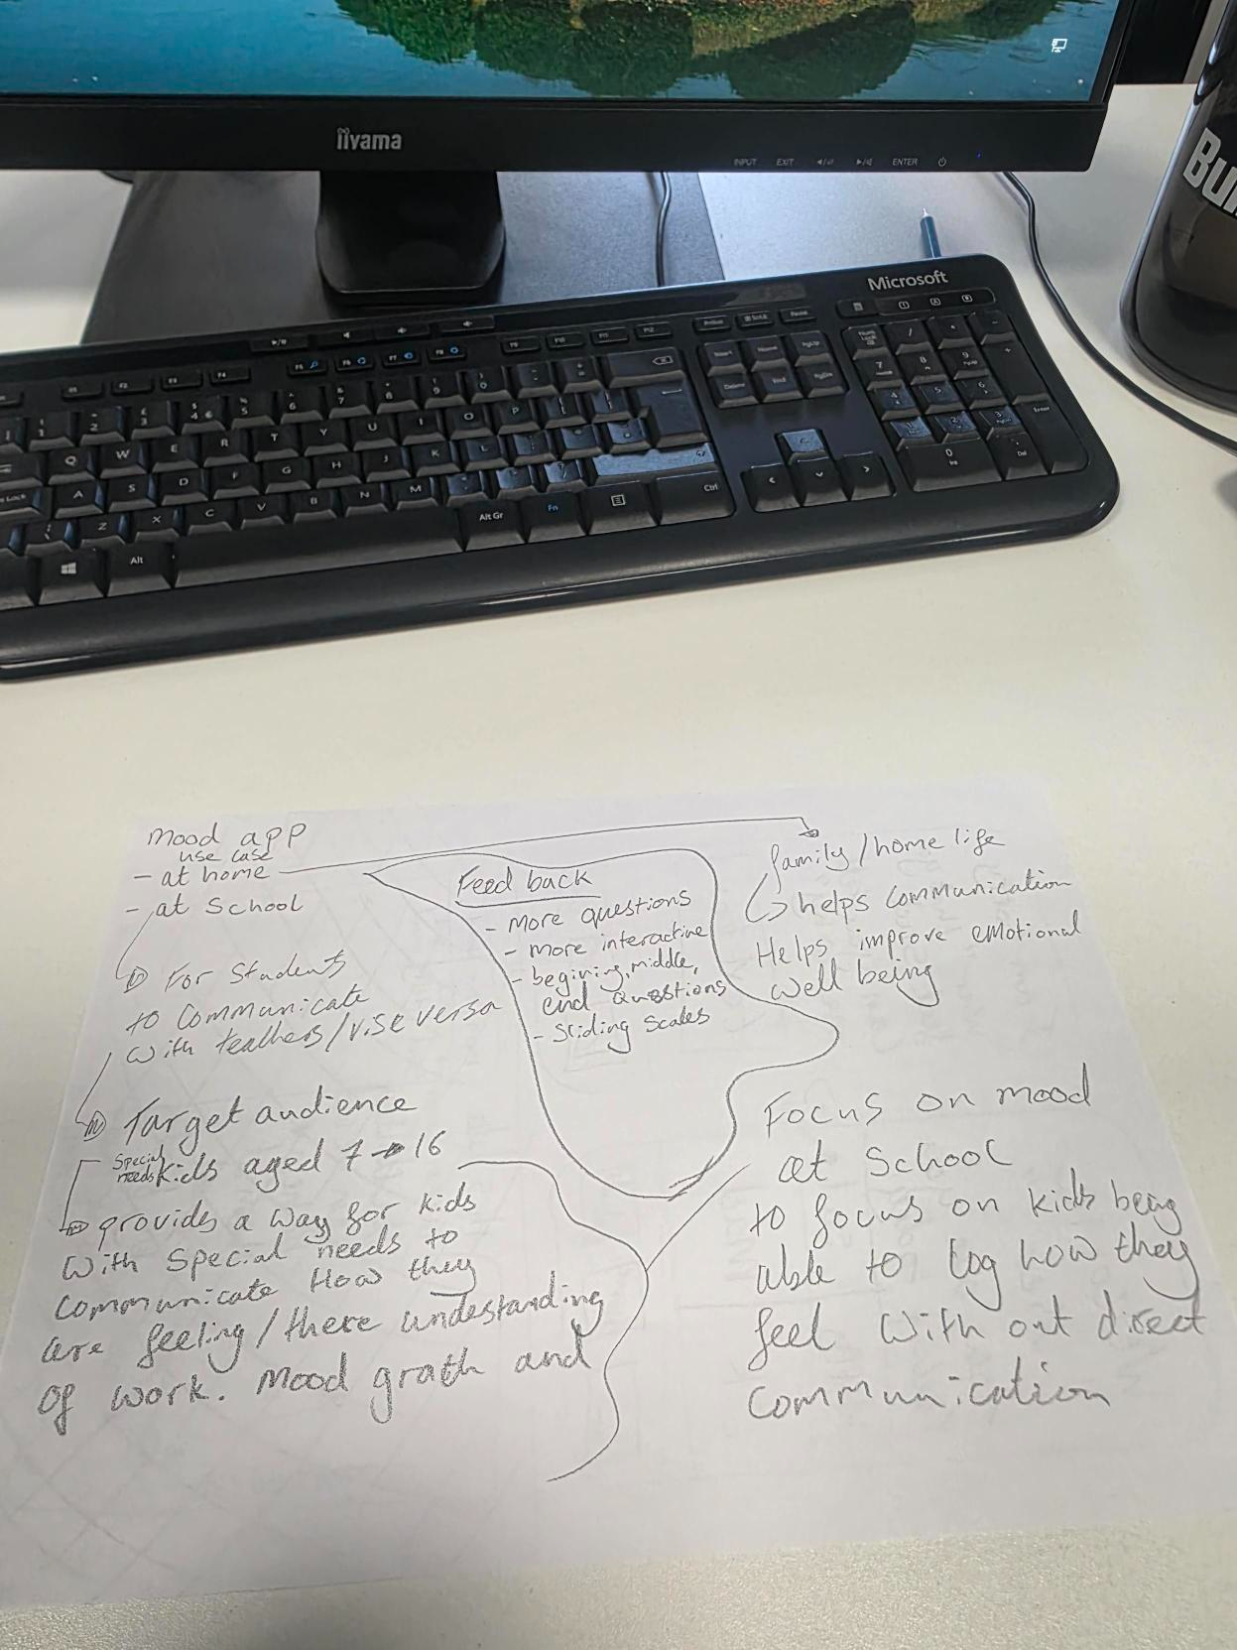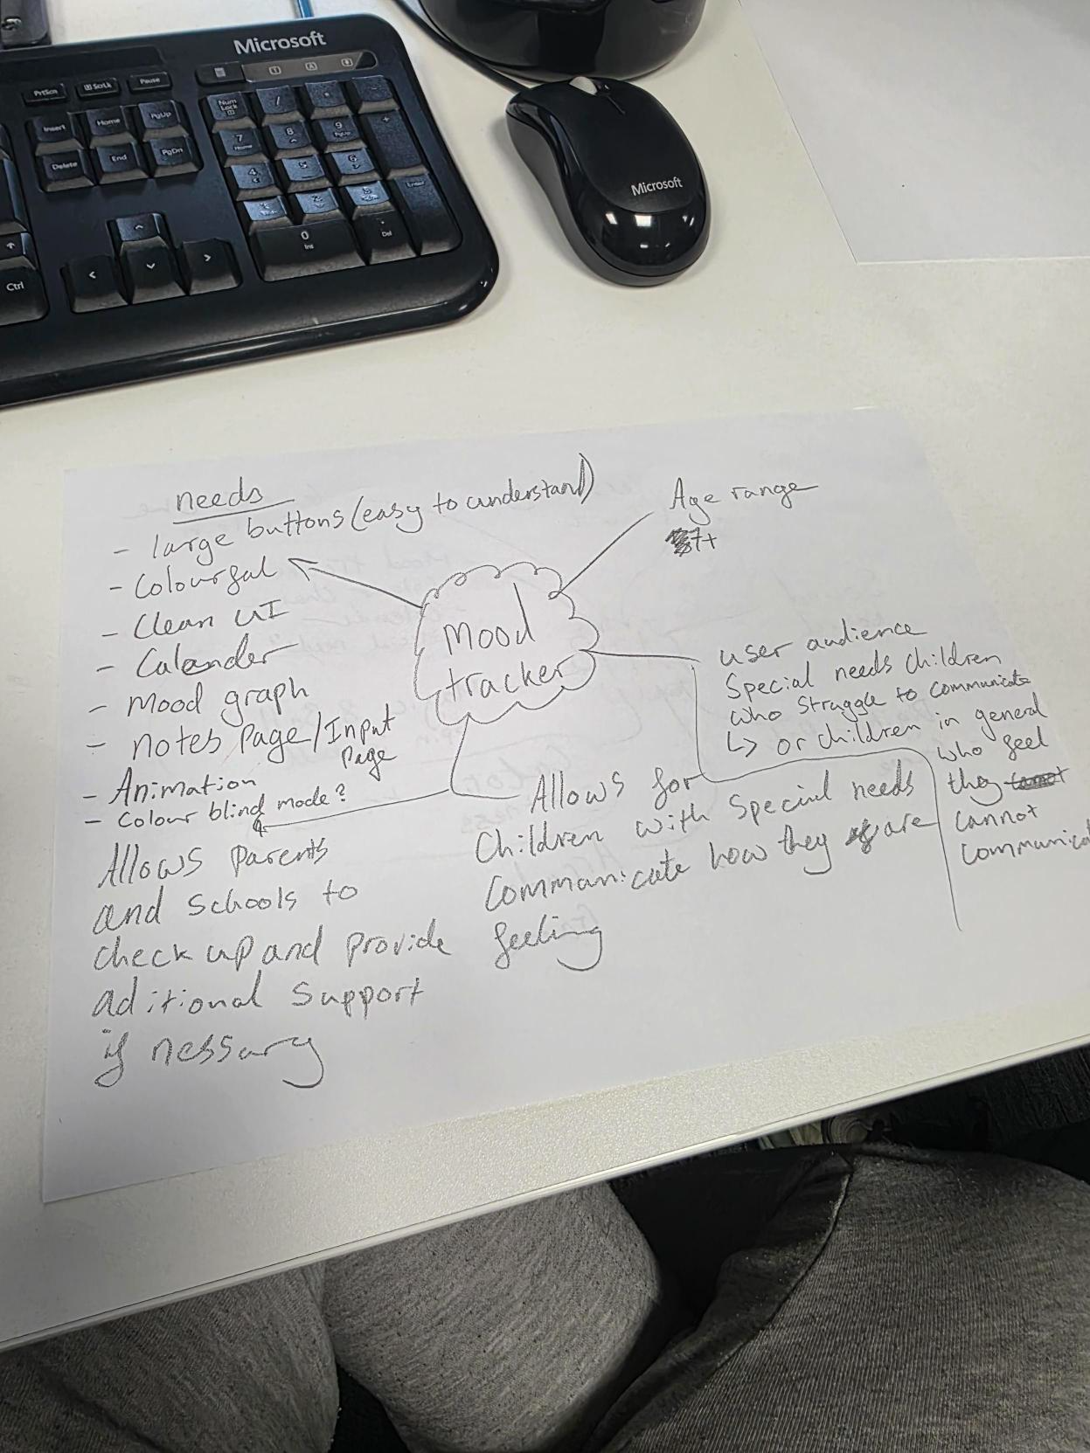
These early sketches show how the planning stage was tackled starting with large mind map with ideas on how the app could look and what features could be used. This mind map allows for a plan and an idea of what to do without rushing into something and making mistakes or missing out on key parts that would make the app accessible, Cloudusinfotech (2017)

Layout planning
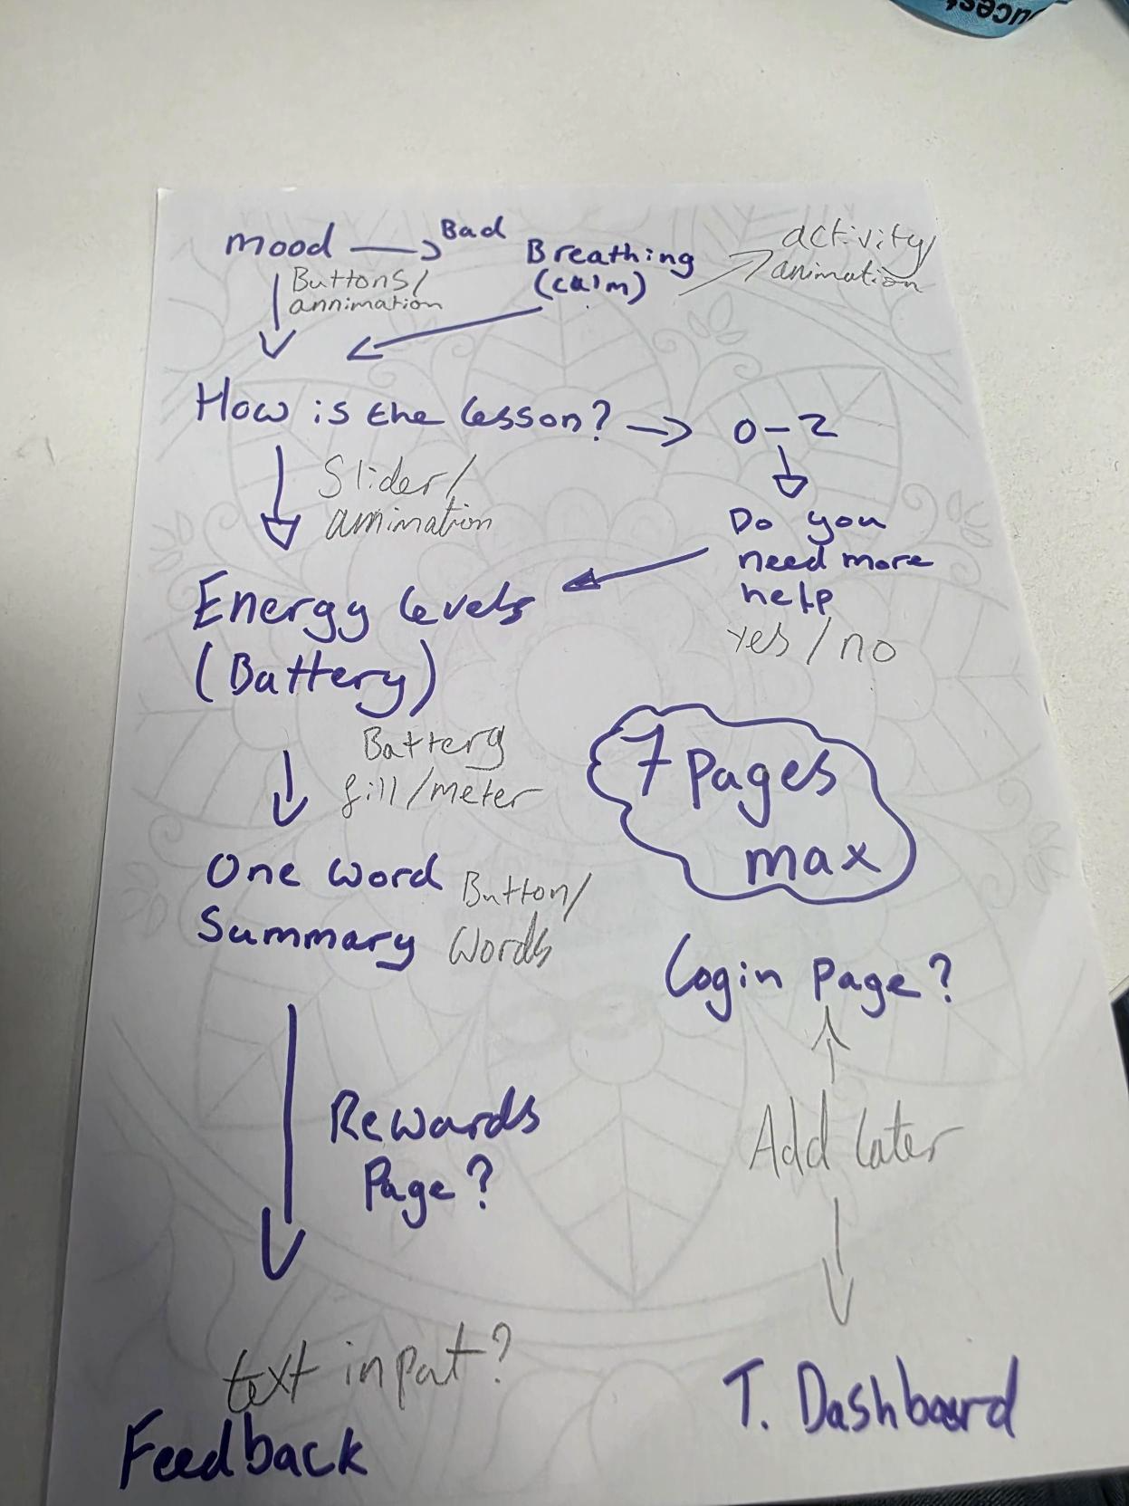
This was the first layout we thought about looking into along with some potential features that could be used within the app. This was good as it gave the group an idea on how the app should look and how each screen should function.

Explanation of navigation
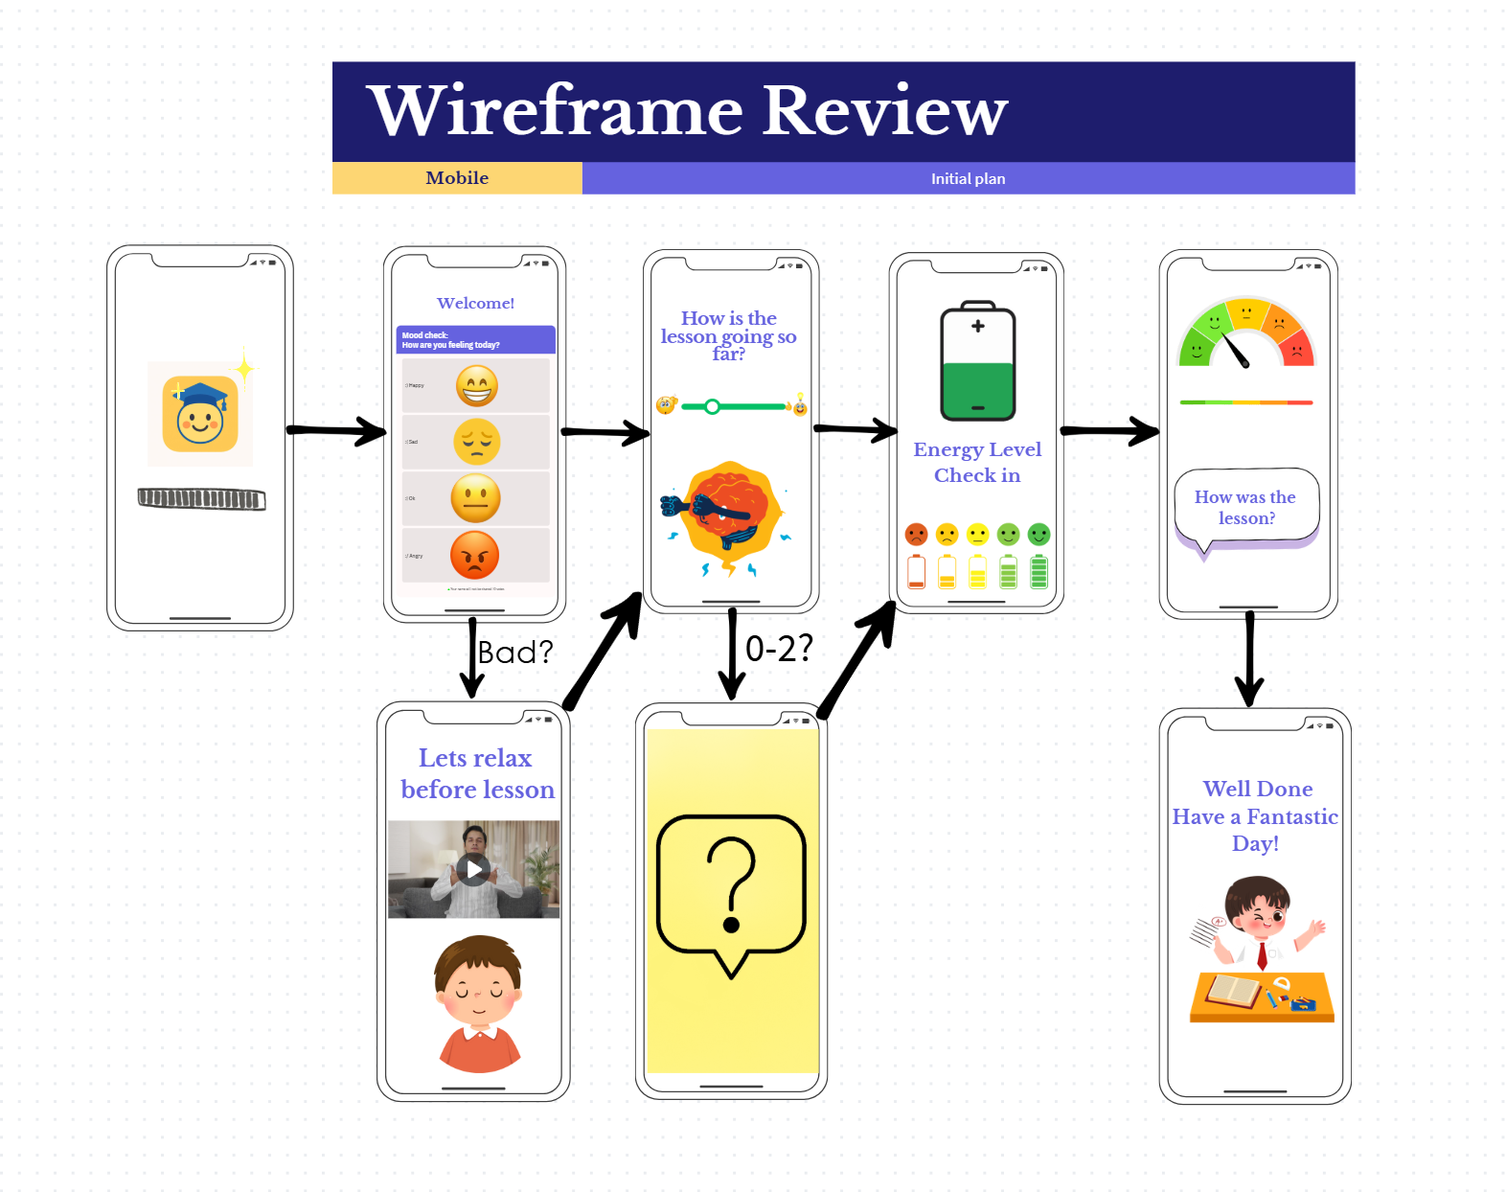
A wireframe is the final stage of planning where the team can add what they want to each screen to see how the app will look and perform, GeeksforGeeks (2020).
This was the wireframe used based off the initial sketches on how the app was supposed to look. At this stage of development, the wireframe was extremely important as it showed exactly how the app was supposed to look and gave every member of the group the exact same idea on what things should look like and how navigation should work around the app. This allowed each member of the group to tackle a different part of the app without having clashing themes when brining the code together. This wireframe however did change as the team removed the battery section and instead added more games to the first half of the app to make it more engaging for children and stickers were added to help improve reusability as children want to collect the stickers as a form of positive reinforcement. However, this early wireframe design was the most important stage of planning.

Wireframe Fidelity Level
The wireframes created for this project are mid-fidelity wireframes. This is because the level of detail at this point was more than a sketch however, they lacked the necessary details to be high-fidelity. At this stage the focus was on planning the layout and how navigation and functionality would work rather than looking at the visual styling such as colours, fonts or imagery. Low-fidelity wireframes were appropriate for the first stage of planning as they allowed the group to quickly explore and write down all their ideas however at this second stage of planning mid-fidelity wireframes were crucial. This approach allowed for colours and images to be added and reviewed at the testing stage meaning that any user feedback on these issues could be quickly incorporated, Vardhan (2025).

Testing

Device testing (emulator + phone)
To test the app during development the android studio emulator was used as it is an extremely useful tool to see how code can change and what needs fixing in real time. However, when the app was given to users to test it was done on an android device so they could give us real world feedback. As an example, this could be button placement to make sure it works on that size of phone.

UX testing (what people liked/disliked)
The first group that tested the app was a tutor that tutors children of primary school age. The review we got here was extremely good as the tutor loved the app and what it was meant to do. However, she did suggest making sure all the colours were consistent across the app. However, the tutor did say that the confetti animation that was on the final congratulations screen was too flashy and could cause people with epilepsy or other photosensitivity to be extremely unwell meaning the app was not accessible to everyone.
The second testing group was a group of students with additional learning needs that were studying level 2 computing. These reviews were essential for the app as it helped look at the accessibility of the app and how people with additional needs approached problems and issues, they encountered. The feedback we received was massively positive with the overall useability of the app however there were some additions that they wanted to add. The first addition was that they wanted a score board and to make it online so that the stickers could be shown off to friends. The second addition was for music that could be turned on and off in the settings. Despite this however the app received massive praise for the colour choice and games that were on offer. One of this group was told to test the app to its limits and try to get it to crash to see if any accidental inputs or too many inputs too quickly could cause issues. This was not the case however and the app worked perfectly which was met with lots of positivity.
The third testing group came from level 4 students that had been doing coding at the time so could be harsher towards the app and its features. This group was chosen as it allowed the app to be tested by people that had experience creating and coding their own projects to see what their perspective was on the overall feel of the app. The first user noted that the apps dark mode features were not working correctly inside of the games as the backgrounds would stay white, but the text would change from black to white meaning that the user could not see the text. Additionally this user talked about not being able to go back from the breathing game to the home screen meaning if the user accidentally pressed on this game, they were stuck until the game had played out all of the breathing cycles meaning the overall feel of the app in this situation was not great. The second user talked about the one-way system of the app and did not like this feeling as they would like to go back and redo things if they were missed or accidentally clicked just like the first user. Secondly, they want the how are you feeling now slider emojis to be clickable so that the user does not always need to slide but instead can click on what they are feeling. Additionally the user wants more difficulty when looking at the memory game as they did not like how there was one square left over that did not pair with anything so they also suggested increasing the number of cards or adding a slider that lets the user set there difficulty with a 3x3 square being easy and then moving to a 4X4 or even 5x5 square in the final difficulty.
The third user looked at the dark mode useability and talked about how the buttons in dark mode did not have clear contrasting colour text meaning occasionally the text could be difficult to read. This user also investigated the breathing game and made the same comments about the back button however they also remarked that the start button is a bit small and thinks it would be better to be able to press the circle to start the breathing game as this is bigger and could be easier to press.
Despite these improvements that were extremely valuable at this stage over all opinion of the app was massively positive, especially for our target audience.

Fixes and bugs resolve
With all this user testing and key insights into areas of the app that needed improvement the team went straight back to adding in features and fixing existing features for example a back and next button was added to the breathing game to make it easier to navigate as well as this however the start button was removed and now the user can press anywhere on the screen to start the game. This was all done based on the feedback the app received and therefore the feedback was extremely useful. A bug that was fixed was the light and dark mode colours clashing so that some dark mode text was unreadable. This was an easy fix as it came from a silly mistake where the background colour had been changed when dark mode was activated however the text colour had not been and it was still set to the same colour. The last bug to be fixed was the dark mode background not being applied to all the screens it was supposed to. This also came from a silly mistake where the boxes on the background had been changed but not the actual background its self-meaning there was parts of the app that did not change and did not have a pastel background it just had a pure white background and did not tie in with the app. The confetti were also removed on the final congratulations screen as it was deemed too dangerous as it was so flashy that it could have cause people with light sensitivity to have seizures. This made the app extremely non accessible and meant that it had to be removed for safety reasons. Instead, a fun animation was added to the stickers as they popped up.

Screen-by-Screen Final product breakdown

Loading screen
The loading screen is the first part of the app that the child will see therefore it was extremely important to ensure that the loading screen was fun and silly to ensure children were excited from the get-go. To do this a line of emojis were used along with the apps logo and were made to bounce like a wave to show that the app was loading. The team added this idea as they believed it to be more fun for the user.

Welcome Screen
The welcome screen was designed to act as a calm and simple entry point into the app without lots of overwhelming buttons therefore it includes a clear title and a large start button as well as a settings button that allows access to the dark and light mode options. This feature is ideal for the overall useability of the app for everyone making it more accessible. As well as this the overall layout does not include unnecessary buttons or text meaning younger users are able to use the app well even when opening the app for the first time.

Mood Selection Screen
The mood selection screen looks at allowing the user to express how they are feeling using coloured buttons and emojis as well as text. This was done so that the child can clearly see what each button represents mood wise. Each mood option is spaced out evenly and are extremely easy to press making this screen easily accessible to children with learning difficulties. This screen was placed here to ensure that the child's mood could be observed early and monitored as they played through the app.

Game Menu
The game menu presents the available games this allows the user to be able to choose exactly what they want to play at that time or there is an option to play all allowing for the user to experience all the games in order. Each game has its own button with an icon and label to help the child choose what they need or think is the most fun.

Breathing Game
The breathing game looks at a breathing exercise that has been used for a very long time to get people to calm down and relax. To do this the game uses a large circle that moves in and out helping the child with visual instructions on what to do and when. The game starts by the user pressing anywhere on the screen making it extremely easy to start the exercise and allows for other buttons to be used as a back button and a next button to help with navigation.

Drawing Game
The drawing game looks at giving the child/user the freedom to do what they want as many times as they want. The game features a prompt on what the user can draw but it is not restrictive. As well as this the user can clear the screen and generate a new prompt. Drawing tools are kept simple to help avoid distraction but also promote creativity.

Memory Game
The memory game has a grid of face-down cards arranged in a simple 3x3 layout. The design here looks at making sure each card is spaced evenly apart and are big enough so that they are easily clickable. This game focuses on cognitive engagement while also playing like a game so that it is fun for children to use.

Mood Slider
The mood slider screen starts with a slider in the middle of the screen that allows the user to slide to how they are feeling once they have completed the game. Once this is completed a text box comes from the bottom of the screen and asks the user if they want to type anything, this is good as it can be a way for the user to type out in more detail what they are feeling and more importantly why. This allows the people around them to understand as well as this it can be used as self-reflection for the user.

Congratulations screen
The congratulations screen looks at congratulating the user on their progress and helps reinforce positive behaviour and make the child feel like they have accomplished something. This is also the first place the user can see their stickers. The confetti effects used to make sure that the user knows they have accomplished something and should feel like celebrating.

Sticker Book
The sticker book is where the user can see all their stickers and what they have collected. Along with this it gives the user a reason to keep replaying the app to collect all the stickers. The stickers are clickable and grow bigger when the user presses on them.

User Flow & Navigation
The user flow was designed to guide the user through the app through in a very clear and orderly way this was to mimic some of the mindfulness apps already on the market that are more like stories however during testing this was found to be restrictive therefore the back and next buttons were added to allow the user to move from section to section in their own time and they could even go back to change answers or to play missed games. The app starts with the welcome screen and then moves onto the mood screen once the user has pressed start. Next the games screen where the user can choose what game to play and when. After this the mood slider and congratulations screen ending with the sticker book or the start again button to restart the loop.

App Lifecycle Considerations
The app is designed to open and load the welcome screen. As well as this, if the app is paused or minimised then the current state of the app is maintained for example if the user is playing the breathing game and minimize the app when they go back to it, they will still be on the breathing game. This was done to prevent loss of progress during activities. No personal data is stored on the app meaning it is very secure, and all the data needed for each game is stored locally. This means that the app will need to be updated massively if more features are added especially login pages and accessing the internet. This would need to be done to keep the user safe and should be a top priority if these features are added later in the app's life.

Composites / Visual Design

App Icon Design
The app icon was designed to be very simple whilst still fitting with the overall theme of the app. The icon was designed to be friendly and recognisable by children. To make this fit in with the rest of the app using emojis, the app icon was designed around this and is a happy face with a school graduation hat on. This was to show that school is fun as the primary place for this app to be used would be schools.
This image was created by the team member Matt Howe.

The other image used in the app was on the final congratulations screen and was taken from Pngtree (2026). This image was selected as it fit with the overall theme of the app and the team wanted to add a human element into the app so that it was not all just focused on emojis.
Fig 1 taken from Pngtree (2026).

Colour Palette & Emotional Meaning
The app’s colour was extremely difficult to get right because the developers are older leading to fun design choices such as a light and dark mode focusing on mountains and the time of day. This first choice was visually pleasing however in the very first test it was deemed too much and too distracting for the target audience. Instead, the calm pastel colours were used as they did not hurt the eye to look at and could be calming to use. For light mode a light pastel pink was used and in dark mode a deep purple was used. This made it easy to find other colours that would stand out. On top of this the font that was used was just the standard font as children might not have been able to clearly read a fancy font and it could make it tricky for them to understand and identify letters especially if they were still learning.

Light mode:

Dark mode:

UI Asset Scaling
The app was mostly tested on a medium sized phone however the intended device was the medium sized tablets like most schools would have access to. This meant that during testing certain screens such as the memory screen would need to be looked at and made to scale on any device as the grid could either look extremely small or extremely big. The scaling was extremely important as the range of devices that the user could use the app on is massive and the app would have to work with all of these to ensure that it can be useable wherever making it extremely accessible.

Phone:

Tablet:

Bibliography
- Obretti, F. (2024). Understanding the Impact of Communication Difficulties on Children’s Behaviour. [online] phren.uk. Available at: https://www.phren.uk/post/understanding-the-impact-of-communication-difficulties-on-children-s-behaviour. [accessed 11th January 2026]

- ‌Junell, T (2025). The Definitive Guide to Building Apps for Kids. [online] Toptal Design Blog. Available at: https://www.toptal.com/designers/interactive/guide-to-apps-for-children. [accessed 12th January 2026]

- PCMag UK. (2023). The 7 Best Meditation and Mindfulness Apps for Kids. [online] Available at: https://uk.pcmag.com/mobile-apps/145970/the-6-best-meditation-and-mindfulness-apps-for-kids. [accessed 12th January 2026]

- GeeksforGeeks (2020). What is Wireframing? [online] GeeksforGeeks. Available at: https://www.geeksforgeeks.org/websites-apps/wireframing/. [accessed 12th January 2026]

- Cloudusinfotech (2017). Have Some Question. [online] Available at: https://cloudusinfotech.com/Importance-of-Planning-and-Budgeting-in-App-Development.php [accessed14th January 2026]

- ‌Vardhan H (2025). Wireframe Fidelity: Levels of Detailing in Wireframes. [online] Medium. Available at: https://medium.com/@harsh.mudgal_27075/wireframe-fidelity-levels-of-detailing-in-wireframes-ee071509808c [accessed 14th January 2026]

- Pngtree (2026). Human verification | Pngtree. [online] Available at: https://pngtree.com/freepng/cute-cartoon-school-children-clipart-illustration_16838569.html [Accessed 15th January 2026].

