Final Year Project Proposal Report

AI Coding Agent: An Autonomous LLM Agent for Proactive Code Generation and Reactive Debugging

Supervisor:
Anthony Assi

A report submitted in partial fulfillment of the requirements for the degree of
COMPUTER AND COMMUNICATIONS ENGINEERING
February 2026

Ecole Supérieure d’Ingénieurs de Beyrouth
Université Saint-Joseph de Beyrouth

Contents
Contents 2
List of Figures 3
List of Tables 4
Acronyms 4
1 Introduction 6
2 Background Research and Related Work 8
2.1 Market Landscape of AI Coding Tools 8
2.2 Local Code Generation Models 9
2.3 Agent Architecture Patterns 9
3 Requirements (Functional and Non-Functional Requirements) 11
3.1 Functional Requirements 11
3.2 Non-Functional Requirements: Encompassing Measurable Quality Attributes, Constraints, Standards, and Regulations 12
Quality Attributes and Technical Constraints 12
Standards, Laws, and Regulations 13
3.3 Conceptual Model 13
3.3.1 Workflow Phases 14
3.3.2 The Iteration Loop 15
3.3.3 Phase Connectivity Summary 15
4 Solution Design 18
4.1 Propose Multiple Solutions: Design Alternatives and Comparison 18
High Level Alternatives 18
Low Level Alternatives 18
4.2 Solution Modeling 19
Proactive Code Generation Workflow (Generate Mode) 19
Code Debugging Workflow (Debug Mode) 21
Risk Assessment and Mitigation 23
Required Resources 25
5 Preliminary Implementation/Tests 26
6 Conclusion and Future Work Planning 27
7 References 28
Appendix 1 29

List of Figures
Figure 1:AI Agent Workflow – High-level block diagram showing all nine modules, their connectivity, and the iteration loop. 16
Figure 2: Proactive Code Generation Workflow – Detailed ten-phase pipeline from user input to execution with decision points. 20
Figure 3: Code Debugging (Reactive) Workflow V2 – Error-driven loop showing deterministic and probabilistic error classification branches and corrective tools. 22
Figure 4: Risk Assessment and Mitigation Workflow – Six-step risk management process with intersection points to the debugging workflow. 24

List of Tables

Table 1: Functional Requirements 11
Table 2: Non-Functional Requirements 12
Table 3: Standards, Laws, and Regulations 13
Table 4: Low Level Alternatives 19
Table 5: Required Resources 25

Acronyms
Acronym | Definition
LLM | Large Language Model
AST | Abstract Syntax Tree
API | Application Programming Interface
CLI | Command-Line Interface
IDE | Integrated Development Environment
ReAct | Reasoning and Acting
PyPI | Python Package Index
MoE | Mixture of Experts
PEP | Python Enhancement Proposal
GoF | Gang of Four
OOP | Object-Oriented Programming
NLP | Natural Language Processing
CVE | Common Vulnerabilities and Exposures
GDPR | General Data Protection Regulation
FIM | Fill-in-the-Middle

1 Introduction
The developer workflow is currently being revolutionized by Generative AI and Large Language Models (LLMs). Developers increasingly rely on AI-powered tools to write, review, and debug code. However, the current landscape remains bifurcated: developers use one process for generating new code (prompting on GenAI platforms such as ChatGPT or GitHub Copilot) and a separate, manual process for debugging it when it fails on their targeted host machine. This disconnect creates a fragmented experience that slows development cycles, particularly for common but time-consuming tasks such as resolving missing dependencies, fixing syntax errors, and adapting code to local system configurations.
This project aims to build a dual-function autonomous AI Coding Agent that addresses this gap. The agent serves two core functions. First, it proactively generates runnable Python scripts from high-level natural language requirements (for example, "write a Python script that displays the latest Microsoft stock price"). Second, it reactively debugs existing broken code or local system dependencies by iteratively executing it, analyzing errors, and applying automated fixes until the code runs successfully on the local environment with no human intervention.
The scope of this project encompasses the complete lifecycle of code from idea to functional execution. The agent must be capable of interpreting natural language prompts, planning multi-step implementations, identifying and validating required libraries, generating code, executing it in a sandboxed environment, and autonomously correcting any errors that arise. Furthermore, the debugging logic is designed to be isolated and applied as a standalone feature to any existing broken Python script, automating the tedious "copy-paste-error-fix" loop that developers endure daily.
The importance of this project lies in the growing demand for fully autonomous development tools that operate on local machines rather than cloud sandboxes or IDE-constrained environments. Current tools such as GitHub Copilot, Cursor, and Replit Agent each address parts of the workflow but none provide a unified, lightweight solution that generates code, executes it locally, and autonomously debugs it to completion. The intended beneficiaries are software developers, researchers, and students who need rapid prototyping capabilities and automated debugging for Python projects.
The project is structured in eight phases: Agent Technology Analysis and Project Scoping, Unified System Architecture Definition, Proactive Code Generation implementation, Agent Self-Correction Loop development, Standalone Reactive Debugger formalization, Integration and Evaluation, Code Packaging and Documentation, and Final Deliverables preparation. The deliverables include a working agent with dual-mode operation, an analysis report comparing agent design patterns, a comprehensive final report, and presentations with a pre-recorded demonstration.
Key challenges include ensuring reliable error classification across diverse Python error types, preventing infinite debugging loops, managing security risks inherent in autonomous code execution, and maintaining performance within acceptable latency bounds. These challenges are addressed through layered guardrails including sandboxed execution, iteration limits, input validation, and comprehensive logging.

2 Background Research and Related Work
2.1 Objective of the Market Analysis

The market analysis summarizes the current landscape of AI coding tools with respect to their ability to generate code, execute it, and debug errors autonomously. The goal is to identify strengths and limitations of existing solutions and highlight the market gap addressed by the proposed AI Coding Agent.

2.2 Key Comparison Dimensions

The comparison of existing AI coding tools is performed using the following dimensions:

- Code Generation Capability: Ability to generate complete and runnable source code from high-level natural language requirements.
- Autonomy Level: Degree of independence, ranging from assistive copilots to fully autonomous agents.
- Execution Capability: Ability to run generated or existing code and access execution outputs (stdout, stderr, exit codes).
- Debugging Loop: Presence of an execution-driven correction cycle including error detection, classification, automatic fix application, and re-execution.
- Environment Realism: Whether execution occurs in cloud, IDE sandbox, or real local machine.
- Dependency Handling: Support for detecting and resolving missing libraries and environment issues.
- Limitations and Risks: Reliability concerns, security exposure, and operational constraints.

2.3 Market Comparison Table

 | Code Generation | Autonomy Level | Execution | Debugging Loop | Environment | Dependencies | Limitations
GitHub Copilot (Microsoft) | Strong for snippets | Low–Medium | Partial (IDE) | Weak | IDE sandbox | Limited | Human-driven debugging
Codex CLI (OpenAI) | Strong | Low | No | None | Terminal only | None | No execution or debugging
Gemini CLI (Google) | Strong | Low–Medium | No | Weak | Terminal only | Advisory | Manual error copying required
Cursor (Anysphere) | Strong (multi-file) | Medium–High | Yes | Medium | Local via IDE | Partial | Reliability varies with task size
Windsurf (Codeium) | Strong | Medium | Partial | Medium | IDE sandbox | Partial | IDE-constrained autonomy
Replit Agent (Replit) | Strong (end-to-end) | Medium | Yes (cloud) | Medium | Cloud environment | Strong (cloud-managed) | Not local systems
Claude Code (Anthropic) | Strong | Medium–High | Yes | Strong | Local terminal (sandboxed) | Strong | Requires security controls
Gemini Code Assist (Google) | Strong | Medium | Partial | Medium | IDE sandbox | Partial | Ecosystem-dependent
Amazon Q Developer (AWS) | Strong | Medium–High | Yes | Medium | Local / IDE | Strong | Safety & permission risks
Devin (Cognition AI) | Strong | High | Yes (sandbox) | Strong | Sandbox | Strong | Limited transparency

2.4 How Current Tools Work

OpenAI Codex CLI: Generates code from natural language but lacks execution capability. Users must manually execute code and paste errors back, creating a multi-step manual loop per error.

Google Gemini CLI: Suggests fixes when users paste error messages but requires manual execution and error copying.

Claude Code: Operates in a Docker container, executes bash commands with permission, captures stdout/stderr, and applies fixes iteratively. Operates in sandboxed environment rather than user’s actual local system.

IDE Agents (Cursor, Windsurf): Execute through IDE terminals with user approval. Partial debugging autonomy; reliability decreases for complex tasks.

Replit Agent: Operates in cloud containers with full package management and automatic dependency installation. Execution is limited to cloud-managed environments.

Amazon Q Developer: Integrates with AWS services, includes log correlation and security scanning. Requires manual approval for non-AWS packages.

Devin (Cognition AI): Fully autonomous agent operating in isolated Ubuntu containers with planning and iterative execution. Demonstrates autonomy but operates in controlled sandbox environments.

2.5 Identified Market Gap

The market analysis reveals that:

- Most tools excel at code generation but fall short on fully autonomous debugging.
- Debugging often remains human-in-the-loop.
- Many agents operate in IDE sandboxes or cloud environments rather than real local systems.
- Fully autonomous agents exist but introduce reliability, transparency, and safety concerns.
2.6 Positioning of the Proposed Solution

The proposed AI Coding Agent addresses these limitations through:

- A dual-mode architecture combining proactive generation and reactive debugging.
- Direct operation on a local Ubuntu environment.
- A unified self-correction loop bridging generation and debugging.
- Integrated safety guardrails to mitigate execution risks.

This positions the project as a lightweight, locally operating autonomous coding system designed to bridge the gap between code generation and real-world execution-debugging workflow

3 Requirements (Functional and Non-Functional Requirements)
This section specifies the functional and non-functional requirements for the AI Coding Agent, derived from the project description and informed by the market analysis and risk assessment. Requirements are structured following the ISO/IEC/IEEE 29148:2011 standard for requirements engineering.

3.1 Functional Requirements
The functional requirements define the core capabilities the system must provide to fulfill its dual-mode operation as both a code generator and a code debugger.
ID | Functional Requirement
FR-01 | Accept natural language prompts describing desired Python code functionality
FR-02 | Parse and classify user intent, extracting task type, domain, complexity, and estimated libraries
FR-03 | Generate a multi-step implementation plan using the ReAct (Reasoning and Acting) loop pattern
FR-04 | Identify, validate, and resolve all required Python library dependencies against PyPI
FR-05 | Generate complete, runnable Python code with error handling, type hints, and logging
FR-06 | Validate generated code syntax using AST (Abstract Syntax Tree) parsing before execution
FR-07 | Execute generated or user-provided Python scripts in a sandboxed subprocess environment
FR-08 | Capture and parse stdout, stderr, and exit codes from script execution
FR-09 | Classify runtime errors by type using a hybrid deterministic/probabilistic approach (ModuleNotFoundError/ImportError, SyntaxError/IndentationError, FileNotFoundError, and other errors via LLM)
FR-10 | Apply automated corrective actions based on error classification (package installation, code editing, environment fixes)
FR-11 | Implement an iterative self-correction loop that re-executes code after each fix until success or iteration limit
FR-12 | Operate in Generate Mode: accept natural language input and produce working Python code end-to-end
FR-13 | Operate in Debug Mode: accept a file path to a broken script and autonomously fix it
FR-14 | Provide a unified command-line interface supporting both Generate Mode and Debug Mode
FR-15 | Detect and extract environment information including Python version, OS, installed packages, and network connectivity
Table 1: Functional Requirements

3.2 Non-Functional Requirements: Encompassing Measurable Quality Attributes, Constraints, Standards, and Regulations

Quality Attributes and Technical Constraints
The following non-functional requirements define measurable quality attributes and technical constraints that govern system behavior. These requirements are critical for software design and testing, as functional requirements may be considered met even when non-functional requirements are not, rendering the product unusable.
ID | Category | Non-Functional Requirement
NFR-01 | Performance | End-to-end code generation latency shall be less than 60 seconds for simple tasks. Parsing, validation, and syntax checking shall complete in sub-second times.
NFR-02 | Performance | The debugging loop shall resolve common errors (ModuleNotFoundError, SyntaxError) within 3–5 iterations on average.
NFR-03 | Security | All code execution shall occur in sandboxed subprocess environments with restricted capabilities, preventing host system access.
NFR-04 | Security | A command whitelist shall be enforced, allowing only safe commands (python3, pip, cat, ls, mkdir) and blocking dangerous ones (rm, sudo, curl, wget, ssh).
NFR-05 | Security | Generated code shall be scanned for dangerous constructs (eval, exec, os.system, subprocess with shell=True) via AST analysis before execution.
NFR-06 | Reliability | The system shall enforce a maximum of 15 debugging iterations per session to prevent infinite loops.
NFR-07 | Reliability | Same-error detection shall halt execution after 3 consecutive identical errors to detect stuck states.
NFR-08 | Reliability | Session timeout shall be enforced at 30 minutes maximum to prevent resource exhaustion.
NFR-09 | Resource | Execution shall be constrained to 2GB memory, 5GB disk, and a 60-second per-script timeout (maximum 300 seconds).
NFR-10 | Privacy | The system shall restrict filesystem access to the designated workspace directory, blocking path traversal attempts.
NFR-11 | Usability | The CLI shall provide clear feedback on agent progress, including current iteration, error type, and action taken.
NFR-12 | Maintainability | The codebase shall follow Object-Oriented Design principles with modular, testable components adhering to PEP 8 and GoF design patterns.
Table 2: Non-Functional Requirements

Standards, Laws, and Regulations
Standard | Part/Section | Title | Compliance Description
PEP 8 | Full | Style Guide for Python Code | All agent source code and generated code follows PEP 8 formatting conventions including indentation, naming, and line length.
PEP 257 | Full | Docstring Conventions | All public functions include docstrings following PEP 257 conventions for documentation.
IEEE 12207 | 6.3.5 | Software Configuration Management | The project uses Git for version control on a private GitHub repository with branch management.
IEEE 12207 | 6.4.11 | Software Validation Process | A test suite of 10–15 generation tasks and 10–15 broken files evaluates agent success rate and reliability.
ISO/IEC 25010 | 4.2.6 | Security (Confidentiality, Integrity) | Sandboxed execution, command whitelisting, filesystem restrictions, and input validation protect against security threats.
OWASP | A06:2021 | Vulnerable and Outdated Components | Library validation checks PyPI for package existence, version compatibility, and known vulnerabilities before installation.
JSON | RFC 8259 | Data Interchange Format | All inter-module communication uses JSON-formatted structured data for requirement specifications, plans, and execution results.
RegEx | IEEE 1003.1 | Pattern Matching | Regular expressions are used for error message parsing, prompt injection detection, and dangerous code pattern identification.
The following standards are applicable to the project’s domain. Each standard is identified with the specific sections implemented and a description of how the solution achieves compliance.
Table 3: Standards, Laws, and Regulations

Regarding data privacy, the system is designed to operate entirely on local infrastructure. When using local LLM models (such as Qwen2.5-Coder), no code or data is transmitted to external servers, mitigating GDPR and data sovereignty concerns. If cloud LLM APIs are optionally used, the system logs this clearly and the user must provide explicit consent.

3.3 Conceptual Model
The conceptual architecture of the AI Coding Agent is organized around nine interconnected modules that form an iterative processing pipeline. This architecture supports two operational modes through the same pipeline. In Generate Mode, the full pipeline is traversed from input parsing through code generation to execution and self-correction. In Debug Mode, the pipeline enters at the execution stage with an existing script, bypassing generation and proceeding directly to the Execute-Analyze-Fix loop. The self-correction loop is the critical bridge that unifies both features into a single coherent system.

3.3.1 Workflow Phases
User Interface / Input Layer (INPUT). This is the system’s entry point. It accepts natural language prompts from the user and defines the task. In Debug Mode, it also accepts a file path to a broken script. The raw input is forwarded to the Perception module, while simultaneously triggering the Environment Context module to gather system-level information.
Environment Context. This module captures the state of the local machine: installed OS and file system layout, available libraries and dependencies, runtime constraints such as Python version and available memory, and network access status. This information ensures every decision the agent makes is grounded in what the host environment actually supports. It feeds constraints into both the Perception module and the Reasoning Engine.
Perception / Observation (OBSERVE). The Perception module processes all raw inputs both from the user and from the system, including execution outputs from previous iterations. It filters noise, extracts relevant signals, and structures the data for the Reasoning Engine. For example, if a script just failed, this module detects that the error is a ModuleNotFoundError, extracts the missing module name, and packages it as a structured observation. During retry iterations, it also receives execution results from the Evaluation module, closing the feedback loop.
Reasoning Engine / LLM Core (REASON). The Reasoning Engine is the brain of the agent, powered by a large language model. It interprets user intent, processes environment feedback, makes decisions, and generates strategies. In Generate Mode, it reasons about what code to write and which libraries are needed. In Debug Mode, it analyzes what went wrong and how to fix it. The engine also retrieves historical context from the Memory System to avoid repeating failed approaches and sends its decisions to the Planning Module.
Planning Module (PLAN). This module decomposes high-level decisions from the Reasoning Engine into concrete, ordered action steps. It identifies dependencies between steps and allocates the right tools for each one. A typical generation plan might be: identify required libraries, write the Python file, save to disk, execute the script, and validate the output. A debugging plan might be: run the script, parse the error, install the missing package, and re-run. The Planning Module interacts bidirectionally with the Memory System, updating it with the current plan and retrieving past plans to avoid repeating failed strategies.
Tool Manager / Action Executor (ACT). The Tool Manager is the component that performs concrete actions in the real environment. It executes the action plan through file operations (read, write, create), code execution via subprocess, package installation (pip install), and API calls. Each tool is modular, allowing the Planning Module to chain them in any order. After execution, results are sent to the Evaluation module and stored in the Memory System.
Memory System. The Memory System provides both short-term and long-term memory. Short-term memory holds the current task context: what has been tried, the current plan, and errors encountered. Long-term memory stores past solutions and error patterns, enabling the agent to learn across iterations and avoid trying the same failing fix repeatedly. It is accessed by the Reasoning Engine, Planning Module, and Tool Manager.
Evaluation & Feedback (EVALUATE). After every action, this module assesses the outcome. It validates results, detects errors through stderr analysis, classifies error types, and determines the next step. If the script ran successfully with expected output, it signals success. If an error is detected, structured feedback loops back to the Perception module to restart the correction cycle. This module is the core of the agent’s self-correction capability.
Control Loop / Agent Orchestrator. The Agent Orchestrator is the meta-controller that wraps the entire workflow. It supervises all phases, controls the iteration count (e.g., a maximum of 10 retries), prevents infinite loops, and manages termination conditions. It has the authority to halt execution if the retry limit is reached or if the agent determines an error is beyond its capability.

3.3.2 The Iteration Loop
The defining feature of this architecture is its feedback loop. A typical execution proceeds as follows: (1) The user provides a goal via the Input Layer. (2) The Environment Context is gathered. (3) The Perception module structures the input into actionable data. (4) The Reasoning Engine decides on a strategy using LLM analysis and memory. (5) The Planning Module breaks the strategy into ordered action steps. (6) The Tool Manager executes the steps (writes code, runs it, installs packages). (7) The Evaluation module checks the result against the goal. (8) If the goal is achieved, the task is complete, and output is delivered to the user. (9) If the goal is not achieved, error feedback loops back to the Perception module (step 3), and the cycle repeats with new information.
This loop continues until either the code runs successfully, or the Orchestrator terminates execution due to maximum retries or an unrecoverable error. The Memory System ensures each iteration is more informed than the last, and the Environment Context keeps every decision grounded in the real constraints of the user’s machine.

3.3.3 Phase Connectivity Summary
Phase | Receives From | Sends To
1. Input Layer | User | Perception, Environment Context
2. Environment Context | Input Layer | Perception, Reasoning Engine
3. Perception | Input Layer, Environment, Evaluation | Reasoning Engine
4. Reasoning Engine | Perception, Memory System | Planning Module
5. Planning Module | Reasoning Engine, Memory System | Tool Manager, Memory System
6. Tool Manager | Planning Module | Evaluation, Memory System
7. Memory System | Planning, Tool Manager | Reasoning Engine, Planning Module
8. Evaluation | Tool Manager | Goal Check / Perception (loop)
9. Orchestrator | All phases (supervisory) | Termination control
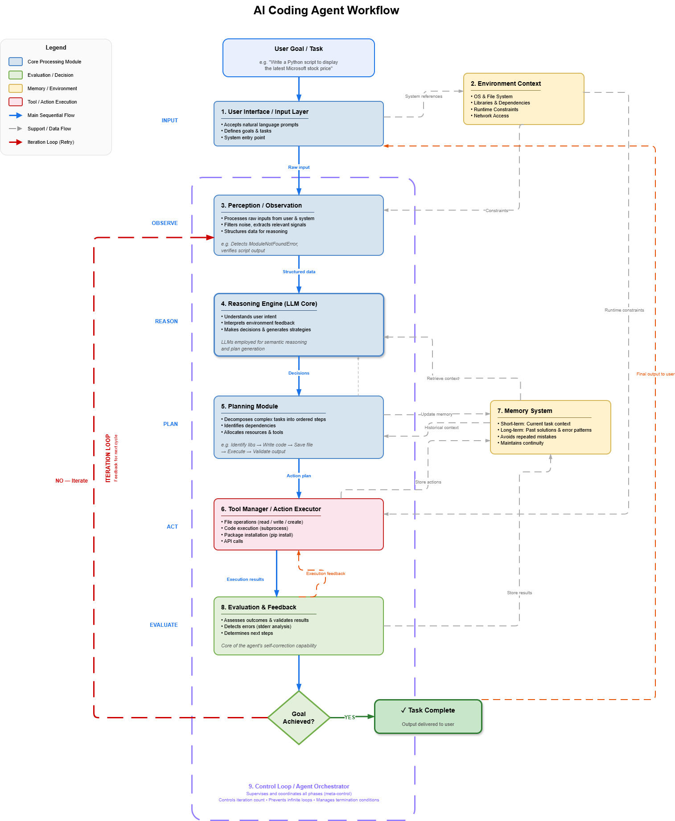
Figure 1:AI Agent Workflow – High-level block diagram showing all nine modules, their connectivity, and the iteration loop.

4 Solution Design
This section describes the proposed solution architecture, compares design alternatives at both high and low levels, and presents the detailed workflow designs for both operational modes of the AI Coding Agent.

4.1 Propose Multiple Solutions: Design Alternatives and Comparison

High Level Alternatives
Three high-level architectural approaches were considered for the AI Coding Agent:
Alternative A: Monolithic Single-Pass Architecture. In this approach, a single LLM call generates code from the prompt, and the output is returned directly to the user without execution or validation. This is the approach used by Codex CLI and Gemini CLI. It is simple to implement but provides no execution capability, no error detection, and no self-correction. The user must manually execute, debug, and fix all errors, resulting in a minimum 3-step manual loop per error.
Alternative B: IDE-Integrated Agent Architecture. This approach embeds the agent within an IDE (similar to Cursor or Windsurf), leveraging editor context, workspace awareness, and IDE terminal access. It provides rich context but is constrained to IDE sandbox environments, depends on specific editor ecosystems, and cannot operate on headless servers or CI/CD pipelines. Autonomy is limited by IDE permission models.
Alternative C: Standalone CLI Agent with Dual-Mode Architecture (Selected). This approach implements the agent as an independent command-line tool with two operational modes: Generate Mode and Debug Mode. It operates directly on the local Ubuntu system, uses sandboxed subprocess execution for safety, and implements an autonomous self-correction loop. This design provides full autonomy without IDE dependencies, supports headless operation, and directly addresses the identified market gap of no unified local solution for generation and debugging.
Alternative C was selected because it uniquely addresses the market gap identified in the background research: no existing tool provides a lightweight, unified solution that generates code, executes it locally, and autonomously debugs it without human intervention. The CLI-based approach also aligns with the project constraints of running on an Ubuntu Linux cloud VM.

Low Level Alternatives
LLM Selection. The choice of underlying language model is critical to agent performance. The following table compares the leading candidates evaluated during Phase 1:
Model | Parameters | Context | HumanEval | Size (fp16) | License
Qwen2.5-Coder 7B | 7.61B | 128K | 48–52% | ~16 GB | Apache 2.0
DeepSeek-Coder V2 16B | 16B (2.4B active) | 160K | ~68% | ~8.9 GB | MIT
CodeLlama 34B | 34B | 16K | ~48% | ~68 GB | Llama 2 Community
StarCoder2 15B | 15B | 16K | ~46% | ~32 GB | OpenRAIL-M
Table 4: Low Level Alternatives

Qwen2.5-Coder 7B was selected as the primary model for its optimal balance of performance (48–52% HumanEval), 128K token context window enabling full-file reasoning, Apache 2.0 licensing for unrestricted use, and compatibility with the available cloud VM hardware (16–24GB GPU). DeepSeek-Coder V2 16B is designated as the fallback model due to its superior HumanEval score and efficient MoE architecture requiring only 8.9GB GPU memory for 2.4B active parameters. Both models can be deployed locally using Ollama, ensuring complete data isolation.
Planning Strategy: ReAct vs. Chain-of-Thought. Two planning approaches were evaluated. Chain-of-Thought (CoT) prompting asks the LLM to reason step-by-step internally before generating code but does not interact with external tools, leading to hallucinated library names and outdated API usage. The ReAct pattern alternates reasoning with tool-augmented actions (searching documentation, validating libraries on PyPI, fetching code examples), grounding the plan in real data. ReAct was selected because it substantially reduces hallucination and produces plans validated against actual library metadata and documentation.
Error Classification: Rule-Based vs. LLM-Based. For the debugging loop, two error classification strategies were considered. A purely rule-based classifier uses regex pattern matching on stderr to identify error types and map them to predefined fixes. This is fast and deterministic but cannot handle unfamiliar error patterns. A purely LLM-based classifier sends the full error and code context to the LLM for analysis, which is flexible but slower and may hallucinate fixes. The selected hybrid approach uses deterministic rule-based classification for known error types (ModuleNotFoundError/ImportError, SyntaxError/IndentationError, FileNotFoundError) and falls back to probabilistic LLM-guided analysis for unrecognized errors, combining the speed and reliability of deterministic rules with the flexibility of LLM reasoning.

4.2 Solution Modeling
The selected solution implements a nine-module pipeline architecture supporting two operational modes through shared infrastructure. The following subsections detail the workflows for each mode.

Proactive Code Generation Workflow (Generate Mode)
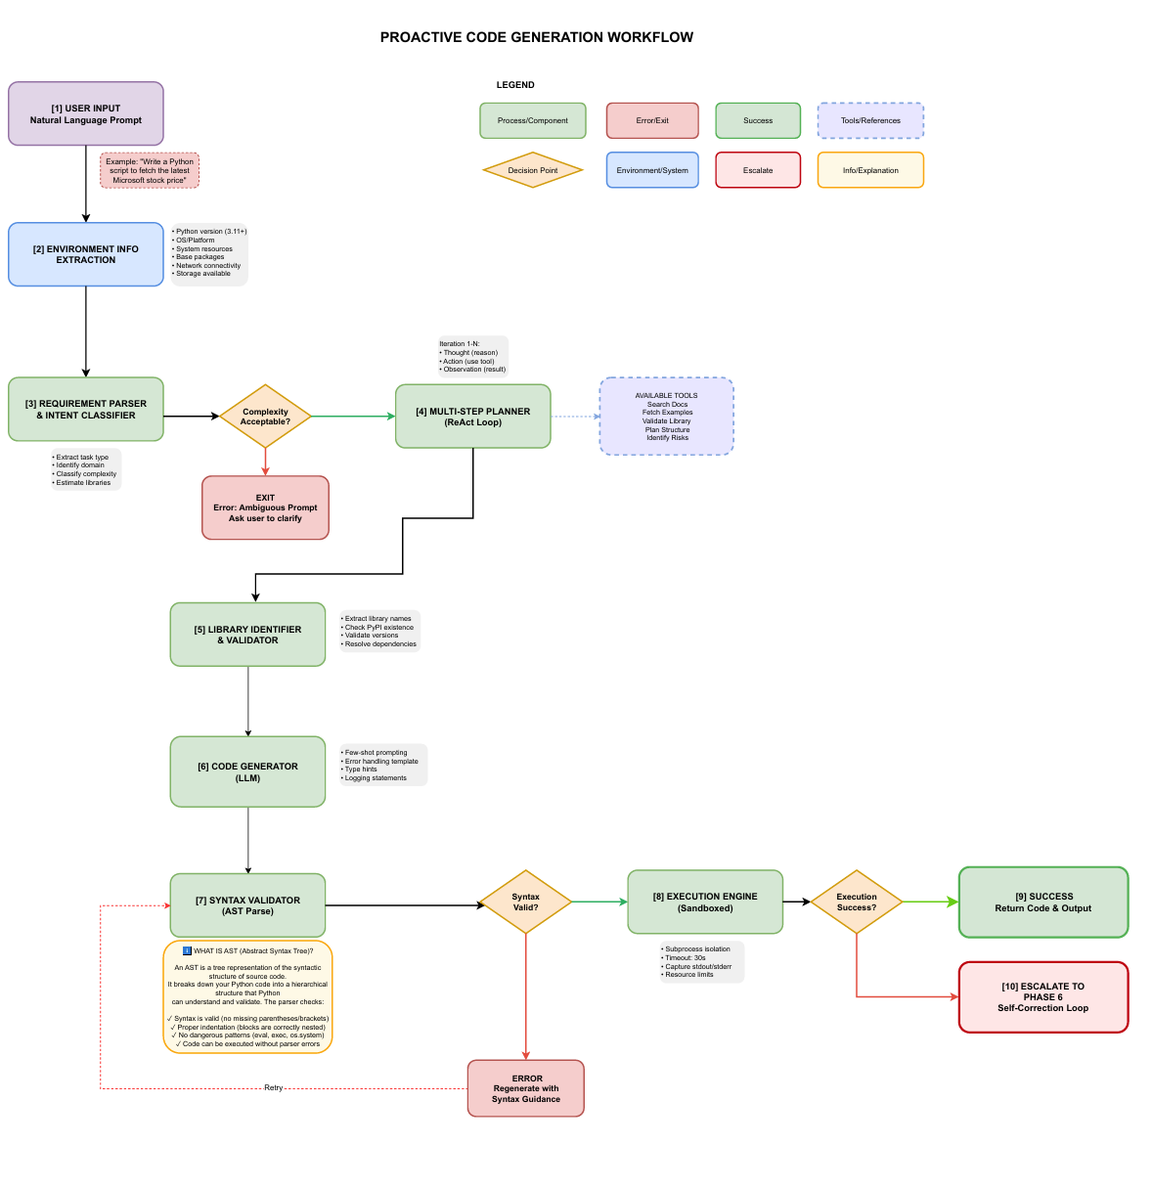
Figure 2: Proactive Code Generation Workflow – Detailed ten-phase pipeline from user input to execution with decision points.
The Generate Mode workflow is a ten-phase pipeline that transforms natural language into verified, executable Python code:
Phase 1 – User Input: The system accepts a natural language prompt describing the desired code functionality. The raw prompt is passed verbatim to downstream processing with timestamp and metadata attached for traceability.
Phase 2 – Environment Information Extraction: The system detects and catalogs target environment characteristics including Python version, OS and architecture, available system resources, pre-installed packages, network connectivity, and file system permissions. This profile serves as a constraint document for all downstream phases, eliminating a major class of execution failures by making environmental constraints explicit before code synthesis.
Phase 3 – Requirement Parser and Intent Classifier: The parser converts unstructured natural language into a structured requirement specification. It extracts task type, identifies the problem domain (finance, data science, web services), classifies complexity using a weighted scoring rubric (simple: 1–3 operations, medium: 4–6, complex: 7+), and estimates required libraries with confidence scores. Ambiguity detection flags contradictory or underspecified requirements for early rejection.
Decision Point 1 – Complexity Acceptability: Tasks exceeding acceptable operation counts or containing detected ambiguities are rejected with clarification requests. This gate prevents wasted computation on infeasible tasks.
Phase 4 – Multi-Step Planner (ReAct Loop): The planner decomposes requirements into implementation steps using the ReAct pattern. Each iteration consists of a thought phase (reasoning), an action phase (invoking a tool: search documentation, fetch examples, validate libraries, plan structure, identify risks), and an observation phase (processing results). The planner maintains confidence scoring, advancing to code generation once confidence exceeds 0.75, with a maximum of 5 iterations.
Phase 5 – Library Identifier and Validator: All identified dependencies are validated against PyPI for existence, version compatibility, security vulnerabilities (via CVE database checks), and transitive dependency resolution. Libraries are designated as approved, deprecated, or unsafe. Installation plans are generated as pip commands.
Phase 6 – Code Generator (LLM): Code generation invokes the LLM with an engineered prompt assembling requirements, plan, validated libraries, environment constraints, and few-shot examples. Quality guidelines enforce error handling, logging, type hints, docstrings, and PEP 8 compliance. Post-generation checks verify that imports reference only validated libraries and that no dangerous constructs exist.
Phase 7 – Syntax Validator (AST Parse): Python’s Abstract Syntax Tree parser verifies syntactic correctness. Beyond syntax, safety pattern detection uses regex matching to identify dangerous constructs including eval(), exec(), and os.system(). Validation failure triggers code regeneration with enhanced guidance.
Phase 8 – Execution Engine (Sandboxed): Code is executed via subprocess.run() with stdout/stderr capture, a 30-second timeout, memory constraints (512MB), and sanitized environment variables. Successful execution returns code and output to the user.
Phase 9/10 – Success or Escalation: Successful execution (return code 0, minimal stderr) completes the task. Execution failures escalate to the self-correction loop (Phase 6 of the debugging workflow).

Code Debugging Workflow (Debug Mode)
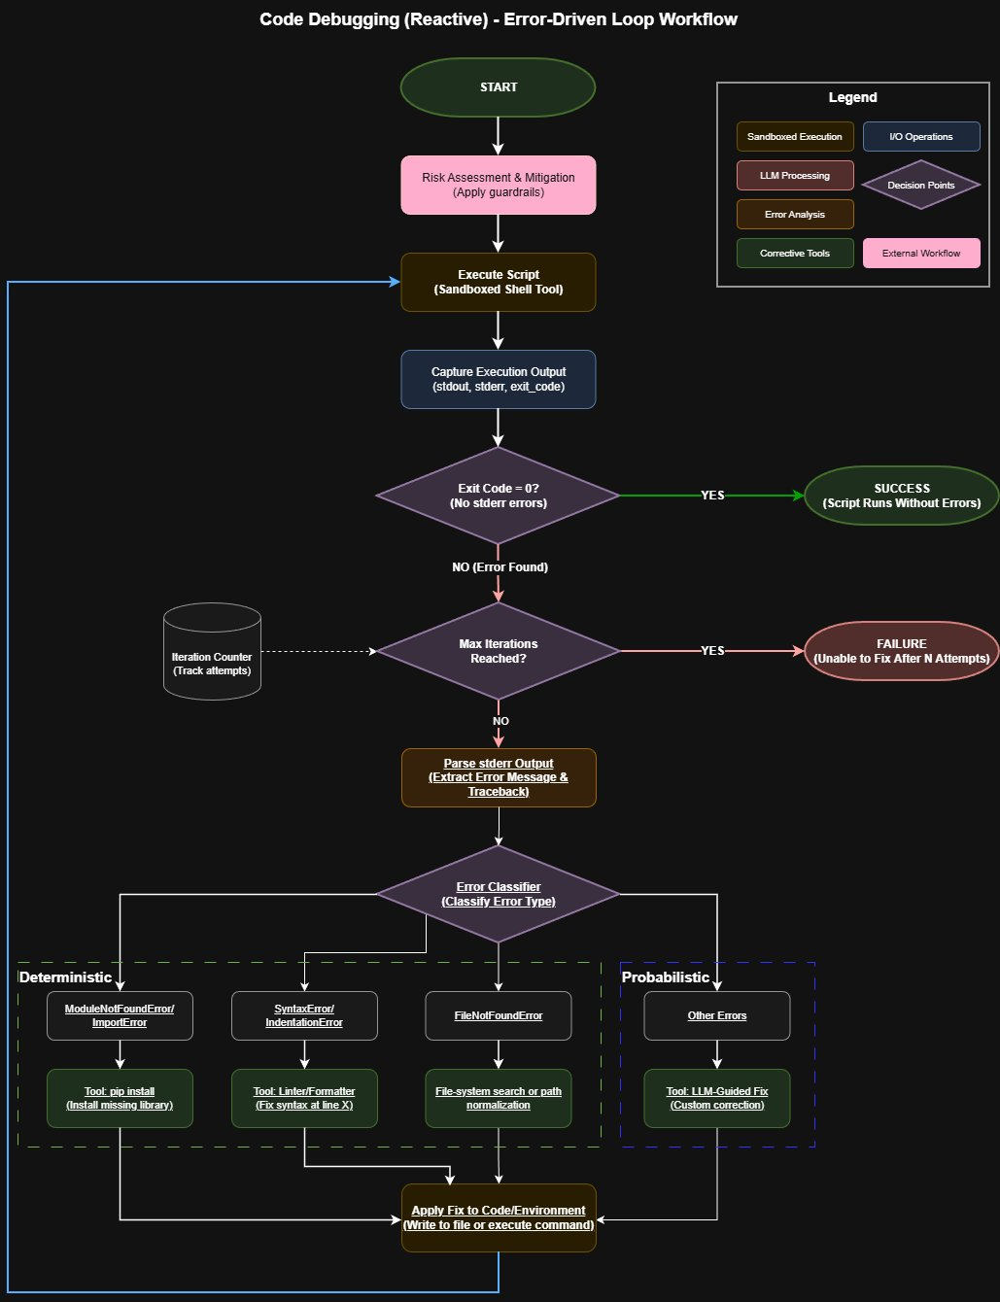
Figure 3: Code Debugging (Reactive) Workflow V2 – Error-driven loop showing deterministic and probabilistic error classification branches and corrective tools.
The Debug Mode workflow implements an error-driven iterative correction loop:
Step 1 – Risk Assessment and Mitigation: Before any code is executed, the agent applies the guardrail framework. This includes verifying that the target script path resides within the designated workspace directory (blocking path traversal attempts), checking container isolation status, and enforcing permission controls. This upfront risk assessment ensures all subsequent execution occurs within established safety boundaries.
Step 2 – Execute Script (Sandboxed): The script is executed in a sandboxed shell with subprocess isolation, a 60-second timeout, and resource limits. stdout, stderr, and the exit code are captured.
Step 3 – Check Exit Code: If the exit code is 0 and no stderr errors are present, the script is declared successful and the process terminates.
Step 4 – Iteration Control: If an error is detected, the iteration counter is checked before proceeding with analysis. If the maximum iteration count (15) has been reached or the same error has recurred 3 or more times, the agent declares failure and reports the unresolvable error to the user. Otherwise, the loop proceeds to error parsing.
Step 5 – Parse stderr Output: The error message and traceback are extracted from stderr for analysis and structured for the Error Classifier.
Step 6 – Error Classifier: The error is classified into one of four categories using a hybrid approach split into deterministic and probabilistic branches. The deterministic branch handles known error patterns through rule-based regex matching: ModuleNotFoundError/ImportError triggers pip install of the missing library; SyntaxError/IndentationError triggers the Linter/Formatter tool to fix syntax at the identified line; and FileNotFoundError triggers file-system search or path normalization. The probabilistic branch handles all other unrecognized errors through LLM-guided custom correction, where the full error context and source code are sent to the LLM for analysis and fix generation.
Step 7 – Apply Fix: The selected corrective action is applied to the code file or environment.
Step 8 – Loop Back: After the fix is applied, the loop returns to Step 2 (Execute Script) to re-execute the corrected code and verify whether the fix resolved the error.

Risk Assessment and Mitigation
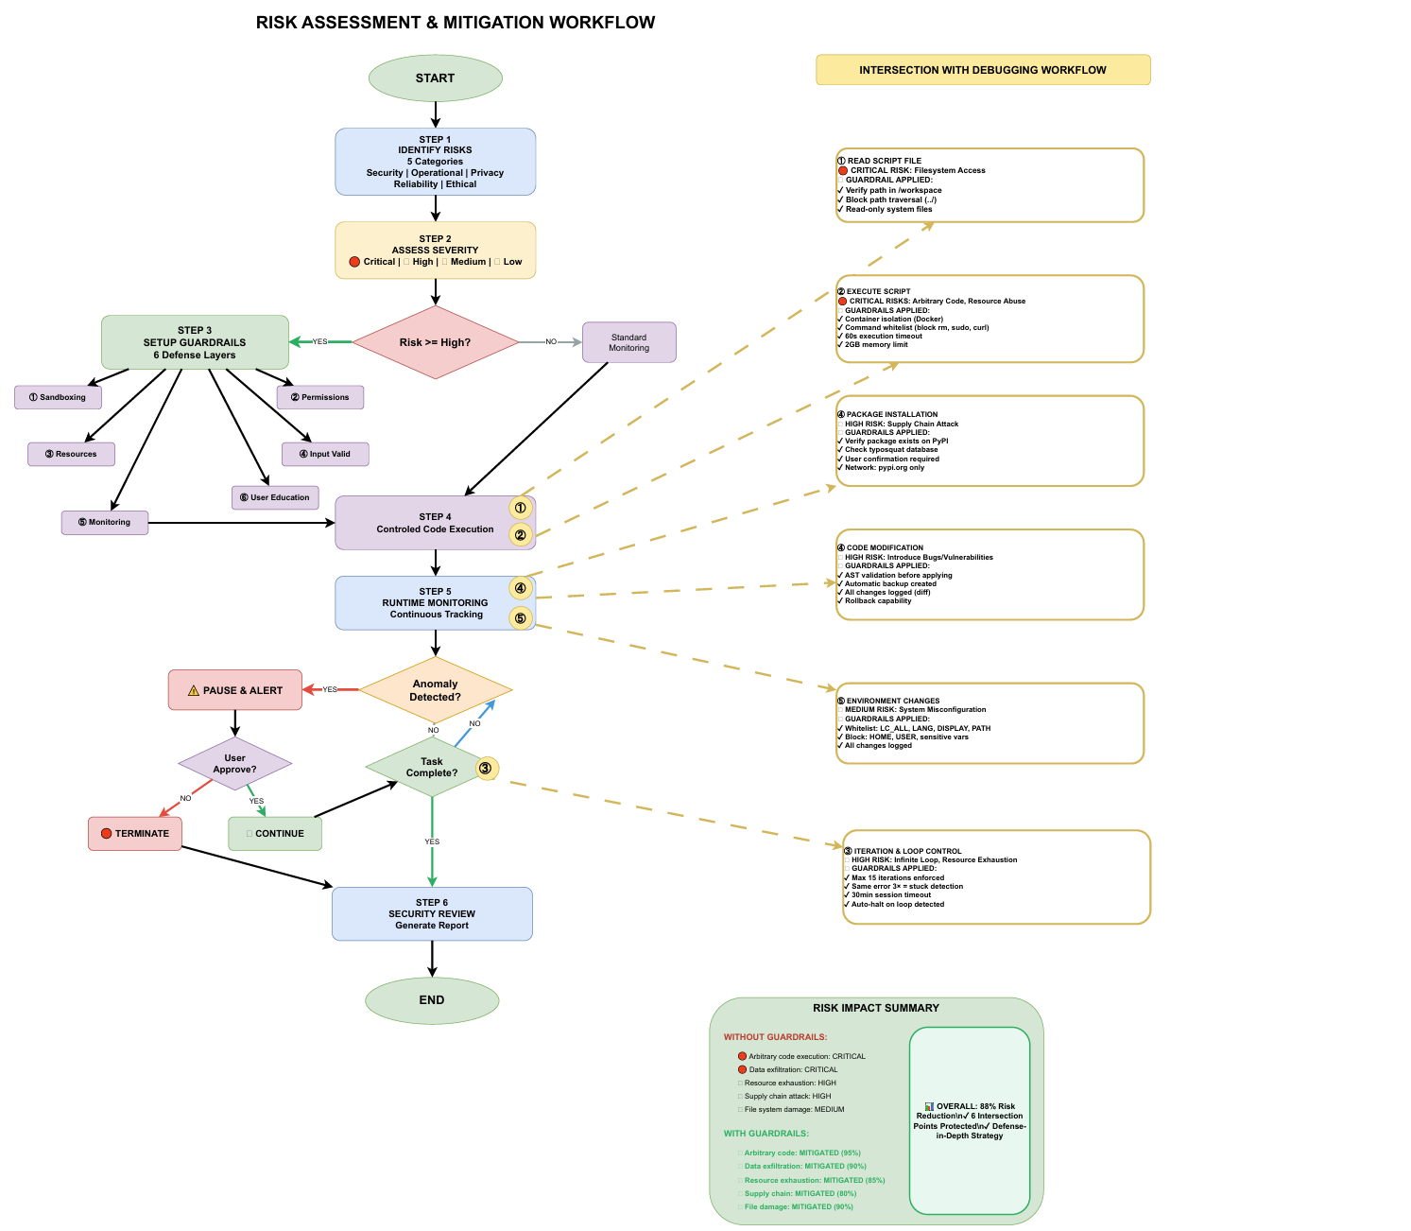
Figure 4: Risk Assessment and Mitigation Workflow – Six-step risk management process with intersection points to the debugging workflow.

The risk assessment identifies five categories of critical risks and six layers of guardrails applied at each intersection point with the debugging workflow:
Security risks include arbitrary code execution (Critical severity, mitigated 95% through container isolation and command whitelisting), data exfiltration (Critical, mitigated 90% through network isolation and domain whitelisting), and supply chain attacks through typosquatted packages (High, mitigated 80% through PyPI verification and typosquat detection). Operational risks include resource exhaustion (High, mitigated 85% through execution timeouts, memory limits, and iteration caps) and infinite debugging loops (High, mitigated through maximum 15 iterations, same-error detection after 3 occurrences, and 30-minute session timeout). Privacy risks include sensitive data exposure and LLM data leakage, mitigated through filesystem restrictions, access controls, and local-first model deployment.
The six defense layers are: (1) Sandboxing via Docker container isolation, (2) Permission controls via command whitelists, (3) Resource limits on memory, disk, and execution time, (4) Input validation including prompt injection detection and code safety analysis, (5) Monitoring through comprehensive logging and anomaly detection, and (6) User education. The overall risk reduction with all guardrails applied is estimated at 88%.

Required Resources
Resource | Provided By | Cost | Notes
Cloud VM (Ubuntu Linux) | Provided by advisor | Free | For development, testing, and agent execution
LLM API Key | Provided by advisor | Free | Access to LLM inference for reasoning and generation
GitHub Repository | Provided by advisor | Free | Private repository for version control
Python 3.11+ | Pre-installed | Free | Primary development language
Docker | Open source | Free | Container isolation for sandboxed code execution
Ollama | Open source | Free | Local LLM deployment and model management
VSCode | Microsoft | Free | Development IDE
Google Colab (optional) | Google | Free | Supplementary compute for model experimentation
Table 5: Required Resources

5 Preliminary Implementation/Tests
The project is currently in the early phases of implementation following the completion of Phase 1 (Agent Technology Analysis and Project Scoping) and Phase 2 (Unified System Architecture Definition). The following work has been accomplished:
Phase 1 deliverables completed: A comprehensive market analysis of ten major AI coding tools was conducted, documenting their operational approaches, technical specifications, and limitations across seven comparison dimensions. An evaluation of local code generation models was performed, benchmarking Qwen2.5-Coder, DeepSeek-Coder, CodeLlama, and StarCoder2 series across performance, hardware requirements, and licensing. A detailed risk assessment identifying critical security, operational, and privacy risks was produced along with a six-layer guardrail framework.
Phase 2 deliverables completed: The unified system architecture was defined with nine interconnected modules supporting dual-mode operation. Detailed workflow diagrams were produced for the AI Agent Workflow (high-level), the Proactive Code Generation Workflow (ten-phase pipeline), and the Code Debugging Workflow (error-driven loop). The Risk Assessment and Mitigation Workflow was designed showing integration points with the debugging pipeline.
Configuration and change management: A private GitHub repository has been set up for version control. The project follows Agile methodology with iterative development sprints. A cloud VM with Ubuntu Linux has been provisioned for development and testing.
Next steps: Implementation of Phase 3 (Proactive Code Generation) is the immediate priority, beginning with the Requirement Parser and Intent Classifier module, followed by the ReAct-based Multi-Step Planner, Library Validator, and Code Generator. Phase 4 (Self-Correction Loop) will follow directly, establishing the critical bridge between generation and debugging capabilities.

6 Conclusion and Future Work Planning
This proposal report has presented the design and planning for the AI Coding Agent, an autonomous LLM-powered system for proactive code generation and reactive debugging. The market analysis confirmed a clear gap in existing tools: no lightweight, unified solution currently generates code from natural language, executes it on a local Ubuntu environment, and autonomously debugs it to successful execution without human intervention. The system architecture addresses this gap through a nine-module pipeline with dual-mode operation, layered security guardrails, and an iterative self-correction loop.
The remaining phases of implementation will follow Agile methodology with the following plan:
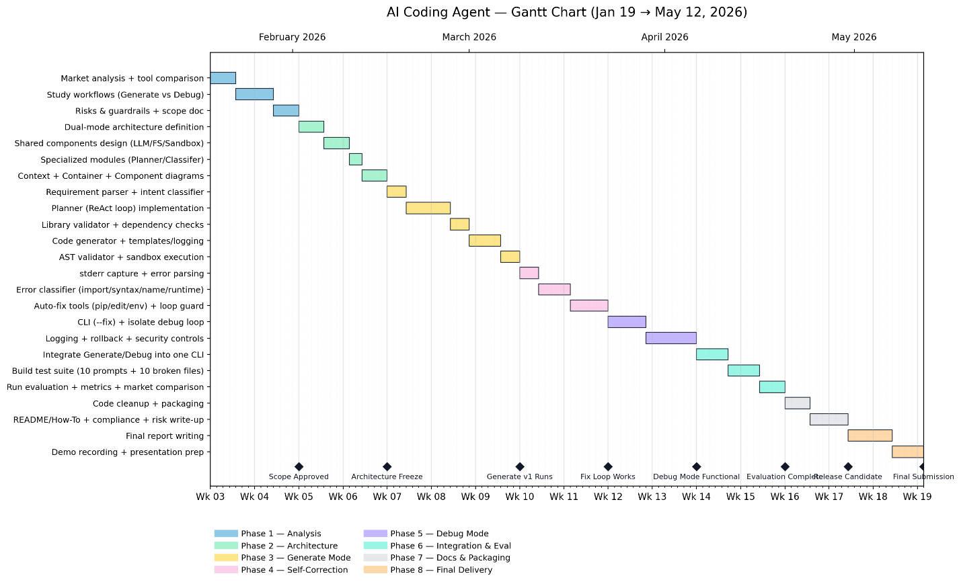

7 References
[1] Qwen Team, “Qwen2.5-Coder Technical Report,” Alibaba Cloud, September 2024.
[2] DeepSeek AI, “DeepSeek-Coder: When the Large Language Model Meets Programming,” arXiv:2401.14196, November 2023.
[3] B. Rozière et al., “Code Llama: Open Foundation Models for Code,” Meta AI, arXiv:2308.12950, August 2023.
[4] A. Lozhkov et al., “StarCoder 2 and The Stack v2: The Next Generation,” BigCode, arXiv:2402.19173, February 2024.
[5] S. Yao et al., “ReAct: Synergizing Reasoning and Acting in Language Models,” ICLR 2023, arXiv:2210.03629.
[6] ISO/IEC/IEEE 29148:2011, “Systems and software engineering – Life cycle processes – Requirements engineering,” 2011.
[7] ISO/IEC 25010:2011, “Systems and software engineering – Systems and software Quality Requirements and Evaluation (SQuaRE),” 2011.
[8] IEEE 12207:2017, “ISO/IEC/IEEE International Standard – Systems and software engineering – Software life cycle processes,” 2017.
[9] OWASP Foundation, “OWASP Top Ten 2021,” https://owasp.org/Top10/.
[10] GitHub Copilot Documentation, https://docs.github.com/en/copilot.
[11] Cognition AI, “Devin: AI Software Engineer,” https://www.cognition.ai/devin, 2024.
[12] Anthropic, “Claude Code Documentation,” https://docs.anthropic.com/en/docs/claude-code, 2024.
[13] Replit, “Replit Agent Documentation,” https://docs.replit.com/replitai/agent, 2024.
[14] PEP 8, “Style Guide for Python Code,” https://peps.python.org/pep-0008/.
[15] Gang of Four, E. Gamma et al., “Design Patterns: Elements of Reusable Object-Oriented Software,” Addison-Wesley, 1994.

Appendix 1
This appendix contains the detailed workflow diagrams referenced throughout the report.
Figure 1: AI Agent Workflow. The high-level block diagram showing all nine modules (User Interface/Input Layer, Environment Context, Perception/Observation, Reasoning Engine/LLM Core, Planning Module, Tool Manager/Action Executor, Memory System, Evaluation and Feedback, and Control Loop/Agent Orchestrator), their data flow connections, and the iteration loop. The workflow illustrates how the agent progresses through INPUT, OBSERVE, REASON, PLAN, ACT, and EVALUATE phases, with failure conditions looping back to the Perception module with updated information.
Figure 2: Proactive Code Generation Workflow. The ten-phase pipeline showing: [1] User Input, [2] Environment Info Extraction, [3] Requirement Parser and Intent Classifier (with complexity decision gate), [4] Multi-Step Planner using the ReAct loop with available tools (Search Docs, Fetch Examples, Validate Library, Plan Structure, Identify Risks), [5] Library Identifier and Validator, [6] Code Generator (LLM), [7] Syntax Validator (AST Parse) with validity decision gate, [8] Execution Engine (Sandboxed), [9] Success output, and [10] Escalation to the Self-Correction Loop.
Figure 3: Code Debugging (Reactive) Workflow. The error-driven loop starting with a risk assessment and mitigation step (applying guardrails), proceeding through sandboxed execution, exit code checking, iteration control, stderr parsing, and error classification using a hybrid deterministic/probabilistic approach into four categories (ModuleNotFoundError/ImportError, SyntaxError/IndentationError, FileNotFoundError, Other Errors). Deterministic branches map to specific corrective tools (pip install, Linter/Formatter, file-system search or path normalization), while the probabilistic branch routes to LLM-guided custom correction. After fix application, the loop returns to execution.
Figure 4: Risk Assessment and Mitigation Workflow. The six-step risk management process: (1) Identify Risks across five categories (Security, Operational, Privacy, Reliability, Ethical), (2) Assess Severity, (3) Setup Guardrails with six defense layers, (4) Controlled Code Execution, (5) Runtime Monitoring with anomaly detection and user approval, and (6) Security Review with report generation. The diagram includes intersection points showing how guardrails are applied at each step of the debugging workflow: filesystem access, script execution, iteration control, package installation, code modification, and environment changes.
Note: The full-resolution diagrams are available as separate PDF files accompanying this report: AI_Coding_Agent_Workflow_Explanation.pdf, Code-Generation-Workflow-Rework.pdf, Code-Debugging-Workflow-V2.pdf, and Risk_Workflow.pdf.

