Documentation for
Football Scout Analyzer

Project Members:
Mohamed Ramy Farouk 320240014
Youssef Mohamed Elsabagh 320240005

1. Functional Requirements

1.1 Core Features
- FR-01 – Search players by name, team, or league
  - Priority: Must
  - Status: ✅ Implemented
- FR-02 – Filter players by league (5 major leagues)
  - Priority: Must
  - Status: ✅ Implemented
- FR-03 – Sort players by score, goals, assists, etc.
  - Priority: Must
  - Status: ✅ Implemented
- FR-04 – Player comparison feature (up to 5 players)
  - Priority: Must
  - Status: ✅ Implemented
- FR-05 – Detailed player model with advanced statistics
  - Priority: Should
  - Status: ✅ Implemented

  - User Interface Requirements
- FR-6 – Responsive design (mobile, tablet, desktop)
  - Priority: Must
  - Status: ✅ Implemented
- FR-7 – Modern, clean visual design
  - Priority: Must
  - Status: ✅ Implemented
- FR-8 – User feedback notifications
  - Priority: Should
  - Status: ✅ Implemented

  - Data Requirements
- FR-17 – Display 80+ players with realistic data
  - Priority: Must
  - Status: ✅ Implemented
- FR-18 – Include 5 major football leagues
  - Priority: Must
  - Status: ✅ Implemented
- FR-19 – Show key stats (appearances, goals, assists, scout score)
  - Priority: Must
  - Status: ✅ Implemented
- FR-20 – Calculate derived metrics (averages, per-game rates)
  - Priority: Should
  - Status: ✅ Implemented

2. Non-Functional Requirements

2.1 Performance Requirements
- NFR-01 – Page load time
  - Metric: < 3 seconds
  - Status: ✅ Achieved
- NFR-02 – Search response time
  - Metric: < 500ms
  - Status: ✅ Achieved
- NFR-03 – DOM update time
  - Metric: < 100ms
  - Status: ✅ Achieved

  - Usability Requirements
- NFR-05 – Intuitive navigation
  - Validation Method: User testing
  - Status: ✅ Achieved
- NFR-06 – Learnability (task completion time)
  - Metric: < 2 minutes
  - Status: ✅ Achieved

  - Reliability Requirements
6.NFR-09 – Availability
  - Metric: 99.9%
  - Status: ✅ Achieved
- NFR-10 – Data integrity
  - Metric: 100%
  - Status: ✅ Achieved
- NFR-12 – Browser compatibility
  - Requirement: Chrome, Firefox, Edge, Safari
  - Status: ⚠️ Modern only

2.4 Security Requirements
9.NFR-14 – Data validation
  - Implementation: Client-side validation
  - Status: ✅ Implemented
10. NFR-15 – Secure data export
  - Implementation: File validation
  - Status: ✅ Implemented

2.5 Maintainability Requirements
11.NFR-16 – Code modularity
  - Metric: Separation of concerns
  - Status: ✅ Excellent
12.NFR-17 – Documentation
  - Metric: Code comments & structure
  - Status: ✅ Good

3. Stakeholders

3.1 Stakeholder Overview
- Football Scouts (Primary Users)
  - Player discovery
  - Performance comparison
  - Statistical analysis
- Club Managers (Secondary Users)
  - Talent identification
  - Team building
  - Transfer decisions
- Sports Analysts (Secondary Users)
  - Data visualization
  - Trend analysis
  - Performance metrics
- Development Team (Technical Team)
  - Code maintainability
  - Scalability
  - Performance
- End Users (General Audience)
  - Intuitive interface
  - Responsive design
  - Fast performance

Sequence Diagram:

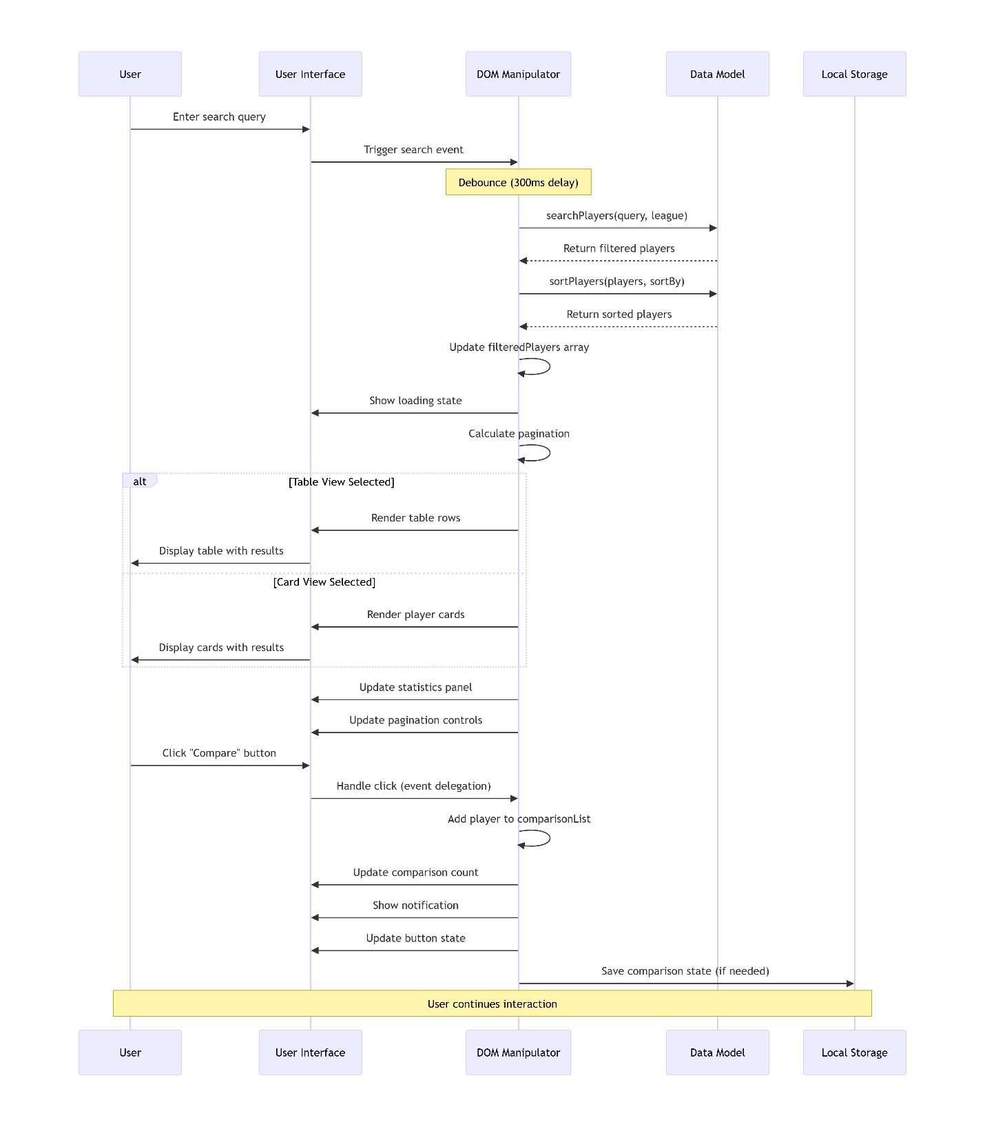
Use Case Diagram:
