**MODULE 3**

**The Python IDLE (GUI)**

**Exercise 1 – String Manipulations**

Instructions:

Type the codes in your Python Shell, run it, and “Print Screen” your Python Shell & the output in the space provided.

1. Write a program that accepts user name, age and gender. Display user name, age and gender. You may use the output shown below as an example. Save the program as “**getString.py**”.

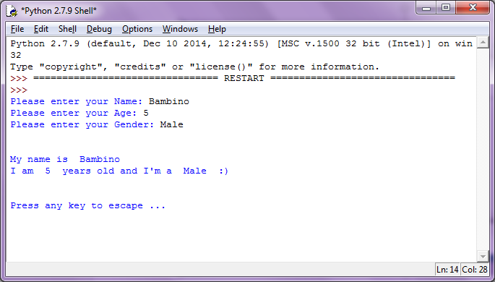

Codes & Result:

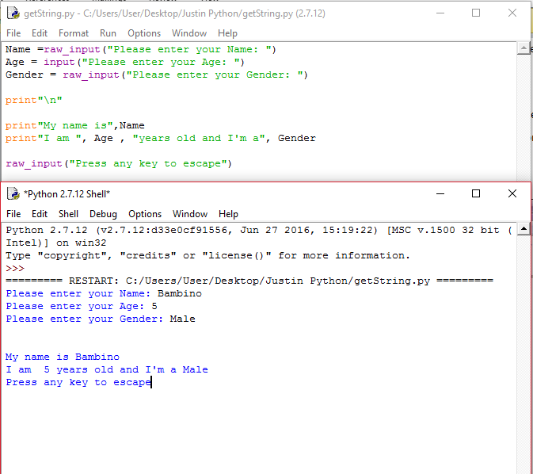

**Exercise 2**

In command-line mode, type the following expressions and write down/print screen the correct output. If you get an error, explain, in your own words, why the error occurred.

|  |
| --- |
| my_str = "Let’s go to the Zoo"  print my_str[:4]  print my_str[5:7]  print my_str[16:19] |

Output:

1.Let’

2. g

3.Zoo

|  |
| --- |
| my_subject = “CMPD123”  my_age = “20”  print type(my_subject)  print len(my_subject)  print my_age * 3 |

Output:

1. <type 'str'>
2. 7
3. 303030

|  |
| --- |
| aString = ”Twinkle Little Star!”  aString = aString[:8] + ‘Bintang’  print aString |

Output: Twinkle Bintang

**Exercise 3**

Write a program for each Flowchart diagram or Pseudocode given below. Please save your codes in a separate files.

“Print Screen” your codes and the output.

1. Sum of 2 numbers

|  |
| --- |
|  |

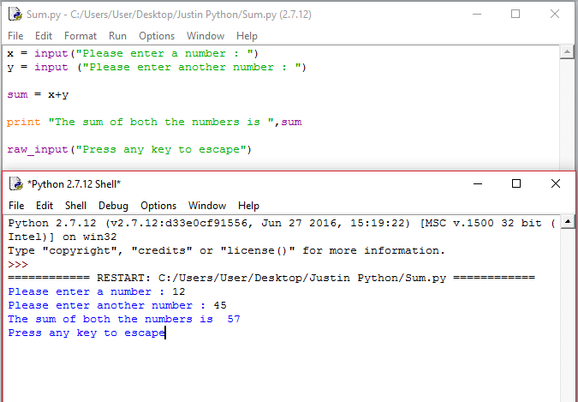

1. Calculate Pay

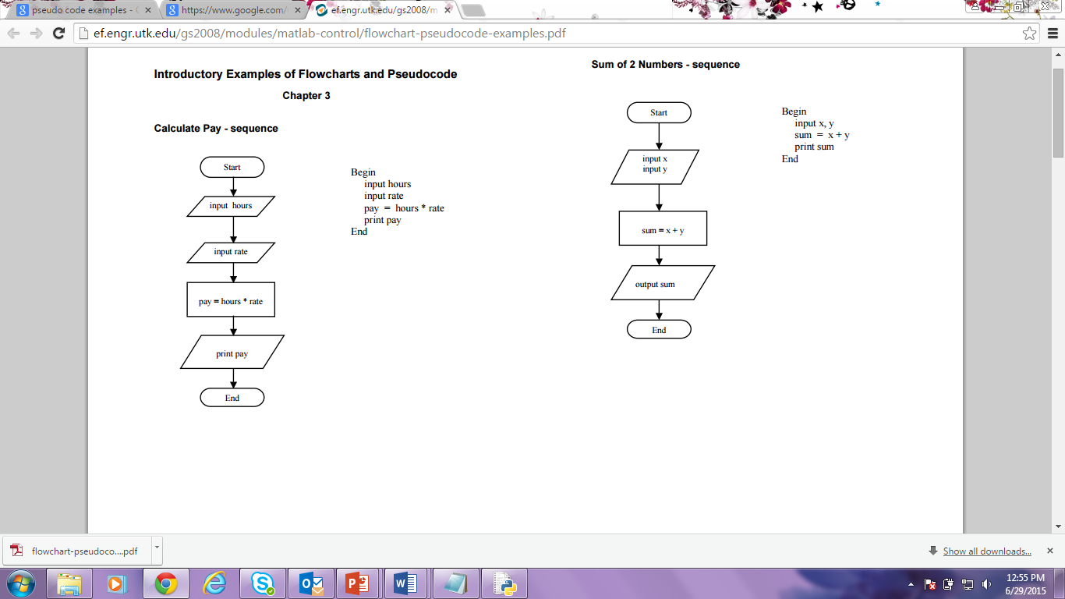

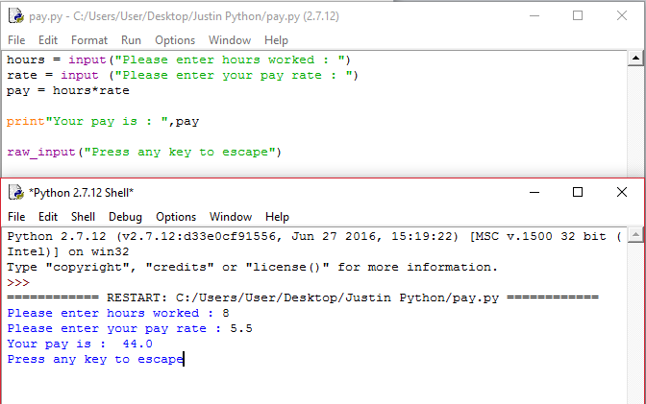

1. Average of 3 numbers

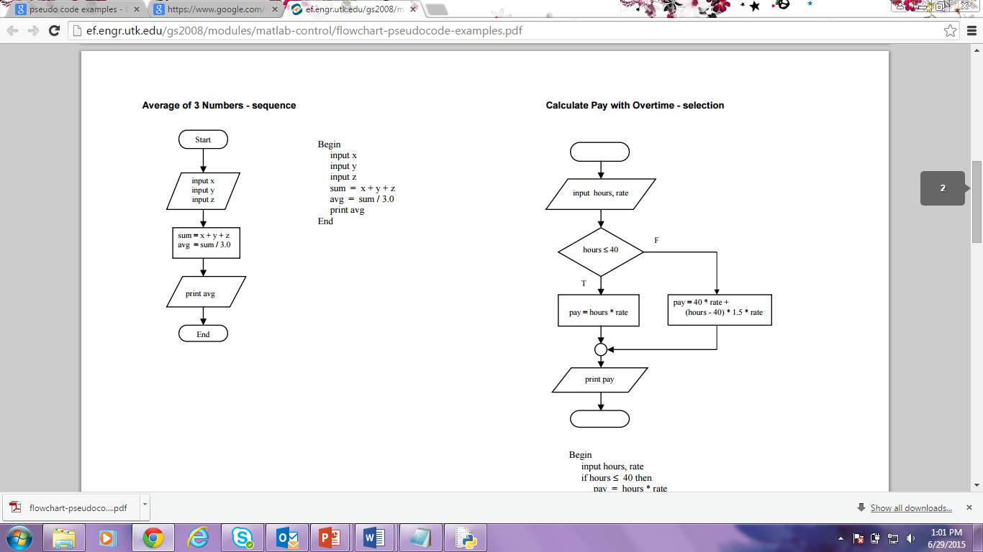

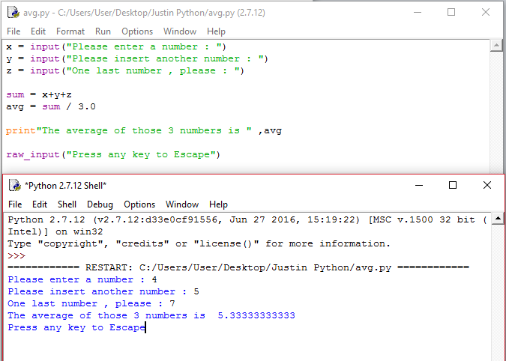

Have FUN!