1. Problem State
Two models
- Heat exchanger: predicts post-recovery temperature T_rec(t+1)
Inputs: T_out, T_ret, T_rec, pressure_hex
Outputs: T_rec(t+1)
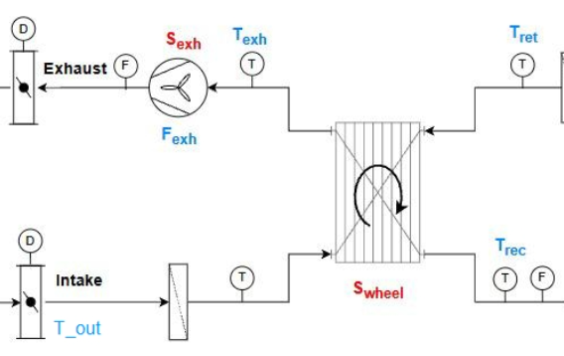
- Heating coil: predicts supply air temperature T_sup(t+1)
Inputs: T_rec, T_coil, T_sup
Outputs: T_sup(t+1)
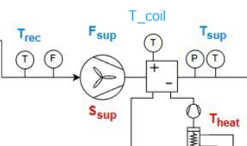

No actuator or control signals are used

All predictions are one-step-ahead (5-minute horizon).
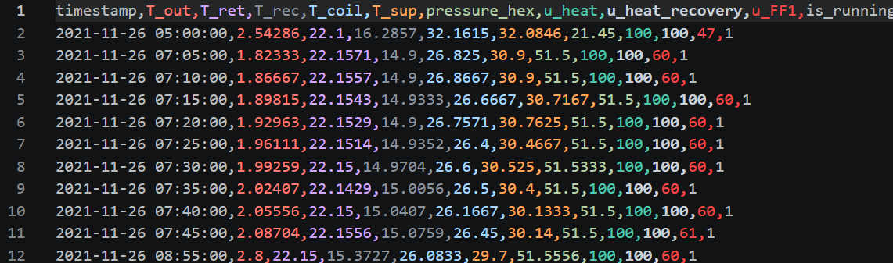

Prediction strategy: rather than predicting absolute values directly, all models predict
the delta delta = X(t+1) - X(t), then reconstruct the absolute value as:
X_pred(t+1) = X(t) + delta_pred

Baseline (persistence): X_pred(t+1) = X(t), i.e. delta_pred = 0.

Primary Evaluation Metric "Closer-to" Analysis

For each predicted value R(t+1):
Is it closer to the true next value X(t+1), or closer to the previous value X(t)?

closer_to_X(t+1): |R(t+1) - X(t+1)| < |R(t+1) - X(t)| -> model beats persistence
closer_to_X(t): |R(t+1) - X(t+1)| > |R(t+1) - X(t)| -> model no better than persistence

2. Method Versions
V1 — ARX Baseline with Lag Features
Approach:
- Models: Ridge regression (ARX) + residual tree ensemble (18 trees, max_depth=8)
- Uniform sample weighting (standard MSE minimisation)

Results on validation set (5-min horizon):
T_rec ridge_arx: closer_to_X(t+1) = 29.2% closer_to_X(t) = 55.8%
T_rec tree_ensemble: closer_to_X(t+1) = 27.9% closer_to_X(t) = 57.1%
T_sup ridge_arx: closer_to_X(t+1) = 21.6% closer_to_X(t) = 74.4%
T_sup tree_ensemble: closer_to_X(t+1) = 14.6% closer_to_X(t) = 81.3%

T_rec validation MAE: ridge = 0.0989, tree = 0.0978 (persistence = 0.1049)
T_sup validation MAE: ridge = 0.1243, tree = 0.1180 (persistence = 0.1294)

Shortcomings:
1. Only 3 lag steps (15 min) — insufficient to capture trend direction

V2 — Sequence Window + Subsystem-Specific Inputs

Approach:
- Extended history window from 3 lag rows to [t-12 ... t] (13 steps = 1 hour)
- Separated subsystem inputs:
heat_exchanger: T_out, T_ret, T_rec, pressure_hex (104 features)
heating_coil: T_rec, T_coil, T_sup (79 features)
- Models: weighted Ridge + tree ensemble (same as v1)

Results on validation set (5-min horizon):
T_rec seq_linear: closer_to_X(t+1) = 27.8% closer_to_X(t) = 57.2%
T_rec seq_tree: closer_to_X(t+1) = 24.7% closer_to_X(t) = 60.3%
T_sup seq_linear: closer_to_X(t+1) = 21.3% closer_to_X(t) = 74.7%
T_sup seq_tree: closer_to_X(t+1) = 11.6% closer_to_X(t) = 84.4%

T_rec validation MAE: linear = 0.0982, tree = 0.1007 (persistence = 0.1048)
T_sup validation MAE: linear = 0.1271, tree = 0.1251 (persistence = 0.1340)

Shortcomings:
1. The closer-to metric did not improve compared to v1, and in some cases worsened.
Extending the history window alone does not solve the root problem.
2. Root cause identified: class imbalance in the delta distribution.
Approximately 54% of T_rec training deltas have |delta| < 0.05 degC.
Under standard MSE, the model learns that predicting near-zero delta (persistence)
minimises the loss — regardless of the input features.

V3 — Linear Sample Weighting (addressing class imbalance)
Improving Approach:
- Sample weights applied during training: w = 1 + k * |delta|
Samples with larger delta receive proportionally more weight, forcing the model
to pay attention to transitional periods rather than just stable periods.
- Three values of k tested: k = 5, 10, 20
- Weighted Ridge: solved via X^T W X formulation (exact weighted least squares)
- Weighted tree ensemble: weighted bootstrap sampling + weighted SSE node splitting

Results on validation set (5-min horizon), closer_to_X(t+1):
k = 5:
T_rec w_ridge: 35.3% w_tree: 35.2%
T_sup w_ridge: 33.3% w_tree: 28.3%
k = 10:
T_rec w_ridge: 37.1% w_tree: 37.7%
T_sup w_ridge: 34.6% w_tree: 34.2%
k = 20:
T_rec w_ridge: 38.9% w_tree: 40.6%
T_sup w_ridge: 36.1% w_tree: 33.7%
T_rec validation MAE (k=20): w_ridge = 0.1088, w_tree = 0.1244 (persistence = 0.0916)
T_sup validation MAE (k=20): w_ridge = 0.2099, w_tree = 0.2775 (persistence = 0.1471)、
Outcomes:
The closer-to metric improved substantially with increasing k, confirming that sample
weighting is an effective strategy for this class imbalance problem.

Shortcomings:
1. Linear weight growth means very large deltas receive extremely high weights
(e.g. at k=20, max weight exceeds 100x the minimum), potentially over-amplifying
noisy outlier samples.
2. The weight function does not distinguish between "near-zero, safely ignorable" deltas
and "moderate" deltas — there is no floor for suppressing stable samples explicitly.
3. T_sup remains harder to improve — the heating coil response is less predictable
from sensor data alone.

V4 — Piecewise Sample Weighting
Improving Approach:
- Replaced linear weight with a two-segment piecewise function:
if |delta| < threshold: w = w_min
else: w = 1 + k * |delta|^power

Default parameters: threshold = 0.05, w_min = 0.1, k = 3.0, power = 2.0

Interpretation:
- Near-stable steps (|delta| < 0.05 degC, ~54% of T_rec samples) are heavily
discounted to weight 0.1, preventing the model from over-learning persistence.
- Transitional steps receive a quadratic boost, which is gentler than linear
for mid-range deltas but still amplifies large transitions.

Weight values at selected delta magnitudes:
|delta| = 0.01: w = 0.10 (suppressed)
|delta| = 0.05: w = 1.01 (boundary)
|delta| = 0.20: w = 1.12
|delta| = 0.50: w = 1.75
|delta| = 1.00: w = 4.00

Results on validation set (5-min horizon):
T_rec pw_ridge: closer_to_X(t+1) = 41.7% closer_to_X(t) = 45.5% tied = 12.8%
T_rec pw_tree: closer_to_X(t+1) = 37.1% closer_to_X(t) = 50.1% tied = 12.8%
T_sup pw_ridge: closer_to_X(t+1) = 38.5% closer_to_X(t) = 56.4% tied = 5.1%
T_sup pw_tree: closer_to_X(t+1) = 29.5% closer_to_X(t) = 65.5% tied = 5.1%

Results on training set (5-min horizon):
T_rec pw_ridge: closer_to_X(t+1) = 46.1% closer_to_X(t) = 41.7% (FLIPPED)
T_rec pw_tree: closer_to_X(t+1) = 41.6% closer_to_X(t) = 46.2%
T_sup pw_ridge: closer_to_X(t+1) = 37.7% closer_to_X(t) = 56.8%
T_sup pw_tree: closer_to_X(t+1) = 29.3% closer_to_X(t) = 65.3%

T_rec validation MAE: pw_ridge = 0.1332, pw_tree = 0.1183 (persistence = 0.0916)
T_sup validation MAE: pw_ridge = 0.2932, pw_tree = 0.2466 (persistence = 0.1471)

Notable observations:
- pw_ridge achieves the best closer_to_X(t+1) on validation for T_rec (41.7%),
surpassing v3 k=20 (38.9%), meaning more predictions close to the true value.
- On the training set, pw_ridge T_rec has FLIPPED: 46.1% > 41.7%, meaning the model
genuinely learns to predict the next state better than persistence on seen data.
- The gap between train (46.1%) and validation (41.7%) indicates mild generalisation
loss — the model learns large-delta patterns well on training data but these do not
fully transfer to unseen periods.
- pw_tree underperforms pw_ridge across all conditions, suggesting Ridge regression
responds more effectively to the piecewise weighting scheme for this dataset.

Shortcomings:
1. On validation, closer_to_X(t+1) still does not exceed 50% for either target —
the model has not fully overcome the persistence tendency.
2. MAE/RMSE are considerably higher than persistence, reflecting the accuracy-
responsiveness trade-off inherent to aggressive sample weighting.
3. T_sup prediction remains significantly harder: even the best model (pw_ridge,
38.5%) still has 56.4% of predictions closer to X(t), meaning the heating coil
subsystem is not yet reliably modelled without control signals.

5. KEY FINDINGS AND LIMITATIONS
1. Delta prediction + sample weighting is the most impactful design decision.
2. The piecewise weight function outperforms linear weighting.
3. Ridge regression outperforms tree ensemble under aggressive weighting.
4. T_sup is harder to model than T_rec without control signals.
5. No validation-set closer_to_X(t+1) ratio exceeds 50%.

