Assessment for Tree CTP6001
Tag ID: | CTP6001 | Species: | Ficus variegata
Girth (m): | 1.2 | Height (m): | 12
Insp date: | 2024-01-22 | Site: | KT01

Observations
- Tree displays good physiological health and vigor.
- Tree has average form.
- Crown form has major asymmetry.
- EDW with decay @ trunk.
- Terminal leader failed previously.
- Trunk flare(s) obvious.

Photos
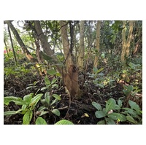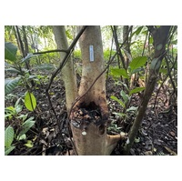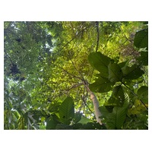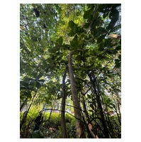

Assessment
- Conservation significance: Native, Common.
- Referring to SULE (Annex A) and TreeAZ (Annex B) tables, the tree is under the following categories of xxx retention value.
- SULE rating: xxx.
- TreeAZ rating: xxx.

Recommendations
- No recommendations.

