Jenkins CI/CD Pipeline Setup
with GitHub Webhook Integration
Step-by-Step Lab Documentation
April 24, 2026 | Joel Robinson

What We Did
In this lab, we set up a full CI/CD pipeline from scratch. The idea is simple: every time we push code to GitHub, Jenkins should automatically pick it up, run it, and email us the result. Here is a quick overview of the steps we followed:
- Initialized a local Git repository and pushed it to GitHub
- Created a Jenkins Freestyle job connected to our GitHub repo
- Set up a GitHub Webhook so Jenkins gets notified on every push
- Added a build step to run our Python script automatically
- Configured email notifications so we get build results in our inbox

Part 1: Setting Up the Git Repository

Step 1: Initialize the Repository
First, we navigated to our project folder and ran git init to create a new local Git repository. You can see from the screenshot below that Git created a hidden .git folder inside the project directory, which is where it stores all version control information.
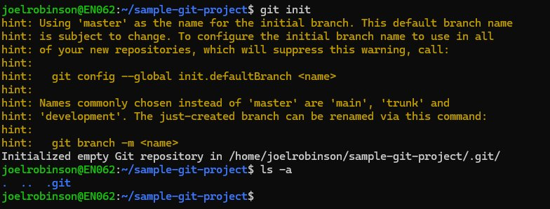
💡 Note: The warning about "master" branch name is normal. We will rename it to "main" later when pushing to GitHub.

Step 2: Create a File, Stage It, and Check Status
Next, we created a simple text file called script.txt using the echo command. Then we ran git status to see that Git detected our new file but it was "untracked" (not yet added to version control). We then ran git add script.txt to stage the file, and checked git status again to confirm it was now ready to be committed.
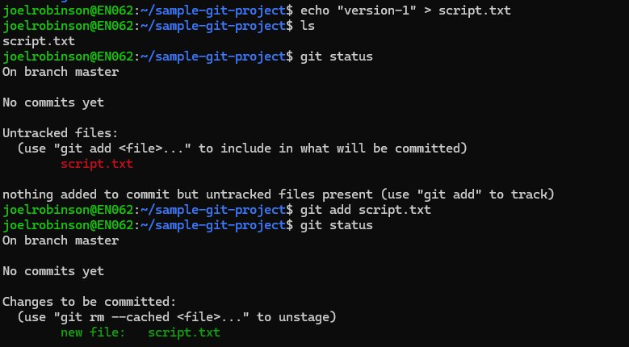
💡 Note: "Untracked" means Git sees the file but is not watching it yet. git add moves the file into the staging area.

Step 3: Make the First Commit
With our file staged, we committed it with a message "first-commit". Git confirms that one file was changed and one insertion was added. This creates the first snapshot in our project history.
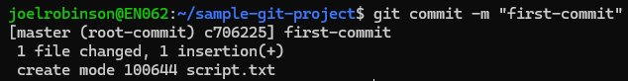

Step 4: Resolving a Merge Conflict (Bonus Step)
At some point during the lab, we created a feature branch and made changes on both branches. When we tried to merge the feature branch into master, Git could not automatically combine the changes and flagged a conflict in script.txt. The nano editor opened automatically showing the merge commit message with the conflict details listed in comments.
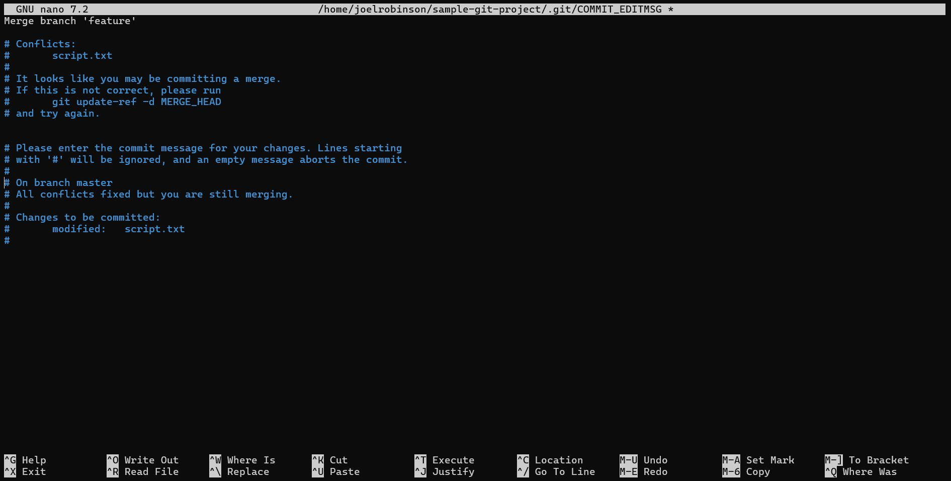
💡 Note: Lines starting with # are just comments from Git and are not included in the actual commit. We saved and exited nano to complete the merge.

Step 5: Push to GitHub
After all local commits were done, we connected our local repo to GitHub by adding a remote origin. We then renamed the branch from master to main (as GitHub expects), and pushed everything up. The output shows 9 objects being uploaded successfully.
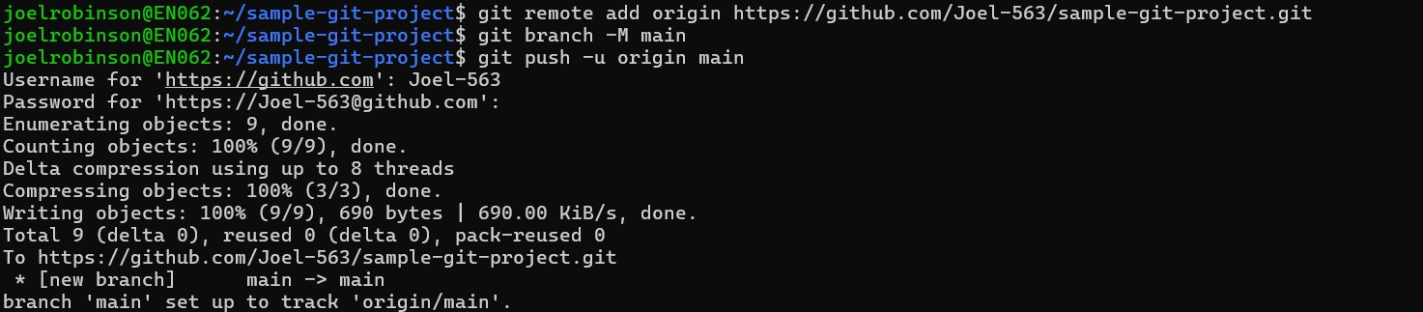
💡 Note: We were asked for our GitHub username and password (or token) here. After this step, the code is live on GitHub at the given repository URL.

Part 2: Configuring Jenkins

Step 6: Create a New Jenkins Job
We opened Jenkins in the browser (running on port 8080 on our server) and clicked "New Item". We named the job git-commit-trigger-demo and selected "Freestyle project" as the job type. Freestyle projects are the simplest type -- they let you check out code from a repo and run shell commands.
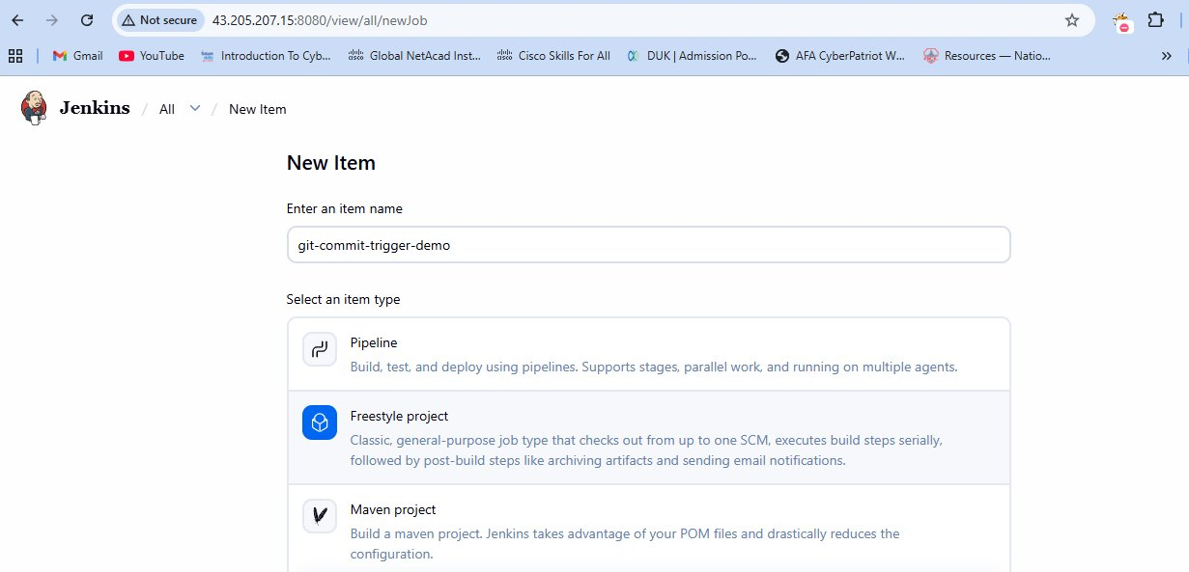

Step 7: Configure the GitHub Webhook
Over on GitHub, we went to our repository settings and added a webhook. The Payload URL points to our Jenkins server's webhook endpoint. We set the content type to application/json and left the secret empty for this demo. The webhook is set to trigger on push events only, meaning every time we push code, GitHub will send a notification to Jenkins.
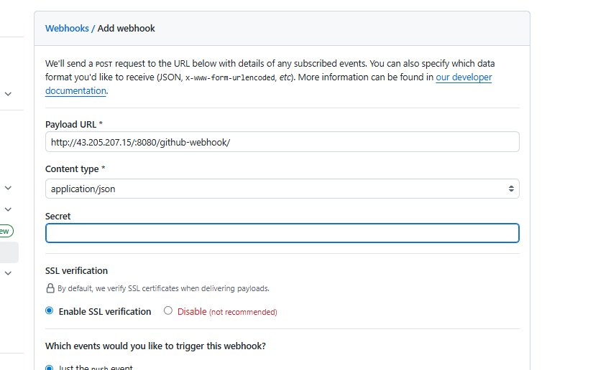
💡 Note: In a production environment, you would always fill in the Secret field to verify that incoming requests are genuinely from GitHub.

Step 8: Add a Build Step in Jenkins
Back in the Jenkins job configuration, we scrolled down to the "Build Steps" section and added an "Execute shell" step. We typed in the commands to run our Python script. This tells Jenkins: when a build is triggered, run sample.py using Python 3.
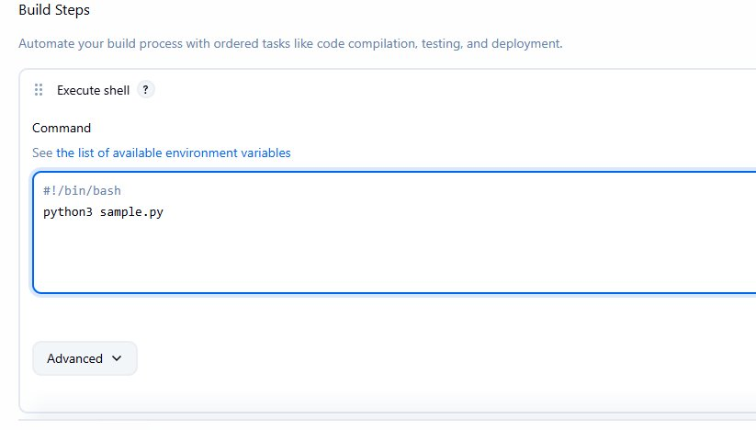

Step 9: Webhook Test - Initial Failure
After saving the Jenkins job, GitHub automatically sends a "ping" to test the webhook. The first delivery failed with "failed to connect to host". This was because Jenkins was not publicly accessible from GitHub at that moment. We fixed the connectivity issue and retried.
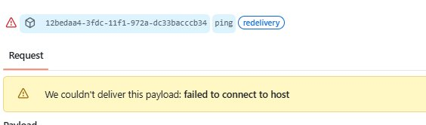
💡 Note: This is a very common issue when Jenkins is running on a local or private server. The server must be reachable from the internet for webhooks to work, or you can use a tool like ngrok to expose it temporarily.

Part 3: Triggering the Build

Step 10: Push a New Commit to Trigger Jenkins
With the webhook set up, we went back to our local machine, edited sample.py with vim, staged it, and committed with the message "pyhton-second-commit" (yes, there is a small typo -- it happens!). The file just contains a simple print("Hello_world") statement. We then ran git push to send the commit to GitHub.
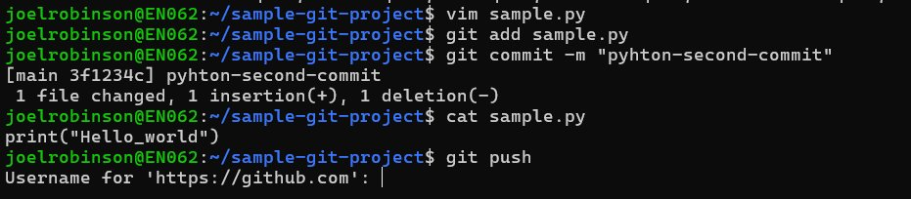

Step 11: Webhook Deliveries - Success!
After our push, the GitHub webhook log shows a new successful push delivery at 19:05. The green checkmark means GitHub successfully notified Jenkins. Earlier entries show our earlier ping attempts (with one failed attempt and one successful retry).
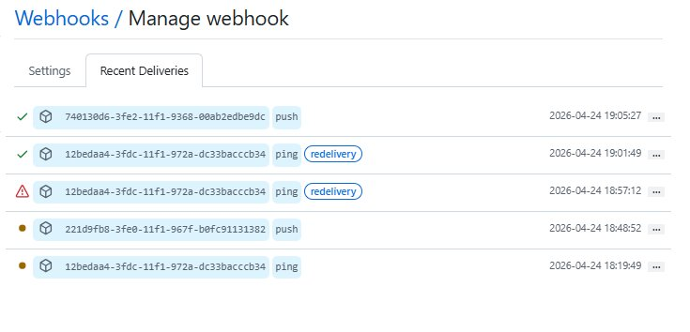

Step 12: Jenkins Build History
On the Jenkins job page, we can see two builds were triggered. Build #1 failed (the red X) -- this was likely before our script was properly set up. Build #2 succeeded (the green checkmark) after we pushed the working sample.py file.
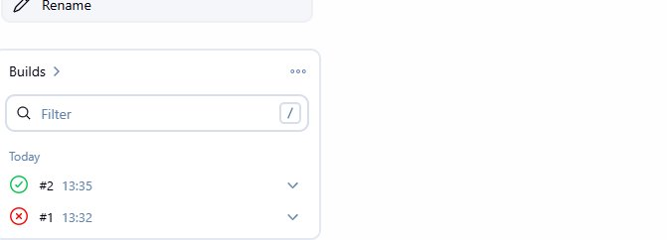

Step 13: Jenkins Console Output - Build Successful
Clicking on Build #2 and viewing the Console Output shows exactly what Jenkins did. It fetched the code from GitHub, checked out the latest commit ("pyhton-second-commit"), ran our shell script which executed sample.py, and got the output "Hello_world". The build finished with status: SUCCESS.
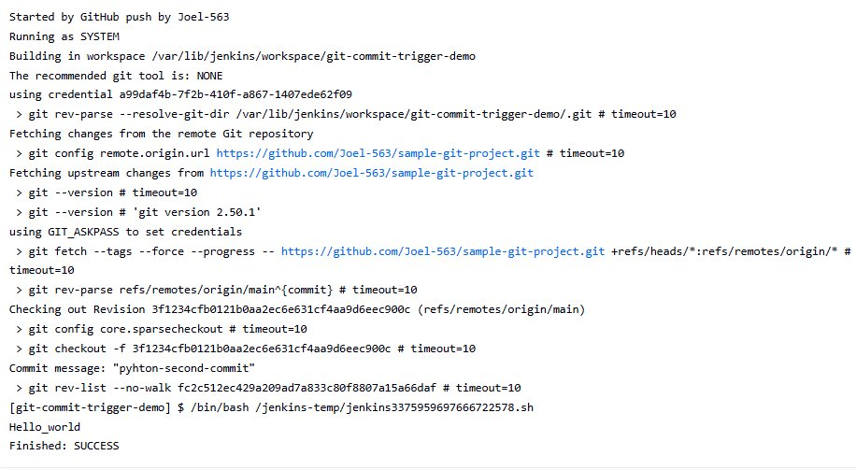
💡 Note: The commit hash shown here links directly to the exact version of code that was built. This is one of the core benefits of CI -- full traceability.

Part 4: Email Notifications

Step 14: Configure SMTP in Jenkins
To get email alerts, we went to Jenkins global configuration and set up the Extended Email Notification section. We entered smtp.gmail.com as the SMTP server and port 25. In a real setup you would also enable SSL/TLS and add Gmail credentials here.
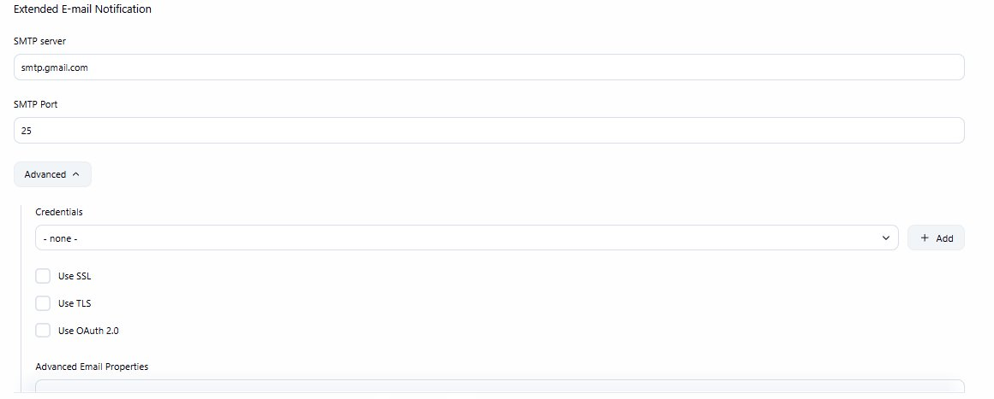

Step 15: Set the Recipient Email Address
Inside the Jenkins job configuration, we added a recipient email address in the "Project Recipient List" field. This is where Jenkins will send the build result notification after each build.
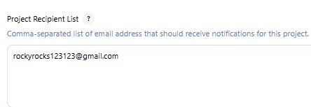

Step 16: Email Notification Working - Final Build Output
After another push (commit message "python-fifth-commit"), the final console output shows the complete pipeline working end to end. Jenkins fetched the code, ran the script which printed "Hello_world", "email-configured", and "email-reconfigured", then sent the email. The last two lines confirm: "Email was triggered for: Success" and "Sending email for trigger: Success".
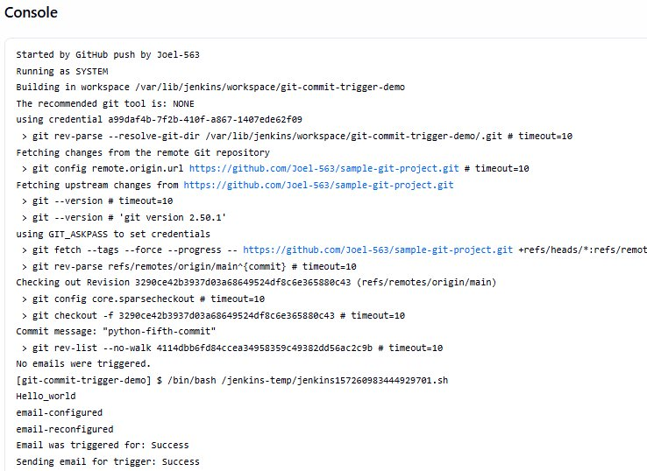

Summary
We successfully built a complete CI/CD pipeline from scratch. Here is what the full flow looks like in practice:
- Developer writes code and commits it locally
- git push sends the code to GitHub
- GitHub fires a webhook to our Jenkins server
- Jenkins automatically triggers a new build
- Jenkins checks out the latest code and runs the script
- The result (success or failure) is emailed to the recipient
This is the foundation of modern DevOps. From here, the same setup can be extended to run tests, deploy to servers, send Slack notifications, and much more.

