PROJECT REPORT ON
DWELLMANAGER — PROPERTY MANAGEMENT SYSTEM

Submitted by:
[Student Name]
[Registration Number / Roll No]

Under the Guidance of:
[Guide's Name]
[Guide's Designation]

Department of Computer Science
Nirmala College Muvattupuzha (Autonomous)
[Year / Semester]

ACKNOWLEDGEMENT
I would like to express my sincere gratitude and indebtedness to all those who generously supported me throughout the development and successful documentation of this project.
I express my profound gratitude to my esteemed project guide, [Guide's Name], [Guide's Designation], for providing invaluable intellectual mentorship, continuous technical encouragement, and constructive critique at every stage of system analysis and software realization.
I also extend my sincere appreciation to the faculty members and staff of the Department of Computer Science, Nirmala College Muvattupuzha (Autonomous), for providing the necessary infrastructural resources, computational lab facilities, and academic environment required to execute this work.
Lastly, I am grateful to my family, peers, and well-wishers for their unwavering moral encouragement and practical insights throughout this endeavor.

[Student Name]
[Registration Number / Roll No]

ABSTRACT
DwellManager is a full-stack, role-based web application engineered using Python and the Django Web Framework to modernize and streamline apartment complex administration. Traditional apartment management suffers from systemic inefficiencies, including informal communication channels, manual paper-based visitor registers, delayed maintenance fulfillment, and untracked billing of base maintenance and repair charges.
The DwellManager platform addresses these persistent domain bottlenecks by establishing a transparent, secure, and role-based digital system structured around three specialized designations: Admins, Guards, and Residents.
The system enables Admins to manage flats, register residents, assign maintenance requests, and oversee billing; Guards to perform visitor check-in/checkout with vehicle details and search visit history; and Residents to view and pay unified bills (base maintenance + additional charges), raise maintenance requests, and download receipts. A single Payment model with a charge_type discriminator handles both recurring and one-off charges, and Django transactions ensure that assigning a maintenance request automatically creates a linked Payment charge atomically.
Built upon a normalized relational schema interfacing with SQLite, DwellManager delivers ACID-compliant transactions, robust defense against web vulnerabilities (CSRF, SQL Injection, XSS), and server-side data isolation, thereby providing a modern, accountable, and dispute-free operational environment for contemporary residential apartment complexes.

TABLE OF CONTENTS
1. INTRODUCTION
1.1 Introduction
1.2 Problem Statement
1.3 Scope and Relevance of Project
1.4 Objectives
2. SYSTEM ANALYSIS
2.1 Introduction
2.2 Existing System
2.3 Proposed System
2.4 Feasibility Study
2.5 Software Engineering Paradigm Applied
3. SYSTEM DESIGN
3.1 Introduction
3.2 Database Design
3.3 Object Oriented Design — UML Diagrams
3.4 Module Description
3.5 Input Design
3.6 Output Design
4. SYSTEM ENVIRONMENT
4.1 Introduction
4.2 Software Requirement Specification
4.3 Hardware Requirement Specification
4.4 Tools, Platforms
5. SYSTEM IMPLEMENTATION
6. SYSTEM TESTING
7. SYSTEM MAINTENANCE
8. FUTURE ENHANCEMENT AND SCOPE FOR FURTHER DEVELOPMENT
9. CONCLUSION
10. BIBLIOGRAPHY
11. ANNEXURES

1
INTRODUCTION

1.1 Introduction
Residential apartment complex management traditionally relies on paper registers, verbal maintenance requests, and manual visitor logs. These practices create operational bottlenecks: delayed maintenance fulfillment, untracked visitor movement, billing discrepancies, and zero accountability across staff shifts.
DwellManager is a full-stack web application engineered to modernize apartment complex administration. The platform eliminates administrative fragmentation by establishing a transparent, role-based management system structured around three distinct user designations:
- Admins: Manage flats and resident records, assign maintenance requests, oversee billing, and monitor complex-wide analytics.
- Guards: Perform visitor check-in/checkout with vehicle details, search visit history, and maintain gate security logs.
- Residents: View and pay bills, raise maintenance requests, download receipts, and track request status.
Technical Architecture Overview
DwellManager is built using a modern multi-tier web architecture:
- Back-End: Powered by Python and the Django Web Framework using the Model-View-Template (MVT) pattern. Django manages core application logic, database Object-Relational Mapping (ORM), custom role-based access controls, and data protection against common web vulnerabilities (CSRF, SQL Injection, XSS).
- Persistent Storage: SQLite relational database (development and production in the current configuration).
- Front-End: Built using HTML5, CSS3, and a custom dark glassmorphism design system (static/style.css). No Bootstrap or external CSS frameworks are used. The interface is server-side rendered with Django templates.
1.2 Problem Statement
Conventional apartment management suffers from systemic inefficiencies:
- Untracked Visitor Movement: Paper visitor logs are easily lost, illegible, or incomplete. No real-time visibility into who is inside the complex.
- Delayed Maintenance Fulfillment: Verbal or informal complaints result in lost requests, delayed contractor dispatch, and zero accountability.
- Billing Errors and Delays: Manual tracking of base maintenance charges and additional repair fees leads to miscalculations and payment disputes.
- Lack of Audit Trails: No centralized record of financial transactions, maintenance history, or visitor logs for administrative review.
1.3 Scope and Relevance of Project
Scope: DwellManager encompasses the complete end-to-end digital lifecycle of apartment complex management, incorporating three user tiers:
- Role-Based Web Dashboards: Dedicated portals for Admin, Guard, and Resident.
- Flat and Resident Management: Admins create, edit, and deactivate flats; register residents and link them to flats.
- Visitor Logging: Guards check in visitors with name, contact, target flat, purpose, and vehicle details; check out visitors; searchable history.
- Maintenance Workflow: Residents raise requests with category and description; Admins assign contractors, set fees, and update status.
- Unified Billing: Automatic creation of base maintenance charges and additional charges from maintenance fees; payment processing with receipt generation.
1.4 Objectives
The primary objective of DwellManager is to design and deploy a secure, transparent web-based apartment management platform that eliminates administrative fragmentation through automated workflows and unified billing. Specific objectives include:
- Implement role-based authentication for Admin, Guard, and Resident.
- Digitalize flat and resident management.
- Provide a complete visitor check-in/checkout system with vehicle tracking.
- Streamline maintenance request lifecycle from submission to completion.
- Unify billing (base maintenance + additional charges) with atomic payment processing.
- Ensure server-side data isolation and IDOR protection.

2
SYSTEM ANALYSIS

2.1 Introduction
System analysis evaluates the existing apartment management domain, identifies operational bottlenecks, and defines structured solutions. For DwellManager, system analysis entails critically examining traditional manual apartment management workflows and formulating a modern, web-based software architecture.
2.2 Existing System
Traditional apartment management relies on paper visitor registers, verbal maintenance complaints, and manual billing ledgers.
Limitations of the Existing System:
- Unverifiable Visitor Logs: Paper registers are easily lost or falsified.
- Maintenance Delays: No formal ticketing queue.
- Billing Disputes: Manual calculations of base maintenance and repair fees.
- No Audit Trail: Difficult to trace financial or operational history.
2.3 Proposed System
DwellManager replaces manual workflows with an automated, role-based web platform:
- Three Role Dashboards: Admin, Guard, Resident.
- Visitor Logging Module: Complete check-in/checkout with vehicle details.
- Maintenance Ticketing: Resident submission → Admin assignment → Status tracking.
- Unified Payment Model: Single Payment table handles both 'Base Maintenance' and 'Additional Charge' via a charge_type discriminator.
- Atomic Transactions: Maintenance assignment and payment processing use transaction.atomic() with select_for_update() to prevent race conditions.
2.4 Feasibility Study
2.4.1 Technical Feasibility
- Back-End: Python + Django with built-in security (CSRF, SQL injection defense, password hashing).
- Front-End: HTML5, CSS3, custom glassmorphism CSS (no Bootstrap dependency).
- Database: SQLite — zero-configuration, ACID-compliant, suitable for the current deployment scale.
Conclusion: Proven open-source stack; technically feasible.
2.4.2 Economic Feasibility
- Zero Licensing Costs: Entire stack is open-source.
- Low Infrastructure Overhead: SQLite requires no separate database server.
Conclusion: High operational value at minimal cost.
2.4.3 Operational Feasibility
- Intuitive Role-Specific Dashboards: Each user sees only relevant tools.
- Server-Side Data Isolation: Residents can only access their own flat’s data.
Conclusion: Aligns with actual apartment management workflows.
2.5 Software Engineering Paradigm Applied
The project follows the Waterfall Model: sequential phases of requirement gathering, system design, implementation, integration/testing, deployment, and maintenance. Each phase is completed before the next begins, with no overlapping phases.

3
SYSTEM DESIGN

3.1 Introduction
System design defines the architecture, components, and data model. DwellManager uses a secure MVT architecture across three user tiers: Admin, Guard, and Resident. Core design priorities include relational database normalization, role-segregated forms, atomic billing workflows, and a verified maintenance tracking pipeline.
3.2 Database Design
The schema consists of five normalized tables:
1. Flat
Field | Type | Constraint | Description
id | BigAutoField | Primary Key | Unique flat identifier
flat_number | CharField(20) | Unique with block | Door/bay number
block | CharField(50) | Unique with flat_number | Block designation
floor | PositiveIntegerField | — | Floor number
flat_type | CharField(20) | Choices: 1BHK…Studio | Unit classification
owner_name | CharField(100) | — | Owner’s full name
base_maintenance_amount | DecimalField(10,2) | Min=0.00 | Monthly base charge
is_active | BooleanField | Default=True | Soft-delete flag
manually_marked_occupied | BooleanField | Default=False | Override for non-portal residents

2. Resident (AUTH_USER_MODEL)
Field | Type | Constraint | Description
id | BigAutoField | Primary Key | Unique user identifier
flat | ForeignKey → Flat | null=True, blank=True | Linked flat (null for Admin/Guard)
username | CharField(50) | Unique, indexed | Login handle
full_name | CharField(100) | — | Display name
contact_number | CharField(15) | null, blank | Phone number
email | EmailField | null, blank | Email address
role | CharField(20) | Choices: Resident, Guard, Admin | RBAC determinant
status | CharField(20) | Choices: Active, Inactive, Moved-out | Resident lifecycle
move_in_date | DateField | null, blank | Date of move-in
is_active | BooleanField | Default=True | Login enable/disable
is_staff | BooleanField | Default=False | Django admin access

3. MaintenanceRequest
Field | Type | Constraint | Description
id | BigAutoField | Primary Key | Request identifier
flat | ForeignKey → Flat | RESTRICT | Impacted flat
category | CharField(30) | Choices (13) | plumbing, electrical, hvac, …
description | TextField(500) | — | Problem narrative
status | CharField(20) | Choices: Pending…Completed | Workflow state
assigned_to | CharField(100) | null, blank | Contractor/vendor name
scheduled_date | DateField | null, blank | Planned visit date
fee_amount | DecimalField(10,2) | null, blank, Min=0.00 | Charge for repair
created_at | DateTimeField | auto_now_add | Submission timestamp

4. Payment (Unified Billing)
Field | Type | Constraint | Description
id | BigAutoField | Primary Key | Payment identifier
flat | ForeignKey → Flat | RESTRICT | Billed flat
charge_type | CharField(30) | Choices: Base/Additional | Discriminator
source_request | ForeignKey → MaintenanceRequest | SET_NULL | Linked maintenance request
billing_month | CharField(20) | — | Billing cycle (e.g., Sept 2026)
amount | DecimalField(10,2) | Min=0.00 | Charge amount
description | CharField(200) | null, blank | Charge description
status | CharField(20) | Choices: Unpaid, Paid | Payment status
payment_method | CharField(20) | Choices: UPI, Net Banking, Cash | Remittance channel
paid_at | DateTimeField | null, blank | Payment timestamp
receipt_ref | CharField(50) | null, blank | Receipt reference
created_at | DateTimeField | auto_now_add | Creation timestamp

5. Visitor
Field | Type | Constraint | Description
id | BigAutoField | Primary Key | Visitor log identifier
full_name | CharField(60) | — | Visitor name
contact_number | CharField(15) | — | Visitor phone
target_flat | ForeignKey → Flat | RESTRICT | Flat being visited
purpose | CharField(30) | Choices (4) | Delivery, Guest, Service, Other
vehicle_number | CharField(20) | null, blank | Vehicle registration
vehicle_type | CharField(10) | Choices: Car, Bike, None | Vehicle classification
check_in_time | DateTimeField | auto_now_add | Entry timestamp
exit_time | DateTimeField | null, blank | Exit timestamp
status | CharField(20) | Choices: Inside/Checked-Out | Current state

3.3 Object Oriented Design — UML Diagrams
3.3.1 Activity Diagram
The activity diagram below models the complete swimlane workflow across all three roles — Admin, Guard, and Resident — with decision diamonds showing action branching, the atomic database transaction for maintenance assignment (with fee > 0 branching to create the Additional Charge Payment), and the atomic payment processing flow.
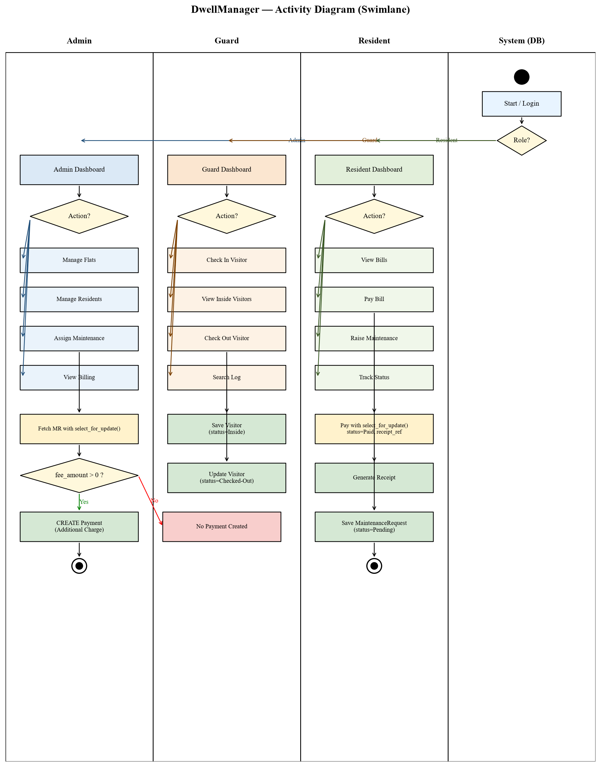
Figure 3.1 — DwellManager Activity Diagram (Swimlane)
3.3.2 Sequence Diagram
The sequence diagram below illustrates the atomic Maintenance-to-Charge pipeline. When an Admin assigns a maintenance request, the view wraps the operation in transaction.atomic() and uses select_for_update() to lock the MaintenanceRequest row, preventing race conditions. If fee_amount > 0, a linked Payment record (charge_type = Additional Charge) is created in the same transaction, and the Resident Billing View immediately sees the new charge.
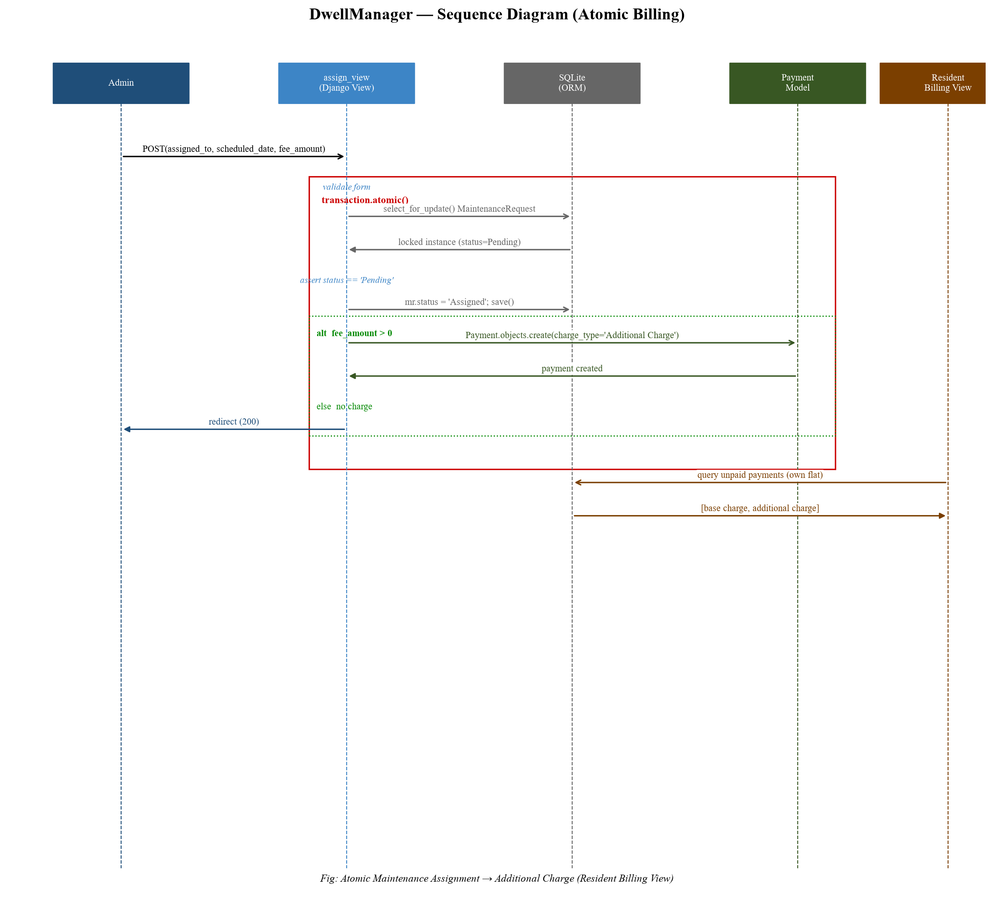
Figure 3.2 — DwellManager Sequence Diagram (Atomic Billing)
3.3.3 Use Case Diagram
The use case diagram below shows all three actors — Admin, Guard, and Resident — with their associated use cases enclosed within the DwellManager system boundary. Include relationships (<<include>>) connect base use cases to their mandatory sub-behaviors, such as Assign Maintenance including Set Fee and Create Additional Charge.
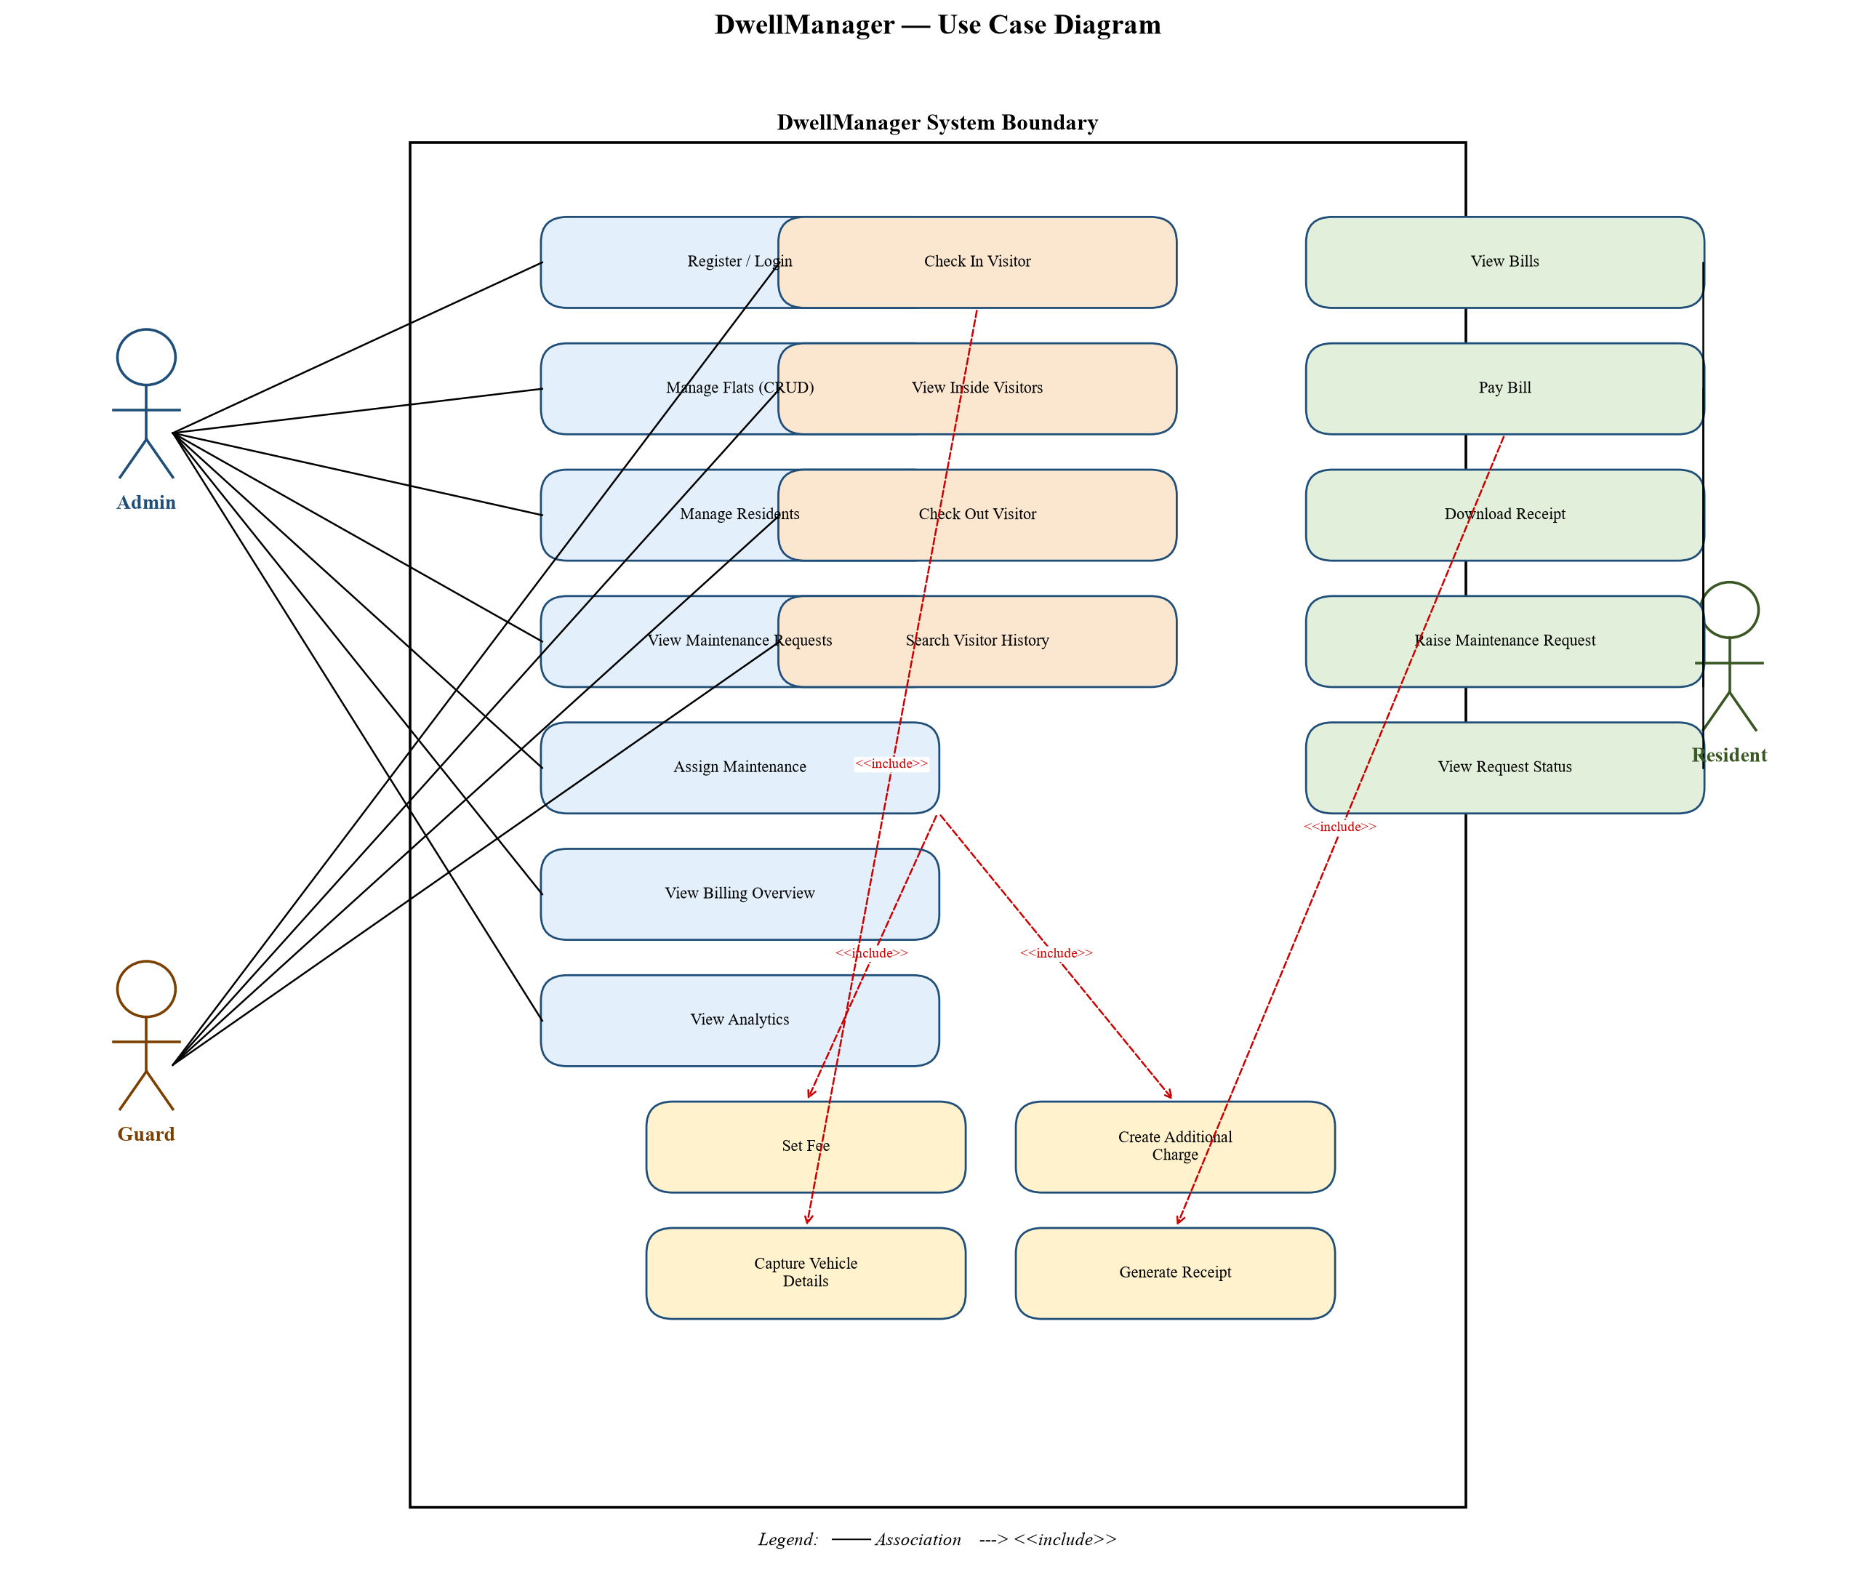
Figure 3.3 — DwellManager Use Case Diagram
3.4 Module Description
1. Admin Module
- Flat Management: Create, edit, deactivate flats. Set base_maintenance_amount.
- Resident Management: Register residents, link to flats, manage roles and statuses.
- Maintenance Assignment: View pending requests, assign contractor, set fee, update status.
- Billing Overview: View all unpaid/paid charges, total outstanding.
- Dashboard Analytics: Total flats, active residents, pending requests, visitors inside, total unpaid.
2. Guard Module
- Visitor Check-In: Record name, contact, target flat, purpose, vehicle details.
- Visitor Check-Out: Timestamp exit, set status to Checked-Out.
- Visitor Log: Searchable history by name, contact, flat number, or date.
3. Resident Module
- Billing Dashboard: View base maintenance and additional charges.
- Payment Processing: Pay via UPI, Net Banking, or Cash; receive receipt reference.
- Maintenance Requests: Submit request with category and description.
- Request Tracking: View status (Pending → Assigned → In Progress → Completed).
3.5 Input Design
Input is handled through Django ModelForms with:
- Client-side HTML5 validation (required, pattern, min, max, type).
- Server-side validation via Django forms (clean() methods).
- CSRF tokens on all state-changing forms.
- Server-side role guards via decorators (@admin_required, @guard_required, @resident_required).
3.6 Output Design
Output is rendered using Django templates with custom CSS:
- Role-Aware Sidebar: Dynamic navigation based on request.user.role.
- Dashboard Cards: Key metrics for each role.
- Data Tables: Sortable, paginated lists for flats, residents, maintenance, visitors, payments.
- Receipts: Formatted payment receipts with reference numbers.

4
SYSTEM ENVIRONMENT

4.1 Introduction
The system environment encompasses the browser client, Django WSGI server, and SQLite database.
4.2 Software Requirement Specification
Component | Specification
Operating System | Windows 10/11, Linux (Ubuntu 22.04 LTS)
Development Platform | Python 3.10+ / Django
Front-End | HTML5, CSS3, custom JavaScript
Database | SQLite (current configuration)
Web Server | Django Development Server
Browser | Chrome, Firefox, Edge, Safari

4.3 Hardware Requirement Specification
Server/Developer Side: Intel Core i5 or equivalent, 8 GB RAM (16 GB recommended), 256 GB SSD.
Client Side: Any internet-enabled device with a modern browser, 2 GB RAM minimum.
4.4 Tools and Platforms
4.4.1 Django
- MVT Architecture: Decoupled models, views, and templates.
- ORM: Python-based database operations with automatic SQL parameterization.
- Built-in Security: CSRF protection, XSS prevention, SQL injection defense.
- Transaction Support: transaction.atomic() for atomic database operations.
4.4.2 SQLite
- Zero Configuration: No separate server process.
- ACID Compliance: Reliable transaction execution.
- Django Compatibility: Native backend support.
- Suitable Scale: Adequate for single-complex deployments.

5
SYSTEM IMPLEMENTATION

5.1 Introduction
Implementation translates design into executable Django code.
5.2 Coding
The codebase follows PEP 8 and modular Django app structure (api/ app containing models, forms, views, permissions, serializers, tests).
5.2.1 Coding Standards
- PEP 8 Compliance: Python style guide adherence.
- Descriptive Naming: Domain-explicit names (e.g., admin_maintenance_assign).
- Docstrings: All views documented.
5.3 Code Validation and Optimization
- N+1 Prevention: select_related() used for foreign key relationships.
- Atomic Transactions: transaction.atomic() + select_for_update() for financial operations.
- IDOR Protection: Resident views derive flat from request.user.flat, never from user input.
5.3.1 Debugging
Debugging via Django’s debug toolbar, pdb, and structured logging.

6
SYSTEM TESTING

6.1 Introduction
Testing validates that the system meets functional specifications.
6.2 Types of Testing
6.2.1 Unit Testing
- Flat CRUD operations.
- Resident management.
- Maintenance request lifecycle.
- Atomic billing (assignment + charge creation).
- Payment processing with double-payment protection.
- Visitor check-in/checkout.
- IDOR/security tests (cross-flat access denied).
- Authentication and role-based redirects.
6.2.2 System Testing
End-to-end workflows: resident registration → maintenance request → admin assignment → charge creation → resident payment → receipt.
6.2.3 Integration Testing
- Signal triggers: Maintenance assignment creates Payment record.
- Database transactions: Payment updates atomic.
- Template contexts: Views pass complete, sanitized context.
6.2.4 Test Cases Verification Table
Test ID | Module | Scenario | Expected Result | Status
TC_AUTH_01 | Authentication | Admin login redirect | Redirect to /dashboard/admin/ | Pass
TC_AUTH_02 | Authentication | Resident access to admin route | 403 Forbidden | Pass
TC_FLAT_01 | Flat Mgmt | Create new flat | Flat saved; visible in list | Pass
TC_MAINT_01 | Maintenance | Resident raises request | Ticket saved; status Pending | Pass
TC_MAINT_02 | Maintenance | Admin assigns with fee | Request Assigned; Payment created | Pass
TC_PAY_01 | Payment | Resident pays charge | Status Paid; receipt generated | Pass
TC_VIS_01 | Visitor | Guard checks in visitor | Visitor Inside; visible in dashboard | Pass
TC_VIS_02 | Visitor | Guard checks out visitor | Status Checked-Out; exit time set | Pass
TC_SEC_01 | Security | Cross-flat payment access | 403/404 denied | Pass

7
SYSTEM MAINTENANCE

7.1 Introduction
System maintenance ensures ongoing reliability, security, and performance.
7.2 Maintenance Types
- Corrective: Fixing bugs discovered in production.
- Adaptive: Updating dependencies (Django, Python versions).
- Perfective: Enhancing UI, optimizing queries, adding features.
- Preventive: Security audits, database vacuuming, code refactoring.

8
FUTURE ENHANCEMENT

8.1 Introduction
DwellManager provides a solid foundation for apartment complex management. Future iterations can expand capabilities.
8.2 Merits of the System
- Three-Role Clarity: Admin, Guard, Resident each see only relevant tools.
- Complete Visitor Logging: Real-time inside/outside visibility with vehicle tracking.
- Unified Billing: Single Payment model handles base and additional charges.
- Atomic Financial Operations: No race conditions in payment processing.
- Server-Side Security: IDOR protection, role guards, CSRF tokens.
- Custom Glassmorphism UI: Modern, responsive dark theme.
8.3 Limitations
- Web-Only Architecture: No native mobile apps.
- SQLite Database: May need migration to PostgreSQL for large-scale deployments.
- No IoT Integration: Smart locks or utility meters not supported.
- Domestic Currency Only: No multi-currency support.
- Internet Dependency: Requires active connectivity.
8.4 Future Enhancements
- Native Mobile Apps: Android/iOS with push notifications for visitors and bills.
- PostgreSQL Migration: For multi-complex scalability.
- IoT Integration: Smart locks, digital utility meters.
- AI Predictive Maintenance: Forecast equipment failures.
- Multi-Language Support: Malayalam, Tamil, Hindi.
- Payment Gateway Integration: Online payment processing.

9
CONCLUSION

9.1 Conclusion
DwellManager successfully resolves the systemic inefficiencies of traditional apartment management by providing an automated, transparent, role-based digital platform. Built with Python, Django, and custom glassmorphism CSS, the system connects Admins, Guards, and Residents in a unified operational environment.
A central achievement is the atomic maintenance-to-charge pipeline: when an Admin assigns a maintenance request with a fee, a linked Additional Charge Payment record is created in the same database transaction — eliminating race conditions and manual billing errors.
The Visitor Logging module provides real-time gate security with vehicle tracking, while the unified Payment model simplifies billing for both base maintenance and repair charges. Server-side data isolation and role-based decorators ensure residents can only access their own flat’s data.
While acknowledging current boundaries — SQLite database, web-only architecture, and domestic currency scope — the system establishes a robust, extensible foundation. Future enhancements such as native mobile apps, PostgreSQL migration, and IoT integration can readily expand its capabilities.
In conclusion, DwellManager effectively fulfills all core objectives, demonstrating how full-stack Django solutions can modernize apartment complex administration.

10
BIBLIOGRAPHY

10.1 Books
- Pressman, R. S., & Maxim, B. R. (2019). Software Engineering: A Practitioner's Approach (9th ed.). McGraw-Hill Education.
- Lutz, M. (2013). Learning Python (5th ed.). O'Reilly Media.
- Holovaty, A., & Kaplan-Moss, J. (2009). The Definitive Guide to Django: Web Development Done Right. Apress.
- Fowler, M. (2003). UML Distilled: A Brief Guide to the Standard Object Modeling Language (3rd ed.). Addison-Wesley Professional.
10.2 Web Resources
- Django Software Foundation. (2026). Django Documentation. https://docs.djangoproject.com/
- Python Software Foundation. (2026). Python 3 Documentation. https://docs.python.org/3/
- Mozilla Developer Network (MDN). (2026). Web Docs: HTML, CSS, JavaScript. https://developer.mozilla.org/

11
ANNEXURES

11.1 Screenshots
[Insert DwellManager system screenshots here — Login page, Admin Dashboard, Guard Dashboard, Resident Dashboard, Visitor Log, Maintenance Assignment, Payment Receipt.]

