SEO Project: Personal Portfolio Website

Part 1: Analysis

Website URL: https://joelmacwan.000webhostapp.com/

- Research and choose several keywords for your personal web page. Explain why you chose the ones you did.
Answer: The several keywords used in my personal web page are:
- Exceptional
- Knowledge
- Skilled
- Experienced
- Designer and Developer
- Data Analyst
- Professional
- Solve problems
- Data
- Website
- Performance
- Capacity
- Quality
- Websites
The reason why I have chosen this words is

- Design the basic structure of your website and create an XML site map.
Answer:
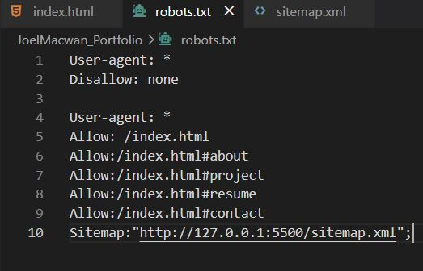
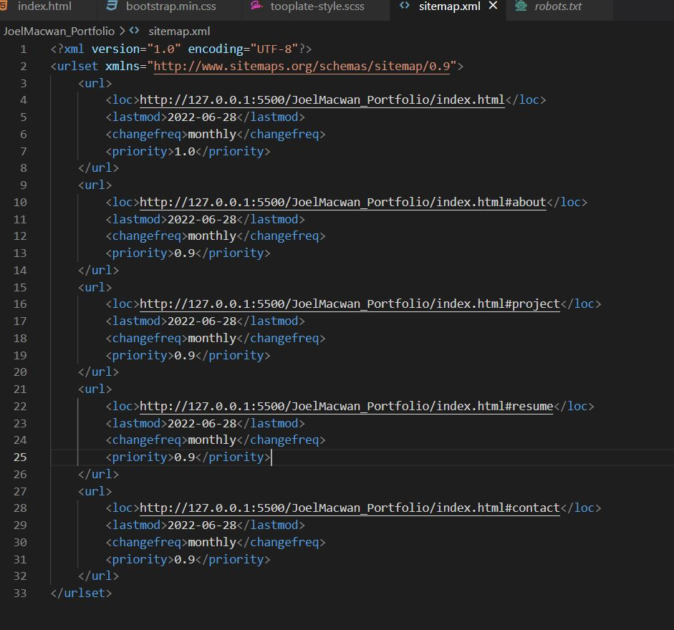

- Search for local competitors, try to find individual people, not a company.
Answer:
- Claudia ten Hoope - https://www.claudiatenhoope.com/
- H.Jansma - https://harrisonjansma.com/
- Naledi Hollbruegge - https://naledi.co.uk/
- tdhopper - https://tdhopper.com/
- Ger Inberg - https://gerinberg.com/

- Use tools like openlinkprofiler to find the backlinks for your competitors.
Answer:
- https://www.itread01.com/eeqyy.html
- https://careerfoundry.com/en/blog/data-analytics/data-analytics-portfolio-examples/
- https://careerfoundry.com/en/blog/data-analytics/data-analyst-portfolio/
- https://www.worldfullofdata.com/code-visualize-correlation-matrix-r/
- https://boulevardbatel.com.br/aitmo/data-science-portfolio-website-template
- https://www.kdnuggets.com/2018/09/dropout-convolutional-networks.html
- https://careerfoundry.com/en/blog/data-analytics/data-analyst-portfolio/
- https://dqlab.id/siap-berkarir-menjadi-data-analyst-ini-4-media-untuk-portofolio-data
- https://www.projectpro.io/article/how-to-build-a-data-analyst-portfolio/529
- https://githubhelp.com/ginberg?from=https://githubpk.com
- https://githubhelp.com/ginberg

- Create a brief plan (about 650 words) describing what your SEO strategy would be to improve your ranking for your chosen keywords and how you would deal with your competition. Note: You don’t have to implement the strategy.
Answer:
My SEO strategy to improve my websites ranking would be as follows:
- Firstly my objective is to raise my sites overall rating in the major search engines so that more people will like to visit the website.
- Using many advance technology and tools I will increase the users revenue and engagement of the website.
- As I have chosen many good keywords in my website the search index of the site will automatically be increased , and it will be viewed more by the visitors.
- I have made efficient use of back links and keywords will result in spike in traffic to my site.
- I'll try to grow my website organically, but advertising is also a good option to grow traffic to the website.
- I have made use of as many SEO principles as possible. which will be really challenging to my competitors.
- The way I would deal with my competition is by showing the best version of my website.
- I have made use of Heading tags, made proper heading hierarchy as per SEO, implemented Page title, added alternate text to the images.
- I have made efficient use of external links and internal links in my website.
- I have made my website responsive, it can be accessed through Desktop as well as mobile.
- The site loading speed of my website is very minimal, I have made use of HTML5, CSS, JAVASCRIPT, SASS, Bootstrap.
- I have used various keywords such as head keywords, Body Keywords and Long tail keywords. My website also contains Google trending keywords.
- All the above strategies have been used and implemented in my website to deal with competition.
- I have also created a basic structure and sitemap of my website which is added in question number2.
- I am also adding screenshot of my code of the website.
