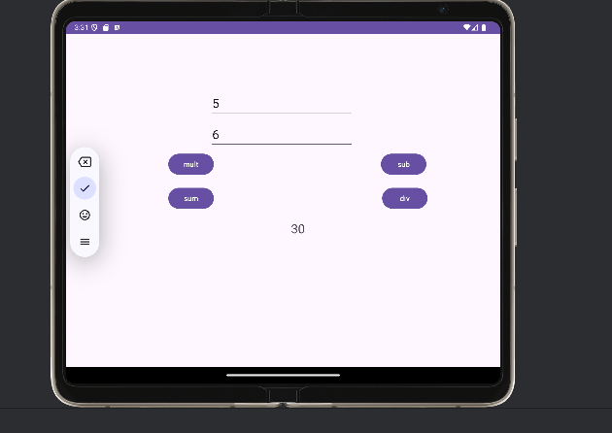

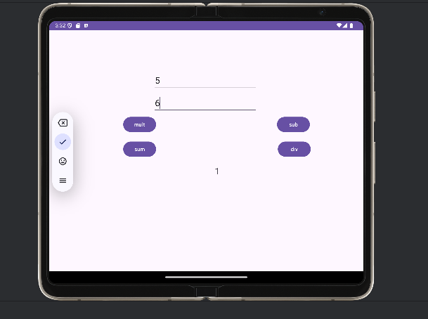

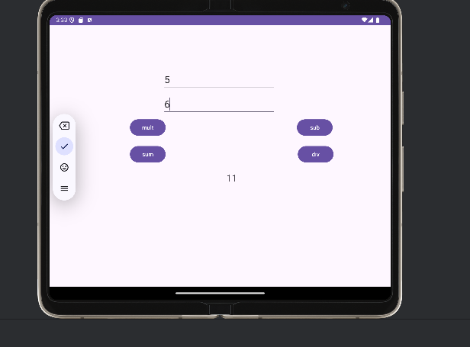

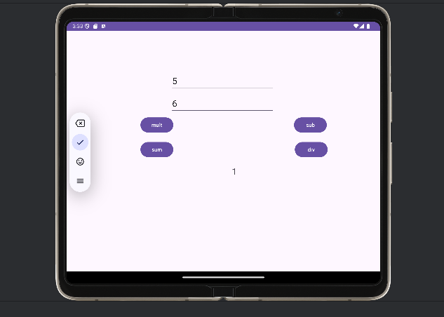

package com.example.calculator;  
import androidx.appcompat.app.AppCompatActivity;  
import android.os.Bundle;  
import android.view.View;  
import android.widget.EditText;  
import android.widget.TextView;  
  
public class MainActivity extends AppCompatActivity {  
  
 EditText e1,e2;  
 TextView t1;  
 int n1,n2;  
  
 protected void onCreate(Bundle savedInstanceState) {  
 super.onCreate(savedInstanceState);  
 setContentView(R.layout.*activity_main*);  
 }  
 public boolean getNumbers() {  
 e1 = (EditText) findViewById(R.id.*num1*);  
 e2 = (EditText) findViewById(R.id.*num2*);  
 t1 = (TextView) findViewById(R.id.*res*);  
 String s1 = e1.getText().toString();  
 String s2 = e2.getText().toString();  
 n1 = Integer.*parseInt*(s1);  
 n2 = Integer.*parseInt*(s2);  
 return true;  
 }  
 public void dosub(View v){  
 if (getNumbers()) {  
 int sum = n1-n2;  
 t1.setText((Integer.*toString*(sum)));  
 }  
 }  
 public void dosum(View v){  
 if (getNumbers()) {  
 int sum = n1+n2;  
 t1.setText((Integer.*toString*(sum)));  
 }  
 }  
 public void domult(View v){  
 if (getNumbers()) {  
 int sum = n1*n2;  
 t1.setText((Integer.*toString*(sum)));  
 }  
 }  
 public void dodiv(View v){  
 if (getNumbers()) {  
 int sum = n1/n2;  
 t1.setText((Integer.*toString*(sum)));  
 }  
 }  
  
}

**xml code**

<?xml version="1.0" encoding="utf-8"?>  
<androidx.constraintlayout.widget.ConstraintLayout xmlns:android="http://schemas.android.com/apk/res/android"  
 xmlns:app="http://schemas.android.com/apk/res-auto"  
 xmlns:tools="http://schemas.android.com/tools"  
 android:id="@+id/main"  
 android:layout_width="match_parent"  
 android:layout_height="match_parent"  
 tools:context=".MainActivity">  
  
  
 <EditText  
 android:id="@+id/num1"  
 android:layout_width="wrap_content"  
 android:layout_height="wrap_content"  
 android:layout_marginTop="50dp"  
 android:ems="10"  
 android:hint="Enter second number"  
 android:inputType="text"  
 android:textSize="24sp"  
 app:layout_constraintBottom_toBottomOf="parent"  
 app:layout_constraintEnd_toEndOf="parent"  
 app:layout_constraintHorizontal_bias="0.496"  
 app:layout_constraintStart_toStartOf="parent"  
 app:layout_constraintTop_toTopOf="parent"  
 app:layout_constraintVertical_bias="0.219" />  
  
 <EditText  
 android:id="@+id/num2"  
 android:layout_width="wrap_content"  
 android:layout_height="wrap_content"  
 android:layout_marginTop="40dp"  
 android:ems="10"  
 android:hint="Enter first number"  
 android:inputType="text"  
 android:textSize="24sp"  
 app:layout_constraintBottom_toBottomOf="parent"  
 app:layout_constraintEnd_toEndOf="parent"  
 app:layout_constraintHorizontal_bias="0.496"  
 app:layout_constraintStart_toStartOf="parent"  
 app:layout_constraintTop_toTopOf="parent"  
 app:layout_constraintVertical_bias="0.123" />  
  
 <Button  
 android:id="@+id/button"  
 android:layout_width="wrap_content"  
 android:layout_height="wrap_content"  
 android:layout_marginTop="50dp"  
 android:onClick="dosum"  
 android:text="sum"  
 app:layout_constraintBottom_toBottomOf="parent"  
 app:layout_constraintEnd_toEndOf="parent"  
 app:layout_constraintHorizontal_bias="0.263"  
 app:layout_constraintStart_toStartOf="parent"  
 app:layout_constraintTop_toTopOf="parent"  
 app:layout_constraintVertical_bias="0.447" />  
  
 <Button  
 android:id="@+id/button2"  
 android:layout_width="wrap_content"  
 android:layout_height="wrap_content"  
 android:layout_marginStart="30dp"  
 android:onClick="dosub"  
 android:text="sub"  
 app:layout_constraintBottom_toBottomOf="parent"  
 app:layout_constraintEnd_toEndOf="parent"  
 app:layout_constraintHorizontal_bias="0.802"  
 app:layout_constraintStart_toStartOf="parent"  
 app:layout_constraintTop_toTopOf="parent"  
 app:layout_constraintVertical_bias="0.383" />  
  
 <Button  
 android:id="@+id/button3"  
 android:layout_width="wrap_content"  
 android:layout_height="wrap_content"  
 android:onClick="domult"  
 android:text="mult"  
 app:layout_constraintBottom_toBottomOf="parent"  
 app:layout_constraintEnd_toEndOf="parent"  
 app:layout_constraintHorizontal_bias="0.263"  
 app:layout_constraintStart_toStartOf="parent"  
 app:layout_constraintTop_toTopOf="parent"  
 app:layout_constraintVertical_bias="0.383" />  
  
 <Button  
 android:id="@+id/button4"  
 android:layout_width="wrap_content"  
 android:layout_height="wrap_content"  
 android:layout_marginStart="30dp"  
 android:layout_marginTop="50dp"  
 android:onClick="dodiv"  
 android:text="div"  
 app:layout_constraintBottom_toBottomOf="parent"  
 app:layout_constraintEnd_toEndOf="parent"  
 app:layout_constraintHorizontal_bias="0.805"  
 app:layout_constraintStart_toStartOf="parent"  
 app:layout_constraintTop_toTopOf="parent"  
 app:layout_constraintVertical_bias="0.447" />  
  
 <TextView  
 android:id="@+id/res"  
 android:layout_width="wrap_content"  
 android:layout_height="wrap_content"  
 android:text="result"  
 android:textSize="24sp"  
 app:layout_constraintBottom_toBottomOf="parent"  
 app:layout_constraintEnd_toEndOf="parent"  
 app:layout_constraintHorizontal_bias="0.535"  
 app:layout_constraintStart_toStartOf="parent"  
 app:layout_constraintTop_toTopOf="parent"  
 app:layout_constraintVertical_bias="0.589" />