Clinical Referral Safety Automation
The Plain-English Guide
Understand it · Explain it in an interview · Rebuild it yourself
⚠ Portfolio simulation — 100% synthetic data. Not a live NHS system.
⏱ The 30-second pitch (memorise this)
A software robot safely handles NHS GP referral letters. It reads each letter, uses AI to pull out the patient and referral details, checks the patient against a real hospital records system, and applies clinical-safety rules.
If the case is clean and low-risk, it creates the record automatically. If anything looks risky — wrong patient, urgent/cancer, safeguarding, incomplete — it hands the case to a human.
Every single action is logged. The AI assists; rules and humans make every safety decision.
How to use this doc: each section is short and has a picture. Read it top to bottom once. The last section is your interview cheat sheet.

1. The problem (why anyone cares)
- The NHS receives a huge volume of GP referral letters every day.
- Processing them by hand is slow and easy to get wrong.
- Three mistakes are genuinely dangerous:
- • Wrong patient — the referral is attached to the wrong person.
- • Duplicate — the same referral is entered twice.
- • Delayed urgent — a 2-week-wait suspected-cancer referral sits in a pile.
So the idea is simple: automate the safe, boring part — and protect the risky part with humans.
🧠 The analogy that makes it click
Think of a careful hospital post-room clerk. Easy, obvious letters they file themselves. Anything confusing, urgent, or sensitive, they put on the manager's desk instead of guessing.
This robot is that clerk — and it writes down everything it does.

2. What the robot actually does (one letter's journey)
Every referral goes through the same six steps:
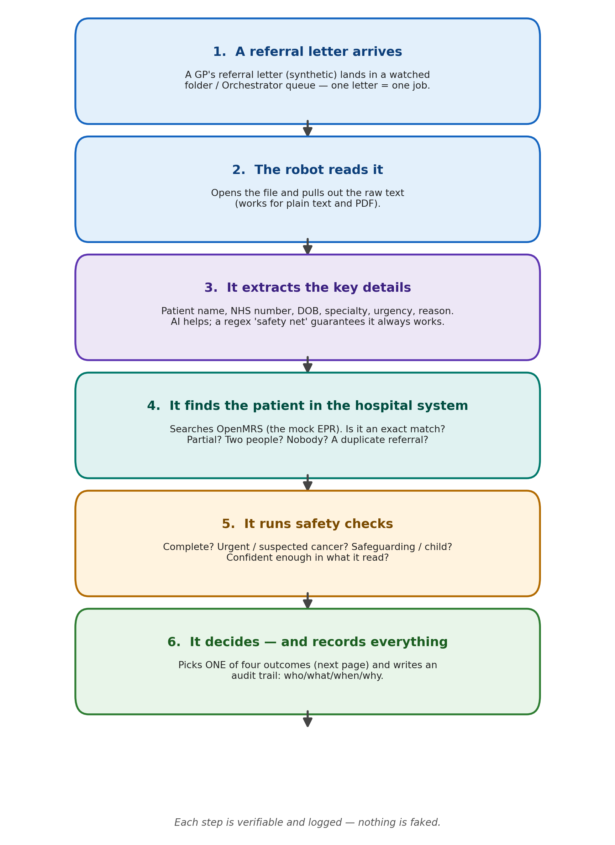
The journey of a single referral, start to finish.

3. The four possible outcomes
At the end, the robot picks exactly ONE of four outcomes. This is the heart of the project:
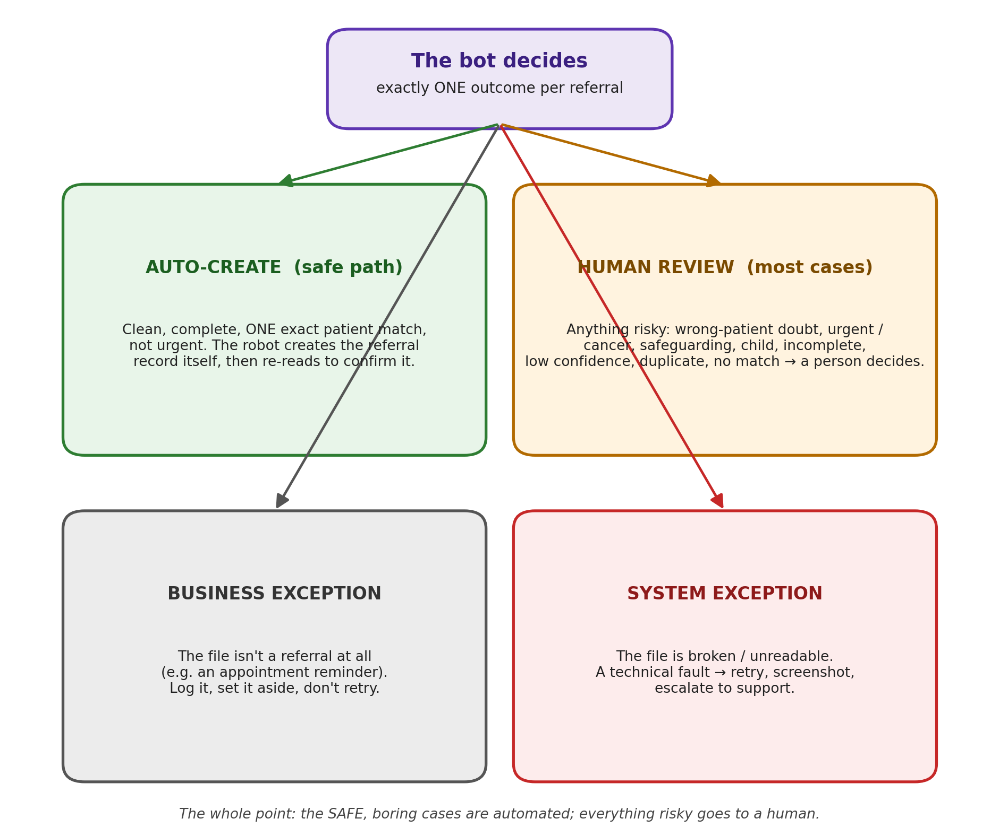
Safe + boring = automated. Anything risky = a human decides.

4. The golden safety rule (your #1 interview point)
🛡 The AI never makes the final decision
The AI only suggests what it read from the letter. Plain, predictable rules and human reviewers own every safety-sensitive outcome.
Anything uncertain, urgent, incomplete, duplicate, or patient-match-risk is escalated to a human.
In a clinical setting, that restraint is the selling point, not a weakness. Say exactly that in the interview.

5. How it's built (the moving parts)
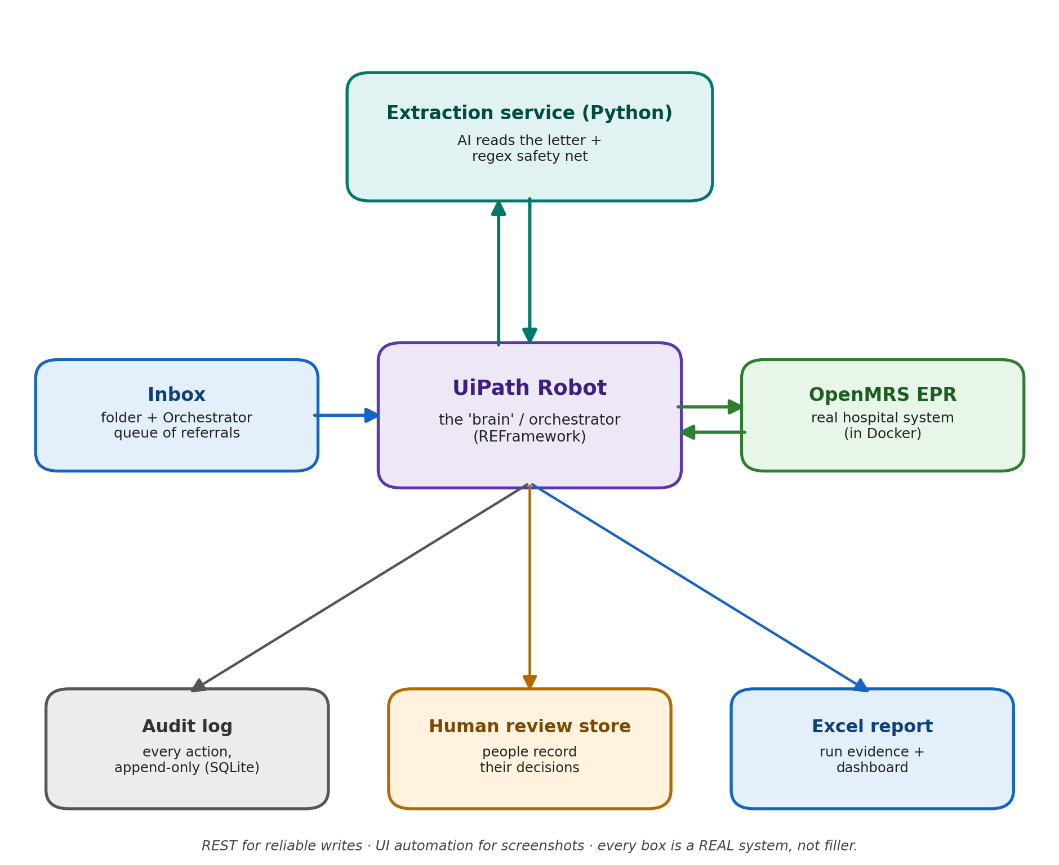
The robot is the brain in the middle; everything around it is a real system.

The tech stack — in plain words
Piece | What it is, and why it's here
UiPath REFramework | The robot 'engine'. A standard template that processes one item at a time, with retries and proper error handling. It's the industry-standard NHS automation tool.
Orchestrator queue | A reliable to-do list of referrals the robot works through, one by one.
OpenMRS (in Docker) | A REAL open-source hospital records system (EPR) running on the laptop. Proves the automation works against a genuine clinical system — not a hand-faked one.
Extraction service (Python) | A small program that reads the letter and turns messy text into clean, structured data.
LLM (the 'AI', optional) | Reads free-text and suggests the field values. Assists only — it never decides.
Regex fallback | Pattern-matching rules. The dependable safety net used when the AI is off or fails. Fully reproducible.
JSON schema validation | An automatic check that the extracted data has the right shape before anything is trusted.
SQLite audit log | A simple database storing every action (who/what/when/why). Your proof and accountability.
Human review store | Where flagged cases wait for a person to decide. The 'human-in-the-loop'.
Excel / dashboard | Reports of what happened in a run — the evidence for your portfolio.

6. Progress so far
The project is built in 14 phases (0–13). No phase moves on until it passes its own test. Five are done:
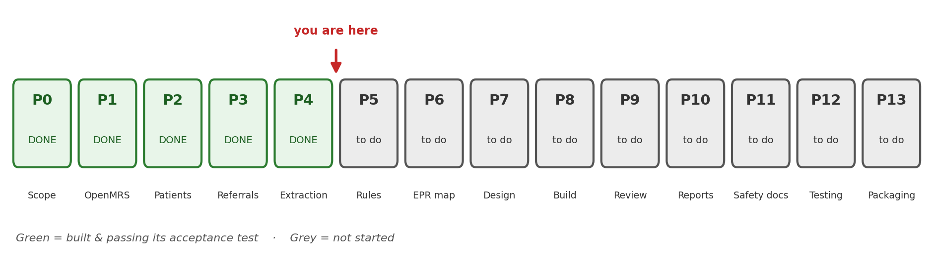
Phase (done) | What it delivered, in one line
P0 · Scope & architecture | Decided what it is, drew the design, and set the safety boundary (AI assists, never decides).
P1 · OpenMRS setup | Got a real hospital records system running in Docker with 50 demo patients.
P2 · Synthetic patients | Added 32 fake patients with valid-looking NHS numbers and match scenarios (exact / partial / duplicate / none).
P3 · Referrals + answer keys | Wrote 15 fake referral letters covering every scenario, each with an 'expected outcome' answer key.
P4 · Extraction service | Built the reader (AI + regex + validation). Result: 15/15 letters extracted correctly vs the answer keys.
Next up — Phase 5: the rules & safety decision engine (match the patient, apply the safety rules, output a decision with a reason code for every case).

7. Rebuild it yourself (the recipe)
If you had to recreate this from scratch, here is the order — each step is one phase:
- Write the scope. One paragraph on what it does + the hard rules (synthetic data only; AI never decides). Draw a simple architecture diagram.
- Stand up OpenMRS with Docker. One compose file. Log in and confirm patient search + the REST API work.
- Seed ~30 synthetic patients with a small Python script over the REST API. Use 999-range NHS numbers with a valid check digit. Build match scenarios (exact / partial / duplicate / none).
- Write ~15 referral letters (text/PDF) covering every scenario. For each, write an 'expected outcome' JSON answer key, kept in a SEPARATE folder so the robot never ingests it.
- Build the extraction service. Read file → extract fields (regex first, AI optional) → validate against a JSON schema → score completeness + confidence. Compare to the answer keys until all pass.
- Build the rules engine (Phase 5). Match the patient + apply safety rules → produce the decision + a reason code for every case.
- Finish the chain. Map to OpenMRS → write the REFramework spec → build it in UiPath → add human review → reporting → clinical-safety docs → testing → packaging.
💡 The one trick that makes it easy
Build an answer key (oracle) for every test case FIRST. Then a small script checks the robot's output against the answer keys automatically. You always know if you've broken something.

8. Interview cheat sheet

Your STAR story
Situation: NHS referral intake is high-volume, manual, and safety-critical — wrong-patient, duplicate, and delayed-urgent errors cause real harm.
Task: Automate the safe parts of intake while guaranteeing every risky case reaches a human, with full auditability.
Action: Built an end-to-end RPA solution — UiPath REFramework + Orchestrator queues, a real EPR (OpenMRS), AI-assisted extraction with a deterministic regex guardrail and schema validation, patient matching, clinical-safety rules, a human review store, audit logging, and clinical-safety governance docs.
Result: A defensible, auditable pipeline where AI only assists and rules/humans own every decision. Each scenario passes an automated acceptance test; built to DCB0129/DCB0160-inspired standards.

Questions you'll get — and crisp answers
Q. Isn't it dangerous to let AI handle medical referrals?
A. The AI never decides — it only suggests what it read. Deterministic rules and human reviewers own every safety outcome, and anything uncertain is escalated. That's the whole design.
Q. Why use OpenMRS instead of a mock?
A. It's a real EPR with a REST/FHIR API. It proves the automation works against a genuine clinical system, not hand-faked data.
Q. What is 'REFramework'?
A. UiPath's standard template for reliable, transactional automation — one item at a time, with retries and a clear split between business and system exceptions.
Q. How do you tell a broken file from a wrong document?
A. Two different exceptions. An unreadable file is a System Exception (technical → retry/escalate). A readable-but-wrong document, like an appointment reminder, is a Business Exception (won't fix on retry → log + set aside).
Q. How do you know it actually works?
A. Every test case has an answer key. An automated harness compares the robot's output to the expected outcome. Phase 4 result: 15 out of 15 pass.

Power phrases (drop these in)
- “AI-assisted, deterministically guarded.”
- “Rules and humans own safety; the model only proposes.”
- “Real EPR, real REST writes, real audit rows — no Log Message filler.”
- “Idempotent and safely re-runnable — no duplicate records on a rerun.”
- “Every decision carries a reason code and an audit trail.”

Jargon decoder
Term | Plain meaning
RPA | Robotic Process Automation — software robots doing rule-based computer tasks.
EPR / EMR | Electronic Patient/Medical Record — the hospital's records system.
OpenMRS | A free, real, open-source EPR used here as the stand-in hospital system.
LLM | Large Language Model — the 'AI' that reads free text.
Regex | Pattern-matching rules for pulling fixed bits of text (like an NHS number).
JSON schema | A definition of the exact shape data must have, used to validate it.
Idempotent | Running it twice does no harm — no duplicate records.
2WW | Two-Week Wait — an urgent suspected-cancer referral pathway.
Safeguarding | Protecting a child or vulnerable person — always handled by a human.
Human-in-the-loop | A person makes the final call on flagged cases.
DCB0129 / DCB0160 | NHS clinical-safety standards this project is modelled on (inspired by, not certified).
Docker | A way to run software (like OpenMRS) in a self-contained box on any machine.
You now know enough to explain this project end-to-end — and to rebuild it.

