ECG Phone Bridge — UI layout map (β.40)
Printable wireframes of what ships today. Mark up freely; this is not a redesign proposal.
Views: one main scroll screen. Menu toggles Patient ↔ Tech. Overlays are dialogs.

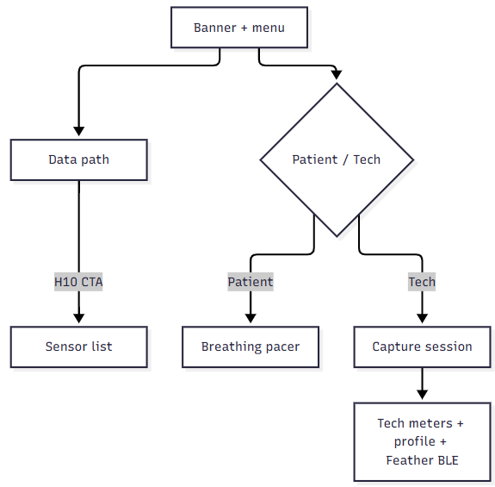

1. Screen stack (top → bottom)
┌─────────────────────────────────────────┐
│ RED BANNER │
│ "ECG Phone Bridge" [☰] │
│ ┌─────────────┐ │
│ │ Conn settings│ │
│ │ Patient/Tech │ │
│ │ About │ │
│ └─────────────┘ │
├─────────────────────────────────────────┤
│ [opt] Update banner: Get update | Later│
├─────────────────────────────────────────┤
│ [opt] Wi‑Fi client off (hotspot note) │
├─────────────────────────────────────────┤
│ │
│ ▼ SCROLL BODY ▼ │
│ │
│ [opt] "On your PC… IP:port" │
│ [opt] Background keep-alive note │
│ │
│ ┌─ DATA PATH (BridgeFlowDiagram) ────┐ │
│ │ [ heart glyph ] │ │
│ │ │ │ │
│ │ [ TAP TO FIND SENSORS / H10 ] │ │ ← Polar CTA
│ │ "Polar H10 button: Bluetooth" │ │
│ │ │ │ │
│ │ [ this phone ] │ │
│ │ │ │ │
│ │ [ PC / host ] │ │ ← user + client_app
│ └────────────────────────────────────┘ │
│ │
│ [if Polar linked] │
│ Connected to: name · contact · dBm │
│ [ Disconnect sensor ] │
│ Phone IP / hotspot line │
│ │
│ ╔═══════════════════════════════════╗ │
│ ║ TECH VIEW ONLY ║ │
│ ║ · Capture session panel ║ │
│ ║ · Tech meters (+ profile/BLE) ║ │
│ ║ · (no breathing pacer) ║ │
│ ╚═══════════════════════════════════╝ │
│ │
│ ╔═══════════════════════════════════╗ │
│ ║ PATIENT VIEW ONLY ║ │
│ ║ · Breathing pacer ║ │
│ ║ · (no Capture / Tech meters) ║ │
│ ╚═══════════════════════════════════╝ │
│ │
├─────────────────────────────────────────┤
│ Footer: version · "J. Kobe Software" │
└─────────────────────────────────────────┘

2. Patient view (scroll body detail)
┌─────────────────────────────────────────┐
│ [hints + Data path diagram] │
│ [optional Polar connected block] │
│ │
│ ┌─ BREATHING PACER ──────────────────┐ │
│ │ title / short help │ │
│ │ presets: 5.5/5.5 5/5 4/6 4/4 │ │
│ │ │ │
│ │ ( expanding circle ) │ │
│ │ Inhale / Exhale │ │
│ │ [n] │ │
│ │ │ │
│ │ [ Start / Stop pacer ] │ │
│ └────────────────────────────────────┘ │
└─────────────────────────────────────────┘
Patient can: find Polar (diagram button), disconnect Polar, pace breath, open menu (settings / Tech / About).
Patient cannot: Start/Stop capture, Feather connect, edit coeffs, see Tech meters.

3. Tech view (scroll body detail)
┌─────────────────────────────────────────┐
│ [hints + Data path diagram] │
│ [optional Polar connected block] │
│ │
│ ┌─ CAPTURE SESSION ──────────────────┐ │
│ │ Stream ○ Record ○ │ │
│ │ Idle|Running · kind · session_id │ │
│ │ IBIs · RMSSD │ │
│ │ [hint if no source] │ │
│ │ [ Start ] [ Stop ] │ │
│ └────────────────────────────────────┘ │
│ │
│ ┌─ TECH METERS ──────────────────────┐ │
│ │ Mode / Settling / Elapsed │ │
│ │ Contact · IBIs · bpm · dBm │ │
│ │ Bridge RMSSD · Accepted beats │ │
│ │ Quality flags [i] + chips │ │
│ │ │ │
│ │ [ Simulate Feather IBI + ECG ] │ │
│ │ │ │
│ │ ── Patient profile ── │ │
│ │ Active: name (id) │ │
│ │ [Change] [Add patient] [Delete] │ │
│ │ coeff fields (editable keys) │ │
│ │ [ Save profile / Save+push ] * │ │
│ │ │ │
│ │ ── Feather BLE test ── │ │
│ │ phase — detail · Last IBI │ │
│ │ [Connect Feather] │ │
│ │ or [Start][Stop][Disconnect] │ │
│ │ ECG strip label │ │
│ │ ┌─────────────────────────────┐ │ │
│ │ │ live / sim ECG strip │ │ │
│ │ └─────────────────────────────┘ │ │
│ └────────────────────────────────────┘ │
└─────────────────────────────────────────┘
* gray until coeffs dirty

4. Overlays (dialogs)
☰ menu
├─ Connection settings ──► Dialog
│ Bridge port [____] [Select ▾]
│ IP · subnet (read-only)
│ Keep bridge active in background [switch]
│ [Cancel] [Save]*
│ └─ confirm: Change port? / Disconnect PC?
│
├─ Switch Patient ↔ Tech
└─ About ──► Dialog (date, version, Close)
Sensor list (from Data path H10 button)
Scanning… / radio list / Connecting…
[Cancel] [Connect]
Tech-only nested dialogs
├─ Profile picker (Change)
├─ Add patient (name → OK)
├─ Delete confirm
└─ Quality flag help [i]

5. View / overlay flow (Mermaid)
See flow chart at top

6. Markup scratch (print & scribble)
Known parked / cleanup themes from handoff (not commitments):
Area | Today | Notes / ideas
Polar CTA | Big capsule in Data path
Feather CTA | Buried in Tech meters | Unify with Polar?
Capture Start/Stop | Tech only | OK for patient?
Breathing pacer | Patient only
Profile + coeffs | Long Tech scroll | Collapse / Tuner-only?
ECG strip | Always under Feather BLE
Two connect stories | H10 vs Feather vs Sim

Generated from Compose layout as of v1.0.0-beta.40. Update when chrome changes.

