INTERFACES IN JAVA
Case study: Start the class with this case study
Consider a system where both employee and invoices require payment processing. Design and implement a java system to implement the payment processing. [Note:The problem statement is more abstract, it needs analysis: How to design interface The main advantage of interfaces is implementing the polymorphism across unrelated classes. Here the employee and invoice are unrelated classes. By designing an interface Payable, we can have the polymorphic behaviour across unrelated classes]
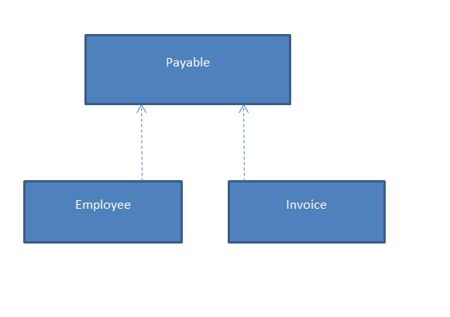

//Java Code
interface Payable {
double calculatePayment();
}
class Employee implements Payable {
String name;
double grossSalary;
double basicSal;
double da;
double hra;

Employee(String name, double basicSal, double da,double hra) {
this.name = name;
this.basicSal = basicSal;
this.da=da;
this.hra=hra;
}
//implementing the interface method
public double calculatePayment() {
grossSalary=basicSal+basicSal*(da/100)+basicSal*(hra/100);
return grossSalary;
}
void printEmployee(){
System.out.println(name+":"+calculatePayment());
}

}
class Invoice implements Payable {
String item;
int quantity;
double pricePerItem;

Invoice(String item, int quantity, double pricePerItem) {
this.item = item;
this.quantity = quantity;
this.pricePerItem = pricePerItem;
}
//implementing the interface
public double calculatePayment() {
return quantity * pricePerItem;
}
void printInvoice(){
System.out.println(item+":"+calculatePayment());
}
}
public class PayableTest {
public static void main(String[] args) {

Payable p1 = new Employee("Ram", 50000,85,20);
Payable p2 = new Invoice("Laptop", 2, 45000);

System.out.println("Employee Payment: " + p1.calculatePayment());
System.out.println("Invoice Payment: " + p2.calculatePayment());
((Employee)p1).printEmployee(); //type casting
((Invoice)p2).printInvoice(); //type casting
}
}

General syntax & Basic Interface example

/*
access interface name{
return-type method-name1(parameter-list);
return-type method-name2(parameter-list);
type final-varname1 = value;
type final-varname2 = value;
//….
return-type method-nameN(parameter-list);
type final-varnameN = value;
//JDK 8.0 onwards
default type methodName1([param-list]){
//code
}
//……
default type methodNamen([param-list]){
//code
}
static type methodName([param-list]){
//code : any number of static methods can be created
}
private type methodName([param-list]){
//code: helper method
}
//note: [] in method parameter says: it is optional
}
Note: all methods are abstract in interface
All interface variables are final and static

*/
interface Callback{
//by deafault the methods are public and abstract
//The abstract key word is optional with method declaration
void callback(int param);
}
class Client implements Callback{
//when implementing you need to declare it as public
public void callback(int param){
System.out.println("callback called with:"+param);
}
}
class InterfaceDemo{
public static void main(String[] args){
Client client = new Client();
client.callback(10);
}
}

//creating interface
interface Callback1{
//by deafault the methods are public and abstract
//The abstract key word is optional with method declaration
void callback(int param);
}
class Client1 implements Callback1{
public void callback(int p){
System.out.println("call back called with:"+p);
}
//classes are free to define their own methods
void nonIfaceMeth(){
System.out.println("Non interfacemethod" );
}
}
class InterfaceDemo1{
public static void main(String[] args){
Client1 client1=new Client1();
client1.callback(10);
//The interface reference variable can be assigned
//the object of the class which implements that interface
Callback1 callback1=client1;
callback1.callback(20);
//calling non interface method
//callback1.nonIfaceMeth(); //Error cannot find symbol
}
}

interface Callback2{

void callback(int param);
}
/*class Incomplete implements Callback2{
int a;
int b;
Incomplete(){
a=0; b=0;
}
Incomplete(int a, int b){
this.a=a;
this.b=b;
}
void show(){System.out.println(a+"-"+b);}
}*/
abstract class Incomplete implements Callback2{
int a;
int b;
Incomplete(){
a=0; b=0;
}
Incomplete(int a, int b){
this.a=a;
this.b=b;
}
void show(){System.out.println(a+"-"+b);}
}
class InclompleteDemo{
public static void main(String[] args){
Incomplete incomplete=new Incomplete(10,20);
incomplete.show();
} }
Basic Definitions: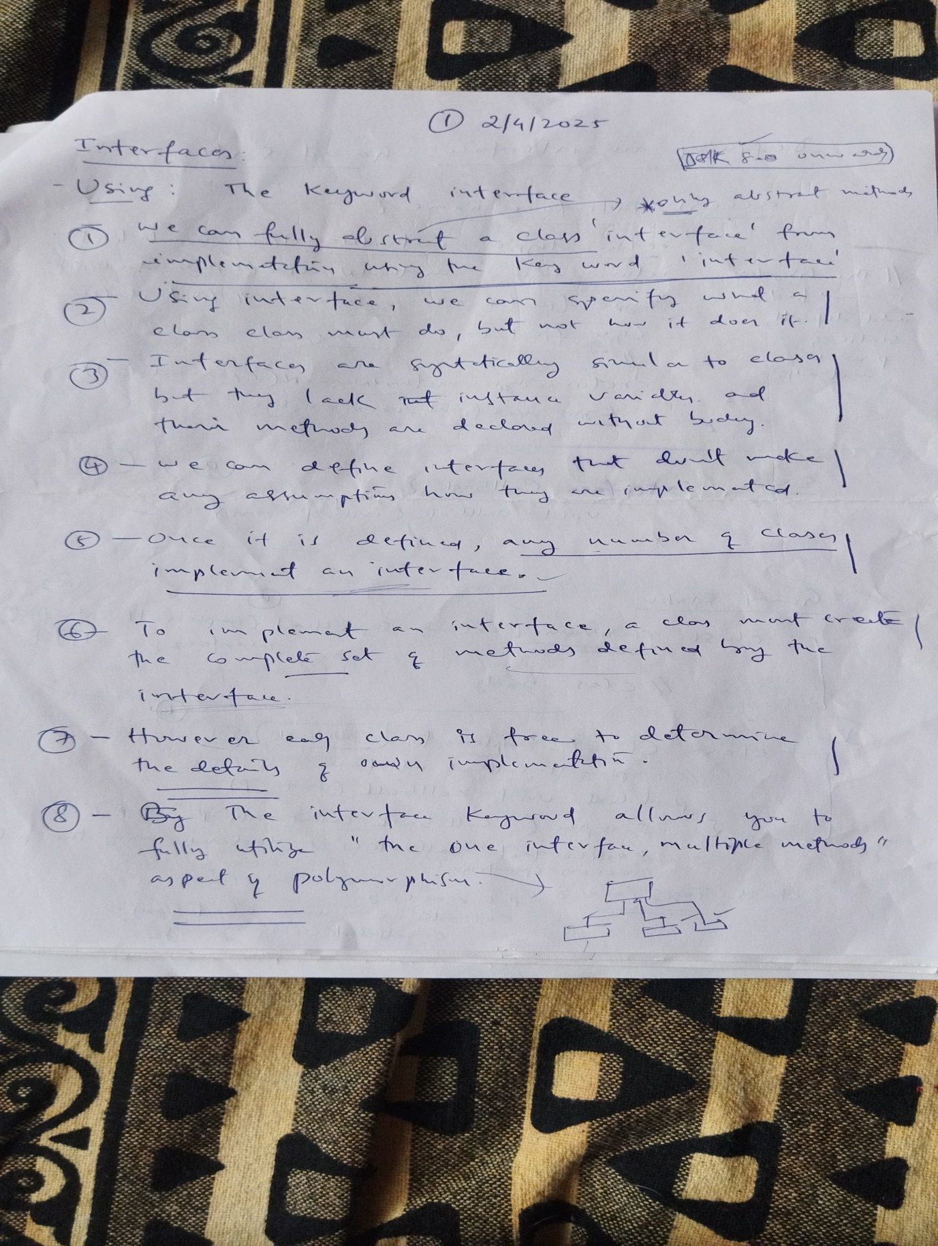

Inheritance in interface
/*
Interfacecan be extended: inheritance in interfaces

*/
//Base interfaces
interface Iface{
void printData(String data);

}
//Base interface
interface Iface1{
void square(int x);
}
//Iface2 is extending Iface and Iface1
interface Iface2 extends Iface, Iface1{
void compute(int a);
}
// class A
class A{
int a;

}
// the class B extends A and implements Iface2
//The class B has to give definition for all the methods of interface hierarchy
//
class B extends A implements Iface2{
public void printData(String data){
System.out.println(data);
}
public void square(int x){
System.out.println("Square of:"+(x*x));
}
public void compute(int a){
int b=100;
a=a+b;
System.out.println("a="+a);
}

}
// The class C implements the interface Iface separately
class C implements Iface{
public void printData(String data){
System.out.println("Printing: "+data);
}

}
class Demo{
public static void main(String[] args){
B obj=new B();

obj.a=2;
obj.printData("Kiran");
obj.square(obj.a);
obj.compute(obj.a);
//1 interface refernece variable iFace is assigned the object of the class
//which implemets that (Iface) interface
Iface iFace=obj;
iFace.printData("data");
//2 interface refernece variable iFace is assigned the object of the class

Iface1 iFace1=obj;
iFace1.square(10);

//3 interface refernece variable iFace is assigned the object of the class

Iface2 iFace2=obj;
iFace2.printData("Find me");

}
}

Interface Example: default(JDK8.0) , static(JDK9.0) and private(JDK9.0) methods

interface Iface{
//Before jdk 8.0
void printData(String data);
//from jdk 8.0
default void square(int data){
System.out.println(data*data);
//private method called
findData();
}
//static methods can be part of an interface from jdk9.0
static void display(){
System.out.println("Displaying....");
}
// The private method can be part of interface from jdk9.0
private void findData(){
System.out.println("Finding...");
}
}
// the class A implements Iface
class A implements Iface{
//implementing the interface method
public void printData(String data){
System.out.println(data);
}
}
class Demo2{
public static void main(String[] args){
A obj=new A();
obj.printData("data");
obj.square(10);

//static method of interface
Iface.display();

}
}

Example:
/*
The system needs a simple way to print text using object-oriented concepts. An interface is used to define a method for printing a string, and a class implements this interface to provide the actual printing functionality.

The program should also show how an object can be passed as a parameter using an interface reference and how the same method can be called using both the class object and the interface reference, demonstrating basic polymorphism and code reusability.
*/

interface IFace{
void printData(String name);
}
class A implements IFace{
public void printData(String name){
System.out.println(name);
}
void display(IFace iface){
iface.printData("a");
}
}
class Demo111{
public static void main(String[] args){
A obj=new A();

obj.printData("Ram");

obj.display(obj);//passing object of class implementing interface

IFace iface=obj; //using interface variable
iface.printData("aaa");
}
}
/*
class A{
int a;
A(){a=0;}
A(int a){this.a=a;}
void printData(A obj){
System.out.println(obj.a);
}
}

class B extends A{

}
class Demo111{
public static void main(String[] args){
A obj=new A(10);

B obj1=new B();
obj1.a=100;
obj.printData(obj1); //The subclass can be passed as argument in place of
//base class reference variable
} }*/

CASE STUDY:
A banking system needs to be designed to manage different types of customer accounts with controlled financial operations. The system should support basic functionalities such as deposit and withdrawal for certain account types while restricting these operations for others. Specifically, a Savings Account must allow users to deposit, withdraw, and transfer funds, whereas a Provident Fund Account should only accept funds through authorized transfers and not permit direct deposit or withdrawal operations. The design should use interfaces to define capabilities like deposit and withdrawal, and an abstract base class to represent common account properties such as account number and balance. Additionally, the system should ensure validation of transactions (e.g., sufficient balance) and model the relationship between a customer and their associated accounts.
Class (block) diagram:
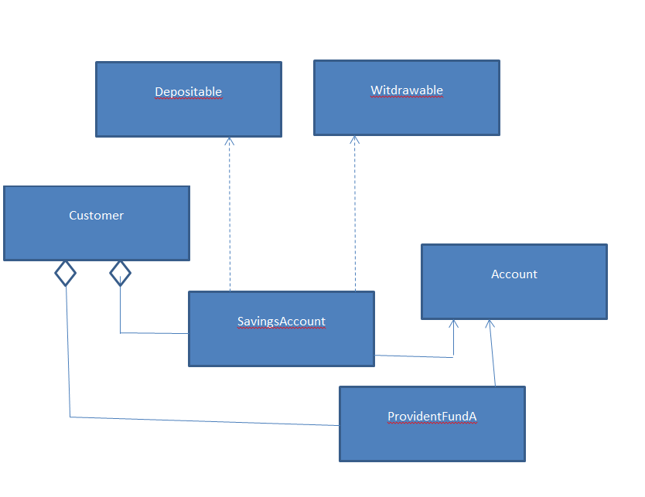

//Java code

interface Depositable {
void deposit(double amount);
}
interface Withdrawable {
void withdraw(double amount);
}
abstract class Account {
String accountNumber;
double balance;

Account(String accountNumber, double initialBalance) {
this.accountNumber = accountNumber;
this.balance = initialBalance;
}

double getBalance() {
return balance;
}

String getAccountNumber() {
return accountNumber;
}
}

class SavingsAccount extends Account implements Depositable, Withdrawable {
SavingsAccount(String accountNumber, double initialBalance) {
super(accountNumber, initialBalance);
}
public void deposit(double amount) {
if (amount > 0) {
balance += amount;
System.out.println("Deposited " + amount + " to SavingsAccount");
}
}
public void withdraw(double amount) {
if (amount > 0 && balance >= amount) {
balance -= amount;
System.out.println("Withdrew " + amount + " from SavingsAccount");
} else {
System.out.println("Insufficient balance in SavingsAccount");
}
}

void transferToPF(ProvidentFundAccount pfAccount, double amount) {
if (amount > 0 && balance >= amount) {
balance -= amount;
pfAccount.receiveTransfer(amount);
System.out.println("Transferred " + amount + " to ProvidentFundAccount");
} else {
System.out.println("Transfer failed: Insufficient balance.");
}
}
}

class ProvidentFundAccount extends Account {
ProvidentFundAccount(String accountNumber, double initialBalance) {
super(accountNumber, initialBalance);
}

// Can only receive money via transfer
void receiveTransfer(double amount) {
if (amount > 0) {
balance += amount;
}
}
}
class Customer {
String name;
SavingsAccount savingsAccount;
ProvidentFundAccount pfAccount;

Customer(String name, SavingsAccount savingsAccount, ProvidentFundAccount pfAccount) {
this.name = name;
this.savingsAccount = savingsAccount;
this.pfAccount = pfAccount;
}

SavingsAccount getSavingsAccount() {
return savingsAccount;
}

ProvidentFundAccount getPfAccount() {
return pfAccount;
}
}

class BankSimulation {
public static void main(String[] args) {
SavingsAccount savings = new SavingsAccount("SAV123", 1000);
ProvidentFundAccount pf = new ProvidentFundAccount("PF456", 500);

Customer customer = new Customer("Ram", savings, pf);

// Perform deposit to savings

customer.savingsAccount.deposit(200);
System.out.println("Savings Balance: " + customer.savingsAccount.getBalance());

// Perform withdrawal from savings
customer.savingsAccount.withdraw(150);
System.out.println("Savings Balance: " + customer.savingsAccount.getBalance());
// Attempt transfer to PF account
customer.savingsAccount.transferToPF(pf, 300);
System.out.println("Savings Balance: " + customer.savingsAccount.getBalance());
System.out.println("PF Balance: " + customer.pfAccount.getBalance());
}
}

