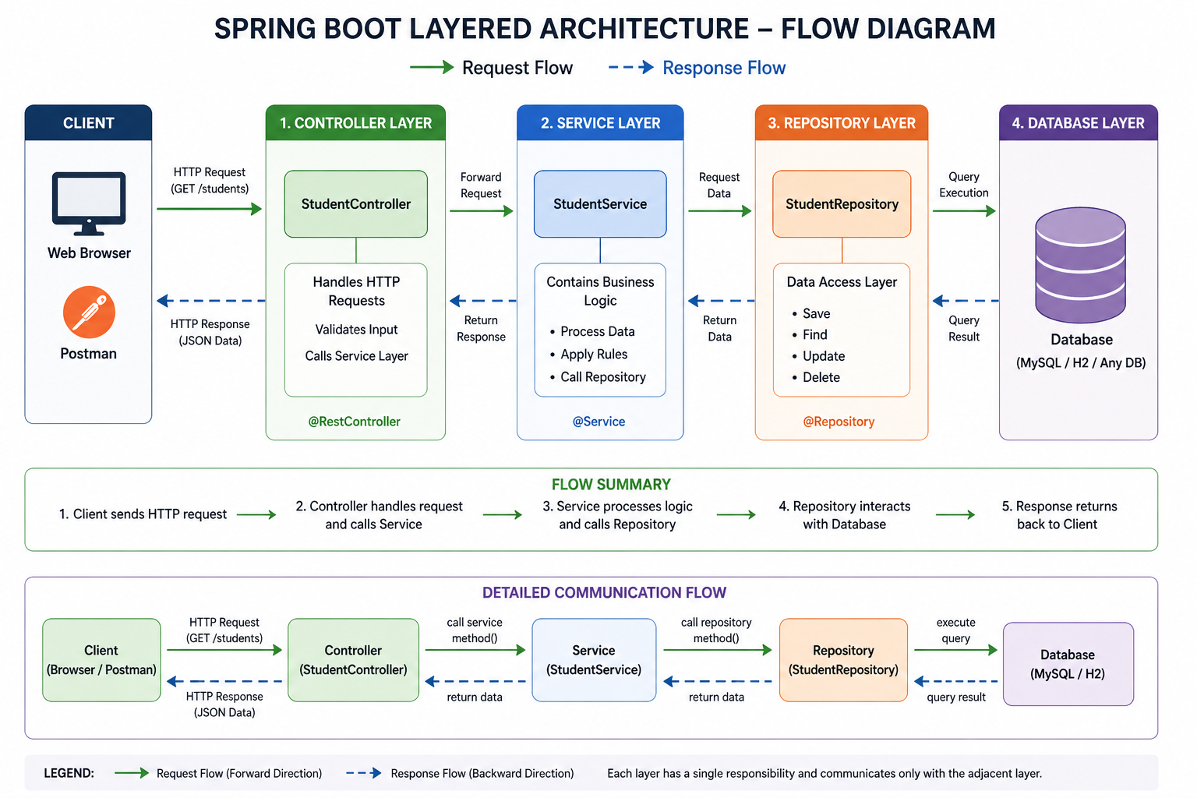

Project structure
com.example.demo
├── controller
│ └── StudentController.java
├── service
│ └── StudentService.java
├── repository
│ └── StudentRepository.java
├── model
│ └── Student.java
└── DemoApplication.java

Model Class (model/Student.java)
package com.example.demo.model;

public class Student {
private int id;
private String name;
private int age;

public Student() {}

public Student(int id, String name, int age) {
this.id = id;
this.name = name;
this.age = age;
}

public int getId() { return id; }
public void setId(int id) { this.id = id; }

public String getName() { return name; }
public void setName(String name) { this.name = name; }

public int getAge() { return age; }
public void setAge(int age) { this.age = age; }
}

2. Repository Layer (repository/StudentRepository.java)

package com.example.demo.repository;

import com.example.demo.model.Student;
import org.springframework.stereotype.Repository;

import java.util.*;

@Repository
public class StudentRepository {

private List<Student> students = new ArrayList<>();

public List<Student> findAll() {
return students;
}

public Optional<Student> findById(int id) {
return students.stream()
.filter(s -> s.getId() == id)
.findFirst();
}

public void save(Student student) {
students.add(student);
}

public void deleteById(int id) {
students.removeIf(s -> s.getId() == id);
}
}

3. Service Layer (service/StudentService.java)
Contains business logic

package com.example.demo.service;

import com.example.demo.model.Student;
import com.example.demo.repository.StudentRepository;
import org.springframework.beans.factory.annotation.Autowired;
import org.springframework.stereotype.Service;

import java.util.*;

@Service
public class StudentService {

@Autowired
private StudentRepository repository;

// GET all
public List<Student> getAllStudents() {
return repository.findAll();
}

// GET by ID
public Student getStudentById(int id) {
return repository.findById(id).orElse(null);
}

// POST
public String addStudent(Student student) {
repository.save(student);
return "Student added successfully";
}

// PUT
public String updateStudent(int id, Student student) {
Optional<Student> existing = repository.findById(id);

if (existing.isPresent()) {
Student s = existing.get();
s.setName(student.getName());
s.setAge(student.getAge());
return "Student updated successfully";
}
return "Student not found";
}

// PATCH
public String patchStudent(int id, Map<String, Object> updates) {
Optional<Student> existing = repository.findById(id);

if (existing.isPresent()) {
Student s = existing.get();

if (updates.containsKey("name")) {
s.setName((String) updates.get("name"));
}

if (updates.containsKey("age")) {
s.setAge((Integer) updates.get("age"));
}

return "Student partially updated";
}
return "Student not found";
}

// DELETE
public String deleteStudent(int id) {
Optional<Student> existing = repository.findById(id);

if (existing.isPresent()) {
repository.deleteById(id);
return "Student deleted successfully";
}
return "Student not found";
}
}

4. Controller Layer (controller/StudentController.java)

package com.example.demo.controller;

import com.example.demo.model.Student;
import com.example.demo.service.StudentService;
import org.springframework.beans.factory.annotation.Autowired;
import org.springframework.web.bind.annotation.*;

import java.util.*;

@RestController
@RequestMapping("/students")
public class StudentController {

@Autowired
private StudentService service;

// GET all
@GetMapping
public List<Student> getAllStudents() {
return service.getAllStudents();
}

// GET by ID
@GetMapping("/{id}")
public Student getStudent(@PathVariable int id) {
return service.getStudentById(id);
}

// POST
@PostMapping
public String addStudent(@RequestBody Student student) {
return service.addStudent(student);
}

// PUT
@PutMapping("/{id}")
public String updateStudent(@PathVariable int id, @RequestBody Student student) {
return service.updateStudent(id, student);
}

// PATCH
@PatchMapping("/{id}")
public String patchStudent(@PathVariable int id, @RequestBody Map<String, Object> updates) {
return service.patchStudent(id, updates);
}

// DELETE
@DeleteMapping("/{id}")
public String deleteStudent(@PathVariable int id) {
return service.deleteStudent(id);
}
}

Annotation:

In Java, an annotation is a special type of metadata (data about data) that provides information about code but does not directly change the program logic.

What is an Annotation?
👉 An annotation is written using @ symbol and is used to:
- Give instructions to the compiler
- Provide information to frameworks (like Spring)
- Reduce boilerplate code

Simple Example
@Override
public String toString() {
return "Hello";
}

Meaning:
- @Override tells the compiler:
👉 “This method overrides a method from the parent class”

Common Built-in Annotations

1. @Override
- Ensures method overriding is correct

2. @Deprecated
- Marks method/class as outdated

@Deprecated
void oldMethod() {}

@SuppressWarnings("unchecked")

Annotations in Spring Boot (Very Important)
These are heavily used in your REST API:

🔸 @RestController
👉 Marks a class as REST API controller

🔸 @GetMapping
👉 Maps HTTP GET request
@GetMapping("/students")

@PostMapping
👉 Maps HTTP POST request

🔸 @Service
👉 Marks business logic layer

🔸 @Repository
👉 Marks data access layer

🔸 @Autowired
👉 Automatically injects dependency

Why Use Annotations?
- ✅ Cleaner code (less XML/config)
- ✅ Easy to understand
- ✅ Used by frameworks like Spring
- ✅ Enables automation (dependency injection, routing)

Key Points
- Uses @ symbol
- Adds metadata, not logic
- Used by compiler, JVM, or frameworks
- Widely used in Spring Boot

One-Line Summary
👉 Annotations are metadata that help Java and frameworks understand how your code should behave.

Q. Explain how @Autowired works internally

@Autowired looks simple, but under the hood it’s doing quite a bit of work inside the Spring container.

What @Autowired Does (Concept)
👉 It tells Spring:
“Find the required object (bean) and inject it here automatically.”

Example:
@Autowired
private StudentService service;

Internal Working (Step-by-Step)

1. Spring Container Starts
When you run your app (@SpringBootApplication):
- Spring creates an IoC container (ApplicationContext)
- It scans classes using component scanning

2. Bean Creation
Classes annotated with:
- @Component
- @Service
- @Repository
- @RestController
👉 are automatically detected and created as beans

Example:
@Service
public class StudentService { }
Spring creates an object:
studentService → StudentService instance

Dependency Detection
Spring scans for @Autowired
Example:
@Autowired
private StudentService service;
pring identifies:
- This field needs a dependency of type StudentService

Dependency Resolution (Core Logic)
Spring tries to find a matching bean:

By Type (default)
- Looks for a bean of type StudentService

🔸 If multiple beans exist:
- Uses @Qualifier to decide

@Autowired
@Qualifier("studentService")

Injection Happens
Spring injects the dependency using:
- Reflection (internally)
Equivalent to:
this.service = studentServiceBean;

Types of Injection

1. Field Injection (your example)
@Autowired
private StudentService service;

2. Constructor Injection (Recommended ✅)
private final StudentService service;
@Autowired
public StudentController(StudentService service) {
this.service = service;
}
👉 Spring automatically calls constructor with required bean

Setter Injection
@Autowired
public void setService(StudentService service) {
this.service = service;
}
VISUAL FLOW
Spring Boot starts
↓
Scan classes (@Service, @Repository, etc.)
↓
Create beans
↓
Find @Autowired
↓
Match dependency (by type)
↓
Inject using reflection
↓
Application ready

Important Notes
- Injection happens at runtime
- Works only for Spring-managed beans
- Avoid using new keyword manually:

