Firing Mech Parts List

|  |  |  |  |
| --- | --- | --- | --- |
| **Table 1 - Document History** | | | |
| **Revision** | **Initials** | **Date** | **Description** |
| Rev 1 | CH | 23rd Feb 2022 | Document created (Template AD) |
|  |  |  |  |
|  |  |  |  |
|  |  |  |  |

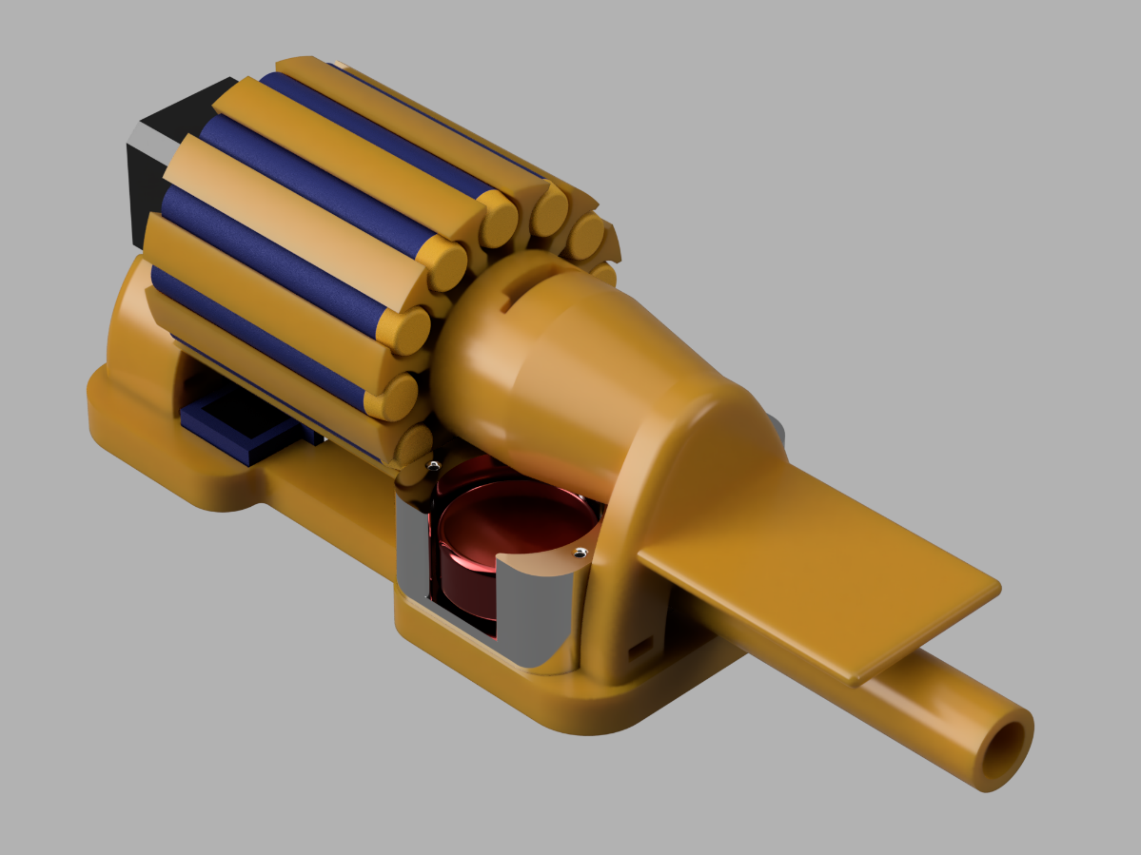

Figure 1 - Render of Firing Mech Assembly

| **Table 2 – 3D Printed Parts** | | | | |
| --- | --- | --- | --- | --- |
| **Part Number** | **Image of Part** | **Description of Part** | **Quantity** | **GitHub Link** |
| 3DP-9 |  | 12 Dart Magazine | 1 | Link Here |
| 3DP-10 |  | Bearing Holder (Supports camera) | 1 | Link Here |
| 3DP-11 |  | Stepper Holder | 1 | Link Here |
| 3DP-12 |  | Baseplate | 1 | Link Here |
| 3DP-13 |  | Servo Arm | 1 | Link Here |

|  |  |  |  |  |
| --- | --- | --- | --- | --- |
| **Table 3 – Off-The-Shelf Parts** | | | | |
| **Part Number** | **Qty** | **Description** | **Manufacturer** | **MFN PN** |
| LAU1 | 1 | Dart Launcher Upgrade Kit | Worker Mod | [W0315](https://www.etsy.com/uk/listing/773251736/worker-mod-flywheel-diagonal-mental-type?gpla=1&gao=1&utm_source=google&utm_medium=cpc&utm_campaign=shopping_uk_en_gb_d-toys_and_games-toys-pretend_play&utm_custom1=_k_Cj0KCQiA2NaNBhDvARIsAEw55hhXqCKTxp1lLAjBLih-g_JXGRaxLPQ56nzUaiS2Fwt2SR0uGbGwbpkaAtghEALw_wcB_k_&utm_content=go_12604682562_122820637354_508814539871_aud-1183050946056%3Apla-352859725846_c__773251736engb_470996125&utm_custom2=12604682562&gclid=Cj0KCQiA2NaNBhDvARIsAEw55hhXqCKTxp1lLAjBLih-g_JXGRaxLPQ56nzUaiS2Fwt2SR0uGbGwbpkaAtghEALw_wcB&variation0=1359296827) |
| BR3 | 1 | Plain Race Bearing (20mm ID, 32mm OD) | RS PRO | [6804-2RS](https://uk.rs-online.com/web/p/ball-bearings/6190323/?relevancy-datasearchHistory=%7B%22enabled%22%3Atrue%7D) |
| MTR3 | 1 | NEMA 14 Stepper Motor | Schneider Electric | [NEMA14](https://www.imshome.com/downloads/datasheets/Nema14_motors.pdf) |
| SEN2 | 1 | AS5600 Magnetic Position Sensor |  | [AS5600](https://www.ebay.co.uk/itm/313603433699) |
| DRIV2 | 1 | TMC2208 Stepper Motor Driver | TMC | [TMC2208](https://www.ebay.co.uk/itm/353868844618?hash=item52643a0e4a:g:5qEAAOSwxjZgLhU9) |
| 9g Servo | 1 | Micro Servo | Lofty Ambition | [MG90S](https://www.ebay.co.uk/itm/283464089727?_trkparms=ispr%3D1&hash=item41ffc6c07f:g:0bQAAOSwzVFcs3L6&amdata=enc%3AAQAGAAACkPYe5NmHp%252B2JMhMi7yxGiTJkPrKr5t53CooMSQt2orsSwcmzw5CLtzTE60FqHcnq2FqP1IUpIAAH8m53cOZ3DvDb8SXY%252BB58iAxFOBNmGdW%252BMV9FOw9TDQwGZVlHdvhFgKVJpIFKDAN49%252FSeNg0EeWN%252FOVh2SeIL%252Boo%252FUX1sZ4McE6Bfc%252FqZHC%252BOwP0DjrtCZk6ozosCq4oaAUfhIiAYXN%252F2hKoUolho%252B62yi3REr7RTeYCB6LUdLzVX2TrkvoWIA1mNWM8ekz%252BAti0qnUON%252FTAYd6LfHStSaUmRL4TORy67M2R8Qmj%252BhwpUWn%252BNBfkeLutlAyySDUsK4HQfZO3hTmC0PM2qmhNAOXBwNUlgICjFhTc8IFF9kvYr%252FCRA7TrOS89ZreIlRHBSKXDK%252FKDkT7dopHfenS3KjpddfiA%252BnasCpv5ntZEUdQZUeJp46QUIxqAGlH2lDC02TTmX9gzEG%252B0ep1d3yQkroMuKa3F9oofZO4sFS0jYsVPRWLQLR7tnkGy9bsAmMGtTX%252BWTd1i3QbNaMEqdGp4pD66yEhRug7wHdVfb7gpw9uDUYgfxU7dde7792HDwLps16%252FcbN6Ixw5LzGgukdq5AOcMi4ZhPzhbKJuTNHivYr64WSBN4m1JHoGEoXglTh0yXudARPhspTd7DgzBAP8i8DOvJtWUVAocUiNy2%252BuR2rAZiU9pXJztwJZ41YF0KIn8GpokusInDt21RjcN%252Fz5%252F%252FCho6xjWkujblK1eH%252BA13XDrGCMw2yDip1epghAj604ur%252B8JWaGTeqz4op7LFYd6UUkyRAjacxKivti8GME7fbRtXhahEca4vEPWOP83KOuWD4fNWbvxh9fR8U8Fs6ogtLOo7wAX2nk6m%7Cclp%3A2334524%7Ctkp%3ABFBMmJbwvOdf) |
| FX-Various | ~ | Various M4 Fixings including hex nuts and bolts. | - | - |