5-Class Posture Classification
Offline Neural Network Training for IMU-Based Posture Recognition (Nano 33 BLE Sense)
CEN598 - Embedded Machine Learning, Lab 3
Name: ____________________________

A. System Design
Motivation and High-Level Design
This lab extends the Lab 2 lying-posture project from a hand-tuned threshold rule to a properly trained neural network classifier, and grows the problem from 3 classes to 5: supine, prone, side (left or right, one label), sitting, and unknown. The sensor remains an Arduino Nano 33 BLE Sense (Rev1, LSM9DS1 IMU), assumed mounted on a chest band. Unlike Lab 2, the model here is trained and evaluated entirely offline in Python -- there is no on-device deployment requirement this lab -- which shifted the engineering effort from real-time embedded code toward dataset construction and model training.
Two requirements shaped the design beyond simply adding two classes. First, the classifier needed to be robust to how the sensor is mounted -- for example, the same 'supine' label should hold whether the USB connector points toward the head or the feet, and 'side' should hold for lying on either the left or right side. This was addressed primarily through the data collection design (Section B), by deliberately recording multiple physical mounting variants under the same class label rather than through any special model architecture. Second, since the data is collected by holding the board by hand rather than actually wearing it, it is unrealistically clean; synthetic noise was added during dataset construction to better represent a real, worn deployment (Section C).
Environment Setup
A notable, unplanned part of this lab's system design was getting a working Python/deep-learning environment running at all. The development machine had no working Python, Node.js, or LibreOffice installed natively -- only stub Windows Store aliases that immediately fail. The fix was to use the Windows Subsystem for Linux (WSL2) Ubuntu distribution already present on the machine. Its own packaged Python (3.14, very new) does not ship pip or ensurepip, and installing them via apt needs sudo, which could not be supplied interactively in this workflow. This was resolved without sudo by creating a virtual environment with python3 -m venv --without-pip, then bootstrapping pip inside just that venv via pip's own get-pip.py installer script -- Debian/Ubuntu's PEP 668 'externally managed environment' protection only blocks the system Python, not a venv. TensorFlow does not yet provide a build for Python 3.14, so PyTorch was used instead for the neural network itself, alongside NumPy, pandas, scikit-learn, and Matplotlib.
Sampling Frequency
Data logging continued at 5 Hz (one sample every 200 ms), the same rate used in Lab 2, for the same reason: posture is a held, near-static orientation rather than fast motion, so a high sampling rate is not needed to characterize it, and it keeps each trial's row count small and manageable.
Deep Learning Model Architecture and Training Parameters
The network is a small fully-connected multilayer perceptron: 6 raw sensor inputs (ax, ay, az in g; gx, gy, gz in deg/s) directly, with no windowing or hand-engineered features, feeding two hidden layers of 32 and 16 units, and a final linear layer producing 5 output logits (one per class). A softmax over these 5 logits gives the predicted class probabilities; during training this is implemented via PyTorch's CrossEntropyLoss, which combines log-softmax and negative-log-likelihood loss internally, and at inference time the predicted class is the argmax of the softmax output.
Three otherwise-identical copies of this network were trained, differing only in the activation function used at both hidden layers: sigmoid, tanh, and ReLU (Section C has the full comparison). Each was trained for 60 epochs with the Adam optimizer (learning rate 1e-3, batch size 64), using weights initialized with the textbook-appropriate scheme for its activation -- Xavier/Glorot initialization for sigmoid and tanh, Kaiming/He initialization for ReLU -- so that no activation was unfairly handicapped by a mismatched initialization. Input features were standardized (zero mean, unit variance) using statistics computed from the training split only, then applied unchanged to validation and test data.
B. Experiment
Data Collection Procedure and Tooling
As in Lab 2, data was collected by holding the board by hand rather than physically wearing it, per the assignment's own allowance. The much larger number of trials needed for 5 classes with multiple orientation variants each (29 total) made Lab 2's manual copy-and-paste workflow impractical, so a new PowerShell-based tool chain was built: a shared library function opens the board's COM port directly using .NET's System.IO.Ports.SerialPort (no external dependency), waits adaptively for the board's boot output to settle (these boards commonly reset when the port is opened), sends the same 's' start-recording command the Lab 2 logger firmware already supported, and writes the resulting CSV straight to disk. A batch script then walks through the full 29-trial checklist, prompting for repositioning between each and skipping any trial already collected, so the whole process is resumable.
Two bugs surfaced and were fixed during this process: first, an initial fixed 2-second delay before sending the start command was too short for the board to fully reboot and re-initialize its IMU after the port opened, causing a trial to silently capture nothing; this was fixed by replacing the fixed delay with an adaptive wait that actively drains and echoes the board's boot output until it stops arriving. Second, piping an empty PowerShell collection into Set-Content silently skips file creation entirely rather than creating an empty file, which had made the first failure invisible; this was fixed by writing the file directly via -Value instead of the pipeline.
Ground-Truth Labeling
Each trial's file name directly encodes its ground-truth label and mounting orientation (e.g. supine-usbhead-trial1.csv), and a dataset-construction script parses the class from the filename prefix. Every posture except side and unknown was recorded in exactly two mounting-orientation variants -- USB connector toward the head and toward the feet, a 180-degree rotation around the axis normal to the chest -- with 3 trials per variant. Side was recorded as left and right (3 trials each), matching the assignment's explicit example of orientation-independence.
Designing the 'Unknown' Class
The unknown class was defined as: standing upright (3 trials, one mounting orientation), plus two deliberately distinct 'boundary' orientations chosen to cover corners of orientation space that the other 4 classes do not exercise -- a roughly 45-degree tilt directly between the supine and side signatures (intentionally recreating an ambiguous case first observed in Lab 2), and a compound diagonal tilt (roughly 30-40 degrees in two directions at once, simulating a body caught mid-motion). A third random-orientation trial, originally planned to specifically force the board's width axis to dominate, was dropped once inspection of the actual collected data showed that axis was already being exercised by sitting and standing (see below) -- a case of checking real data rather than continuing to guess.
Addressing Orientation-Independent Classification
Two concrete experiments/analyses addressed the orientation-independence requirement directly, beyond simply collecting more data. First, for supine, prone, and sitting, both the USB-toward-head and USB-toward-feet mounting variants were recorded and given the same class label, so the training data itself teaches the model that both raw signatures mean the same posture. Second, for the side class, adding an equivalent USB-flip variant was considered and deliberately rejected: since side already only has one label regardless of left or right, and the geometry of the flip and the left/right distinction both flip the sign of the same axis (ay), a 'side-left with USB-toward-feet' trial would produce a raw signature very close to 'side-right with USB-toward-head' -- meaning the left/right data already provides that orientation diversity, and adding the flip explicitly would have been low-value extra data collection rather than new information.
A related, unplanned finding came out of checking the collected data directly: sitting and standing were assumed, before checking, to put gravity's dominant component on the same axis as the side class (ay); the real data showed it is actually the ax axis (board width) that is dominant for both sitting and standing (mean ax around -0.99 for the USB-toward-head orientation, and around +1.00 for USB-toward-feet in sitting). This both confirmed all three axes are exercised across the 5 classes (az by supine/prone, ay by side, ax by sitting/standing), and directly enabled dropping the redundant third unknown trial described above.
Challenges Mimicking Real-World Postures
Beyond the general difficulty of a hand-held simulation not perfectly matching a worn sensor (discussed in Lab 2), this lab surfaced a more specific, fundamental limitation: once collected, sitting and standing data showed nearly identical readings (mean ax about -0.9932 for standing vs. about -0.9926 for sitting, both USB-toward-head). This makes sense physically -- a chest-mounted accelerometer measures torso orientation, and sitting upright versus standing upright puts the torso in the same orientation regardless of hip or knee angle. This is not a data-collection mistake to fix; it is an honest limitation of the sensing modality, discussed further in Section D.
C. Algorithm
Dataset Construction
Before any model training, the 29 raw trial files were combined into a single labeled dataset and split into train/validation/test sets. A key design decision was to split by TRIAL (whole files), not by individual row: since each trial's ~100 rows are repeated readings of the same held-still posture at 5 Hz, they are highly correlated, and a row-level split would let near-duplicate rows from the same trial appear in more than one split, artificially inflating the apparent test accuracy. Instead, for each class, one whole trial was held out for validation and one for test, with the remainder used for training.
Synthetic noise was then added independently within each split (never before splitting, so noise cannot leak information across the split boundary either): every clean row was kept as-is, plus 4 additional noisy copies were generated by adding independent Gaussian noise (standard deviation 0.02 g on the accelerometer channels, 1.5 deg/s on the gyroscope channels) to a copy of that row. These noise levels were chosen as a few times larger than the natural jitter already visible in the clean, hand-held data (roughly 0.005-0.01 g), intended to represent the additional motion a real, worn sensor would pick up from breathing and small incidental body movement. This expanded the dataset 5x: 9,500 training rows, 2,500 validation rows, and 2,500 test rows, from 2,900 raw collected rows.
Model, Activation Functions, and Output Layer
As described in Section A, the network is a 6 -> 32 -> 16 -> 5 fully-connected MLP. Three versions were trained, identical in every respect except the hidden-layer activation function:
* Sigmoid -- squashes to (0,1); classic choice, but prone to vanishing gradients in deeper networks since its derivative is small away from 0.
* Tanh -- squashes to (-1,1), zero-centered (often trains a little faster than sigmoid for that reason), but shares the same saturation/vanishing-gradient concern at its extremes.
* ReLU -- zero for negative inputs, identity for positive; avoids saturation on the positive side and is by far the cheapest to compute (a single comparison), which matters for embedded inference even though this lab does not deploy on-device.
For a multi-class problem with more than two classes, the correct output-layer activation is softmax, not sigmoid (which would treat classes as independent binary decisions) -- softmax guarantees the 5 output values are non-negative and sum to 1, i.e. a valid probability distribution over mutually-exclusive classes. In PyTorch this is applied implicitly and numerically stably by CrossEntropyLoss during training (via log-softmax), and explicitly via softmax + argmax to obtain the predicted class label at inference.
Training used the Adam optimizer (learning rate 1e-3), batch size 64, and 60 epochs, with a fixed random seed for reproducibility. Weight initialization was matched to each activation's theory (Xavier/Glorot for sigmoid/tanh, Kaiming/He for ReLU) specifically so the 3-way comparison would not be biased by giving every network the same, only-sometimes-appropriate initialization scheme.
D. Results
Activation Function Comparison
All three activation functions converged to the same final test accuracy, 80.00 percent, with an identical confusion matrix pattern:
Activation | Final train acc | Final val acc | Test acc
Sigmoid | 0.935 | 0.736 | 0.800
Tanh | 0.936 | 0.734 | 0.800
ReLU | 0.937 | 0.732 | 0.800

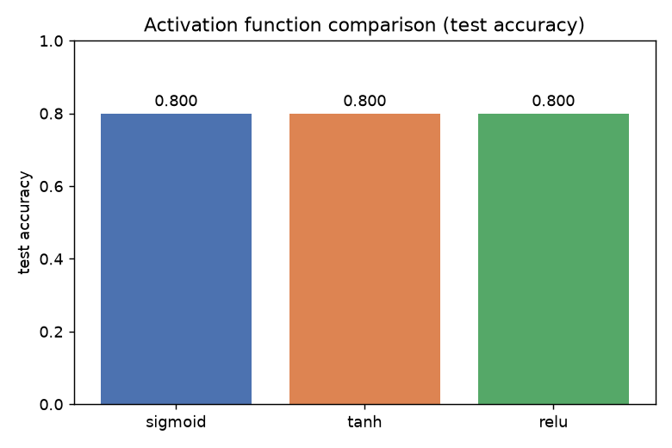
Figure 1. Test accuracy was identical across all three activation functions.
This is a real, notable result in itself: for this architecture, dataset, and task, the choice of hidden-layer activation function did not change the final classification outcome. The most likely explanation is that the network is small and shallow (two hidden layers), and the underlying classification problem -- five reasonably well-separated clusters in a 6-dimensional, standardized feature space -- is easy enough that the vanishing-gradient/saturation concerns that usually distinguish sigmoid and tanh from ReLU never really come into play at this depth. The activations did, however, produce visibly different training dynamics, shown in Figures 2-4.
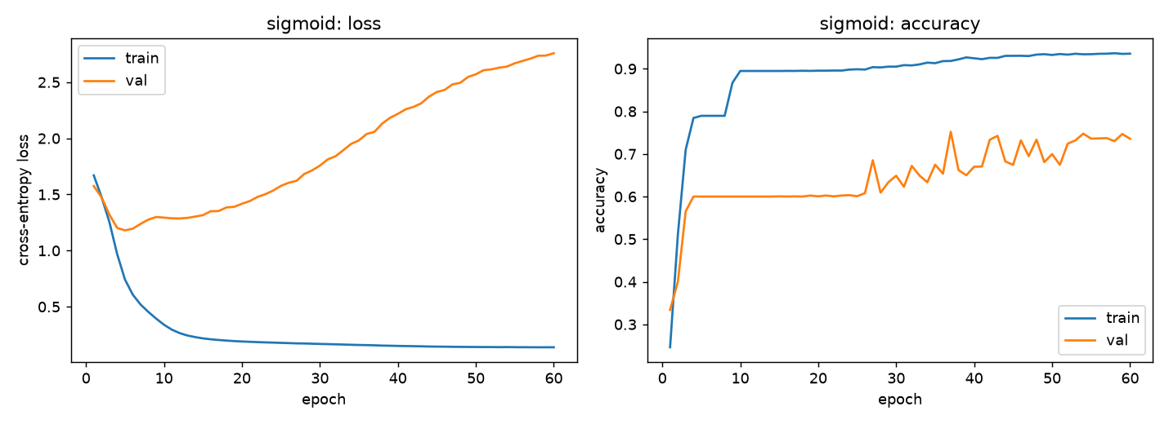
Figure 2. Sigmoid: training/validation loss and accuracy curves.
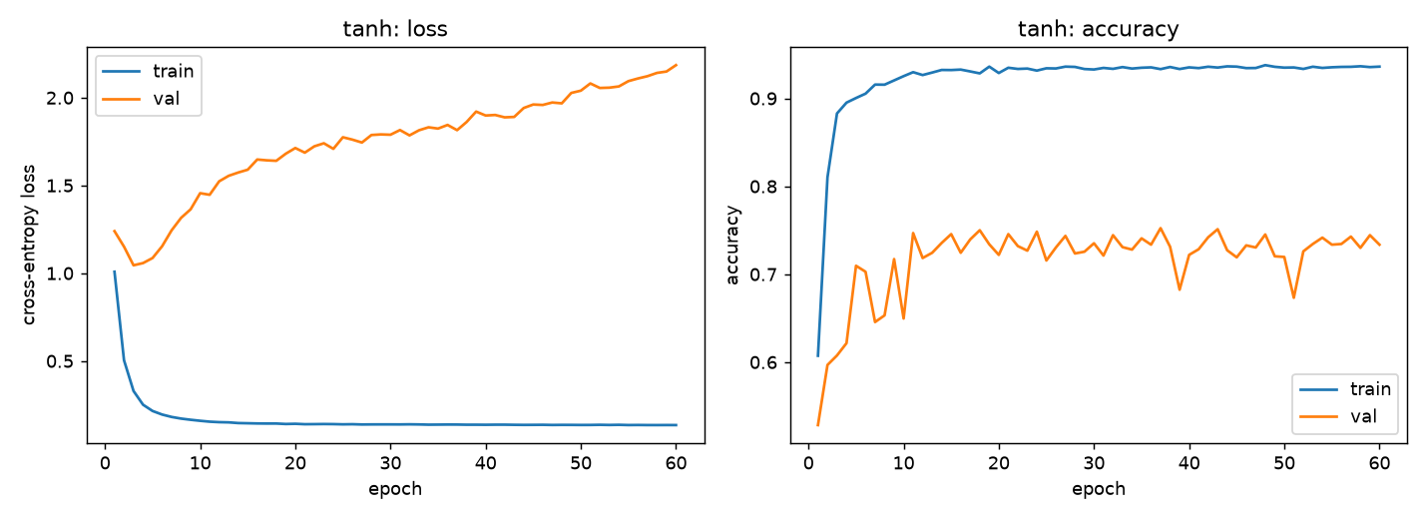
Figure 3. Tanh: training/validation loss and accuracy curves.
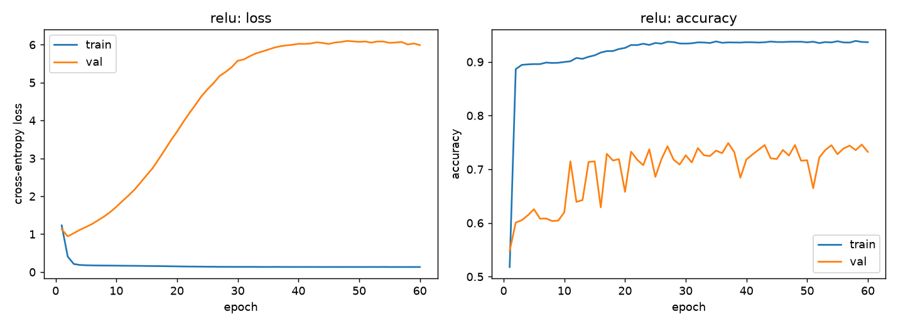
Figure 4. ReLU: training/validation loss and accuracy curves.
All three show the same qualitative pattern: training loss drops to a low, flat value within the first 5-10 epochs while training accuracy climbs above 90 percent, but validation loss climbs steadily for the rest of training even as validation accuracy keeps slowly improving. This is a classic overfitting signature (the model becomes increasingly confident, including confidently wrong on cases it has not learned), discussed further below and in Section E.
Confusion Matrices and the Unknown-Class Failure Mode
All three activations produced the exact same confusion matrix on the test set: supine, prone, side, and sitting were all classified with 100 percent accuracy (500/500 each), while every unknown test sample was misclassified as supine (0/500 correct). Figure 5 shows this for ReLU; sigmoid and tanh are pixel-for-pixel identical.
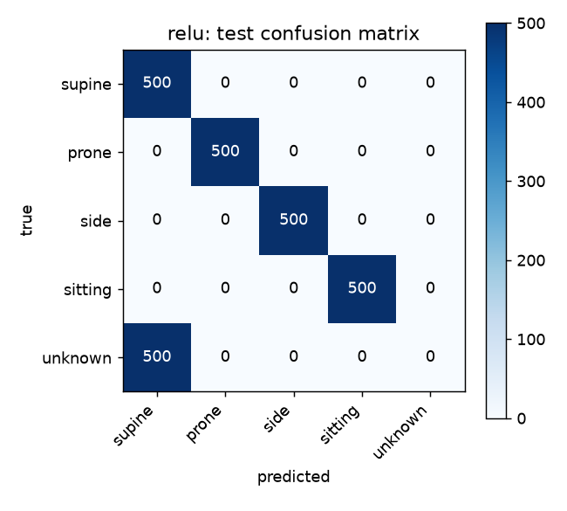
Figure 5. Test confusion matrix (identical for all three activations). Every 'unknown' sample was misclassified as 'supine'; all other classes were perfect.
This failure mode was fully traced, not left as a mystery. The random, per-class trial split (Section C) happened to place all 3 'standing' trials for the unknown class into the training set, while both 'boundary-tilt' trials landed in validation and test -- meaning the model never saw a single boundary-tilt-style unknown example during training, only the standing signature (ax around -0.99). The test file responsible for the failure, a 45-degree tilt between supine and side, averages ax=0.012, ay=-0.652, az=0.764: a real blend between the supine and side signatures that is nowhere near the ax~=-0.99 pattern the model actually learned to call 'unknown.' Given that, the network falls back to whichever learned class region is closest -- supine, since az (0.764) is the larger-magnitude of the two active components. This result is reported as-is rather than smoothed over with a re-balanced split, since it is an honest and fully-explained consequence of the 'unknown' class having only 5 raw trials across 2 quite different sub-types (see Section E).
Overfitting
The loss curves (Figures 2-4) show clear overfitting for all three activations: training loss falls to roughly 0.13-0.17 within the first 5-10 epochs and stays essentially flat for the remaining 50 epochs, while validation loss rises steadily to between 2 and 6 by epoch 60, even though validation accuracy keeps slowly climbing over the same period. The most likely cause is that the raw dataset, before noise augmentation, is only 19 training trials; the 4 additional noisy copies generated per row are correlated variants of the same small set of underlying clean samples rather than truly independent new data, so the network can substantially memorize per-trial characteristics rather than learning a more general decision boundary.
E. Discussion
Summary
A 5-class posture classifier was successfully trained entirely offline using raw IMU readings, achieving 80.00 percent test accuracy with 4 of 5 classes classified perfectly. The one failure mode is fully understood and directly traceable to a known, honestly-reported gap in how the smallest class's trials happened to be split between training and test, rather than to a flaw in the model or training procedure. The choice among sigmoid, tanh, and ReLU activation functions made no difference to final test accuracy for this task, though it visibly affected training dynamics.
Difficulties Encountered
* Getting a working Python/PyTorch environment running on a machine with no native Python, Node, or LibreOffice install required setting up WSL, working around a sudo-free pip bootstrap, and discovering that TensorFlow was not yet available for the installed Python version -- more setup effort than the modeling work itself in some respects.
* Manually copying data out of the Arduino Serial Monitor (Lab 2's method) did not scale to the 29 trials this lab needed; building and debugging automated PowerShell serial-capture tooling (including a board-reset timing bug and a silent-failure bug in file writing) took real, unplanned effort.
* Assumptions about sensor geometry (which axis dominates for a given posture) were wrong at least once (assumed sitting/standing would use the same axis as side) and were only caught by checking the actual collected data rather than continuing to reason abstractly.
* The small size of the raw dataset (29 trials, especially only 5 for the unknown class) is the root cause of both the overfitting observed in training and the specific unknown-class test failure -- a more production-grade system would need substantially more collected data, particularly more diversity within the smaller classes.
Future Improvements
* Collect substantially more trials, especially for the unknown class, ensuring every sub-type (standing, and multiple distinct boundary tilts) is represented in every split rather than left to chance.
* Add regularization (dropout, weight decay) or early stopping (the validation loss curves suggest stopping around epoch 10-15 would avoid most of the observed overfitting) to improve generalization without needing more data.
* Consider whether sitting and standing should really be separate classes at all, given they are indistinguishable from chest-accelerometer data alone -- or accept and clearly document that limitation if they remain separate.
* Explore short windowed/aggregated features (e.g. mean and variance over a brief window) instead of single-timestep raw readings, which might reduce the model's ability to overfit to individual noisy samples.
Hardest Part / Did the Approach Work?
The most time-consuming parts of this lab were arguably not the neural network itself, but the surrounding infrastructure: getting a working deep-learning Python environment set up at all, and automating reliable serial data collection well enough to make collecting 29 trials practical. Once that infrastructure was in place, the modeling approach worked well: the network readily learned 4 of 5 classes perfectly, and its one failure mode is a clean, explainable consequence of a known, disclosed dataset limitation rather than an unexplained deficiency -- which is arguably a more useful outcome for understanding the system's real behavior than an artificially perfect result would have been.

