Sensor-Agnostic Posture Classification
On-Device TensorFlow Lite Deployment for IMU-Based Posture Recognition (Nano 33 BLE Sense)
CEN598 - Embedded Machine Learning, Lab 4
Name: ____________________________

A. System Design
Motivation and High-Level Design
This lab extends the Lab 3 posture classifier in three directions at once. First, the model must be sensor-agnostic. It has to accept a generic 3-channel window of x, y, z readings and produce a posture label regardless of whether that window came from the accelerometer, the gyroscope, or the magnetometer, rather than being trained for one specific sensor. Second, the classifier must actually run on the board itself. Lab 3 trained and evaluated entirely offline, but this lab requires real on-device inference using TensorFlow Lite for Microcontrollers. Third, the classifier must respond to requests from an external base station rather than predicting continuously on its own, so a laptop can ask the board for a prediction and specify which sensor to use for it.
The sensor is still an Arduino Nano 33 BLE Sense, Rev1, with the LSM9DS1 IMU. Two more requirements shaped the design beyond the three above. Signal windowing of 2 to 5 seconds is required, with the same normalization applied consistently at both training time and inference time, and synthetic noise is explicitly disallowed this lab, the opposite of Lab 3's approach, since a real deployment already supplies real sensor noise and adding synthetic noise on top of that would create a mismatch between what the model was trained on and what it actually sees once deployed.
Environment Setup
The same local-machine limitation from Lab 3 applied here, no working native Python, Node.js, or LibreOffice install, only stub Windows Store aliases. Lab 3 worked around this using a WSL2 Ubuntu virtual environment bootstrapped with pip via get-pip.py, since Ubuntu's packaged Python 3.14 ships without pip. That environment runs PyTorch, but this lab specifically needs real TensorFlow, since converting a trained model to a TensorFlow Lite Micro file requires TensorFlow's own converter. Installing an older Python version (3.11 or 3.12) through WSL's apt repositories was investigated as a way to unlock a TensorFlow wheel, but Ubuntu 26.04's default repositories only ship Python 3.14, and the deadsnakes PPA that might carry older versions was not confirmed to support such a new Ubuntu release.
Rather than keep fighting the local environment, the TensorFlow-dependent steps, training and TFLite conversion, were moved to Google Colab, which has TensorFlow preinstalled and needs no local setup. Data collection, windowing design, and the on-device Arduino firmware all still happened locally as before. Only the model training and conversion step ran in the cloud. This is the second distinct environment blocker encountered across two labs, each resolved a different way, and is worth noting in the difficulties section below.
Sampling Frequency
Data logging continued at 5 Hz, one sample every 200 ms, the same rate used in Lab 2 and Lab 3. Posture is a held, near-static orientation rather than fast motion, so a higher sampling rate is not needed to characterize it.
Sensor-Agnostic Model Architecture
Each window covers 3 channels (x, y, z) across 15 samples, 3.0 seconds at 5 Hz, flattened into 45 inputs. The network is a small fully connected multilayer perceptron, 45 inputs feeding a Dense layer of 32 units with ReLU activation, a Dropout layer with rate 0.2, a Dense layer of 16 units with ReLU activation, and a final Dense layer of 5 units with softmax activation producing class probabilities. This is close to the architecture Lab 3 used, but with dropout added this time as a direct response to the overfitting Lab 3 documented.
The network never sees a feature indicating which sensor produced a given window. Every window, whether it came from the accelerometer, the gyroscope, or the magnetometer, is presented to the network in the exact same generic x, y, z form. This is what makes the trained model sensor-agnostic. Sensor-agnostic behavior is not achieved through any special layer or architectural trick. It comes entirely from how the training data is constructed, described in Section C.
Normalization Strategy
Per-window normalization, computing a fresh mean and standard deviation for each window right before feeding it to the model, was considered and rejected. For a static posture task, that approach would zero out exactly the information that distinguishes postures, the steady DC level of each channel, for example az sitting near positive one g for the whole window, leaving only noise-dominated residuals behind.
Instead, the same strategy Lab 3 used was carried forward and generalized to all 9 raw channels. One fixed mean and standard deviation is computed per raw channel from the training data only, then applied globally to the training, validation, and test sets, and identically to real-time inference on the board. The board always knows which sensor is active for a given request, so it applies the matching 3 of 9 constants. This preserves the posture-defining signal while still centering and scaling the input for the network, and it is trivial to replicate on-device since the constants are fixed numbers baked into the firmware rather than statistics computed on the fly.
On-Device Deployment Architecture
The board runs TensorFlow Lite for Microcontrollers using the Arduino_TensorFlowLite library, version 2.4.0-ALPHA, provided as a zip archive on the assignment page. The real API of this library differs from what the course slides showed it as. Inspecting the library's actual header files directly, before attempting to compile against it, surfaced three differences. There is no tensorflow/lite/version.h file in this library. TFLITE_SCHEMA_VERSION is defined inside micro_interpreter.h instead. The micro_error_reporter.h header lives at a different path than the slides showed. Most significantly, the MicroInterpreter constructor in this library no longer accepts an ErrorReporter argument at all, that parameter was removed from the API since the slides were made. The firmware was written against the library's real signature from the start, so no MicroErrorReporter object is created, and every TFLite call is instead checked directly against its own returned TfLiteStatus.
The static tensor arena reserved for the model's tensors is 20 KB. This was chosen generously given the model's small parameter count and never needed adjustment once testing began.
B. Experiment
Data Collection Procedure and Tooling
The IMU_Data_Logger firmware was extended to record all three sensors together per row, accelerometer, gyroscope, and magnetometer, 9 feature columns instead of Lab 3's 6, at the same 5 Hz rate and using the same start and stop serial command protocol. The PowerShell-based serial capture tooling built for Lab 3, opening the board's COM port directly through System.IO.Ports.SerialPort, waiting adaptively for the board's boot output to settle, and writing each trial straight to a CSV file, was reused unchanged apart from pointing it at Lab 4's folders.
The physical data-collection plan itself, which postures to record, which mounting-orientation variants, and how the unknown class is constructed, was reused as-is from Lab 3's 29-trial checklist. Collecting one trial now simultaneously captures accelerometer, gyroscope, and magnetometer data together, so there was no need to redesign which postures or orientations to physically hold. Only the firmware needed to change to add the magnetometer channels.
No Synthetic Noise This Lab
Lab 3 added synthetic Gaussian noise to represent the extra motion a real, worn sensor would pick up, since the data was collected by holding the board by hand rather than wearing it. This lab deliberately does the opposite and adds no synthetic noise at all. The reasoning is a direct train and deploy consistency argument. This lab's model is meant to run in real time on the actual board, and the real board already supplies real sensor noise from its own ADC and from natural hand tremor while holding it. Layering synthetic noise on top of that during training would shift the training distribution away from what the deployed model actually sees at inference time, which is the opposite of what noise augmentation is supposed to accomplish. Leaving the training data clean and letting the real deployment be the only source of noise keeps train and deploy conditions consistent.
Base-Station Interface
The assignment calls for an interactive base-station app that requests predictions from the board and specifies which sensor to use, accelerometer, gyroscope, or magnetometer. This was implemented as a PowerShell script, request_prediction.ps1, using the same System.IO.Ports.SerialPort approach as the Lab 2 and Lab 3 data-collection tooling rather than building new infrastructure from scratch. The script opens the board's serial port, drains its boot banner the same way the collection tooling does, sends a single digit, 1 for accelerometer, 2 for gyroscope, or 3 for magnetometer, and prints whatever line the board replies with.
USB serial was chosen over Bluetooth Low Energy for this link. The Nano 33 BLE Sense supports BLE, but the serial approach reuses proven, already-debugged infrastructure from earlier labs and fully satisfies the functional requirement, an external interface that initiates a prediction and specifies which sensor to use, without adding the extra complexity of a BLE GATT service on top of an already substantial lab. This tradeoff is discussed further in Section E.
C. Algorithm
Windowing and Sensor-Agnostic Pooling
Each raw trial is windowed independently for each of the three sensors. A window covers 15 samples per channel, 3.0 seconds at the 5 Hz logging rate, within the assignment's own 2 to 5 second guidance. Windows overlap with a stride of 5 samples, one third of the window length, which produces more training examples per trial without needing synthetic data to pad the dataset out.
All three sensors' windows are then pooled into one shared training set under the same class label. This pooling step is the actual mechanism that makes the trained model sensor-agnostic. The network never sees a feature indicating source sensor, only generic x, y, z values, so it has no way to learn a sensor-specific shortcut even if one existed. Test accuracy is explicitly broken down by sensor type in addition to the overall number, specifically to check whether the model performs comparably regardless of which sensor supplied the window rather than simply averaging out a large gap between sensors.
The dataset was split by trial, not by individual row, for the same reason as Lab 3. Each trial's rows are repeated, highly correlated readings of the same held-still posture, so a row-level split would let near-duplicate rows from the same trial leak across the train, validation, and test boundary and artificially inflate the apparent test accuracy. One trial per class was held out for validation and one for test, with the remainder used for training, mirroring Lab 3's split strategy.
Model Architecture, Dropout, and Early Stopping
As described in Section A, the network is a 45 to 32 to 16 to 5 fully connected MLP with ReLU hidden-layer activations and a softmax output layer. Two additions were made directly in response to the overfitting Lab 3 documented and flagged as a future improvement. A Dropout layer with rate 0.2 sits between the two hidden layers. Training uses Keras's EarlyStopping callback, monitoring validation loss with patience 8 and restore_best_weights enabled, so training stops and the best-performing weights are kept as soon as validation loss stops improving for 8 consecutive epochs, rather than continuing to run for a fixed epoch count regardless of overfitting.
Training used the Adam optimizer with a learning rate of 1e-3 and sparse categorical cross-entropy loss, appropriate since the 5 classes are mutually exclusive and labels are provided as integer indices rather than one-hot vectors.
TFLite Conversion and On-Device Embedding
Once trained, the Keras model was converted to a plain float32 TensorFlow Lite model using tf.lite.TFLiteConverter, run inside the Colab notebook alongside training since both steps need real TensorFlow. Int8 quantization was considered but ultimately skipped, since the float32 model is already small enough to fit comfortably in the board's flash and RAM budget, and quantization would have added extra complexity, a representative dataset and a calibration step, for no measurable benefit at this model size.
The notebook exports the converted model as a C byte array header file, model_data.h, containing the array g_model and its length g_model_len, ready to embed directly in the Arduino sketch. The same notebook cell also prints the per-channel training mean and standard deviation as C float arrays, which were copied directly into the firmware as CHANNEL_MEAN and CHANNEL_STD so the normalization applied on-device matches training exactly.
D. Results
Early Stopping and Training Curves
Early stopping worked as intended. Validation loss plateaus around 1.0 to 1.1 rather than climbing unbounded the way Lab 3's did, where validation loss reached 2 to 6 by the end of a fixed 60-epoch run. This is a direct, visible improvement from adding dropout and early stopping in response to Lab 3's overfitting finding.
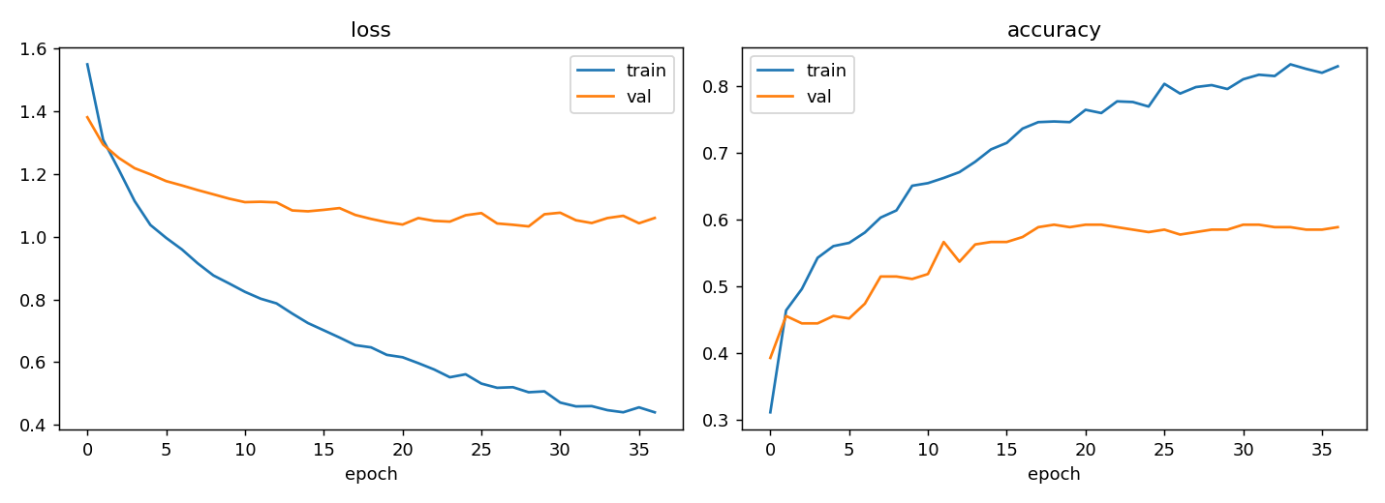
Figure 1. Training and validation loss and accuracy curves. Validation loss plateaus instead of climbing, the direct effect of dropout and early stopping.
Overall Test Accuracy and Confusion Matrix
Overall test accuracy across all pooled sensor windows was 66.3 percent, 179 correct out of 270 windows. This is lower than Lab 3's 80 percent, which is expected, since this task is genuinely harder. It has to generalize across three sensors with different underlying physics, work on windowed rather than single-timestep input, and do so without the synthetic noise augmentation Lab 3 relied on.
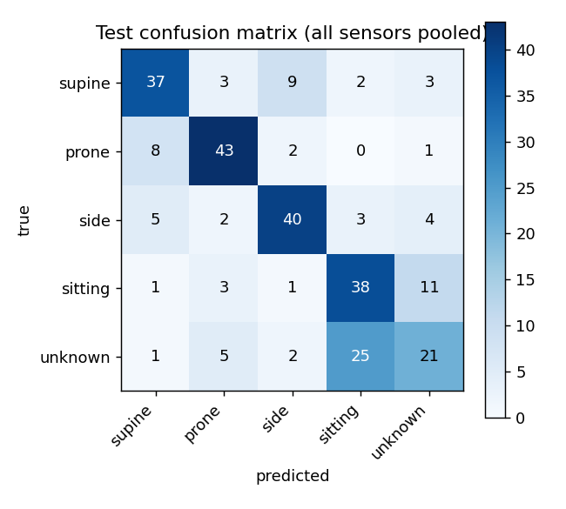
Figure 2. Test confusion matrix, pooled across all three sensors. The dominant confusion is between sitting and unknown.
The largest single source of error is confusion between sitting and unknown. 20 percent of true sitting windows were predicted as unknown, and 46 percent of true unknown windows were predicted as sitting. This is a direct, numeric confirmation of the sitting and standing accelerometer ambiguity first observed in Lab 2 and Lab 3, since the unknown class here is built mostly from standing trials, and a chest-mounted accelerometer cannot distinguish standing from sitting upright by orientation alone.
Accuracy by Sensor Type
Breaking test accuracy down by which sensor supplied each window produced the most notable finding in this lab. Accelerometer windows scored 83.3 percent, magnetometer windows scored 84.4 percent, and gyroscope windows scored 31.1 percent, only slightly above the 20 percent chance level for 5 classes.
Sensor | Test accuracy
Accelerometer | 83.3%
Magnetometer | 84.4%
Gyroscope | 31.1%

This corrected an earlier hypothesis going into this lab. The magnetometer was expected to underperform because its readings depend on compass heading in addition to posture, a confound the accelerometer does not share, but it actually matched and slightly beat the accelerometer. The real story turned out to be the gyroscope, and the reason is more fundamental than any heading confound. A gyroscope measures angular velocity, the rate of rotation, not orientation itself. The accelerometer and magnetometer both sense a fixed reference vector, gravity for the accelerometer and Earth's magnetic field for the magnetometer, that stays stable and distinguishing while the board is held still in a given posture. A gyroscope reads close to zero regardless of posture whenever the board is held still, since it only carries information about a changing orientation, not a static one. For a task defined entirely around held, static postures, gyroscope data is essentially noise with no real signal to learn from, and 31.1 percent, a bit above chance, is the expected outcome of that physical fact rather than a training failure.
The magnetometer's strong score here still carries a caveat. Its heading dependence was a real concern going in, and this single data-collection session likely had a fairly consistent compass heading throughout, since all trials were collected in one location without deliberately rotating the whole setup. The 84.4 percent figure may therefore be somewhat optimistic and not fully representative of how well the magnetometer would generalize across sessions collected at different headings. This is discussed further in Section E.
On-Device Compilation
After fixing the three library API differences described in Section A, the sketch compiled successfully on the first real attempt. The build reported 353336 bytes of program storage used, 35 percent of available flash, and 73080 bytes of dynamic memory used, 27 percent of available RAM. The Arduino IDE printed a non-fatal warning that no precompiled binary matched the exact compiler flags for this board's Cortex-M4 core with its floating point unit, so it fell back to compiling the TensorFlow Lite Micro library from source, which completed without error.
Real-Time On-Device Validation
With the sketch uploaded, request_prediction.ps1 was used to request live predictions from the board while holding it in known postures. In the first round, the board was held supine and all three sensors were requested in turn.
Sensor | Predicted class | Confidence
Accelerometer | SUPINE (correct) | 0.915
Gyroscope | SIDE (incorrect) | 0.248
Magnetometer | SUPINE (correct) | 0.947

The accelerometer and magnetometer both predicted the correct class with high confidence and agreed with each other. The gyroscope predicted the wrong class, but its confidence, 0.248, sits barely above the 0.20 chance level for 5 classes, meaning the model was not confidently wrong, it was simply guessing close to randomly, exactly the behavior the 31.1 percent offline test accuracy for gyroscope windows predicted.
A second round tested the accelerometer alone across all 5 posture classes in sequence.
True posture | Predicted class | Confidence
Unknown (standing) | UNKNOWN (correct) | 0.563
Side | SIDE (correct) | 0.959
Prone | PRONE (correct) | 0.906
Supine | SUPINE (correct) | 0.900
Sitting | SITTING (correct) | 0.990

All 5 classes were predicted correctly. The one visibly weaker result was the unknown class, at 56.3 percent confidence versus 90 to 99 percent on the other four. This matches the offline confusion matrix finding directly, unknown is the class most often confused with sitting in the test set, and here the live board's own confidence was lowest on exactly that class rather than being falsely confident. Across both rounds, real-time on-device behavior tracked the offline test-set results closely, both in which sensor and which class the model struggled with, and in how it struggled, low confidence rather than confidently wrong predictions.
E. Discussion
Summary
A sensor-agnostic, windowed posture classifier was trained offline in Colab, converted to TensorFlow Lite, and deployed to run real inference directly on the Nano 33 BLE Sense, achieving 66.3 percent overall test accuracy. Accelerometer and magnetometer windows classify well, 83 to 84 percent, while gyroscope windows sit near chance level, 31.1 percent, a direct and well-understood consequence of what each sensor physically measures rather than a flaw in the model or training procedure. Real-time predictions requested through a serial base station matched the offline test-set behavior closely across both sensor choice and posture class.
Sensor-Agnostic Robustness
The model is sensor-agnostic in the sense that a single set of trained weights accepts a 3-channel window from any of the three sensors and produces a posture label, without ever being told which sensor supplied that window. This works well specifically for sensors that encode static orientation information, the accelerometer and magnetometer, since pooling their windows under shared labels during training gives the network genuinely equivalent information to learn from regardless of source. It does not, and physically cannot, work equally well for the gyroscope, since a gyroscope simply does not carry orientation information while the board is held still. Sensor-agnostic architecture only works as well as the union of what each sensor can physically encode about the task. It cannot manufacture information a sensor does not carry in the first place, no matter how the model or training data are designed.
Base-Station Coordination
The board never predicts on its own. It continuously buffers the last 3 seconds of raw samples across all 9 channels in the background so a fresh window is always ready, but it only runs the model and reports a result once it receives a single digit over serial from the base station specifying which sensor to use. This keeps the board idle and power-cheap between requests and puts the base station fully in control of when and how predictions happen, matching the assignment's request and response model. The tradeoff made here was choosing USB serial over Bluetooth Low Energy for that link. Serial is simpler and reuses proven tooling built up over three labs, at the cost of requiring a wired connection between the base station and the board rather than a wireless one. For a lab focused on demonstrating sensor-agnostic inference and on-device deployment, this tradeoff kept the implementation reliable and left more engineering time for the harder problems, the windowing, normalization, and model deployment itself.
Test-Set Versus Real-Time Accuracy
The two real-time validation rounds in Section D are a small sample, 8 live requests total, but they line up closely with the offline test-set numbers in both directions. Where the test set predicted strong performance, accelerometer and magnetometer, live requests were correct with high confidence. Where the test set predicted weak performance, gyroscope, and predicted a specific confusion pattern, sitting and unknown, the live board reproduced both the wrong class and the low-confidence, near-chance behavior almost exactly. This agreement is a meaningful, if limited, confirmation that the offline test-set accuracy is a reasonably honest predictor of real-time, on-device behavior for this model, rather than an optimistic number that fails to transfer once deployed.
Difficulties Encountered
* Getting real TensorFlow available for the training and conversion steps required moving those specific steps to Google Colab, since the local WSL environment's Python 3.14 has no TensorFlow wheel and installing an older Python version through apt was not confirmed to work on such a new Ubuntu release.
* The TensorFlow Lite Micro library's real API differs from what the course slides showed. The MicroInterpreter constructor no longer accepts an ErrorReporter argument, and two header paths have changed. These were caught by inspecting the library's actual source before attempting to compile, which avoided a round of compile errors entirely.
* Extending the data logger to record all three sensors together, rather than redesigning the physical data-collection plan from scratch, kept this lab's data-collection effort much smaller than Lab 3's despite adding a third sensor's worth of channels.
Future Improvements
* Collect a second data-collection session at a different compass heading, or physically rotate the setup between trials, to directly test whether the magnetometer's strong 84.4 percent score holds up once the heading confound is actually stress-tested rather than left as a documented but unaddressed caveat.
* Collect more unknown-class trials with more sub-type diversity, since sitting and unknown remain the dominant confusion pair, echoing the same sitting and standing ambiguity documented in Lab 2 and Lab 3.
* Add a wireless link, most naturally Bluetooth Low Energy given the board's own name, as a follow-up to the USB serial base station used here, now that the harder sensor-agnostic and on-device deployment problems are solved and proven working.
Hardest Part / Did the Approach Work?
The hardest part of this lab was not any single step but the number of distinct systems that all had to work correctly together, a Colab-trained model, a hand-converted TensorFlow Lite Micro library with an API that did not match the course slides, and firmware coordinating continuous sampling with on-demand inference. Each piece was verified before moving to the next, the library's real API was checked before writing firmware against it, and the sketch was verified to compile cleanly before uploading. The approach worked. The board compiled on the first real attempt, ran correctly on the first upload, and its real-time predictions matched the offline test-set accuracy pattern closely across both sensor type and posture class, including reproducing the gyroscope's expected near-chance behavior rather than failing in some unexpected way.

