Absolutist Keyword Spotting
Real-Time On-Device Detection of Absolutist Language Markers via Audio Keyword Spotting (Nano 33 BLE Sense)
CEN598 - Embedded Machine Learning, Lab 5
Name: ____________________________

A. Introduction
This lab builds a small embedded system that listens for five absolutist words, never, none, all, must, and only, using the onboard microphone of an Arduino Nano 33 BLE Sense, the same board family used in Labs 2 through 4 for posture detection. Absolutist language, words that describe things in all-or-nothing terms rather than in degrees, has been studied as a language-style marker that correlates with anxiety, depression, and suicidal-ideation forum activity more strongly than markers like pronoun use or explicitly negative-emotion words. The goal here is to build the underlying embedded detection capability that such a system would need, a low-power device that could in principle flag everyday absolutist word usage in a pen or necklace form factor, though the physical enclosure itself is out of scope for this lab.
This project is explicitly not a diagnostic tool. Detecting the presence of a word is a completely different, and much simpler, problem than assessing someone's mental state, and no such assessment is attempted or implied anywhere in this system.
The lab follows the same overall pipeline shape used in Lab 4, collect data, preprocess it, design a model, train it, evaluate and optimize it, convert it to TensorFlow Lite, deploy it to the board, and make real inferences on real hardware. Four concrete steps drive that pipeline here. Gather audio samples for the five target words. Merge that data into Google's Speech Commands dataset to build a larger keyword-spotting dataset with realistic negative examples. Train a model to spot the five words, following the same feature extraction, training, and validation procedure covered in class. Deploy the trained model to the board and test real-time keyword spotting against a base-station interface.
B. Experiments
Data Collection
Audio samples for the five target words were collected using the Harvard TinyML Open Speech Recording tool, a browser-based recorder that saves each utterance as an .ogg file. 500 raw recordings were collected in total, 100 per word, downloaded in batches since the tool's browser memory is limited and a page refresh loses anything not yet downloaded. Comparing the downloaded files by content found that 250 of the 500 were byte-identical duplicates, the browser had re-downloaded the same batch twice, leaving 250 unique recordings, 50 per word, stored in Audio_Data_Collection.
Dataset Construction
A shared Colab template notebook converts the raw .ogg recordings into a keyword-spotting dataset. Each file is converted to a 16 kHz .wav with ffmpeg, then trimmed to a 1 second clip centered on its loudest section using Pete Warden's extract_loudest_section C++ tool, and sorted into per-word folders. Two real bugs in the shared template had to be fixed before this produced a clean dataset. ffmpeg silently failed to overwrite existing .wav files from a previous run, since it prompts for confirmation with no input available and defaults to not overwriting, fixed by adding the -y flag. extract_loudest_section failed to compile on the Colab image's current GCC 13 compiler, since its source used uint8_t and similar types without including cstdint, something older compilers tolerated implicitly and GCC 13 does not, fixed by inserting an explicit include before compiling.
A related misconception was corrected during this process. Colab's Restart Session option only resets the Python kernel's memory, it does not wipe the underlying virtual machine's disk, so folders left over from a previous, broken run persisted across a restart and had to be cleaned up explicitly rather than assumed gone. The conversion cell was made self-cleaning, removing its own working folders at the start of every run, so it could be re-run safely any number of times.
The 250 collected clips alone are not enough to train a keyword-spotting model, since a model also needs realistic negative examples, non-target speech and non-speech sound. Google's Speech Commands dataset (version 0.02) was merged in for exactly this purpose. None of the five target words appear in its standard 35-word vocabulary, so it never contributes additional target-word samples, only negative data. Two negative classes were built from it, _unknown_, 9 samples drawn from each of the 35 non-target words with a fixed random seed, and _background_noise_, its handful of raw ambient noise recordings copied in directly.
Dataset Size and Class Counts
A seventh class, _silence_, was built separately during training setup rather than during dataset construction, by cropping 260 one-second clips at random offsets from the 6 _background_noise_ files, a count deliberately comparable to _unknown_'s size so that neither negative class dominates training. This class teaches the model to report nothing when there is no speech at all, distinct from _unknown_, which teaches it to reject speech it does not recognize. Final class counts across the full merged dataset are listed below.
Class | Clip count
_silence_ | 260
_unknown_ | 315
all | 50
must | 49
never | 50
none | 50
only | 50
Total | 824

One must clip was dropped during the trimming step and not investigated further, since the assignment's 50-per-word figure is a guideline rather than a hard minimum. The dataset was split by clip into training, validation, and test sets using a stratified 70/15/15 split with a fixed random seed. Each clip here is already an independent utterance or an independent random crop, not a repeated reading from one continuous trial the way the IMU labs' rows were, so a straightforward stratified split per class is appropriate, unlike the trial-level split those earlier labs required.
C. Algorithm
Feature Extraction
Each 1 second, 16 kHz clip is first peak-normalized, dividing by its own maximum absolute sample value, before any further processing. This step matters more here than it would in a single-source dataset, since the five target words were recorded through an unleveled browser microphone while the negative classes come from the professionally leveled Speech Commands set, and without normalization the model can partly learn to key off which source a clip came from rather than the word actually spoken.
The normalized waveform is converted into a log-magnitude spectrogram using a short-time Fourier transform, a 256-sample frame length, a 400-sample frame step, cropped to the bottom 65 frequency bins, covering 0 to 4 kHz of the full 0 to 8 kHz range. This is a deliberately plain STFT spectrogram rather than a full mel-filterbank feature, chosen because the exact same feature computation has to be reproduced later in Arduino C++, and a plain STFT is far simpler to replicate exactly than adding a mel filterbank matrix on top. A single global scalar mean and standard deviation, computed from a 200-clip sample of the training set, is subtracted and divided through every bin, kept as one shared constant pair rather than one pair per bin, since every bin represents the same kind of quantity, just a different frequency.
The frame length, frame step, and frequency crop above were sized specifically around the board's memory budget, not chosen for a clean-looking output shape. This is discussed in full in Section E, since it was a real, diagnosed design change made partway through the project, not a decision made once and left alone.
Model Architecture
The classifier is a small convolutional network over the spectrogram, three convolution and max-pooling blocks with 8, 16, and 32 filters respectively, each using a 3 by 3 kernel and ReLU activation, followed by global average pooling, a Dense layer of 32 units with ReLU activation, a Dropout layer with rate 0.3, and a final Dense layer of 7 units with softmax activation, one output per class. Global average pooling is used instead of flattening the feature maps before the dense classifier, a choice driven directly by the board's 1 MB flash budget rather than a general style preference, flattening the spectrogram's feature maps before a dense layer would create roughly 445,000 parameters in that one layer alone, well over a megabyte on its own.
Training Procedure and Parameters
The model was trained with the Adam optimizer at a learning rate of 1e-3, sparse categorical cross-entropy loss, a batch size of 32, for up to 60 epochs. Keras's EarlyStopping callback monitored validation loss with a patience of 8 epochs and restored the best-performing weights once training stopped, rather than training for a fixed epoch count regardless of overfitting. class_weight was set to balanced, computed from the training label distribution, since _silence_ and _unknown_ heavily outnumber any individual word in training, roughly 182 and 220 clips respectively against about 35 per word, and without this weighting the loss function could reach high overall accuracy by nailing the two large negative classes while barely learning the words themselves.
Conversion and On-Device Export
The trained Keras model was converted to a plain float32 TensorFlow Lite model, the same choice made in Lab 4, since this model is already small enough to fit comfortably within the board's flash and RAM budget without needing int8 quantization's added complexity, a representative calibration dataset and a calibration pass, for what would be a small benefit at this model size. The converted model was exported as a C byte array header, model_data.h, containing g_model and g_model_len, ready to embed directly into the Arduino sketch through TensorFlow Lite for Microcontrollers. The same export step printed the exact normalization and feature constants the firmware needed to reproduce, SPEC_MEAN, SPEC_STD, SAMPLE_RATE, CLIP_LEN, FRAME_LENGTH, and FRAME_STEP, copied directly into the sketch rather than retyped from memory.
D. Results
Training Curves
Training reached its final result after early stopping restored the best validation-loss checkpoint rather than running the full 60 epochs unconditionally.
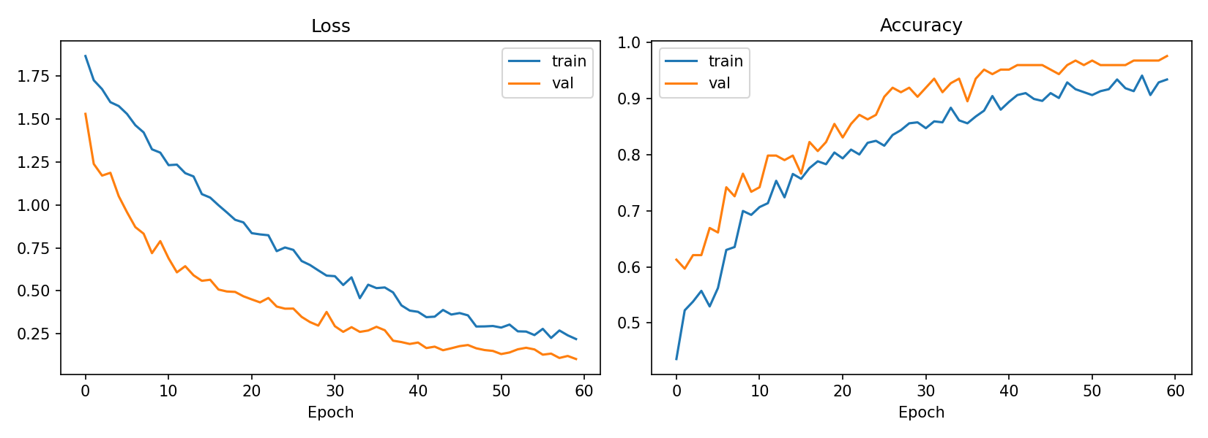
Figure 1. Training and validation loss and accuracy curves for the final model.
Overall Test Accuracy and Per-Class Breakdown
Overall test accuracy on the held-out test set was 94.4 percent, 117 correct out of 124 clips. Breaking this down by class shows the model performs very well on four of the five words and on both negative classes, with two words trailing noticeably behind.
Class | Test accuracy | Test clips
_silence_ | 100.0% | 39
never | 100.0% | 8
only | 100.0% | 7
_unknown_ | 97.9% | 47
all | 85.7% | 7
must | 75.0% | 8
none | 62.5% | 8

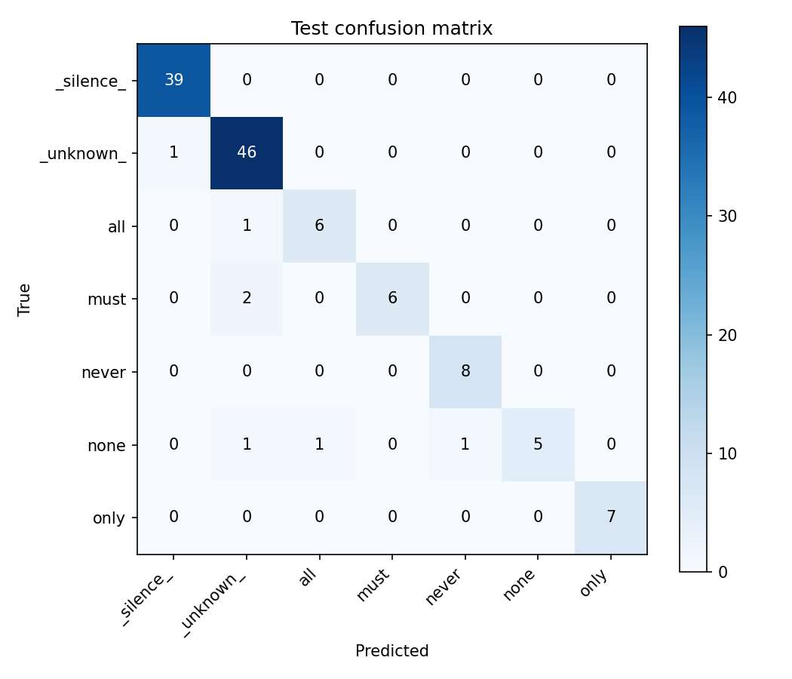
Figure 2. Test confusion matrix. none is most often confused with _unknown_, all, and never.
An example spectrogram, showing the 40 by 65 time-frequency input the model actually receives, is shown below.
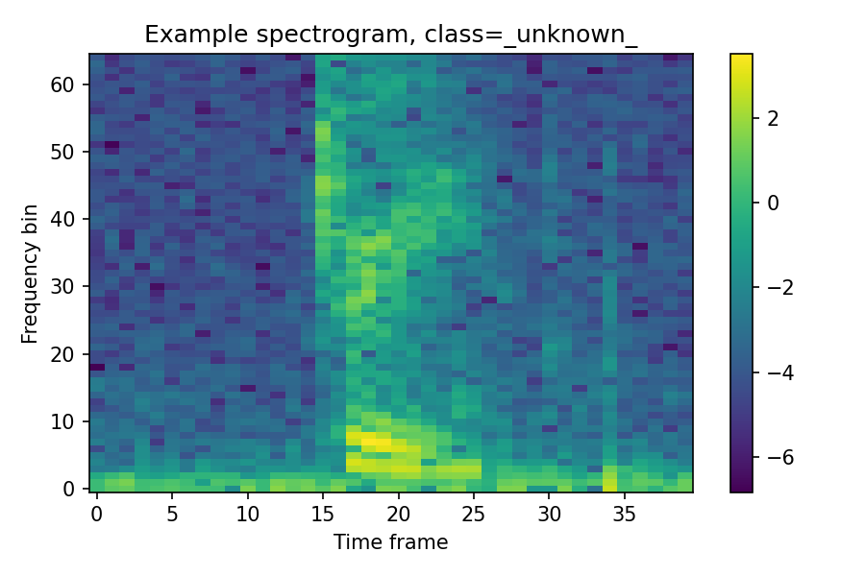
Figure 3. Example log-magnitude spectrogram input, one training clip.
The test set has only 7 or 8 clips per individual word class, so a single wrong prediction swings that class's reported accuracy by roughly 12 to 14 percentage points. The gap between none at 62.5 percent and the stronger classes at 85 to 100 percent is real and consistent across training runs, but the exact percentage should be read with that small-sample caveat in mind rather than treated as a precise population estimate.
On-Device Compilation
The sketch compiled using 376072 bytes of program storage, 38 percent of the board's 983040 byte flash budget, comfortably within limits. RAM required a real fix before it was safe to run. An initial, generously sized tensor arena left only 11256 bytes of RAM free for the stack, 95 percent of the board's 262144 bytes used overall, and the Arduino IDE itself flagged this as a stability risk. The tensor arena was tightened from a 150 KB guess down to 100 KB, close to the roughly 75 KB the first convolution layer's activation actually requires, and the audio ring buffer was trimmed slightly as well, bringing RAM use down to 193688 bytes, 73 percent, with 68456 bytes free and no warning.
Real-Time Demonstration
Real-time prediction is requested through a PowerShell base-station script, request_prediction.ps1, run from a laptop connected to the board over USB serial. The board continuously buffers the most recent 1.25 seconds of raw microphone audio in the background regardless of whether a request has been made, so a fresh window is always ready. On request, it computes features from the most recent 1 second of that buffer and reports its prediction as one line of text, the predicted class name and a confidence value. Since a prediction always covers whatever was captured in the instant the request arrives, the base station prints a short Get ready, then Speak now countdown before sending the actual request, giving the speaker a window that lines up with the board's own 1 second capture window rather than requesting a prediction before there was any chance to speak.
Real-Time Versus Test-Set Comparison
A single labeled real-time session, one request per word spoken in a known order, gives a direct point of comparison against the offline test-set numbers above.
Word spoken | Predicted class | Confidence | Correct
never | never | 0.956 | Yes
none | never | 0.723 | No
all | all | 0.976 | Yes
must | must | 0.819 | Yes
only | only | 0.879 | Yes

4 of 5 live requests were classified correctly, 80 percent on this small sample. The single miss was none, misclassified as never, the exact same word the offline test set identified as the model's weakest class at 62.5 percent accuracy, most often confused with _unknown_, all, and never. This agreement between a live, on-device result and the offline confusion matrix is meaningful evidence that the on-device feature pipeline, the custom FFT, windowing, and normalization written directly into the Arduino sketch, faithfully reproduces what the trained model actually learned, rather than the deployed system behaving differently from what testing predicted. An earlier, unlabeled test session before this one showed the same pattern less precisely, never, only, and all were recognized correctly multiple times, while attempts believed to be none or must sometimes landed on _unknown_ instead.
The demo video accompanying this report shows the board running this same real-time request cycle live, the base station requesting predictions across multiple keywords while the board remains visible and its microphone unobstructed.
E. Discussion
Summary
A 7-class keyword-spotting model, the five absolutist words plus _unknown_ and _silence_, was trained offline in Colab on a dataset merging 249 self-recorded word clips with Google's Speech Commands negatives, reaching 94.4 percent overall test accuracy. The trained model was converted to TensorFlow Lite, deployed to run real inference directly on the Nano 33 BLE Sense using a hand-written on-device feature pipeline, and driven by a serial base station that requests predictions on demand. A labeled real-time test session reproduced the offline test set's strongest and weakest classes almost exactly, correctly classifying 4 of 5 live requests and missing only on none, the class the offline confusion matrix already identified as the model's weakest.
Difficulties Encountered
* Two Colab-side bugs in the shared dataset-construction template, ffmpeg silently refusing to overwrite stale .wav files and extract_loudest_section failing to compile under GCC 13's stricter header requirements, both caused by leftover state or compiler version mismatches rather than anything about the actual audio data, and both fixed once diagnosed.
* Model design took five real, diagnosed training iterations rather than one. A first attempt using Flatten before the dense classifier reached 94.4 percent test accuracy but produced a 1.79 MB model file, almost double the board's 1 MB flash budget. Swapping to GlobalAveragePooling2D fixed the flash size but, with only two convolution blocks, collapsed accuracy to 77.4 percent through genuine underfitting, confirmed by low training accuracy itself rather than just a train and validation gap, since averaging pooled away too much of the fine timing and frequency pattern that separates similar-sounding words. Adding a third convolution block barely helped, 79.8 percent, showing the bottleneck was not depth. The real fix, reasoned from the specific failure pattern rather than further guessing at architecture, was peak-normalizing each clip and applying balanced class weighting, recovering accuracy to 84.7 percent.
* A fifth iteration was still required after that fix, caught before writing any firmware. Flash size and RAM size are separate budgets on this board, and the model file's flash size never changed across any of the five runs, staying at roughly 32.7 KB throughout, since GlobalAveragePooling2D makes the dense classifier's parameter count depend only on channel count, not spatial input size. The original 124 by 129 spectrogram input made the first convolution layer's activation alone require roughly 496 KB of RAM at inference time, almost double the board's entire 256 KB budget, a hard failure that no amount of tensor arena tuning could fix. This was only caught by manually computing TensorFlow Lite for Microcontrollers's actual activation memory requirement before writing any Arduino code, not by a compile error. Shrinking the spectrogram itself, a wider frame step and a crop to the lowest 65 frequency bins, brought the first activation down to roughly 75 KB and recovered accuracy back to 94.4 percent on a model that now actually fit the board.
* On real hardware, a silent audio capture failure took real investigation to trace. The sketch's setup function originally called the PDM library's begin function before registering its onReceive callback. Since the library starts capturing immediately inside begin, any hardware buffer that filled before the callback existed was never drained, and the library's own interrupt handler treats that as an overflow condition on the next cycle and silently disables the entire PDM peripheral, with no error message printed anywhere. The board would report a live buffer-not-full error forever, no matter how long you waited after boot. This was traced by reading the PDM library's actual source rather than trusting the initialization order shown in earlier examples, and fixed by registering the callback first, matching the order used in the library's own bundled micro_speech reference example.
* The first successful compile used 95 percent of the board's RAM, only 11 KB free for the stack, flagged by the Arduino IDE itself as a stability risk. This was addressed proactively, tightening the tensor arena and trimming the audio ring buffer before ever testing the sketch, rather than waiting to see whether it actually caused a crash on hardware.
* The base-station script initially requested a prediction the instant it opened the serial port, before the speaker had any real chance to speak, since the board always predicts on whatever is in its most recent 1 second window at the moment of the request. Fixed by adding a short Get ready and Speak now countdown timed to that window.
Hardest Part
The hardest part of this lab was debugging the silent PDM capture failure. Every other problem in this lab produced some kind of direct signal, a compile error, an oversized file, a training curve that plateaued too early, but a peripheral that silently disables itself produces no error at all, only an audio buffer that never fills no matter how long you wait. Diagnosing it required reading the actual PDM library source rather than trusting API usage assumed from an example, and recognizing that an interrupt-driven overflow-detection mechanism, reasonable and correct on its own, becomes a trap if a callback is registered after the hardware has already started running.
Future Improvements
* Collect more none and must samples specifically, the two weakest classes in every training run, since none in particular is consistently confused with _unknown_, all, and never, and a larger, more varied sample for just those two words would both improve the model directly and shrink the small-sample noise in their reported test accuracy.
* Try a mel-filterbank feature representation instead of the plain STFT spectrogram used here, now that the on-device feature pipeline has already been proven working end to end, since a mel-scale representation more closely matches human speech perception and might better separate acoustically similar words like none and never at a similar computational cost.
* Replace the base station's fixed Get ready and Speak now countdown with real voice-activity detection on the board itself, so a prediction is requested only once actual speech is detected in the rolling buffer, rather than relying on a person's timing to line up with a fixed window.
Was Real-Time Accuracy as Expected?
Yes, closely. The labeled real-time session's single miss, none misclassified as never, is exactly the class the offline confusion matrix already flagged as weakest, and every word the offline test set called strong was also recognized correctly live, several times, with confidence well above 0.7. This agreement across two independently generated results, one from held-out test clips evaluated in Python, one from a live microphone and a hand-written feature pipeline running directly on the microcontroller, is a meaningful confirmation that the on-device implementation reproduces the trained model's real behavior rather than diverging from it once deployed.

