Food Image Classification with CNNs
From a Basic CNN to ShuffleNet Transfer Learning on the Food-11 Dataset
CEN598 - Embedded Machine Learning, Lab 6
Name: ____________________________

A. System Design
Motivation and High-Level Design
Food image classification turns a photo of a meal into a label, which is the first step in automating dietary assessment. This project builds that classifier for the Food-11 dataset, which has 16,643 photos spread over 11 categories. The categories are Bread, Dairy product, Dessert, Egg, Fried food, Meat, Noodles-Pasta, Rice, Seafood, Soup, and Vegetable-Fruit. The dataset arrives already divided into 9,866 training images, 3,430 validation images, and 3,347 test images, and that division was kept exactly as provided.
The project is a sequence of four models, each one adding a single idea to the one before it. Phase 1 is a basic CNN with convolutional layers followed by fully connected layers. Phase 2 adds max pooling to that network. Phase 3 adds dropout to fight the overfitting that the first two phases show. Phase 4 abandons training from scratch and instead reuses ShuffleNet V2, a network already trained on ImageNet, keeping its layers frozen and training only a new final layer. All four models are trained and measured with the same code and the same procedure, so the differences in their results can be traced to the single change made in each phase.
Applications Beyond Diet Tracking
The project description mentions diet tracking and calorie estimation. A food classifier is useful in many other places as well.
* Allergen and dietary restriction screening. A phone or a wearable camera could warn someone with a nut, dairy, or seafood allergy, or someone following a halal, kosher, or vegetarian diet, when a dish is likely to contain something they avoid.
* Automated checkout in cafeterias and canteens. A camera over the till can recognize what is on a tray and price it without a cashier or barcodes, which speeds up lines in school and workplace dining halls.
* Food waste monitoring. Cameras over kitchen bins and returned plates can record what kinds of food are thrown away, which helps hospitals, schools, and restaurants reduce waste and cost.
* Smart kitchen appliances. An oven or microwave with a camera could recognize what was put inside and pick a suitable cooking program automatically.
* Medical nutrition support. People managing diabetes could get a rough carbohydrate estimate from a photo of a meal, and hospitals or care homes could check what a patient actually ate without nurses recording it by hand.
* Food quality and safety inspection. On a production line a classifier can catch a wrongly packed or wrongly labelled item.
* Accessibility. A phone app can describe a plate of food aloud for someone with a visual impairment.
Observations and Difficulties in Each Phase
Phase 1, basic CNN
The basic CNN overfits very quickly. Its best validation accuracy, about 40 percent, is reached after only 4 epochs on average. After that the training accuracy climbs to 100 percent while the validation loss rises steadily, from about 1.8 at its lowest to 9.3 by the end of training. The cause is visible in the architecture. With no pooling the feature maps stay at 64 by 64, so the flattened vector has 262,144 values and the first fully connected layer alone has about 33.5 million weights, far more than 9,866 training images can constrain. The network also never learned the Rice class properly, which has the fewest training images (280). It was also the slowest model to train from scratch, about 243 seconds per run.
Phase 2, adding pooling
Pooling improved every measure at once. Validation accuracy rose from 39.9 to 48.1 percent, the parameter count fell from 33.6 million to about 0.56 million, and training became about seven times faster. Each additional pooling layer helped, so the version with a pooling layer after every convolution was kept. Pooling did not cure overfitting however. Training accuracy still reached 100 percent and the validation loss still climbed, from 1.56 to 7.0.
Phase 3, adding dropout
Dropout turned out to be more subtle than expected. A light dropout rate gave the best accuracy but did not stop the validation loss from climbing, so by the project's own instruction the rate was increased. Only a combination of strong dropout on the fully connected layers and on the convolutional layers kept the validation loss flat, and that stronger setting gave up a little accuracy compared with the lightest one. Heavily regularized networks also learn more slowly, so they needed many more epochs to reach their best result, about 44 epochs instead of 9. Section C discusses this trade-off in detail.
Phase 4, ShuffleNet transfer learning
The first attempt at phase 4 used the same learning rate as the earlier phases, 1e-3, for 20 epochs. It reached 79.2 percent validation accuracy, but the training curves were still rising when it stopped, so the model was under-trained rather than finished. A short search on the validation set showed that a learning rate of 1e-2 reaches a much better plateau, and the final model reaches 84.9 percent validation accuracy and 86.7 percent test accuracy. Training the new layer is cheap in parameters but not in time. Each epoch still pushes every image through the whole frozen backbone at 224 by 224 resolution, which made one phase 4 run take about as long as one phase 1 run.
B. Experiments and Algorithms
Environment and Framework
All experiments were written in Python with PyTorch 2.14.1 (the CUDA 13.0 build) and torchvision 0.29.1, running on an NVIDIA GeForce RTX 5060 Laptop GPU with 8 GB of memory, inside WSL2 Ubuntu on Windows 11. PyTorch was chosen because the project recommends it and because torchvision supplies a pretrained ShuffleNet directly. Earlier labs in this course needed Google Colab because their TensorFlow dependency had no wheel for the local Python version. This lab did not need Colab, since PyTorch was already available locally, but the version installed from Lab 3 was a CPU-only build. A separate virtual environment with the CUDA build was created so that the earlier lab environment stayed untouched.
Two problems came up while setting this up. The first attempt to cache the dataset was killed by the Linux out-of-memory killer, because the code that computed the training mean and standard deviation converted the whole 224 by 224 training set to 64-bit floats at once, which needs about 12 GB on a machine with 7.6 GB. It was fixed by computing the statistics in chunks. A later install of the GPU libraries died silently partway through and had to be restarted, after which it finished normally.
Data and Preprocessing
The dataset is imbalanced, with Soup and Dessert having 1,500 training images each and Rice only 280. The test split is the folder named evaluation. The counts per class and split are listed below.
Class | Training | Validation | Test
Bread | 994 | 362 | 368
Dairy product | 429 | 144 | 148
Dessert | 1500 | 500 | 500
Egg | 986 | 327 | 335
Fried food | 848 | 326 | 287
Meat | 1325 | 449 | 432
Noodles-Pasta | 440 | 147 | 147
Rice | 280 | 96 | 96
Seafood | 855 | 347 | 303
Soup | 1500 | 500 | 500
Vegetable-Fruit | 709 | 232 | 231
Total | 9866 | 3430 | 3347

The raw photos are not a uniform size. Most are 512 by 512, but many are non-square, such as 512 by 384 or 1024 by 768. Every image is converted to RGB and resized directly to a square with bilinear interpolation. Resizing straight to a square keeps the whole food item in frame, while a center crop could cut part of the dish away. The cost is a slight stretch for non-square photos, which is applied equally to every split. All images are decoded once, stored as 8-bit arrays, and held on the GPU, so training never waits on JPEG decoding.
The two kinds of model get different input sizes. The networks trained from scratch in phases 1 to 3 use 64 by 64 images. Larger inputs were compared early on using only the validation set, and 128 by 128 images were not better for this small network while making the network without pooling much more expensive. ShuffleNet in phase 4 uses 224 by 224, which is the size it was pretrained at.
Pixel values are scaled to the range 0 to 1 and then normalized per color channel by subtracting a mean and dividing by a standard deviation. For the networks trained from scratch these constants are computed from the training split only, about 0.555, 0.451, and 0.344 for the mean and 0.262, 0.263, and 0.271 for the standard deviation, so that no information from the validation or test images leaks into preprocessing. ShuffleNet instead uses the ImageNet constants, mean 0.485, 0.456, 0.406 and standard deviation 0.229, 0.224, 0.225, because its pretrained weights expect inputs distributed that way. No data augmentation was used in any phase. Augmentation would act as a second regularizer and blur the effect of pooling and dropout that the project asks to measure separately. It is listed as an improvement in Section D.
Evaluation Protocol
Every model is trained with cross-entropy loss, which suits a problem where each image belongs to exactly one of 11 classes. After each epoch the model is scored on the whole training set and on the whole validation set, both with the model in evaluation mode. Scoring the training set in evaluation mode matters when dropout is used, since dropout makes the running training accuracy during an epoch look worse than the model really is and would hide overfitting. The epoch with the highest validation accuracy is kept, and only that version of the model is evaluated on the test set, one time. The test set was never used to choose any setting in this project.
Every configuration was trained three times with different random seeds (42, 43, and 44), and results are reported as the mean and standard deviation over those runs. A single run can land a point or two above or below its typical result just from random initialization and batch order, and several comparisons below differ by less than that. The figures of training curves and confusion matrices show the first seed.
Phases 1 to 3, the Convolutional Network
The network has three convolutional blocks and three fully connected layers. Each block is a 3 by 3 convolution with padding 1, so the height and width are unchanged, followed by a ReLU. The filter counts of 16, 32, and 64 double at each block, which is the usual pattern of looking for more kinds of features as the representation becomes more abstract. The fully connected layers narrow from 128 to 64 to 11 units. ReLU was used throughout because it is simple and avoids the vanishing gradients of sigmoid and tanh. The table lists the layers and the output shape after each one.
Layer | Phase 1 output | Phases 2 and 3 output
Input | 3 x 64 x 64 | 3 x 64 x 64
Conv 3x3, 16 filters, ReLU | 16 x 64 x 64 | 16 x 64 x 64
Max pool 2x2 (phases 2 and 3 only) | none | 16 x 32 x 32
Conv 3x3, 32 filters, ReLU | 32 x 64 x 64 | 32 x 32 x 32
Max pool 2x2 (phases 2 and 3 only) | none | 32 x 16 x 16
Conv 3x3, 64 filters, ReLU | 64 x 64 x 64 | 64 x 16 x 16
Max pool 2x2 (phases 2 and 3 only) | none | 64 x 8 x 8
Flatten | 262,144 | 4,096
Fully connected 128, ReLU | 128 | 128
Fully connected 64, ReLU | 64 | 64
Fully connected 11 | 11 | 11
Total parameters | 33,587,115 | 556,971

Phases 1, 2, and 3 all use the Adam optimizer with a learning rate of 1e-3, a batch size of 64, and a budget of 60 epochs. Adam at 1e-3 is a standard starting point that needs little tuning. A batch of 64 balances noisy but fast updates against stable ones. Since the best validation epoch is the one kept, a long budget cannot hurt a model that overfits early, and it only gives slower models enough time to finish learning. No weight decay was added, so that dropout is the only regularizer being measured in phase 3.
Phase 2, how pooling works
Max pooling with a 2 by 2 window and a stride of 2 keeps the largest activation in each 2 by 2 neighborhood and discards the rest, halving the height and width of the feature maps. It helps in two ways. It makes the network less sensitive to small shifts of a feature inside the image, because a feature that moves by a pixel usually stays inside the same window. It also shrinks the flattened vector that feeds the fully connected layers, which removes most of the weights and with them much of the network's ability to memorize the training images. The project asks for as many pooling layers as seem appropriate, so one, two, and three were compared, adding pooling after the first block, the first two blocks, and all three. The conv widths, fully connected widths, and all training settings were identical across these variants.
Phase 3, the theory of dropout
Overfitting happens when a network memorizes the training examples instead of learning what generalizes. During training, dropout sets each activation in a layer to zero with a probability p and scales the surviving activations by 1/(1-p) so that their expected value is unchanged. A different random subset of neurons is removed at every training step. A neuron can therefore not count on any particular neighbor being present, which discourages neurons from co-adapting to memorize the training set and forces the network to spread what it knows across many units. Training with dropout behaves like training a very large number of thinned networks that share weights, and using the full network at test time, with dropout switched off, approximates averaging all of them. Averaging many models is a well known way to reduce variance and overfitting.
Two kinds of dropout were used. Ordinary dropout was applied after each hidden fully connected layer. Channel dropout, called Dropout2d in PyTorch, was applied after each convolutional block. It removes whole feature map channels instead of single pixels, which suits convolutional layers because neighboring pixels within one channel are so strongly correlated that dropping individual pixels removes very little information.
The project says to try dropout and, if overfitting is not resolved, to adjust the rate until it is. Rates were therefore tried from light to strong. Overfitting was judged on the validation loss, and a model is called resolved when its validation loss at the end of training is within 10 percent of the lowest validation loss it reached, meaning the loss no longer climbs as the network begins to memorize. The validation loss is a better signal than accuracy here because accuracy can stay flat while the loss climbs, as the phase 1 and 2 curves show.
Phase 4, ShuffleNet and Transfer Learning
Transfer learning
Transfer learning reuses a network that was trained on a large problem to help with a smaller one. ShuffleNet was trained on ImageNet, which has about 1.28 million images in 1,000 classes, and ImageNet includes many food and dish categories. The early layers of such a network learn generic visual features like edges, colors, and textures, and the later layers combine them into more specific parts and objects. These features are useful for food photos too, so they need not be relearned from 9,866 images. Only the very last layer, the classifier that maps features to the 1,000 ImageNet labels, is specific to ImageNet. It is removed and replaced with a new layer that maps the same 1,024 features to the 11 food classes. All pretrained parameters are frozen, so the network works as a fixed feature extractor and only the new layer, with just 11,275 weights, is trained. With so few trainable parameters the model has very little room to overfit, it needs far less data, and it converges quickly. The limitation is that the features are not adapted to food, which fine-tuning the upper layers could improve.
Two details matter for frozen networks. Freezing the parameters stops their gradients, but batch normalization layers would still update their running mean and variance in training mode, which would quietly change the supposedly frozen backbone. The backbone is therefore kept in evaluation mode throughout, and only the new layer is switched to training mode. The inputs must also match what the pretrained weights saw, so images are 224 by 224 and use the ImageNet normalization constants.
The ShuffleNet architecture
ShuffleNet was designed for mobile and embedded devices with very limited computing power. The version used here, ShuffleNet V2 at width 1.0, has 2,278,604 parameters in total and needs about 0.145 billion multiply-accumulate operations for one 224 by 224 image, which is a small fraction of a conventional network such as ResNet-50, which needs around 4 billion. Of the parameters, 1,025,000 are in the original classifier and 1,253,604 are in the backbone.
The network starts with a 3 by 3 convolution of stride 2 with 24 filters and a 3 by 3 max pool of stride 2, which together cut the image height and width by a factor of four right away. Three stages follow, containing 4, 8, and 4 units and producing 116, 232, and 464 channels. A final 1 by 1 convolution expands to 1,024 channels, then global average pooling and the fully connected layer finish the network. The savings come from the design of the units. Two ideas do most of the work.
* Depthwise separable convolutions. A standard 3 by 3 convolution mixes information across space and across channels at the same time, which is expensive. ShuffleNet separates the two jobs. A 3 by 3 depthwise convolution filters each channel on its own for spatial structure, and a cheap 1 by 1 pointwise convolution then mixes the channels. For a layer with 116 channels, a standard 3 by 3 convolution needs 121,104 weights, while a depthwise convolution plus a pointwise convolution need 1,044 plus 13,456, which is 14,500 and about 8.4 times fewer.
* Channel split and channel shuffle. In a normal unit, the input channels are split into two halves. One half passes through unchanged and the other goes through a 1 by 1 convolution, a 3 by 3 depthwise convolution, and another 1 by 1 convolution. The two halves are then concatenated and their channels are shuffled, meaning interleaved, so that the next unit's two halves each contain a mixture of both groups. The shuffle lets information flow between groups without any extra computation, which is the idea the network is named for. A unit that reduces resolution skips the split and downsamples both branches.
ShuffleNet V2 was designed around practical guidelines for real hardware, not just operation counts. Its authors found that equal channel widths minimize memory access cost, that excessive group convolution and network fragmentation slow down real devices, and that element-wise operations are not negligible. Following these guidelines is how the network keeps its accuracy, roughly 69 percent top-1 on ImageNet, while remaining very cheap to run.
Phase 4 configuration
The new layer was trained with Adam at a learning rate of 1e-2 for 40 epochs with a batch size of 64. These values were chosen on the validation set after the first attempt, which used a learning rate of 1e-3 for 20 epochs, was found to be under-trained. The search was done quickly by running the frozen backbone once to cache its 1,024 features and training only the final layer on them, which is mathematically the same training as running the whole network each epoch. A learning rate of 1e-2 reached its plateau of about 84.5 percent validation accuracy within roughly 25 epochs. Faster rates reached the plateau sooner but overfit more afterward, and slower rates needed more than 60 epochs. The final results below come from running the real model end to end, not from the cached shortcut.
Setting | Phase 1 | Phase 2 | Phase 3 | Phase 4
Input size | 64x64 | 64x64 | 64x64 | 224x224
Normalization | dataset | dataset | dataset | ImageNet
Pooling | none | max 2x2, 3 | max 2x2, 3 | built into ShuffleNet
Dropout | none | none | FC 0.5, conv 0.2 | none
Trainable parameters | 33,587,115 | 556,971 | 556,971 | 11,275
Optimizer and learning rate | Adam 1e-3 | Adam 1e-3 | Adam 1e-3 | Adam 1e-2
Batch size | 64 | 64 | 64 | 64
Epochs | 60 | 60 | 60 | 40

C. Results
All accuracy figures are the mean and standard deviation over three seeds, measured at the epoch with the best validation accuracy. The training and validation curves and the validation confusion matrices below come from the first seed. The summary table shows every model together before the individual phases are discussed.
Model | Trainable params | Val acc (%) | Test acc (%) | Best epoch | Final train acc (%) | Final val loss
Phase 1, basic CNN | 33,587,115 | 39.9 ± 0.5 | 42.6 ± 0.5 | 3.7 | 100.0 | 9.27
Phase 2, plus pooling | 556,971 | 48.1 ± 0.5 | 50.3 ± 1.2 | 8.7 | 100.0 | 7.01
Phase 3, plus dropout | 556,971 | 48.3 ± 0.9 | 50.6 ± 1.2 | 44.3 | 85.4 | 1.65
Phase 4, ShuffleNet | 11,275 | 84.9 ± <0.1 | 86.7 ± 0.2 | 34.0 | 95.1 | 0.46

The last two columns describe the final epoch of training instead of the best epoch, and they expose the overfitting that the best-epoch accuracy hides. After 60 epochs the phase 1 and phase 2 models have memorized the training set completely and their validation loss has grown to several times its minimum. Phase 3 has a validation loss close to its minimum, and phase 4 is well behaved throughout.
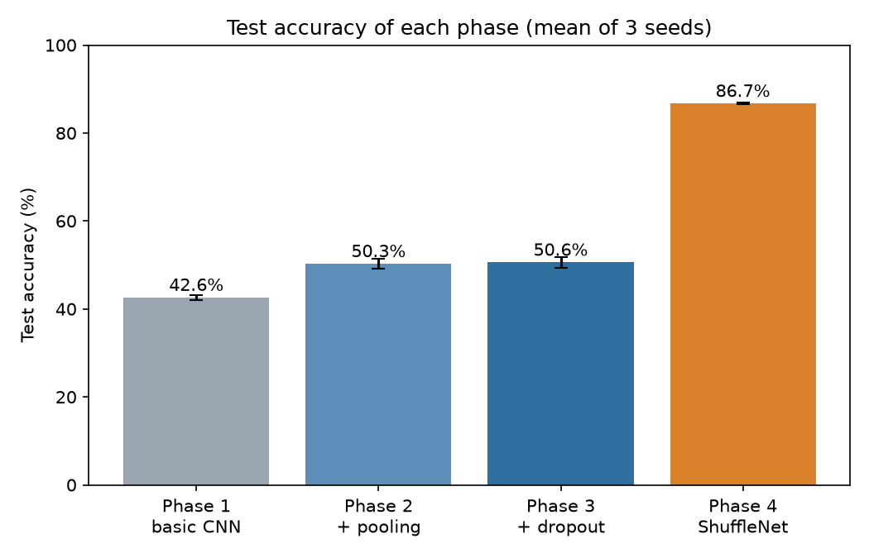
Figure 1. Test accuracy of each phase, mean of three seeds with the standard deviation as the error bar.
Phase 1, Basic CNN
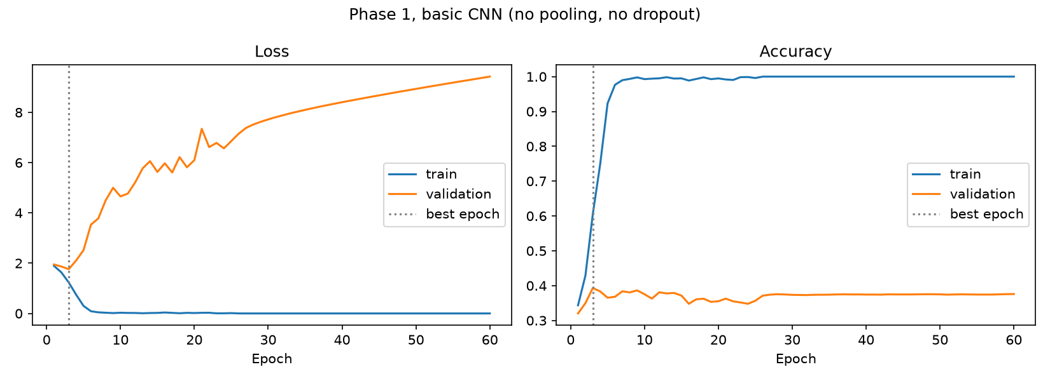
Figure 2. Phase 1 training and validation loss and accuracy. Training accuracy reaches 100 percent while validation loss climbs to above 9.
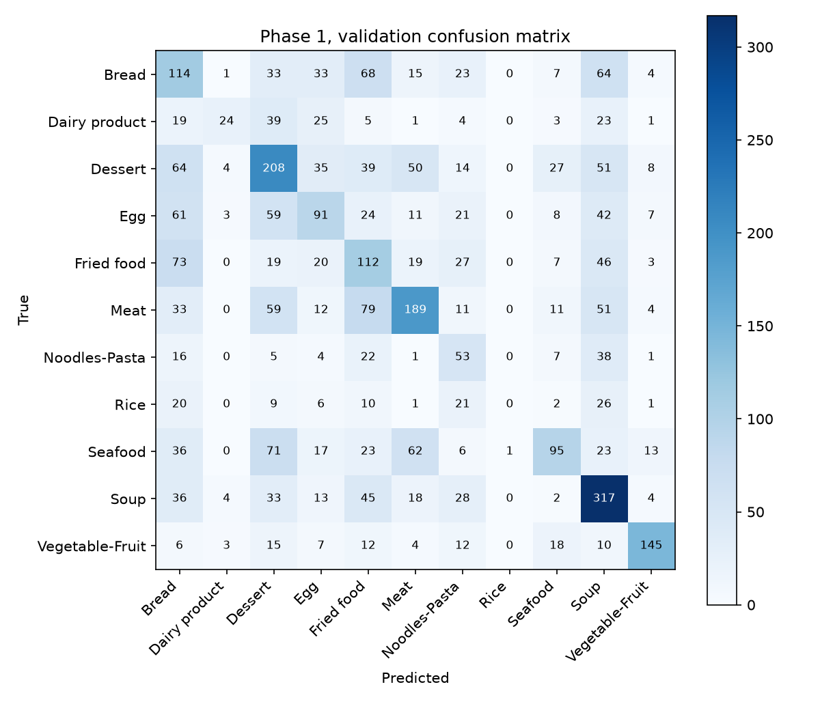
Figure 3. Phase 1 validation confusion matrix.
The curves show the classic picture of overfitting. Training accuracy goes to 100 percent within about 25 epochs while validation accuracy stays near 40 percent, and the validation loss rises more or less continuously. The confusion matrix is spread widely across the classes, with no class reaching high accuracy except the visually distinctive ones. The test accuracy is 42.6 ± 0.5 percent. On the test set the most common mistakes are Bread predicted as Fried food, Meat predicted as Fried food, Egg predicted as Bread, and Seafood predicted as Dessert.
Phase 2, Adding Pooling
Pooling layers | Parameters | Val acc (%) | Test acc (%)
0 (phase 1) | 33,587,115 | 39.9 ± 0.5 | 42.6 ± 0.5
1 | 8,421,291 | 44.1 ± 0.8 | 46.2 ± 0.4
2 | 2,129,835 | 45.6 ± 0.2 | 48.0 ± 1.0
3 (phase 2 model) | 556,971 | 48.1 ± 0.5 | 50.3 ± 1.2

Accuracy improves with every added pooling layer while the parameter count collapses, from 33.6 million with no pooling to 0.56 million with three pooling layers. Pooling after every block was therefore chosen. It improves validation accuracy by 8.3 points and test accuracy by 7.7 points over the basic CNN, and each configuration was measured on three seeds with small spreads, so the ordering is reliable.
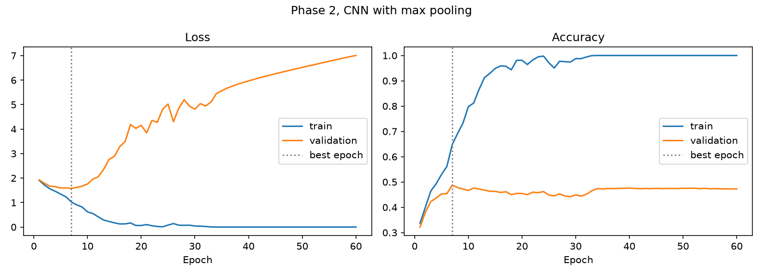
Figure 4. Phase 2 training and validation loss and accuracy.
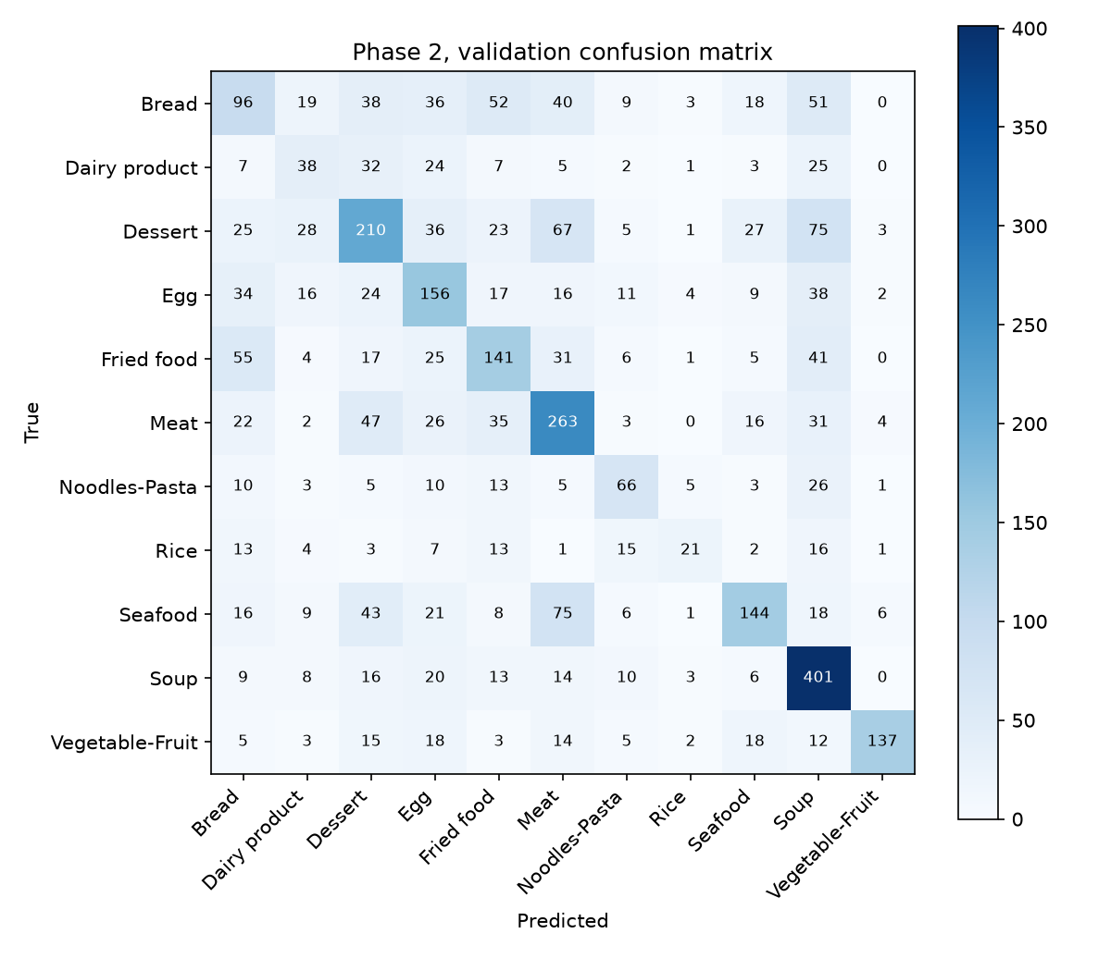
Figure 5. Phase 2 validation confusion matrix.
The improvement over phase 1 is clear in the confusion matrix, with more of the weight on the diagonal, and in the Rice class, which rose from 8.3 percent to 33.7 percent test accuracy. The curves still show overfitting, though. Training accuracy reaches 100 percent and the validation loss turns upward after about 7 epochs, reaching 7.0 by the end. Pooling reduced how much the network can memorize but did not remove the problem, which is what phase 3 addresses.
Phase 3, Adding Dropout
The table shows the dropout settings that were tried on the phase 2 network, from none to strong. The rise column is how far the final validation loss sits above the lowest validation loss reached, and the last column applies the 10 percent rule described in Section B.
Dropout setting | Val acc (%) | Test acc (%) | Lowest val loss | Final val loss | Rise | Resolved
No dropout (phase 2) | 48.1 ± 0.5 | 50.3 ± 1.2 | 1.56 | 7.01 | 349% | No
FC 0.3 | 50.2 ± <0.1 | 53.3 ± 0.9 | 1.49 | 3.94 | 165% | No
FC 0.5 | 49.9 ± 0.2 | 52.4 ± 1.1 | 1.54 | 3.45 | 123% | No
FC 0.7 | 46.5 ± 1.0 | 49.5 ± 1.2 | 1.68 | 2.71 | 61% | No
FC 0.5, conv 0.1 | 48.9 ± 0.4 | 50.8 ± 0.8 | 1.53 | 1.93 | 26% | No
FC 0.5, conv 0.2 (chosen) | 48.3 ± 0.9 | 50.6 ± 1.2 | 1.54 | 1.65 | 7% | Yes
FC 0.3, conv 0.2 | 48.0 ± 1.0 | 50.4 ± 0.2 | 1.53 | 1.85 | 21% | No

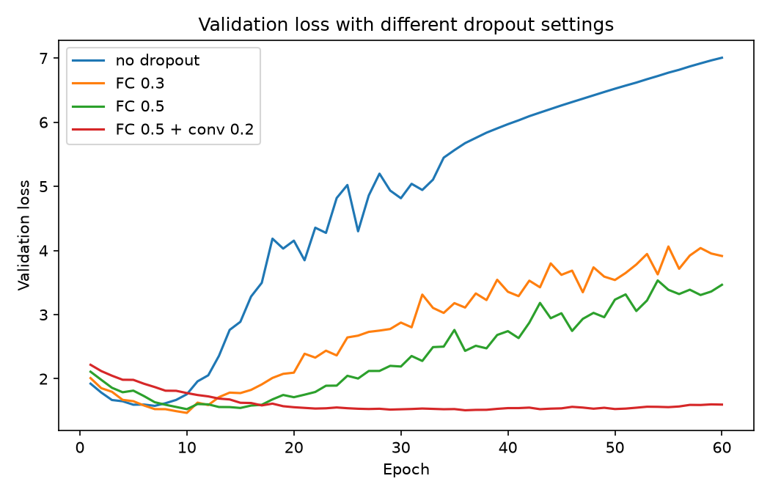
Figure 6. Validation loss with different dropout settings. Without dropout the loss climbs steadily. Only the combination of fully connected and convolutional dropout keeps it flat.
Light dropout on the fully connected layers helped accuracy a little, with a rate of 0.3 giving the best validation and test accuracy of the whole sweep, but the validation loss still rose to more than twice its minimum, so by the project's rule overfitting was not resolved. Raising the rate to 0.5 and then 0.7 shrank the rise in loss, but a rate of 0.7 started to cost accuracy, since the network no longer had enough active units to learn well. Adding channel dropout to the convolutional layers brought the loss under control. A convolutional rate of 0.1 was not enough, and a rate of 0.2 together with a fully connected rate of 0.5 was the only setting where the final validation loss ended within 10 percent of its minimum, at 1.65 compared with 1.54. That setting was chosen as the phase 3 model.
This outcome has an important nuance. The setting that resolves overfitting is not the one with the highest accuracy. The chosen model scores 48.3 ± 0.9 percent validation and 50.6 ± 1.2 percent test accuracy, essentially the same as the phase 2 model, while the lightly regularized model with a rate of 0.3 scores about 3 points higher on the test set. What dropout bought in the chosen model is stable training. The validation loss stays flat for the whole run instead of ending at 7.0, and the best epoch no longer has to be found by watching for the moment the model starts to degrade. Dropout also did not close the gap between training and validation accuracy. The chosen model still reaches a training accuracy in the 80s while validation accuracy sits near 48 percent, a sign that the real limitation is the amount and variety of data available to a small network trained from scratch, and not only the size of the model.
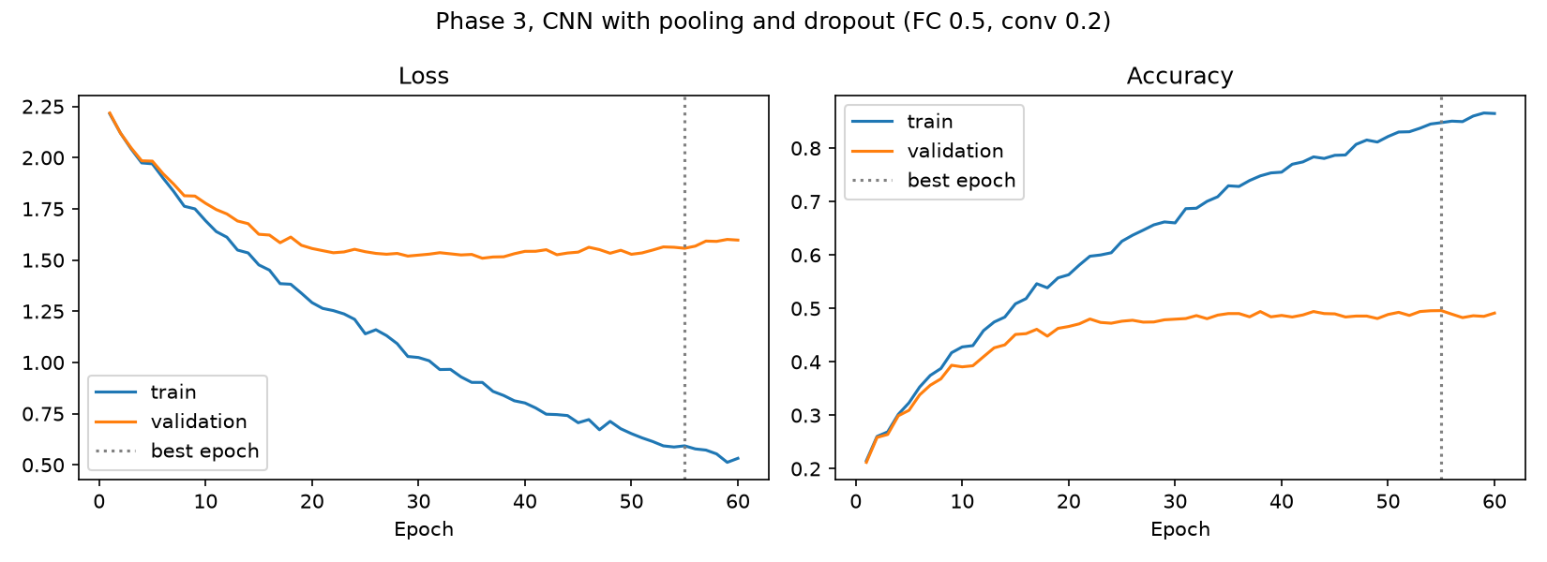
Figure 7. Phase 3 training and validation loss and accuracy for the chosen setting. The validation loss no longer climbs.
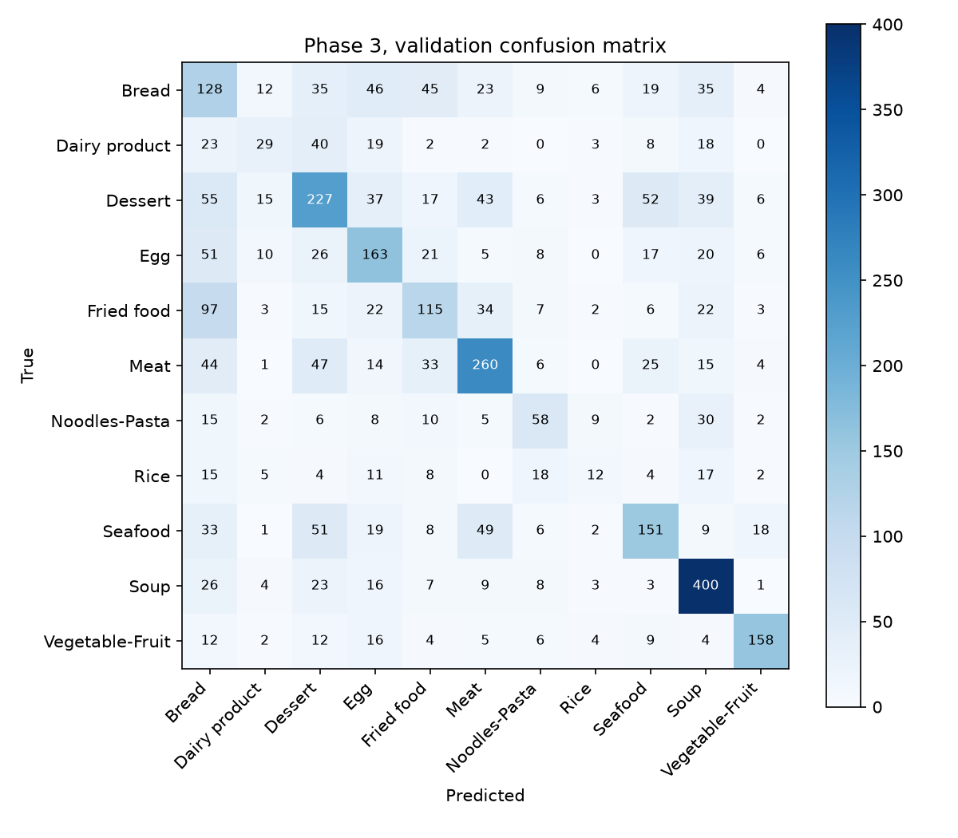
Figure 8. Phase 3 validation confusion matrix.
Phase 4, ShuffleNet
Setting | Val acc (%) | Test acc (%) | Best epoch
First attempt, lr 1e-3, 20 epochs | 79.2 ± 0.1 | 81.1 ± 0.1 | 20 (still improving)
Tuned, lr 1e-2, 40 epochs | 84.9 ± <0.1 | 86.7 ± 0.2 | 34

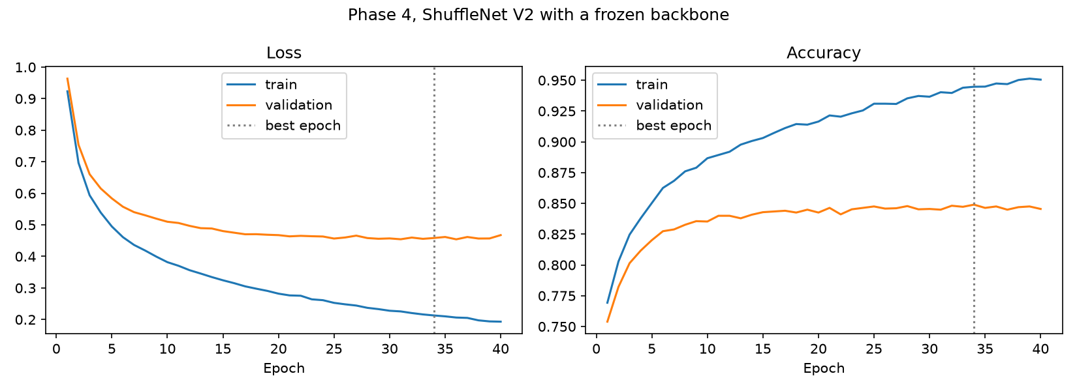
Figure 9. Phase 4 training and validation loss and accuracy for the tuned setting. Validation loss follows training loss closely.
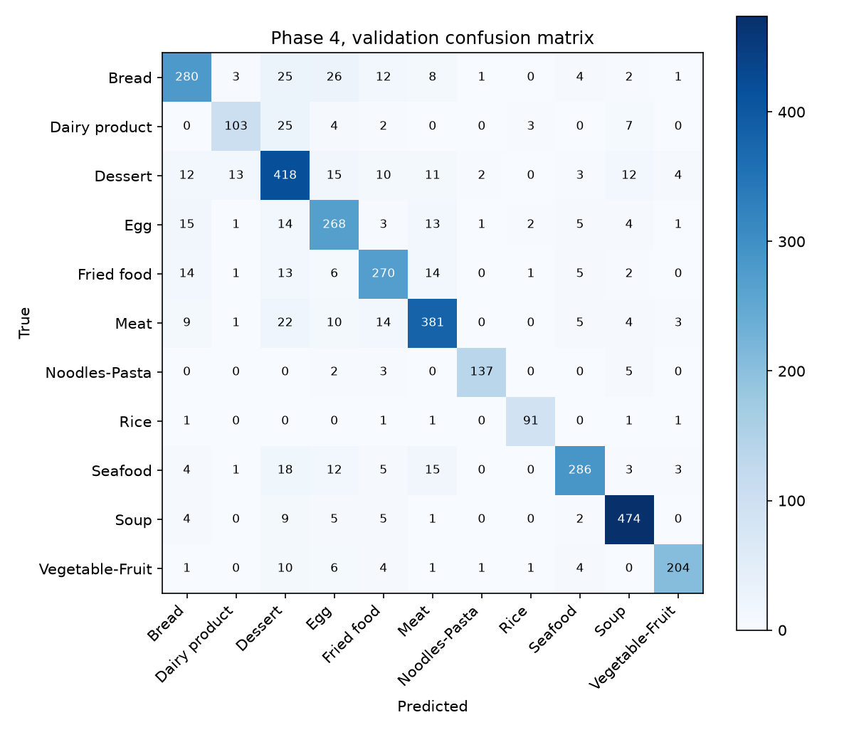
Figure 10. Phase 4 validation confusion matrix.
ShuffleNet with a frozen backbone is far better than anything trained from scratch. Validation accuracy is 84.9 ± <0.1 percent and test accuracy is 86.7 ± 0.2 percent, which is more than 33 points above even the best from-scratch setting. It also reached this result while training only 11,275 weights, about 2 percent as many as the phase 2 network. The curves are healthy. The validation loss follows the training loss and flattens out at 0.46, instead of diverging as in phases 1 and 2. The model is not free of cost though. A phase 4 run took about 233 seconds compared with about 34 seconds for phase 2, since every epoch sends all the images through the whole backbone at 224 by 224 resolution.
Comparison on the Test Set
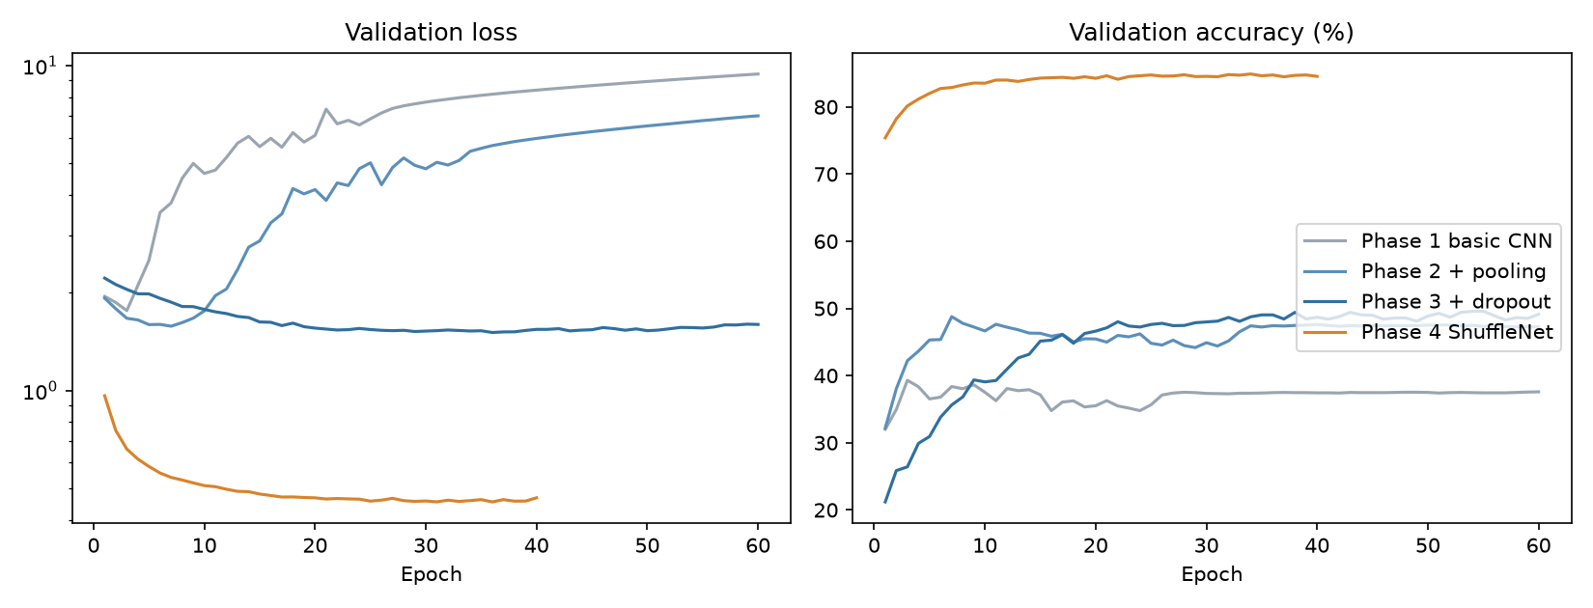
Figure 11. Validation loss and accuracy of all four phases. Phase 4 starts higher and stays far above the others.
Test accuracy is consistently about two points higher than validation accuracy for every model. This is most likely because the two splits have a slightly different mix of classes and images, for example the test split has fewer Fried food images than the validation split, and not because of anything about the models, since the test set was never used to make any choice. The ordering of the four models is the same on both splits. The table breaks the test accuracy down by food class.
Class | Phase 1 (%) | Phase 2 (%) | Phase 3 (%) | Phase 4 (%)
Bread | 28.1 | 30.9 | 32.0 | 79.9
Dairy product | 19.4 | 23.2 | 17.3 | 70.3
Dessert | 34.7 | 38.5 | 40.1 | 81.5
Egg | 33.8 | 45.0 | 49.5 | 78.9
Fried food | 40.9 | 40.5 | 41.1 | 83.0
Meat | 56.6 | 68.0 | 62.7 | 89.1
Noodles-Pasta | 32.9 | 46.5 | 51.5 | 97.3
Rice | 8.3 | 33.7 | 11.1 | 95.8
Seafood | 42.0 | 49.3 | 48.2 | 89.4
Soup | 59.3 | 73.7 | 76.9 | 96.9
Vegetable-Fruit | 71.7 | 70.9 | 76.9 | 94.7
Overall | 42.6 | 50.3 | 50.6 | 86.7

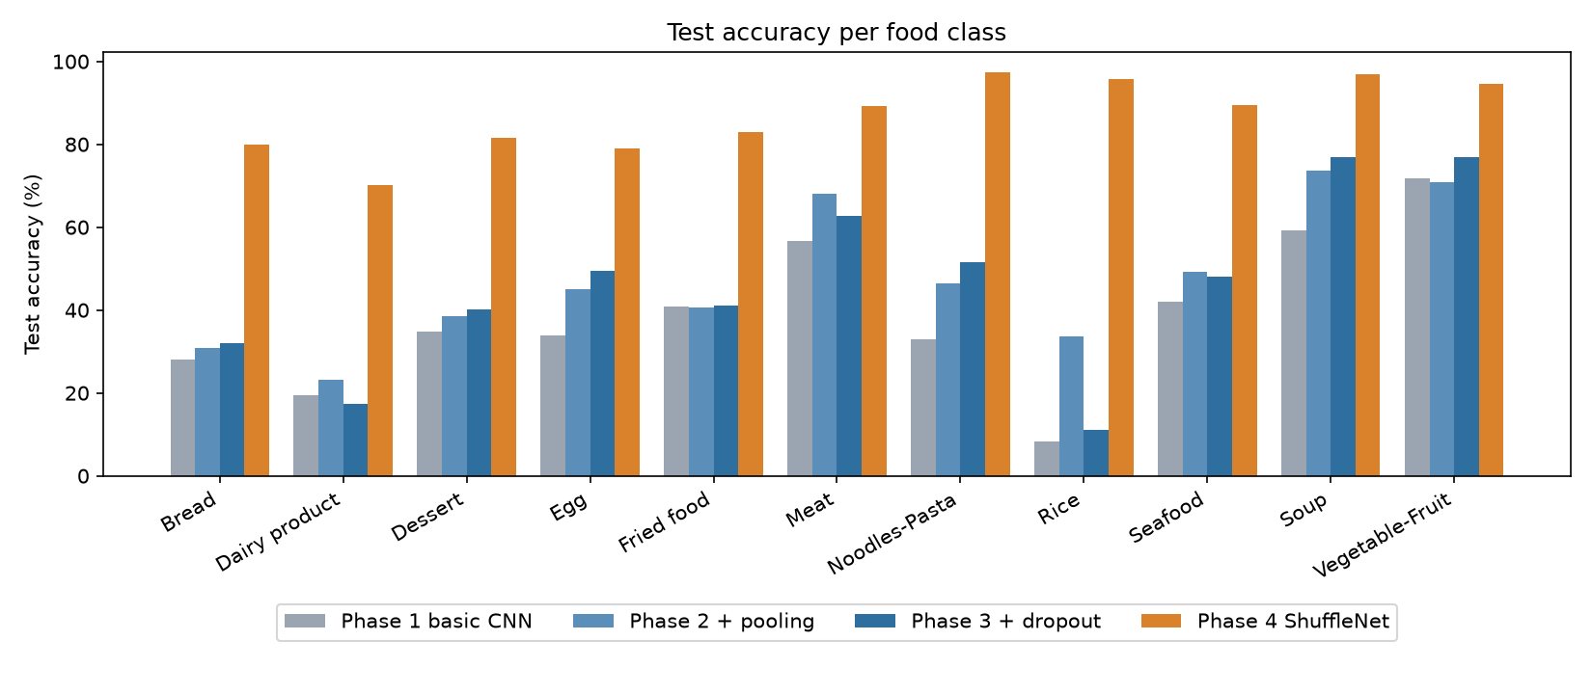
Figure 12. Test accuracy per food class for each phase.
D. Discussions
Summary of Each Model
* Phase 1, basic CNN. 42.6 ± 0.5 percent test accuracy. A plain stack of convolutions and fully connected layers learns something, but its 33.6 million weights memorize the training set almost immediately and it generalizes poorly.
* Phase 2, with pooling. 50.3 ± 1.2 percent test accuracy. Pooling cut the parameters by a factor of 60 and the training time by about seven, and it improved the test accuracy by about eight points. Overfitting remained.
* Phase 3, with dropout. 50.6 ± 1.2 percent test accuracy for the setting that resolves overfitting, and as high as 53.3 ± 0.9 percent for a lighter setting that does not. Dropout makes the training behave, but it gives only a small accuracy gain because the underlying limit is the data.
* Phase 4, ShuffleNet. 86.7 ± 0.2 percent test accuracy while training only 11,275 weights. This is a large improvement over every model trained from scratch and the clear best result.
Difficulties in Designing an Object Classification System
Several things make food classification harder than classifying more rigid objects, and they show up directly in the results.
* Large variation within a class. Dessert covers cakes, ice cream, pastries, and puddings, and Meat covers everything from a steak to a sausage. A class this broad has no single typical appearance.
* Several foods in one picture. A plate often holds bread, egg, and fried items together, so one photo can legitimately belong to more than one class. The dataset gives it a single label, which makes some mistakes unavoidable.
* Class imbalance. Rice has only 280 training images while Soup and Dessert have 1,500. The from-scratch models handled the rare classes badly. Rice test accuracy was between about 8 and 34 percent across phases 1 to 3.
* Limited data for training from scratch. 9,866 images are not many for a network that must learn its features from nothing, which is the main reason the from-scratch models plateau near 50 percent.
* Photographic variation. Lighting, camera angle, plate color, and background change between photos and vary far more than the food itself.
These problems can be reduced in several ways, listed under improvements below. The biggest single remedy seen in this project is transfer learning, which supplies features learned from over a million images and so sidesteps the data shortage.
Which Foods Were Hardest to Recognize
Dairy product and Bread were the hardest classes. With the best model, ShuffleNet, Dairy product reached only 70.3 percent test accuracy and Bread 79.9 percent, compared with 97.3 percent for Noodles-Pasta, 96.9 percent for Soup, and 95.8 percent for Rice. The confusion matrices show why. Dairy product is mistaken for Dessert more than for anything else, 25 of its 144 validation images in phase 4, which makes sense because many desserts are made of cream, milk, or cheese. Bread is confused with Egg, Dessert, and Fried food, since breaded and baked items and breakfast plates look alike. The from-scratch models also had trouble with Egg versus Bread, Fried food versus Bread, and Dessert versus Meat or Soup.
The easiest classes were Soup, Noodles-Pasta, and Vegetable-Fruit. Soup is almost always a bowl of liquid, Noodles-Pasta has a distinctive stringy texture, and Vegetable-Fruit is dominated by bright greens, reds, and oranges, so even a small network could pick them up. Rice is an interesting case. The from-scratch models were erratic on it, with test accuracy of 8.3, 33.7, and 11.1 percent in phases 1 to 3, because there are so few examples that small changes in training swing the result. ShuffleNet reached 95.8 percent on it, which shows that good pretrained features make a rare class far less dependent on having many training images.
Possible Improvements
* Data augmentation, such as random flips, crops, rotations, and color jitter. This effectively multiplies the training data and is the most direct remedy for the overfitting the from-scratch models suffer from. It was left out deliberately to keep each phase's effect isolated, but it would almost certainly raise all of them.
* Fine-tuning the upper ShuffleNet layers, with a small learning rate, instead of keeping the whole backbone frozen. This lets the features adapt to food and is likely to improve on the frozen result.
* Handling class imbalance with a class-weighted loss or by oversampling Rice and Dairy product.
* Using higher resolution inputs, a deeper from-scratch network with batch normalization, or a stronger pretrained backbone such as MobileNet or EfficientNet when computing budget allows.
* Label smoothing, ensembling several models, and test-time augmentation, which each give smaller but dependable gains.
* Treating the problem as multi-label classification, since many photos contain more than one kind of food.
Overall
The four phases tell a consistent story. A plain CNN overfits a small dataset badly. Pooling reduces the size of the model dramatically and improves generalization. Dropout makes training stable and removes the loss divergence, but cannot by itself make up for limited data. Transfer learning from a mobile-friendly pretrained network solves the data problem and delivers the best accuracy with the fewest trained parameters, which also makes it the natural fit for an embedded device.

