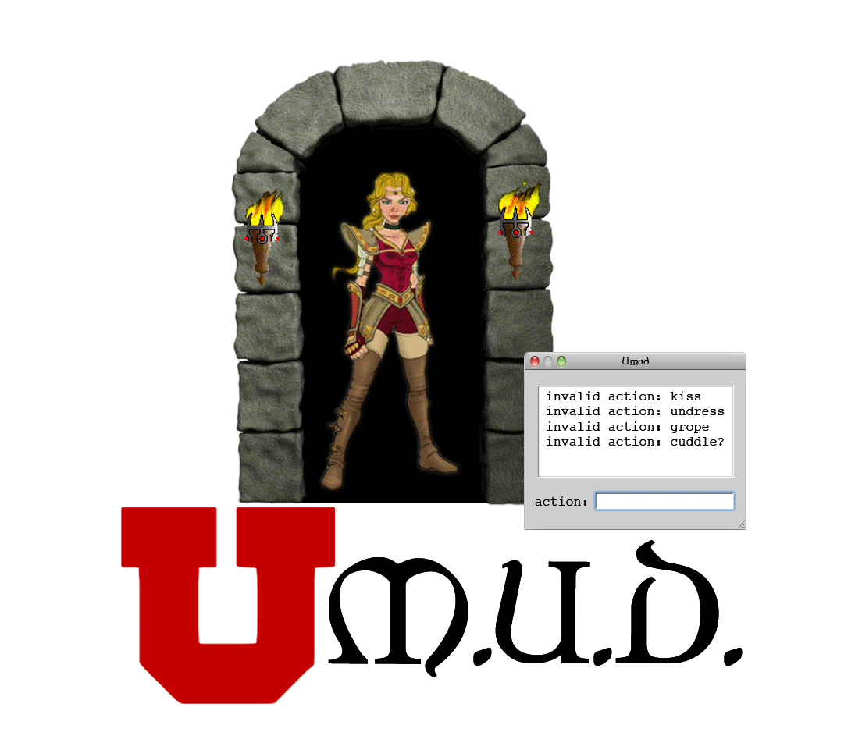
uMUD Ver. 1.0
White Paper
Published: April, 2012

Team Exception
University of Utah, CS3505 Final Project


by John Wells, Joel Hough, Bailey Malone,
Cody Curtis, and James Murdock

Contents
Table of Contents
Introduction: What is uMUD? 3
Executive Summary 3
Project Capabilities 3
Key Features 3
Software Architecture & Technical Contributions 3
Technical Overview 3
Target Demographics 3
Main Features 4
Implemented Technologies 4
Extensibility 4
Missing Pieces 4
Limitations 4
Team Overview 4
Software Practices 4
Individual Contributions 4
Success and Disappointments 5
Lessons Learned 5
Conclusion 5
Illustration Index
Illustration 1: uMUD Atoms Graph 6
Illustration 2: uMUD Functions Graph 7
Illustration 3: uMUD Railroad Graph 8

Introduction: What is uMUD?
A Multi-User Dungeon (MUD) is a text based role playing game (RPG) characterized by the combination of hack and slash, interactive fiction, online chat, and player versus player combat. Players can view information about their environment, and interact with them using a series of commands. uMUD is an extensible MUD platform. It contains the structure and hierarchies required for a MUD, but leaves the game play untouched, allowing for infinite customization by players and administrators (MUDerators).

Executive Summary

Project Capabilities
The capabilities of uMUD v1.0 are vast. The game itself is constructed out of atoms, the most basic idea of something that the game uses. It takes these atoms and combines them to form usable things, rooms, or even word groups in the game.

Key Features
The key features of uMUD are discussed below. Each feature will be discussed in detail at a later point.
- Parser
- Binder
- C++ Server
- Hot Patching
- World Building

Software Architecture & Technical Contributions
The multiple inheritance architecture was inspired by Richard Bartle, the creator of the original MUD. Due to the complications associated with multiple inheritance, Lua was a prime candidate to perform these tasks. Lua is extremely lightweight, the only data structure being an associative table. This allowed us to create our own object system that easily supported multiple inheritance.

Technical Overview

Target Demographics
uMUD aims to entertain the MUD community's relatively small player base. Most MUDs never gather a huge following. Having ten active players is a monumental achievement in a MUD, and that is what we are shooting for. The flexibility of the platform will give us a decisive advantage against other MUDs.

Main Features
Each main feature will be detailed below:
Embedded C++ / Lua
Hot Patching
Game Design stuff
Other cool stuff.

Implemented Technologies
The ideas for uMUD's object system and multiple inheritance hierarchies came from the creator of the first MUD, Richard Bartle. Bartle's system was designed to ....<filler text here> ... <Should probably mention the C++ single threaded server> ...

Extensibility
This should probably be mentioned... Can be implmented to do whatever you can think of for a game.

Missing Pieces
While the platform itself is complete, there is no actual game for players to log into. The platform can now handle any kind of game, so that step is trivial compared to the writing of the platform itself.

Limitations
There are some known problems with parsing long strings of commands. Some of the problems are associated with language patterns common today, such as the excessive use of prepositions before a noun. These types of commands will confuse the parser and will not produce a result. <EXAMPLE OF THIS>. Other limitations include state preservation of the game. Since the server can be hot patched, this is less of an issue, but the inability to save all Lua data is an extreme danger to players in the game. Lua's complex table associations make it difficult to serialize this data, but it is planned in future releases.

Team Overview

Software Practices
uMUD was written primarily using agile development techniques. ... more stuff...

Individual Contributions
Team member contributions are as follows:

Joel Hough – Binder and Parser
Joel is the most experienced programmer in Team Exception. As such, he handled the extremely complicated relationships in the binder and parser.
Cody Curtis – Database
Cody wrote the SQLite portion of uMUD. He ensured that usernames and passwords were stored and could be accessed during login. Cody also wrote the Lua interface on the C++ server.
James Murdock – uMUD Bot
James wrote the IRC based uMUD Bot. Using uMUD bot, anyone can connect to uMUD by sending a private message the bot.

Bailey Malone – Server
Bailey was responsible for the C++ backend. He wrote the single threaded socket handler and ensured that all messages received were routed to the correct place.

John Wells – World Building
John wrote the world builder, the feature that allows a game world to be created from a Lua table. John also assisted with the object system and multiple inheritance hierarchies

Success and Disappointments
uMUD Bot was a success as a uMUD Client.
Time constraints that limited our features were a disappointment, along with hardware issues on presentation day.

Lessons Learned

Conclusion
What grade do we believe we earned? An A++! Because we did something creative!
One to two paragraphs for a conclusion.

We feel that uMUD is an extremely unique project. After viewing some of the other presenters it was evident that no one else did anything quite like this. We believe that the capabilities uMUD possesses are above and beyond the scope of a 3000 level CS course.

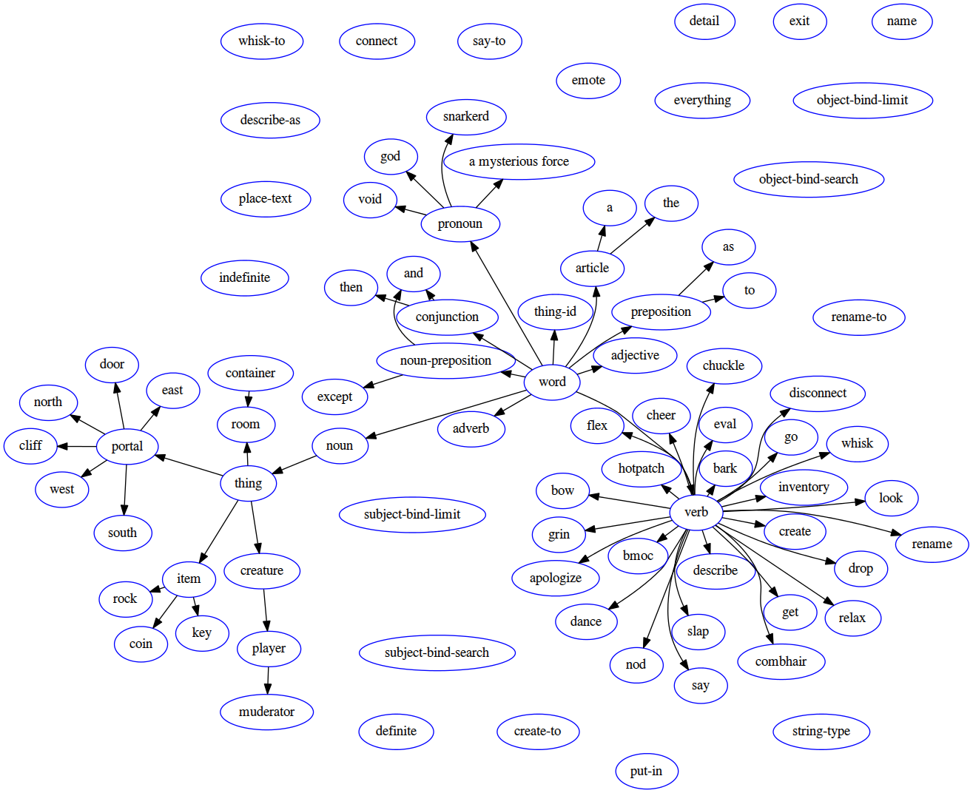Illustration 1: uMUD Atoms Graph

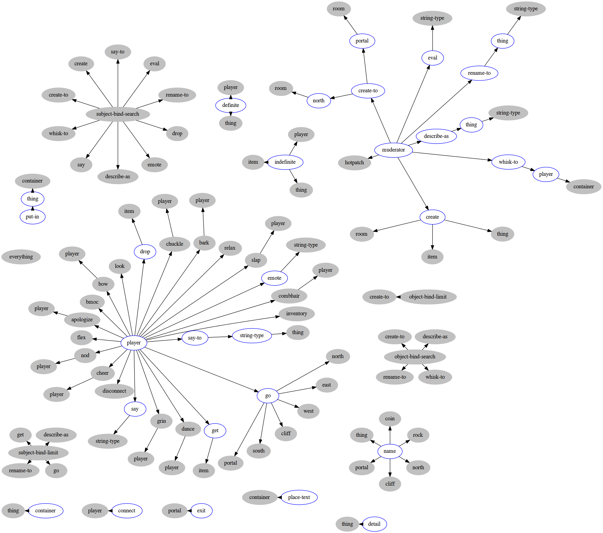Illustration 2: uMUD Functions Graph

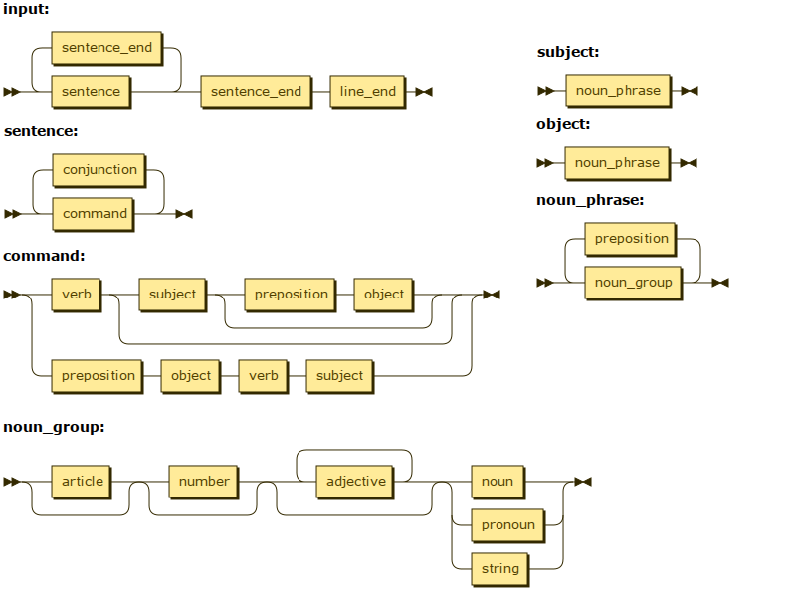Illustration 3: uMUD Railroad Graph

