Install raspbian.

Find address of router using:
route -n
where the destination is 0.0.0.0 the gateway is the location of the router

Find mask and current id using ifconfig (if on wifi use wlan0 on ethernet use eth0):
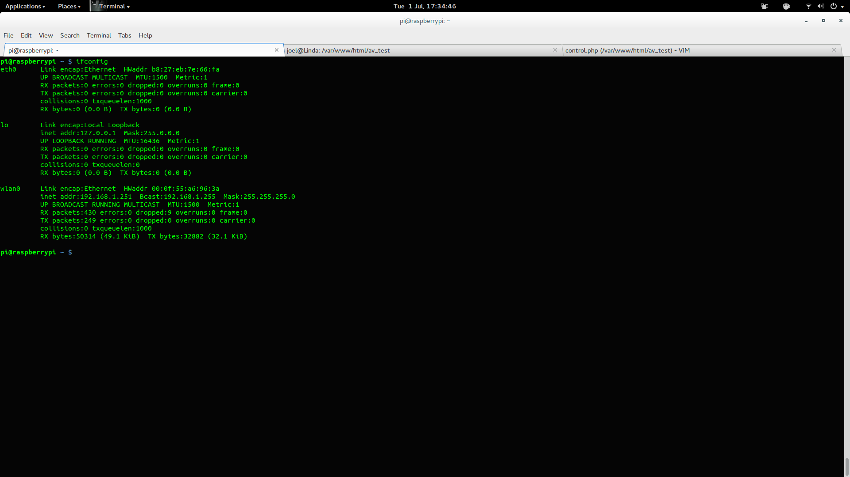

edit /etc/network/interfaces:
auto lo

iface lo inet loopback
iface eth0 inet static
address [desired address(must be on same subnet as router)]
netmask 255.255.255.0
gateway [address of router]

allow-hotplug wlan0
iface wlan0 inet manual
wpa-roam /etc/wpa_supplicant/wpa_supplicant.conf
iface default inet dhcp
iface khyber inet static
address [desired address(must be on same subnet as router)]
netmask 255.255.255.0
gateway [address of router]

edit /etc/wpa_supplicant/wpa_supplicant.conf:
network={
ssid=[your ssid]
psk=[your wifi password]
id_str=[a name for this connection]

ssh into the pi using:
ssh pi@[pi address]

install apache:
sudo apt-get install apache2 libapache2-mod-wsgi php5-cgi php5-cli libapache2-mod-php5

test gpio with:
import RPi.GPIO as gpio
import time

gpio.setmode(gpio.BOARD)
gpio.setup(12, gpio.OUT)
gpio.output(12, True)
gpio.setup(10, gpio.OUT)
gpio.output(10, False)
time.sleep(1)
gpio.output(12, False)

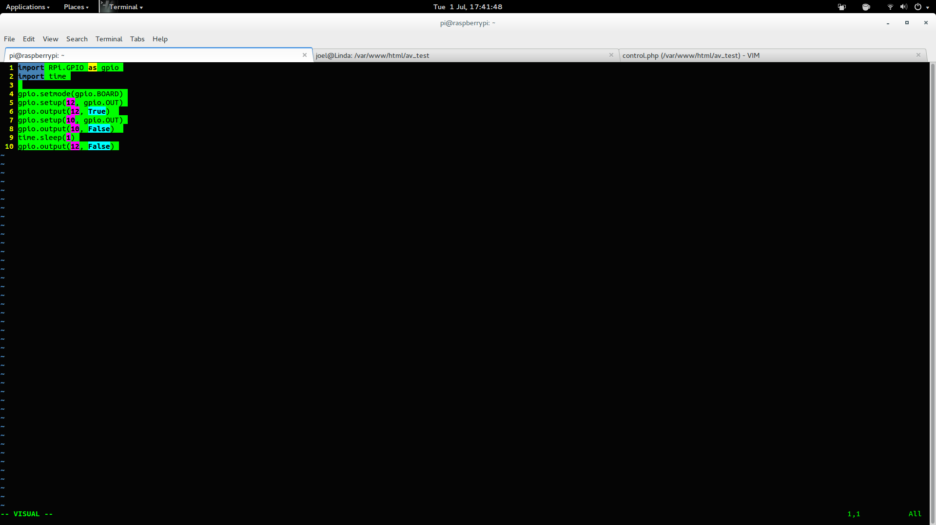
this must be run with sudo python. Attach some sort of test circuit to rxd and pin 18 Numbers

RPi.GPIO Raspberry Pi Name BCM2835
P1_01 1 3V3
P1_02 2 5V0
P1_03 3 SDA0 GPIO0
P1_04 4 DNC
P1_05 5 SCL0 GPIO1
P1_06 6 GND
P1_07 7 GPIO7 GPIO4
P1_08 8 TXD GPIO14
P1_09 9 DNC
P1_10 10 RXD GPIO15
P1_11 11 GPIO0 GPIO17
P1_12 12 GPIO1 GPIO18
P1_13 13 GPIO2 GPIO21
P1_14 14 DNC
P1_15 15 GPIO3 GPIO22
P1_16 16 GPIO4 GPIO23
P1_17 17 DNC
P1_18 18 GPIO5 GPIO24
P1_19 19 SPI_MOSI GPIO10
P1_20 20 DNC
P1_21 21 SPI_MISO GPIO9
P1_22 22 GPIO6 GPIO25
P1_23 23 SPI_SCLK GPIO11
P1_24 24 SPI_CE0_N GPIO8
P1_25 25 DNC
P1_26 26 SPI_CE1_N GPIO7

