DIVISION OF ARTIFICIAL INTELLIGENCE AND MACHINE LEARNING
SCHOOL OF COMPUTER SCIENCE AND TECHNOLOGY
Academic Year 2026-2027 - ODD SEMESTER
Skill-Based Evaluation Report
(III Internal Assessment)
for
23AI2011
SOFTWARE ENGINEERING FOR ARTIFICIAL INTELLIGENCE
in partial fulfillment for the award of the degree of
BACHELOR OF TECHNOLOGY
in
COMPUTER SCIENCE AND ENGINEERING
(ARTIFICIAL INTELLIGENCE & MACHINE LEARNING)
Submitted by
JOEL JAMES (Reg. No: ____________)
October 2026
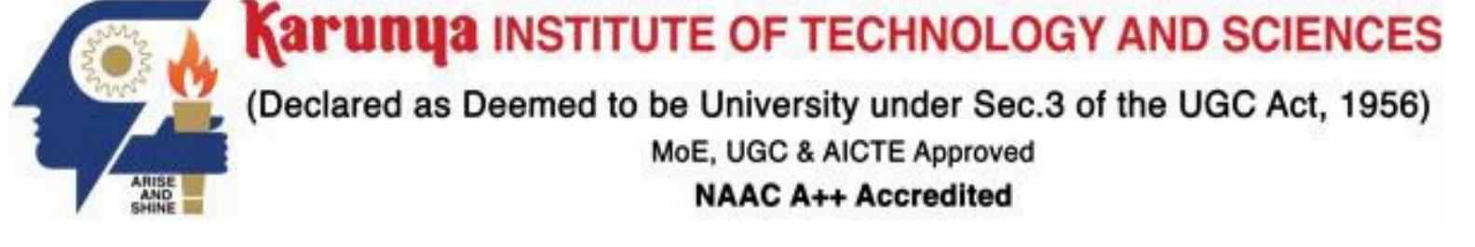

DIVISION OF ARTIFICIAL INTELLIGENCE AND MACHINE LEARNING
SCHOOL OF COMPUTER SCIENCE AND TECHNOLOGY
BONAFIDE CERTIFICATE
This is to certify that the skill-based evaluation report for the course 23AI2011 Software Engineering for Artificial Intelligence is a bonafide work done during the odd semester of the academic year 2026-2027 by
JOEL JAMES (Reg. No: ____________)
in partial fulfillment of the requirements for the award of the degree of Bachelor of Technology in Computer Science and Engineering (Artificial Intelligence & Machine Learning) of Karunya Institute of Technology and Sciences.

Submitted for the assessment held on ______________________
Signature of Course In-charge
Dr. Pramod Mathew Jacob
Assistant Professor-SG
Division of Artificial Intelligence and Machine Learning

DIVISION OF ARTIFICIAL INTELLIGENCE AND MACHINE LEARNING
SCHOOL OF COMPUTER SCIENCE AND TECHNOLOGY
S. No. | Evaluation Parameter | Max Marks | Marks Secured
1. | Software Requirement Specification | 10
2. | Design document | 15
3. | Certification course | 5
4. | Viva Voce | 10
 | Total |  | ____/40

Signature of Course In-charge
Dr. Pramod Mathew Jacob - SG
Assistant Professor
Division of Artificial Intelligence and Machine Learning

EVALUATION REPORT
Table of Contents
1 Project Overview 5
2 Software Requirement Specification 5
3 Design Report 8
4 Platform details 13
5 Implementation steps 13
6 Testing Certificate 15
7 Results and Outputs 16
8 Conclusions 16
9 References 17
MeatVision AI for Meat Species and Freshness Screening
1 Project Overview
1.1 Brief description
MeatVision AI is a computer-vision application that accepts a meat image through a browser dashboard or REST API and returns a species prediction, a freshness class, score distributions and inspection guidance. The supported species are Beef, Chicken, Fish and Pork. The freshness classes are Fresh, Half Fresh and Spoiled. These are model outputs for review; they do not establish food safety.
The system uses separate EfficientNet-B0 classifiers for species and freshness, and a MobileNet-V3 plus image-colour checks for out-of-distribution screening. FastAPI serves a Jinja2 browser interface and JSON endpoints. Docker and Docker Compose files support container deployment. In the current predictor code, both classifiers run before the image validator is called, so the validator does not yet prevent model execution on a rejected image; this is recorded as an implementation limitation.
1.2 Problem statement
Visual meat inspection can vary between operators and working conditions. An image classifier can also assign a familiar class to an unrelated image if it is used without input checks. The project addresses these problems by returning repeatable image-based predictions and an out-of-distribution flag for human review. Image-only freshness grading cannot detect pathogens or replace sensory, laboratory or regulatory inspection.
1.3 Objectives
- Build an accurate image-based classifier that identifies meat species (Beef, Chicken, Fish, Pork).
- Classify freshness into Fresh, Half Fresh or Spoiled and show the model score distribution. Softmax scores are not claimed to be statistically calibrated.
- Reject non-meat and synthetic images through a multi-tier OOD validator before inference.
- Expose the system through a web UI and a JSON REST API.
- Apply software-engineering practices for AI: modular architecture, 19 automated tests, CI pipeline, pinned dependencies and Docker deployment.
1.4 Real-world application
Potential settings include butcher facilities, retail quality-check stations and food-processing workflows. The project is a prototype screening aid for a human reviewer. It is not a validated food-safety instrument and does not replace qualified inspection.
2 Software Requirement Specification
2.1 Scope and user classes
MeatVision AI is a web-based and API-based application that accepts an image of meat and returns (a) a validity decision, (b) the meat species with probabilities and (c) the freshness grade with probabilities, status description and quality guidance. It does not diagnose specific pathogens, measure weight or replace laboratory testing. It can be used by any slaughterhouse, butcher facility or retail kiosk, and new species or grades can be added by retraining the models, since the modules are loosely coupled and reusable. The language used is Python with PyTorch and FastAPI.
- Inspector / Operator - uses the web dashboard to upload images and read results; needs no technical knowledge.
- Developer / Integrator - calls the /api/predict JSON endpoint from other software such as kiosks, mobile apps or ERP systems.
- System Administrator / ML Engineer - deploys the container, monitors /health, retrains and replaces model weights.
2.2 Modules and interfaces
Modules: web interface (index and result pages) → API (HTML and JSON endpoints, health check) → image utility and preprocessing → OOD validation → species classification and freshness grading → result rendering. The training and evaluation module (offline scripts) is run separately by the ML engineer.
External interfaces: a browser dashboard and the HTTP endpoints GET /, GET /health, POST /predict and POST /api/predict over port 8000, using multipart/form-data upload and JSON responses.
2.3 Assumptions and conventions
"Shall" indicates a requirement. FR denotes functional and NFR denotes non-functional requirements. The software runs on Python 3.9+ (tested on 3.10 and 3.11) with PyTorch 2.0+ and Torchvision 0.15+, on CPU or CUDA GPU, on Windows, Linux or macOS, or inside Docker, and is accessed through a modern web browser. Input must be a valid image file; the models cover four species and three freshness classes only; accuracy depends on lighting and image quality; and the weight files species_model.pth and freshness_model.pth must be present in the models/ directory. Performance figures in the NFR table are design targets, not measured results.
2.4 Functional requirements
ID | Functional requirement | Verification
FR-01 | The system shall accept a supported image upload through the browser form or prediction API. | Submit a valid image to each interface; verify the request is accepted.
FR-02 | The system shall decode the uploaded image and convert it to RGB before preprocessing. | Check RGB output for RGB, grayscale and palette fixtures; reject unreadable input with an error response.
FR-03 | The system shall evaluate the image using the configured out-of-distribution validation rules and mark rejected input invalid. | Submit representative meat, non-meat, blank and corrupt fixtures; verify the returned validity flag and reason.
FR-04 | The system shall resize valid image tensors to 224 x 224 and apply ImageNet channel normalization. | Compare a known image tensor with the preprocessing transform and check shape and normalized values.
FR-05 | The system shall classify a valid image into one of Beef, Chicken, Fish or Pork. | Use a labelled evaluation set and compare predicted labels with ground truth.
FR-06 | The system shall classify a valid image into Fresh, Half Fresh or Spoiled. | Use a labelled evaluation set and compare predicted labels with ground truth.
FR-07 | The system shall return a score for each class in both classification tasks. | Verify all expected labels are present and each rounded distribution totals approximately 100%.
FR-08 | The system shall map freshness classes to a status description and display quality guidance. | Check each freshness class and each species guidance entry against the configured maps.
FR-09 | The system shall render an HTML result page for browser submissions. | Submit a valid image to POST /predict and verify the response contains the result view.
FR-10 | The system shall return a JSON assessment from POST /api/predict. | Submit a valid image and verify validity, labels, scores and status fields in JSON.
FR-11 | The system shall expose service and model status through GET /health. | Call the health endpoint and verify status, version, device and class metadata.
FR-12 | The system shall flag rejected input and avoid presenting it as a valid species/freshness result. | Submit rejected fixtures and verify is_valid is false and the response marks the prediction invalid.
FR-13 | The system shall load available model checkpoint weights and use evaluation mode for inference. | Start the service with compatible checkpoints and verify loaded model status; test missing or incompatible files.
FR-14 | The offline workflow shall train and evaluate each classification task and save model checkpoints and evaluation metrics. | Run the documented training/evaluation workflow and inspect saved checkpoints and metric reports.
2.5 Non-functional requirements
ID | Non-functional requirement | Verification
NFR-01 | Performance: prediction latency shall be measured on a declared CPU and GPU reference machine and reported as median and 95th percentile. | Run repeated warm requests on each declared device; record hardware, software and timing.
NFR-02 | Reliability: unsupported or corrupt input shall return a controlled error response without terminating the service. | Exercise corrupt, empty and unsupported files; confirm the service continues to answer health requests.
NFR-03 | Privacy: uploaded images shall have a documented retention period and shall not be exposed through public static URLs. | Inspect upload paths, static routes, access controls and cleanup behavior; verify temporary files are removed as specified.
NFR-04 | Security: uploads shall be size-limited, use server-generated storage names and reject unsafe filenames. | Test oversized files, path traversal strings and malformed multipart requests.
NFR-05 | Usability: an operator shall be able to upload an image and understand the prediction and its limitations from the result page. | Conduct a short task walkthrough and check keyboard access, error text and safety notice.
NFR-06 | Portability: the service shall run locally and in the supplied Docker configuration with matching class labels and response fields. | Start both modes with the same checkpoints and compare structured response fields.
NFR-07 | Maintainability: API, validation, preprocessing, inference and training responsibilities shall remain separated into modules. | Review module boundaries and run focused unit tests after a change to one component.
NFR-08 | Resource control: the deployment shall define upload, memory and request-time limits appropriate to its target hardware. | Measure resource use at the declared workload and verify configured limits reject excess input.
2.6 Main analysis use case
Preconditions: the server is running and both model weight files are loaded. Normal flow: upload → validate → OOD check → preprocess → species and freshness inference → status and guidance → display result page or return JSON. Alternative flow: an unreadable or non-meat image ends before inference and returns a rejection message instead of a prediction.
3 Design Report
3.1 UML use case diagram
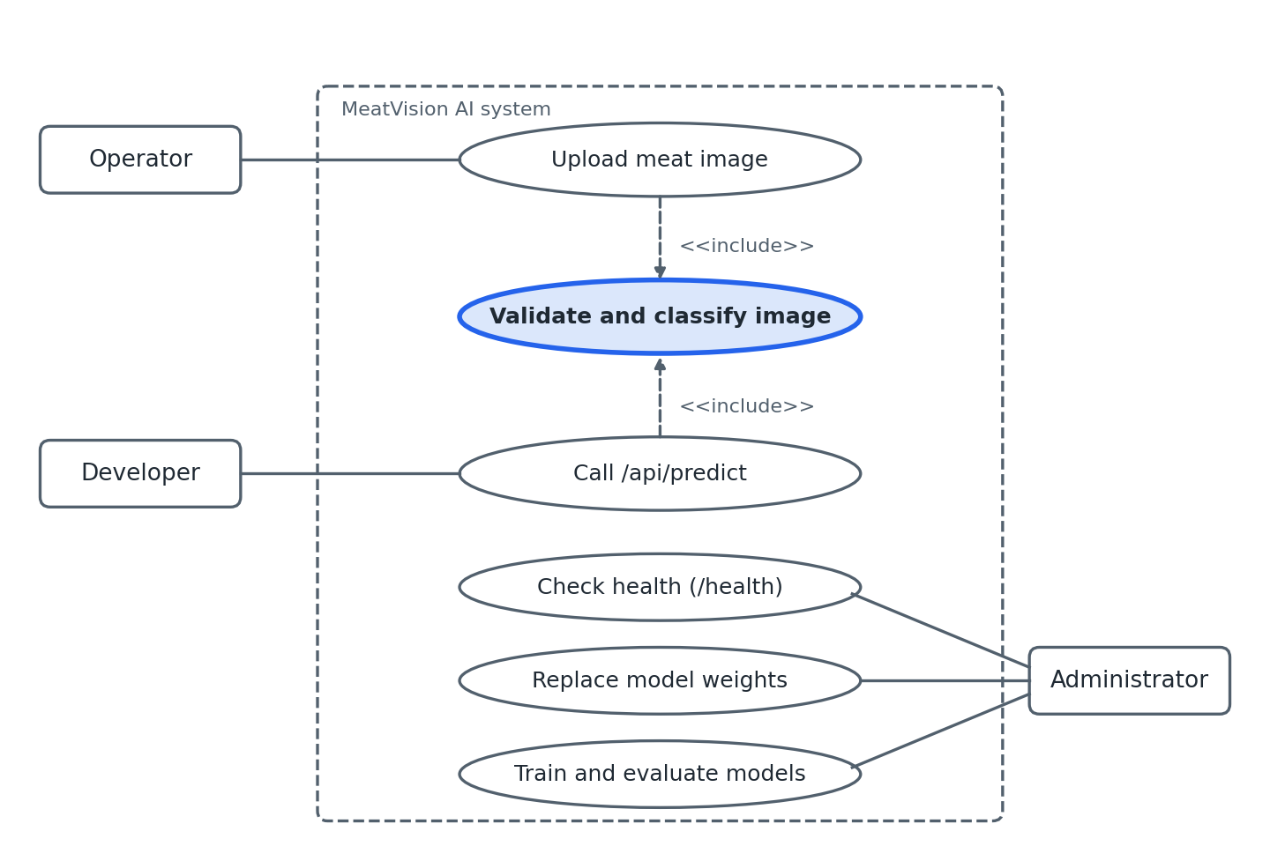
Figure 3.1 Use case diagram
The operator uploads an image and reviews the returned assessment. An integrating application submits an image to the JSON API. The administrator checks service health and manages model files and offline training. Validation is an intended gate in the design; in the current implementation it runs after the two classifier forward passes.
3.2 UML activity diagram
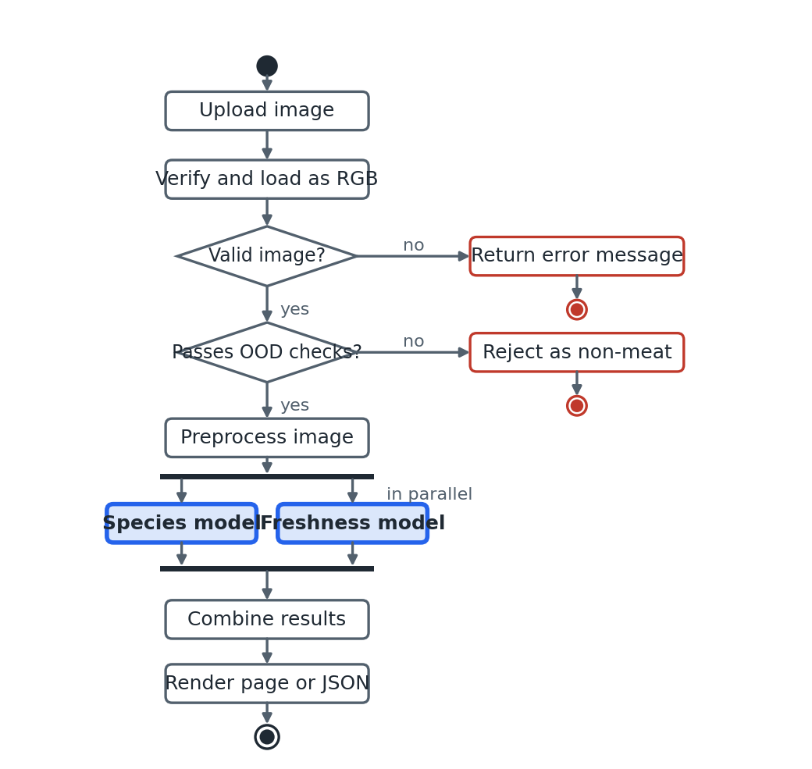
Figure 3.2 Activity diagram of the analysis workflow
The intended flow rejects invalid or out-of-distribution inputs before presenting a valid assessment. The current code runs the species and freshness models sequentially and then calls the validator; therefore, rejected inputs may still consume inference time. Successful results are rendered as HTML or returned as JSON.
3.3 UML sequence diagram
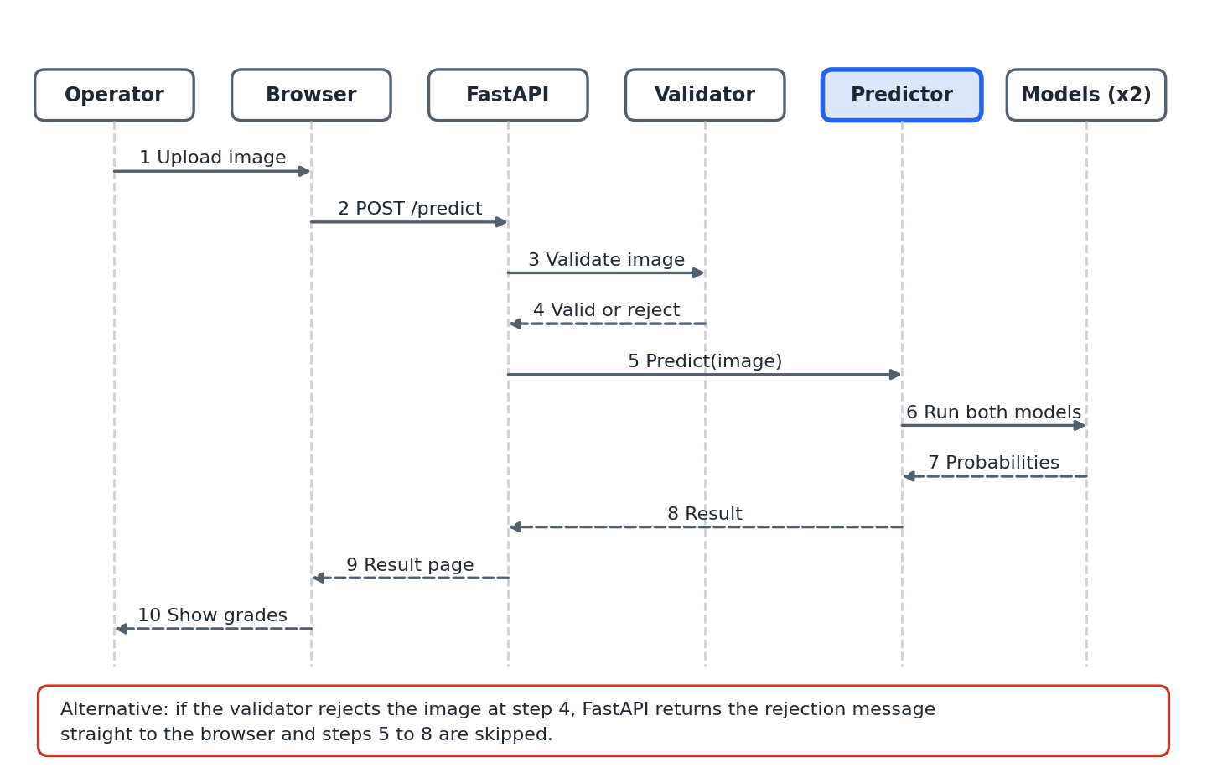
Figure 3.3 Sequence diagram of one prediction request
The browser posts an image to FastAPI, which calls the predictor. The predictor loads and preprocesses the image, runs the species and freshness classifiers, and then calls the validator. FastAPI returns a result page or JSON payload. An invalid image is flagged in the response; moving validation ahead of classifier inference is a required follow-up.
3.4 Architecture and data design
MeatVision AI follows a layered architecture. The presentation layer (templates and CSS) talks to the API layer (FastAPI routes in app.py). The API layer calls the service layer (validator.py, preprocess.py, predictor.py), which uses the model layer (MeatVisionModel in models/architecture.py) and the stored weights. Offline training code lives in scripts/training/.
Layer | Component | Responsibility
Presentation | frontend/templates, static/css | Upload dashboard, results page with dials and probability bars.
API | backend/app.py | FastAPI routes: /, /health, /predict, /api/predict.
Service | validator.py, preprocess.py, predictor.py, utils.py, config.py | OOD validation, preprocessing, dual-stream inference with weight hot-reload, RGB loading.
Model | models/architecture.py, species_model.pth, freshness_model.pth | MeatVisionModel wrapper (EfficientNet-B0 backbone, ConvNeXt-Tiny option) and trained weights.
Offline training | scripts/training/ | Dataset loading, training loop, evaluation and augmentation policies.

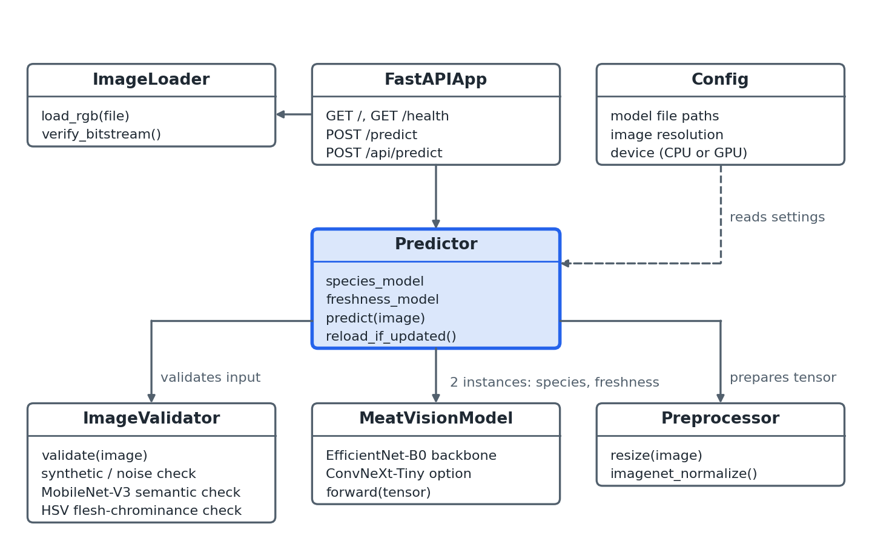
Figure 3.4 Class diagram
The FastAPI routes in app.py call the prediction function. predictor.py loads the two model instances, obtains predictions and invokes validator.py. preprocess.py standardizes tensors, utils.py loads images as RGB, and config.py defines checkpoint paths. Training and evaluation scripts run separately from request handling.
3.5 Algorithms
Algorithm 1 Inference pipeline
INPUT: file
OUTPUT: result (HTML page or JSON)
01 verify_bitstream(file); IF corrupt: RETURN error
02 img <- load_rgb(file)
03 is_valid, reason <- ood_validate(img)
04 IF NOT is_valid: RETURN {is_valid: false, reason}
05 x <- resize(img, resolution); x <- normalize(x, imagenet_mean, imagenet_std)
06 p_species <- softmax(species_model(x))
07 p_fresh <- softmax(freshness_model(x))
08 species <- argmax(p_species); conf_species <- max(p_species)
09 fresh <- argmax(p_fresh); conf_fresh <- max(p_fresh)
10 info <- grade_lookup(fresh) // status, description, colour, guidance
11 RETURN combined result as HTML or JSON
Algorithm 2 4-tier OOD validation
INPUT: file, img
OUTPUT: is_valid, reason
01 Tier 1: IF NOT bitstream_ok(file): RETURN reject
02 Tier 2: IF synthetic_or_noise(img): RETURN reject
03 Tier 3: top <- mobilenet_v3(img)
04 IF top predictions are clearly non-meat objects: RETURN reject
05 Tier 4: share <- flesh_pixel_share(hsv(img))
06 IF share < threshold: RETURN reject
07 RETURN accept // only if all four tiers pass
Algorithm 3 Model training
INPUT: labelled dataset, task (species or freshness)
OUTPUT: best checkpoint, evaluation report
01 train, val, test <- split(dataset) using zero-copy transform subsets
02 IF task = species: sampler <- weighted_class_sampler(train)
03 apply task-specific augmentation to train
04 model <- EfficientNetB0(pretrained); replace final layer with n_classes
05 optimiser <- AdamW; scheduler <- cosine_annealing
06 FOR each epoch: train; compute val_loss; save best checkpoint
07 IF val_loss stops improving: early stop
08 evaluate(best, test) -> precision, recall, F1, confusion matrix
09 SAVE model.pth and report
3.6 User interface design
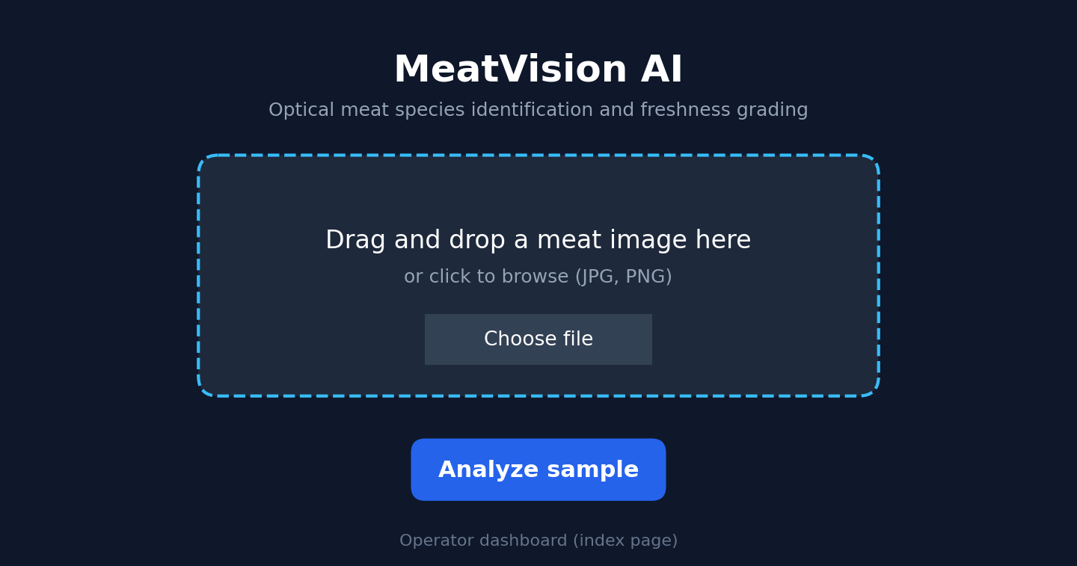
Figure 3.5 Operator dashboard (index page)
Dark-mode layout with the application title, a drag-and-drop upload zone and an Analyze button.
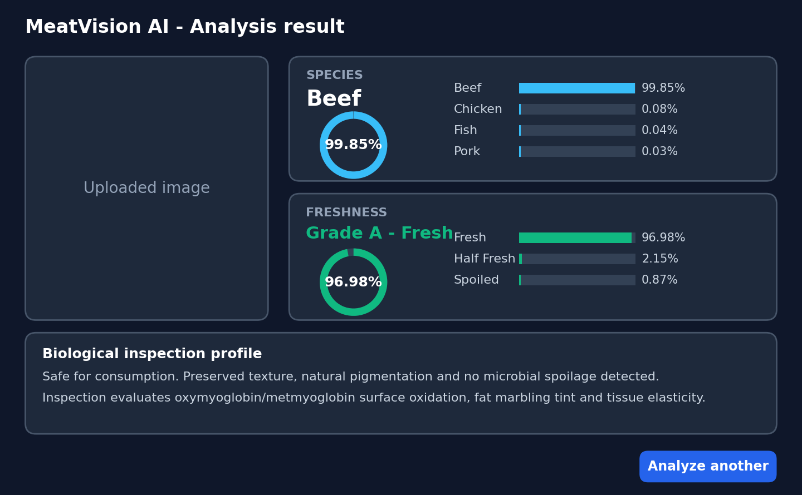
Figure 3.6 Results page
The uploaded image sits on the left. The right side shows the species name with a circular confidence dial and probability bars, the colour-coded freshness grade (green Grade A, amber Grade B, red Grade C) with its own dial and bars, and the inspection profile card with quality guidance. The sample values are from the README example response.
4 Platform details
Layer | Platform
Runtime and inference | Python 3.10/3.11, PyTorch and Torchvision (training and inference).
Backend | FastAPI with Uvicorn.
Frontend | Jinja2 templates with HTML, CSS and JavaScript.
Training | Google Colab (GPU training notebooks).
Deployment | Docker and Docker Compose (containerised deployment).
Version control, CI and testing | GitHub and GitHub Actions; pytest.
Justification
- PyTorch / EfficientNet-B0: strong accuracy with a small model size (about 16 MB per model); well suited to transfer learning.
- FastAPI: high-performance, asynchronous, automatic request validation and easy JSON APIs.
- Docker: identical environment everywhere and simple deployment to any cloud VM or container service.
- Google Colab: free GPU for training without local hardware.
- GitHub Actions: automated tests on every commit.
- Scalability and cost: all tools are open source and the stateless container can move to a cloud platform when scaling is needed.
4.1 Estimated cost
No mandatory paid service is required. Incremental spend can be ₹0 using existing hardware and the free tiers of Google Colab and GitHub, excluding electricity, hardware and development time. Cloud deployment or paid GPU training would add usage-based charges; verify provider pricing before enabling any paid service.
5 Implementation steps
- Collected and organised the meat image datasets for species (Beef, Chicken, Fish, Pork) and freshness (Fresh, Half Fresh, Spoiled).
- Built the data pipeline: zero-copy transform subset loader, class balancer and task-specific augmentation.
- Trained the species and freshness models on Google Colab GPUs using EfficientNet-B0 transfer learning, with early stopping and checkpointing.
- Evaluated both models (precision, recall, F1, confusion matrix) and saved species_model.pth and freshness_model.pth to the models/ folder.
- Implemented the OOD gatekeeper in validator.py with MobileNet-V3 and HSV flesh analysis.
- Implemented preprocessing, image utilities and the dual-stream predictor with hot-reloading.
- Developed the FastAPI backend with the /, /health, /predict and /api/predict endpoints.
- Designed the frontend (index and result templates, CSS design tokens, SVG confidence dials).
- Wrote 19 unit and integration tests with pytest and configured a GitHub Actions CI pipeline.
- Containerised the app with a Dockerfile and docker-compose.yml and tested the endpoints locally at http://127.0.0.1:8000.

Verification group | Requirement coverage
Input handling and OOD gate | FR-01 to FR-04, FR-12: image acceptance, RGB conversion, non-meat rejection, preprocessing.
Inference and guidance | FR-05 to FR-08: species label, freshness grade, probability distributions, status and guidance.
Interfaces and operations | FR-09 to FR-11, FR-13: results page, JSON API, health check, weight hot-reload.
Offline training | FR-14: training and evaluation reports.
Quality targets | NFR-01 to NFR-08: timing, reliability, portability, usability, maintainability (19 pytest tests), scalability, security.

Simulated components: no hardware sensors are used; conveyor or kiosk cameras are simulated by uploading image files through the dashboard or the API.
6 Testing Certificate
Insert a screenshot of your completed software testing course certificate here. The certificate image was not included with the project materials.

7 Results and Outputs
7.1 Model performance
Task | Metric | Recorded result | Evaluation support
Species (4 classes) | Accuracy | 96.84% | 3,587 images
Species (4 classes) | Weighted F1 | 96.87% | 3,587 images
Freshness (3 classes) | Accuracy | 95.42% | 9,364 images
7.2 Sample API output
The README includes an illustrative API payload for a Beef/Fresh result (species score 99.85%; Fresh 96.98%, Half Fresh 2.15%, Spoiled 0.87%). It demonstrates the response schema only and is not presented here as a measured test run.
{
"is_valid": true,
"species": "Beef", "species_confidence": 99.85,
"freshness": "Fresh", "freshness_confidence": 96.98,
"freshness_probabilities": {"Fresh": 96.98, "Half Fresh": 2.15, "Spoiled": 0.87},
"freshness_status": "Grade A - Peak Freshness"
}
7.3 Limitations
- The repository evaluation summary records finite test-set metrics. These results depend on the dataset split and are not guarantees for images from new suppliers, cameras, lighting conditions, packaging or meat cuts. Reproduce the reported runs from saved evaluation outputs before external publication.
- The models cover only four species and three freshness grades; accuracy depends on lighting and image quality.
- The system is an image-based screening aid. It does not detect specific pathogens, establish whether food is safe to eat, or replace laboratory testing and qualified inspection.
- Conveyor and kiosk cameras were simulated through image uploads; no live hardware was tested.
8 Conclusions
MeatVision AI combines two image classifiers, an out-of-distribution validator, a FastAPI service and a browser dashboard. The repository also includes training scripts, tests and container configuration. Its recorded evaluation results are promising for the available dataset, but external generalization and food-safety validity remain unestablished. The current validation order should be corrected so rejected images are screened before classifier inference.
Key takeaways
- Separating species and freshness into specialised models improves focus.
- Probability scores summarize model output but require a separate calibration study before they can be interpreted as calibrated confidence.
- Input validation is essential for AI systems in production.
Future improvements and scalability
- Add more species and finer freshness grades.
- Collect larger real-world datasets under varied lighting.
- Add a mobile app and live camera streaming.
- Deploy on a cloud platform with auto-scaling.
- Add Grad-CAM explainability and prediction logging for audit.
- Integrate gas or temperature sensor data for multimodal freshness estimation.
9 References
[1] M. Tan and Q. V. Le, "EfficientNet: Rethinking Model Scaling for Convolutional Neural Networks," Proc. ICML, 2019.
[2] A. Howard et al., "Searching for MobileNetV3," Proc. IEEE/CVF ICCV, 2019.
[3] I. Loshchilov and F. Hutter, "Decoupled Weight Decay Regularization," ICLR, 2019 (AdamW).
[4] I. Loshchilov and F. Hutter, "SGDR: Stochastic Gradient Descent with Warm Restarts," ICLR, 2017.
[5] J. Deng et al., "ImageNet: A Large-Scale Hierarchical Image Database," Proc. IEEE CVPR, 2009.
[6] A. Paszke et al., "PyTorch: An Imperative Style, High-Performance Deep Learning Library," NeurIPS, 2019.
[7] C. Guo, G. Pleiss, Y. Sun and K. Q. Weinberger, "On Calibration of Modern Neural Networks," Proc. ICML, 2017.
[8] FastAPI documentation, https://fastapi.tiangolo.com/
[9] IEEE Std 830-1998, "Recommended Practice for Software Requirements Specifications."
[10] Object Management Group, "Unified Modeling Language (UML) Specification."
[11] Project repository, https://github.com/JoelJames889/MeatVisionAI

