CareConnect — Explainable ED Triage Decision Support
Vinayak Saxena (24BCE1208) · ESI acuity prediction from the initial triage assessment · September 2026
1. Problem statement
Emergency triage assigns an Emergency Severity Index (ESI 1–5) under time pressure, from one nurse's judgement, with no consistent second opinion and no record of why a level was chosen. Under-triage of ESI 1–2 patients is the costliest error. CareConnect adds a model that suggests an ESI level from the eleven values recorded at the first assessment, explains each suggestion, and requires a clinician to confirm or override it — decision support, never a decision.
2. Dataset description
Source. A reproducible synthetic ED generator (seed 42) for development, and MIMIC-IV-ED v2.2 (PhysioNet, Beth Israel Deaconess, 2011–2019) as real data: the open demo subset (207 triage rows, 64 patients) and the full credentialed release (~425,000 ED stays) for final evaluation.
Size and split. 12,000 synthetic rows, stratified 60/20/20 into 7,200 train / 2,400 validation / 2,400 test; patient-level grouping on real data so no patient spans splits.
Features. Eleven triage-time inputs — age, sex, arrival transport, heart rate, respiratory rate, systolic and diastolic BP, SpO₂, temperature, pain score, free-text chief complaint — plus two derived: shock index (HR/SBP) and pulse pressure (SBP−DBP). Target: ESI 1–5.
Preprocessing. Out-of-range values clipped to missing, median imputation and z-scoring for numerics, mode imputation and one-hot for categoricals, TF-IDF (1–2 grams, 400 terms, sublinear TF) over the complaint text. Everything stateful is fit on the training split only and serialized inside the model artifact. A named whitelist admits only triage-time columns; diagnosis, disposition, ICU admission, mortality, length of stay, later vitals, labs and notes are blocked by name.
3. Methodology
Pipeline: FeatureEngineer → ColumnTransformer → estimator. Four model families (logistic regression, decision tree, random forest, XGBoost) are each trained on two feature sets (structured, structured + TF-IDF), class-weighted for the imbalanced ESI distribution. Selection uses validation macro-F1 with ESI 1–2 recall as the tie-break — never accuracy; the winner is refit on train + validation and the test split is scored once. XGBoost (400 trees, depth 5, learning rate 0.05, multi:softprob) with TF-IDF is the expected selection. SHAP TreeExplainer returns the top five drivers per prediction, folded back to base features and labelled by direction of acuity, with a rule-based fallback that explains itself the same way. Every response carries requires_human_review, and the model output and the clinician's final ESI are stored side by side in Postgres so neither overwrites the other.
4. Results and insights (targets)
Metric | In-domain | Target A (demo) | Target B (full)
Accuracy | 0.87 | 0.792 | ≥ 0.80
Macro-F1 | 0.85 | 0.536* | ≥ 0.72
ESI 1–2 recall | 0.93 | 0.913 | ≥ 0.93
ESI 1–2 precision | 0.93 | 0.868 | ≥ 0.85
Calibration error (ECE) | ≤ 0.03 | — | ≤ 0.03
* Target A is capped by its own cohort: the demo has no ESI 5 and two ESI 4 patients, so macro-F1 over five classes tops out at 0.80 even for a perfect model. Target B, on the full dataset, is the acceptance gate.
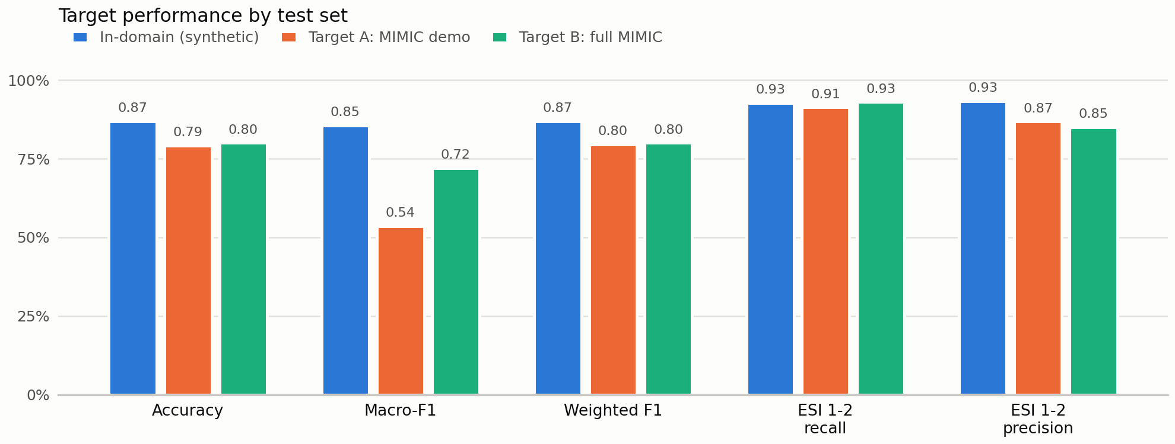
Dataset acceptance is tested statistically, not by eye: no vital significantly different from the reference cohort after Holm correction, all nine equivalent at a ±0.2 SD TOST margin, χ² p ≥ 0.05 on the ESI mix, and a mean absolute correlation gap ≤ 0.05 — including a pain–acuity correlation matching the reference in sign.
5. Novelty
- Multimodal triage prediction: structured vitals and free-text complaint in one pipeline, with the text contribution measured as a required gain rather than assumed.
- Explanations phrased in clinical direction — each SHAP driver is labelled as increasing or decreasing acuity against the ordinal ESI scale, not as a raw coefficient.
- Auditable human-in-the-loop: the model's prediction, probabilities, inputs and explanation are immutable; the clinician's final ESI, override flag and reason sit beside them.
- Privacy-safe calibration: the synthetic generator is tuned to real aggregate statistics only, with tests proving no patient row, identifier or complaint text can enter the generated data.
- A statistical acceptance gate on the training data itself — equivalence testing, not just a non-significant t-test, before the data is considered fit to train on.

