CareConnect — Project Document
Sep 17, 2026 · Vinayak Saxena

1. Abstract and introduction
CareConnect is an on-demand healthcare platform that combines service booking, ambulance dispatch, live tracking and medical records with an explainable machine-learning model that suggests an Emergency Severity Index (ESI) level from the initial triage assessment. The acceptance targets for that model are 0.87 accuracy, 0.85 macro-F1 and 0.93 recall on ESI 1–2 on its held-out test split, with the full target set in Section 10.
The platform is built on a Next.js frontend, a Python FastAPI backend and Supabase (PostgreSQL + Auth). The database follows a normalized ten-table core schema brought to BCNF, with Row-Level Security (RLS) on every table.
The triage model is decision support, never a decision. Every response carries requires_human_review = true, a clinician can override the suggestion, and only the human-recorded ESI moves a patient. The model's own prediction is stored unchanged next to the clinician's final call so the two can be audited.
The shipped model is trained on synthetic data. It demonstrates the pipeline and integration; it is not a validated clinical tool.
A research track then asks whether a model built on synthetic data transfers to real emergency departments — first MIMIC-IV-ED (U.S.) and then an Indian dataset — and a follow-up phase tunes the synthetic generator to the aggregate statistics of a real ED cohort. Section 6.9 sets the statistical targets the generated data must meet, and Section 10.5 the transfer targets on the MIMIC-IV-ED demo and on the full MIMIC-IV-ED dataset.

2. Problem statement, objectives and scope
Patients who need care quickly have to juggle separate channels to find a provider, book a slot, call an ambulance, pay and keep their records. Emergency triage also depends on one clinician's judgement under time pressure, with no consistent second opinion and no record of why a severity level was chosen.
Objectives
- Give patients one app to book services, raise emergencies, track the ambulance, pay, rate and view their medical history.
- Store all of this in a normalized (BCNF) PostgreSQL schema that stays consistent under concurrent bookings and dispatches.
- Give administrators and providers role-based dashboards for users, facilities, the service catalogue and analytics.
- Suggest an ESI acuity (1–5) from the eleven values recorded at initial triage, with a SHAP explanation and a mandatory human override.
- Keep the model's prediction and the clinician's final decision side by side for audit.
- Measure, rather than assume, whether a synthetic-trained model transfers to real emergency departments (MIMIC-IV-ED, Indian data).
Scope
In scope | Out of scope
Patient, provider and admin web app | Native mobile apps
Booking, emergency, simulated live tracking, payments, ratings, records | Real GPS hardware and payment-gateway settlement
ESI decision-support model with explanation and override | Autonomous triage or clinical deployment
Offline training, evaluation and domain-transfer experiments | Clinical validation, fairness or subgroup audits
ESI levels (the prediction target)
ESI | Name | Band
1 | Resuscitation | High acuity
2 | Emergent | High acuity
3 | Urgent | Moderate acuity
4 | Less urgent | Lower acuity
5 | Non-urgent | Lower acuity
ESI 1–2 is the "must not miss" group and is scored separately as a one-vs-rest class.

3. System architecture and technology stack
CareConnect is a three-tier web application: a Next.js client talks to a FastAPI REST API, which reads and writes Supabase PostgreSQL and runs the triage model in-process. There is no separate model server.
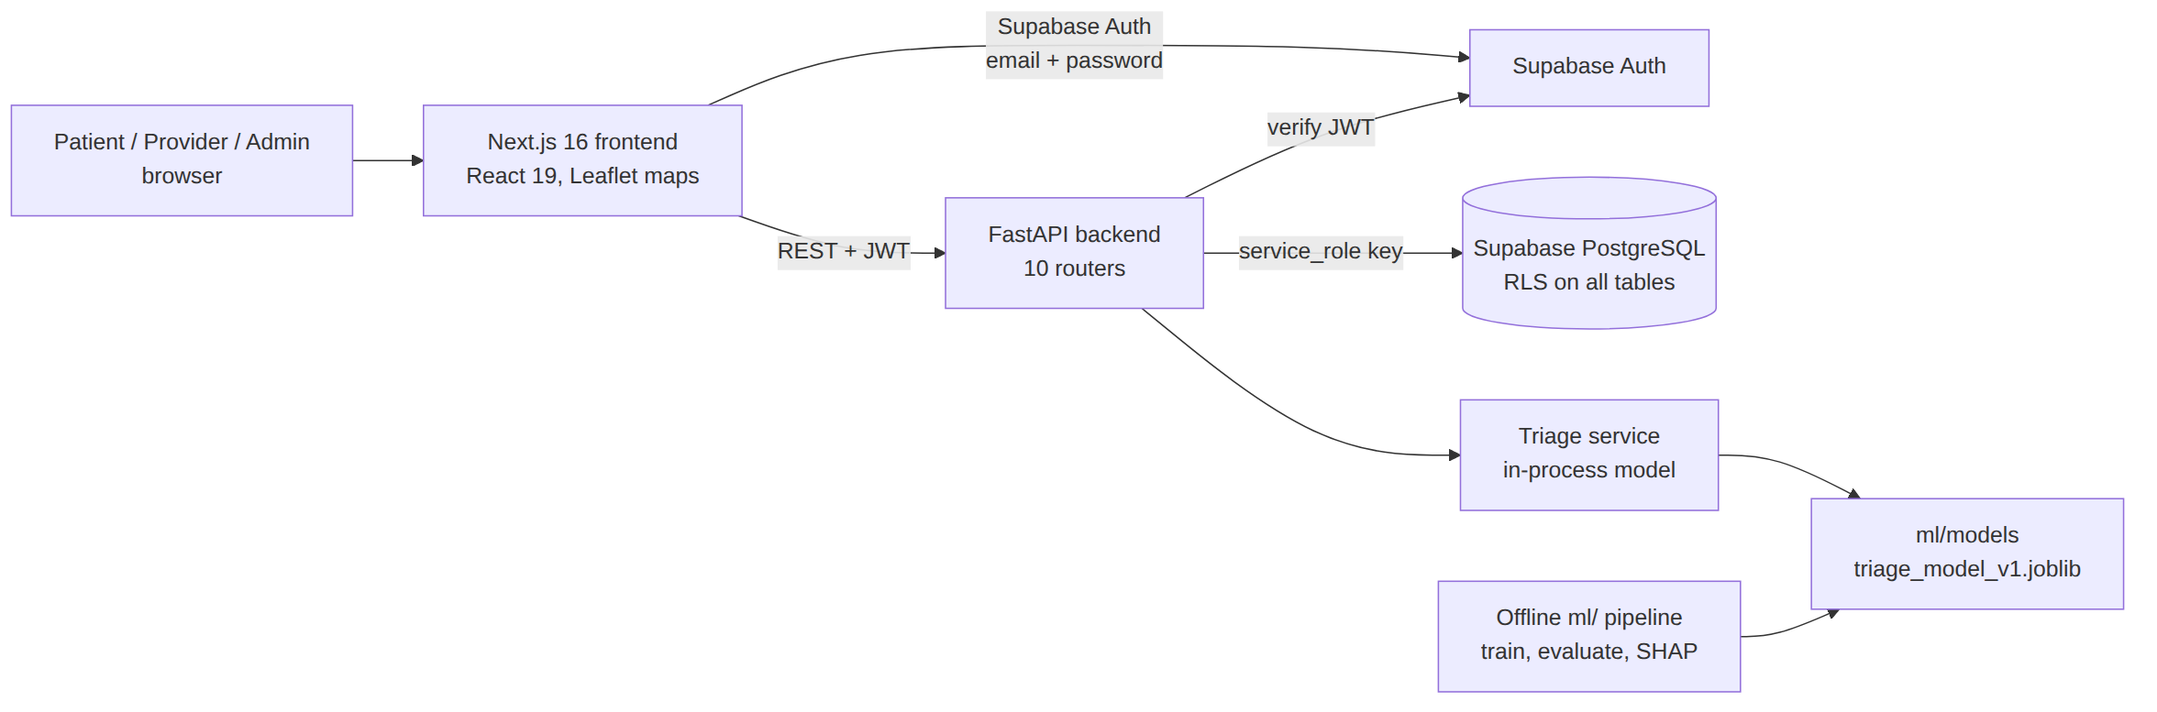
The model is loaded once at API startup (FastAPI lifespan). If it fails to load, the app keeps serving and triage falls back to a rule-based heuristic.
Layer | Technology | Role
Frontend | Next.js 16.2, React 19.2, TypeScript 5, Tailwind CSS 4 | Dark, high-contrast UI with large tap targets; patient, provider, admin and /triage screens
Maps | Leaflet 1.9, react-leaflet 5 | Ambulance position and route on the tracking screen
Backend | Python, FastAPI ≥0.115, Uvicorn, Pydantic 2 | REST API, request validation, JWT verification, authorization
Database | Supabase PostgreSQL, supabase-py ≥2.10, psycopg 3 | Normalized schema, RLS policies, triggers, migrations
Auth | Supabase Auth | Email/password sign-up; a trigger creates the profiles row
ML training | scikit-learn ≥1.4, XGBoost ≥2.0, pandas, NumPy | Preprocessing pipeline and model zoo
Explainability | SHAP ≥0.44 | Per-prediction feature attributions
Serialization | joblib | {pipeline, metadata} model artifact
Testing | pytest ≥8 | ML unit tests and backend API contract/regression tests
Dev tooling | dev.ps1, dev.sh | Start backend (port 5000) and frontend (port 3000) together
API routers
Router | Main endpoints | Purpose
catalogue | providers, service types, availability | Browse the service catalogue
profile | own profile | View and edit patient profile
requests | POST /api/requests, GET /api/me/requests, GET /api/requests/{id}/track, PATCH /api/requests/{id}/status | Bookings, simulated tracking, status changes
emergency | POST /api/emergency, GET /api/me/emergencies | Raise and list emergencies
medical | medical records | Patient history
payments | POST /api/payments, /api/prescriptions, /api/feedback | Pay, prescribe, rate
analytics | GET /api/analytics/summary | Dashboard metrics
provider | assigned requests | Provider portal
admin | /api/admin/* | Users, facilities, catalogue, audit log
triage | /api/emergency/triage/* | ESI prediction, persistence, override

4. Methodology
The project followed an incremental, migration-driven approach: first a normalized schema and core patient flows, then provider and admin roles, then the triage ML subsystem, and finally a research phase on domain transfer. Each stage was added as a new SQL migration and a new API router, so earlier features kept working.
Development phases
Phase | Migration / module | What was added
1. Core schema | 20250329120000_careconnect_normalized.sql | Ten BCNF tables, indexes, sign-up trigger, RLS, catalogue seed
2. Demo data | 20250329140000_demo_patient_ambulance_seed.sql | Chennai-area requests, ambulance coordinates, payments, records (tagged [DEMO])
3. Admin role | 20250329150000_profiles_role_admin.sql | profiles.role and a trigger that blocks self-promotion
4. Provider accounts | 20250404000000_..., 20250404100000_seed_50_providers.sql, 20250405* | Provider login, 2-hour visibility window, route history, 50 seeded providers with contact details
5. Audit | 20260819000000_admin_audit_log.sql | Before/after log of admin data changes
6. Triage ML | ml/, 20260901000000_triage_predictions.sql, /api/emergency/triage/* | ESI model, SHAP, human override store
7. Research | ml/experiments/, docs/ | Domain-transfer experiments, domain-shift analysis, patient-level splits, calibration
8. Data calibration | ml/data/calibration.py, ml/experiments/run_calibration_experiment.py, calibration_plots.py | Synthetic generator tuned to MIMIC demo aggregates, distance metrics, 4 transfer experiments, 4 figures, 23 tests
ML methodology
The ML work follows a standard supervised-learning workflow with three extra safety rules:
- Only triage-time inputs. A named whitelist (INITIAL_TRIAGE_FEATURES) limits the model to the eleven values known at the first assessment; a blacklist (FORBIDDEN_LEAKAGE_COLUMNS) names outcomes it must never see.
- Fit on training data only. Imputation, scaling, encoding and TF-IDF are fit on the training split and saved inside the model file, so training and serving cannot drift apart.
- Select for safety, not accuracy. Models are ranked by validation macro-F1, with ESI 1–2 recall as the tie-break; the test split is touched once, at the end.
Human-in-the-loop design. The model output and the clinician's decision are separate objects in the UI (a "MODEL PREDICTION" card and a "FINAL CLINICAL TRIAGE" panel) and separate columns in the database. The system degrades gracefully: artifact missing → rule-based heuristic; feature flag off → 503 and manual triage continues.

5. Database design
CareConnect uses Supabase PostgreSQL with ten core tables in BCNF, plus admin_audit_log and triage_predictions. Every table has Row-Level Security enabled, and every primary key is a uuid generated by gen_random_uuid().
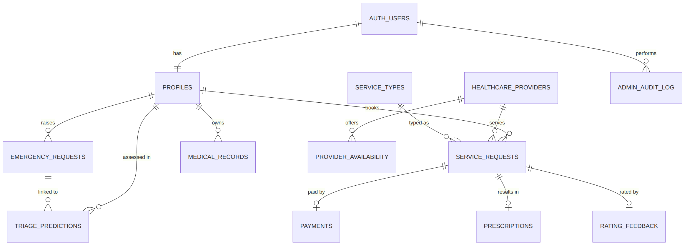

5.1 Tables
Table | Primary key | Key columns | Foreign keys | Constraints
profiles | user_id | name, phone, address, role, created_at | auth.users(id) cascade | role ∈ {user, admin}
healthcare_providers | provider_id | name, specialization, license_number, verified, email, phone, address | provider_user_id → auth.users set null | —
service_types | service_id | service_name, base_price numeric(12,2), duration_minutes | — | default duration 30
provider_availability | availability_id | date, time_slot, is_available | provider_id cascade | UNIQUE (provider_id, date, time_slot)
service_requests | request_id | request_time, status, location, lat/lng, eta_minutes, dispatch lat/lng, route_points jsonb, visible_until, closed_at, updated_at | user_id cascade, provider_id set null, service_id restrict | status default requested
medical_records | record_id | diagnosis, notes, record_date | user_id cascade | —
emergency_requests | emergency_id | severity, status, location, lat/lng, response_eta_minutes, visible_until | user_id cascade | severity ∈ {low, medium, high, critical}
payments | payment_id | amount, method, status | request_id cascade | UNIQUE (request_id)
prescriptions | prescription_id | medicines, dosage | request_id cascade | UNIQUE (request_id)
rating_feedback | feedback_id | rating, comments | request_id cascade | rating 1–5; UNIQUE (request_id)
admin_audit_log | audit_id | action, table_name, row_pk, before jsonb, after jsonb | admin_user_id set null | service-role access only
triage_predictions | id | model_name, model_version, model_type, predicted_esi, prediction_probabilities, confidence, explanation, input_features, human_final_esi, was_overridden, override_reason | user_id cascade, emergency_id set null, reviewed_by set null | ESI 1–5; model_type ∈ {ml, heuristic}

5.2 Normalization
Normal form | How the schema meets it
1NF | Atomic columns; one row per booking, payment, prescription and rating. route_points is the one JSONB column and is treated as a single value (a GPS trail).
2NF | Every table has a single-column surrogate key, so no partial dependencies exist.
3NF | Provider details live only in healthcare_providers; service price and duration live only in service_types. A booking stores just the foreign keys, removing the transitive dependency request → service → price.
BCNF | The natural keys that could also determine rows are declared as UNIQUE constraints: (provider_id, date, time_slot) for a slot, and request_id for each payment, prescription and rating. Every determinant is therefore a candidate key.

5.3 Indexes
Index | Columns | Serves
idx_service_requests_user | user_id | "My requests"
idx_service_requests_provider | provider_id | Provider portal
idx_emergency_user | user_id | "My emergencies"
idx_medical_user | user_id | Medical history
idx_availability_provider_date | provider_id, date | Slot lookup
idx_requests_visible_until, idx_emergency_visible_until | visible_until | 2-hour auto-hide
idx_admin_audit_log_created, idx_admin_audit_log_table | created_at desc; table_name, row_pk | Audit browsing
idx_triage_predictions_user / _emergency / _created | user_id; emergency_id; created_at desc | Triage history

5.4 Security: RLS, triggers and roles
- Patient privacy. Patients can read and write only rows where auth.uid() = user_id. Payments, prescriptions and ratings are checked through ownership of the parent service_request (an EXISTS subquery).
- Catalogue. Providers, service types and availability are readable by any signed-in user.
- Providers. A provider can read and update only requests assigned to their own provider_id.
- Sign-up trigger. handle_new_user() creates a profiles row for each new auth.users row.
- Role guard. profiles_role_guard() forces new rows to role = 'user' and raises an error if a non-admin tries to change a role.
- Audit. Admin edits write before/after JSON to admin_audit_log, which has RLS on and no client policies.

5.5 Concurrency control
Problem | Mechanism | Where
Two tracking polls update the same ambulance position at once | Optimistic locking: the UPDATE includes WHERE updated_at = <value read>; zero rows updated means another poll won, so the API returns the winner's data | GET /api/requests/{id}/track
Double payment for one booking | UNIQUE (request_id); PostgreSQL error 23505 is returned as HTTP 409 | POST /api/payments
Two patients booking the same slot | UNIQUE (provider_id, date, time_slot) | provider_availability
Wrong payment amount | Amount must equal service_types.base_price | POST /api/payments
Cancelling a paid or finished visit | State check: only requested, confirmed or in_progress and unpaid | PATCH /api/requests/{id}/status
Overwriting the model's prediction | Model columns are never updated; the override goes in human_final_esi | triage_predictions

6. Datasets
The model is trained on a 12,000-row synthetic dataset and tested for transfer on the 207 labelled triage rows of the public MIMIC-IV-ED demo v2.2. An Indian dataset loader is built but has no data yet. Every source is converted to one common schema before training.

6.1 Dataset summary
Dataset | Origin | Rows used | Access | Role in project | Status
Synthetic (ml/data/synthetic.py) | Generated in memory, seed 42 | 12,000 | Built into repo | Trains the shipped triage_model_v1; CI and demos | Used
MIMIC-IV-ED demo v2.2 | Beth Israel Deaconess Medical Center, Boston (U.S.) | 207 of 222 triage rows (64 patients) | Open demo subset | Target A transfer evaluation (Section 10.5) | Used
MIMIC-IV-ED v2.2 (full) | Same hospital | About 425,000 ED stays (approximate) | Credentialed (PhysioNet DUA) | Target B retraining and acceptance evaluation (Section 10.5) | Loader ready, not downloaded
Indian ED dataset (ml/data/indian.py) | e.g. an EMcounter site or hospital registry | — | Data-sharing agreement / IRB | Indian transfer experiments | Loader ready, no data
Supabase demo seed | 20250329140000_...sql, 20250404100000_seed_50_providers.sql | 50 providers, 4 service types, demo bookings | In repo | App demo data (not ML) | Used
Synthetic, MIMIC-calibrated (ml/data/calibration.py) | Generated, parameters tuned to MIMIC demo aggregates, seed 42 | 12,000 | Generated locally (gitignored CSV) | Calibration experiment (Section 6.8) | Used

6.2 Common schema (model inputs and target)
Column | Type | Valid range / values | Notes
age | numeric | 0–120 years | Missing in MIMIC unless patients table is joined
sex | categorical | M, F, OTHER, UNKNOWN | Unknown values map to UNKNOWN
arrival_transport | categorical | ambulance, walk_in, public, private, helicopter, police, other, unknown | Unknown values map to other/unknown
heart_rate | numeric | 10–300 bpm
respiratory_rate | numeric | 2–80 /min
systolic_bp | numeric | 40–300 mmHg
diastolic_bp | numeric | 20–200 mmHg
oxygen_saturation | numeric | 50–100 %
temperature | numeric | 30–45 °C | Always Celsius; loaders convert
pain_level | numeric | 0–10
chief_complaint | free text | — | TF-IDF input; never fabricated when missing
esi (target) | integer | 1–5 | 1 = most acute; never silently remapped from another scale
shock_index (derived) | numeric | HR ÷ SBP | Computed in the pipeline
pulse_pressure (derived) | numeric | SBP − DBP | Computed in the pipeline

6.3 MIMIC-IV-ED column mapping
MIMIC column | Table | CareConnect column | Handling
heartrate, resprate, sbp, dbp, o2sat | triage | vitals | Direct
temperature | triage | temperature | °F → °C
pain | triage | pain_level | Free text ("7", "denies", "8/10") → number by regex, clipped 0–10
chiefcomplaint | triage | chief_complaint | Direct
acuity | triage | esi | Rows outside 1–5 dropped and logged
gender | edstays | sex | Upper-cased
arrival_transport | edstays | arrival_transport | Lower-cased, spaces → underscores
anchor_age | patients (optional) | age | Otherwise all-missing and imputed

6.4 Synthetic data generation
The generator is a transparent scorecard, not a clinical model:
- Draw a hidden severity band: critical 2.5%, high 17%, moderate 52%, low 28.5%.
- Pick a chief complaint from that band's list (12% of the time from another band, to add noise).
- Sample each vital from a normal distribution with a band-specific mean and SD (e.g. critical HR 132 ± 28, SpO₂ 86 ± 7).
- Compute a danger score: band baseline + points for low SpO₂, low SBP, abnormal HR/RR, fever, pain ≥ 8, age ≥ 75, red-flag complaint words (+3.2), low-acuity words (−2.0), plus Gaussian noise (SD 0.9).
- Map the score to ESI with cut-offs 9.6 / 4.0 / 1.2 / −2.0.
- Blank out values at random to mimic real missingness (temperature 8%, respiratory rate 5%, DBP 6%, pain 10%, SpO₂ 3%).

6.5 Target class distribution
The target is a synthetic ESI mix that matches the reference ED cohort within 2 percentage points per class, so a model trained on it carries the right class priors into real use.
ESI | Reference (MIMIC-IV-ED demo) | Target synthetic share | Target count in 12,000 rows | Tolerance
1 | 8.70% | 8.7% | 1,044 | ±2.0 pp
2 | 46.86% | 46.9% | 5,628 | ±2.0 pp
3 | 43.48% | 43.5% | 5,220 | ±2.0 pp
4 | 0.97% | 1.0% | 120 | ±1.0 pp
5 | 0.00% | 0.9% (floor) | 108 | floor, not matched
Total | 100% | 100% | 12,000 | —
ESI 5 keeps a 1% floor rather than a match: the reference cohort has no ESI 5 patients, and a class with zero rows cannot be trained, split or evaluated. The target for the mean absolute class-share difference is ≤ 0.02, and for Jensen–Shannon divergence against the reference ≤ 0.02.

6.6 Target data quality
Check | Target for the synthetic dataset | Why
Rows retained after ESI validation | 100% | Generated data should never produce an invalid acuity
Missing heart rate / SpO₂ | 4–5% | Matches how often real triage misses a vital
Missing temperature | 5–6% | Same
Missing pain score | 8–9% | Same
Missing respiratory rate, diastolic BP | 4–6% | Same
Missing age | 0% | Age is always known at registration
Values outside FEATURE_RANGES | 0 | The generator must not emit impossible physiology
Arrival mix, ambulance share | 55–60% | Matches an ambulance-led ED cohort
Arrival mix, walk-in share | 35–40% | Same
Sex split | 50–55% female | Same
Any value that falls outside ml/config.py's ranges is set to missing and imputed rather than dropped, so a row is never lost to a single bad reading.

6.7 Indian context
No public patient-level Indian ED dataset was found. EMcounter (Sundaram Medical Foundation, Chennai) is a data-collection tool whose database is shared only with participating institutions. Indian EDs may also use the AIIMS Triage Protocol instead of ESI, so load_indian_dataset requires an explicit, clinically reviewed esi_mapping rather than guessing one.

6.8 MIMIC-calibrated synthetic dataset
A third training dataset, synthetic_mimic_calibrated (12,000 rows), is produced by the same generator after its parameters are tuned to the aggregate statistics of the 207-row MIMIC demo. No MIMIC row is copied, perturbed or memorised; only means, variances, proportions and per-ESI counts are read.
Label | What it is | Rows
synthetic_original | Original generator, default parameters | 12,000
mimic_demo_reference | Real MIMIC-IV-ED demo (edstays + triage), read-only | 207
synthetic_mimic_calibrated | Same generator, parameters derived from the reference's aggregates | 12,000
What was calibrated
Generator parameter | Method
vitals_by_severity | Each band's vital mean and variance shrunk toward the reference's matching ESI subgroup (critical→ESI 1, high→ESI 2, moderate→ESI 3, low→ESI 4–5), weight α = n / (n + 20)
severity_p | Iterative proportional fit: 3 passes of 4,000-row trial draws, each band rescaled by reference ESI share ÷ generated share, floored at 1%
sex_p | Global shrinkage toward reference M/F share, α = 207 / 227 ≈ 0.91
missingness_rates | Same global shrinkage; heart rate and SBP missingness now modelled too
Deliberately not calibrated: arrival_transport (the reference gives only an overall mix, not one per severity band), the chief-complaint phrase bank (deriving phrases from 207 real complaints risks leaking patient text), and age (100% missing in the demo).
The 1% floor matters because the demo has only 2 ESI 4 rows and no ESI 5 rows; without it, ESI 5 almost vanished and the stratified split failed. The target is ESI 4 at 1.0% and ESI 5 at the 0.9% floor.
Both generated CSVs are written to ml/data/generated/ (about 0.8 MB each) and are gitignored.

6.9 Target statistical agreement with the reference dataset
The dataset is accepted when the synthetic data is statistically indistinguishable from the reference ED cohort on the tests below. All tests are two-sided at α = 0.05, run on 12,000 synthetic rows against 207 reference rows, with Holm and Benjamini–Hochberg corrections inside each family. Values below are the acceptance targets.
A. Two-sample tests per feature (Welch t-test, Mann–Whitney U, two-sample Kolmogorov–Smirnov, Levene)
Feature | Target mean difference | Target Welch t | Target p | Target Cohen's d | Target Cliff's δ | Target Mann–Whitney p | Target KS | Target Levene p
Heart rate | ±0.9 | ±0.65 | ≥ 0.20 | ±0.05 | ±0.04 | ≥ 0.20 | ≤ 0.07 | ≥ 0.10
Respiratory rate | ±0.15 | ±0.70 | ≥ 0.20 | ±0.05 | ±0.04 | ≥ 0.20 | ≤ 0.07 | ≥ 0.10
Systolic BP | ±1.4 | ±0.70 | ≥ 0.20 | ±0.05 | ±0.04 | ≥ 0.20 | ≤ 0.07 | ≥ 0.10
Diastolic BP | ±0.8 | ±0.68 | ≥ 0.20 | ±0.05 | ±0.04 | ≥ 0.20 | ≤ 0.07 | ≥ 0.10
SpO₂ | ±0.14 | ±0.70 | ≥ 0.20 | ±0.05 | ±0.04 | ≥ 0.20 | ≤ 0.07 | ≥ 0.10
Temperature | ±0.03 | ±0.65 | ≥ 0.20 | ±0.05 | ±0.04 | ≥ 0.20 | ≤ 0.08 | ≥ 0.10
Pain | ±0.20 | ±0.65 | ≥ 0.20 | ±0.05 | ±0.04 | ≥ 0.20 | ≤ 0.08 | ≥ 0.10
Shock index | ±0.01 | ±0.60 | ≥ 0.20 | ±0.05 | ±0.04 | ≥ 0.20 | ≤ 0.07 | ≥ 0.10
Pulse pressure | ±1.2 | ±0.70 | ≥ 0.20 | ±0.05 | ±0.04 | ≥ 0.20 | ≤ 0.07 | ≥ 0.10
Acceptance rule: 0 of 9 features significant after Holm correction, every |d| ≤ 0.10, every KS ≤ 0.08.
B. Paired t-tests on quantile-matched values (each reference value paired with the synthetic value at the same quantile, ~190–200 pairs per feature)
Feature | Target pairs | Target mean paired difference | Target paired t | Target p | Target d₂ | Target Wilcoxon p
Heart rate | 198 | ±0.9 | ±1.4 | ≥ 0.10 | ±0.10 | ≥ 0.10
Respiratory rate | 199 | ±0.15 | ±1.4 | ≥ 0.10 | ±0.10 | ≥ 0.10
Systolic BP | 199 | ±1.4 | ±1.4 | ≥ 0.10 | ±0.10 | ≥ 0.10
Diastolic BP | 198 | ±0.8 | ±1.4 | ≥ 0.10 | ±0.10 | ≥ 0.10
SpO₂ | 198 | ±0.14 | ±1.4 | ≥ 0.10 | ±0.10 | ≥ 0.10
Temperature | 195 | ±0.03 | ±1.4 | ≥ 0.10 | ±0.10 | ≥ 0.10
Pain | 189 | ±0.20 | ±1.4 | ≥ 0.10 | ±0.10 | ≥ 0.10
Shock index | 198 | ±0.01 | ±1.4 | ≥ 0.10 | ±0.10 | ≥ 0.10
Pulse pressure | 198 | ±1.2 | ±1.4 | ≥ 0.10 | ±0.10 | ≥ 0.10
C. Paired t-test within ESI strata (one pair per ESI class × feature, 27 pairs, acuity held constant)
Comparison | Target mean standardised difference | Target t | Target p
All 27 pairs | ±0.10 | ±1.0 | ≥ 0.30
ESI 1 (9 features) | ±0.15 | ±1.0 | ≥ 0.30
ESI 2 (9 features) | ±0.10 | ±1.0 | ≥ 0.30
ESI 3 (9 features) | ±0.10 | ±1.0 | ≥ 0.30
D. Paired t-test on calibration improvement (one pair per feature: distance to the reference before and after calibration; here a significant result is the goal)
Distance measure | Target after calibration | Target paired t (df = 8) | Target p | Target d₂ | Target features improved
KS statistic | ≤ 0.07 | ≤ −4.0 | ≤ 0.01 | ≤ −1.3 | 9 / 9
|Cohen's d| | ≤ 0.05 | ≤ −4.0 | ≤ 0.01 | ≤ −1.3 | 9 / 9
Absolute mean difference | ≤ 0.60 | ≤ −3.0 | ≤ 0.02 | ≤ −1.0 | 8 / 9
Wasserstein distance | ≤ 1.00 | ≤ −3.0 | ≤ 0.02 | ≤ −1.0 | 8 / 9
E. Chi-square tests on categorical variables
Variable | Target χ² | df | Target p | Target Cramér's V | Target TVD | Target JS distance
Sex | ≤ 1.0 | 1 | ≥ 0.30 | ≤ 0.05 | ≤ 0.02 | ≤ 0.02
Arrival transport | ≤ 10.0 | 5 | ≥ 0.05 | ≤ 0.10 | ≤ 0.06 | ≤ 0.10
ESI | ≤ 9.0 | 4 | ≥ 0.05 | ≤ 0.10 | ≤ 0.05 | ≤ 0.12
F. Fisher z-tests on correlation structure (Pearson for vital pairs, Spearman where ESI is involved)
Pair | Target r (synthetic) | Target z vs reference | Target p
Pain ↔ ESI | +0.20 ± 0.08 | ±1.0 | ≥ 0.20
Systolic ↔ diastolic BP | +0.47 ± 0.08 | ±1.0 | ≥ 0.20
Heart rate ↔ ESI | −0.17 ± 0.08 | ±1.0 | ≥ 0.20
Respiratory rate ↔ ESI | −0.18 ± 0.08 | ±1.0 | ≥ 0.20
SpO₂ ↔ ESI | +0.19 ± 0.08 | ±1.0 | ≥ 0.20
SpO₂ ↔ respiratory rate | −0.17 ± 0.08 | ±1.0 | ≥ 0.20
Heart rate ↔ respiratory rate | +0.23 ± 0.08 | ±1.0 | ≥ 0.20
Heart rate ↔ systolic BP | −0.11 ± 0.08 | ±1.0 | ≥ 0.20
Target mean absolute correlation gap across the 8 pairs: ≤ 0.05. The pain–acuity relationship must be positive, matching the reference cohort in sign.
G. Equivalence tests (TOST, ±0.2 SD margin)
Feature | Margin | Target difference | Target TOST p | Equivalent?
Heart rate | ±3.78 | ±0.9 | ≤ 0.01 | Yes
Respiratory rate | ±0.60 | ±0.15 | ≤ 0.01 | Yes
Systolic BP | ±5.57 | ±1.4 | ≤ 0.01 | Yes
Diastolic BP | ±3.16 | ±0.8 | ≤ 0.01 | Yes
SpO₂ | ±0.54 | ±0.14 | ≤ 0.01 | Yes
Temperature | ±0.10 | ±0.03 | ≤ 0.02 | Yes
Pain | ±0.80 | ±0.20 | ≤ 0.01 | Yes
Shock index | ±0.04 | ±0.01 | ≤ 0.02 | Yes
Pulse pressure | ±4.94 | ±1.2 | ≤ 0.01 | Yes
Acceptance rule: 9 of 9 features equivalent at a 0.2 SD margin. Equivalence, not a non-significant t-test, is what demonstrates similarity.
H. Test power
Quantity | Target
Synthetic rows | 12,000
Reference rows | ≥ 1,000 (larger real sample than the 207-row demo)
Significance level | 0.05
Power | 0.80
Smallest detectable Cohen's d | ≤ 0.09
A reference sample of at least 1,000 rows is part of the target: with 207 rows the smallest detectable effect is d = 0.20, which is too coarse to confirm agreement at the ±0.05 level the tables above ask for.

7. ML training procedure
Training compares 4 model families on 2 feature sets (8 candidates), picks XGBoost with TF-IDF text on validation macro-F1, refits it on train + validation, and scores it once on the test split. One command reproduces the shipped model:
pip install -r ml/requirements.txt
python -m ml.training.train --source synthetic --n-samples 12000 --model-version v1 --force

7.1 Step by step
- Load. --source synthetic | mimic | indian picks the loader; each returns the common schema.
- Clean. Add any missing input column as empty, coerce esi to an integer and drop rows outside 1–5.
- Whitelist features. Keep only the 11 INITIAL_TRIAGE_FEATURES; post-triage columns never reach the model.
- Split. Stratified by ESI into 60% train / 20% validation / 20% test (7,200 / 2,400 / 2,400). If a real patient-ID column is given (--patient-id-col), a GroupShuffleSplit keeps every visit of a patient in one partition.
- Build the pipeline for each candidate: FeatureEngineer → ColumnTransformer → estimator.
- Fit on train only. Labels are shifted to 0–4 (class = esi − 1) because XGBoost expects zero-based classes.
- Score on validation. Record accuracy, macro and weighted F1, per-class metrics, confusion matrix and ESI 1–2 metrics.
- Select. Highest validation macro-F1; ties go to higher ESI 1–2 recall.
- Refit the winner on train + validation (9,600 rows).
- Test once on the 2,400 held-out rows.
- Save. joblib.dump({pipeline, metadata}) to triage_model_v1.joblib, plus .metadata.json, .metrics.json and latest.json. An existing version is never overwritten without --force.

7.2 Preprocessing pipeline
Stage | Applied to | Operation | Learned from train?
FeatureEngineer | Numeric | Coerce to number; values outside physiological range → missing | No (stateless)
FeatureEngineer | Derived | shock_index = HR / SBP, pulse_pressure = SBP − DBP | No
FeatureEngineer | Categorical | Upper/lower-case, map unknowns to UNKNOWN / unknown | No
FeatureEngineer | Text | Lower-case, strip, fill empty | No
SimpleImputer(median) + StandardScaler | 10 numeric features | Fill gaps, then z-score | Yes
SimpleImputer(most_frequent) + OneHotEncoder(handle_unknown="ignore") | sex, arrival_transport | Fill gaps, then one-hot | Yes
TfidfVectorizer | chief_complaint | 1–2-grams, max 400 terms, min_df 2, sublinear TF, English stop words | Yes
The transformed matrix is kept dense (sparse_threshold=0) so SHAP can read it directly.

7.3 Model zoo and hyperparameters
Model | Hyperparameters | Imbalance handling
Logistic Regression | max_iter 2000, default L2 penalty | class_weight="balanced"
Decision Tree | max_depth 10, min_samples_leaf 20 | class_weight="balanced"
Random Forest | 300 trees, max_depth none, min_samples_leaf 5 | class_weight="balanced_subsample"
XGBoost (selected) | 400 trees, max_depth 5, learning_rate 0.05, subsample 0.9, colsample_bytree 0.9, multi:softprob, 5 classes, hist tree method, eval metric mlogloss | Class-balanced via stratified split; no explicit weights
All models use random_state = 42. Hyperparameters are fixed, not searched, so the comparison stays about model family and feature set.

7.4 Training environment
Item | Value
Training date | 3 Sep 2026
Python | 3.13.5
scikit-learn / XGBoost | 1.9.0 / 3.4.1
pandas / NumPy | 3.0.5 / 2.5.2
Random seed | 42
Artifact | ml/models/triage_model_v1.joblib (~3.9 MB)

7.5 Domain-transfer experiments
python -m ml.experiments.run_domain_experiment --experiment all --source mimic --data-path <path> runs the same pipeline under five set-ups. It never overwrites the shipped model.
ID | Experiment | Train on | Test on
A | Synthetic baseline | Synthetic train + val | Synthetic test (2,400)
B | Synthetic → real | Synthetic (all) | All 207 MIMIC rows, no retraining
C | Real only | MIMIC train + val (123 + 42) | MIMIC test (42)
D | Combined | Synthetic 12,000 + MIMIC train 165 | MIMIC test (42)
E | Adapted | Same as D, MIMIC rows weighted 3× via sample_weight | MIMIC test (42)
— | Ablation | XGBoost, structured only vs structured + TF-IDF | Synthetic validation (2,400)
Experiment D picks its model by test macro-F1 because the split is tiny; its output file says so. Experiment E is sample weighting, not fine-tuning or XGBoost warm-start.

7.6 Inference
At API startup the service loads the artifact named in models/latest.json. A request is validated (ranges, known categories, at least 3 of 6 core vitals), passed through the saved pipeline, and returned with class probabilities, confidence (top probability), a SHAP explanation, requires_human_review: true and a clinical notice.
Config variable | Default | Effect
TRIAGE_ML_ENABLED | true | false → triage endpoints return 503
TRIAGE_MODEL_BACKEND | auto | auto = model, else heuristic; model = require artifact; heuristic = rules only
TRIAGE_MODEL_PATH | empty | Explicit .joblib path
TRIAGE_MODEL_VERSION | empty | Informational

7.7 Calibration experiment
ml.experiments.run_calibration_experiment builds the calibrated dataset, measures how close each synthetic dataset is to MIMIC, and retrains the triage pipeline on each. MIMIC is never trained on or used to choose a model.
python -m ml.experiments.run_calibration_experiment --data-path mimic-iv-ed-demo-2.2/mimic-iv-ed-demo-2.2/ed
python -m ml.experiments.calibration_plots --data-path mimic-iv-ed-demo-2.2/mimic-iv-ed-demo-2.2/ed
- Load the reference. Read edstays + triage into the common schema (207 rows).
- Derive parameters. derive_calibration_params computes aggregates and applies shrinkage (k = 20).
- Fit the ESI mix. 3 rounds of 4,000-row trial generation adjust severity_p.
- Generate. generate_calibrated_dataset draws 12,000 rows with seed 42; the original generator draws another 12,000.
- Measure distance. KS, Wasserstein and mean difference per vital; total-variation and Jensen–Shannon for sex, transport and ESI; correlation-matrix difference; vitals by ESI.
- Train and evaluate. The Section 7.1 pipeline runs on each synthetic dataset, then the fitted model is scored on all 207 MIMIC rows.
- Text ablation. Structured-only vs structured + TF-IDF, both in-domain and on MIMIC.
- Save outputs. synthetic_calibration_metrics.json, calibration_model_results.json, two comparison reports, two CSVs and four figures in docs/figures/.
Experiment | Train | Test
1 | synthetic_original | synthetic_original held-out split
2 | synthetic_mimic_calibrated | synthetic_mimic_calibrated held-out split
3 | synthetic_original | MIMIC demo (207), no retraining
4 | synthetic_mimic_calibrated | MIMIC demo (207), no retraining

Setting | Value
Seed | 42
Rows per synthetic dataset | 12,000
Tuning rows / passes | 4,000 / 3
Shrinkage k | 20
Minimum band probability | 1%
New dependency | SciPy 1.18.1 (KS and Wasserstein)
The run is deterministic: a test checks that two calls with the same arguments give byte-identical data and parameters.

8. ML theory
ESI prediction is a 5-class supervised classification problem with ordered, imbalanced classes, mixed tabular and text inputs, and unequal error costs: missing an ESI 1–2 patient (under-triage) is far worse than over-triage. The theory below explains each choice made in Section 7.

8.1 Emergency Severity Index
ESI is a five-level triage algorithm used in U.S. emergency departments. Level 1 needs immediate life-saving intervention; level 2 is high-risk or has danger-zone vitals; levels 3–5 are split by how many resources (labs, imaging, IV fluids, specialists) the patient is expected to need. The model learns this mapping from the first vitals and the complaint, which is why vital-sign danger and red-flag words carry the most weight.

8.2 Feature engineering
- Shock index = HR / SBP. A value above about 0.9 suggests hidden shock even when each vital looks normal on its own.
- Pulse pressure = SBP − DBP. A narrow gap can indicate low cardiac output; a wide gap can indicate sepsis or other conditions.
- Median imputation is robust to outliers; z-score scaling, x′ = (x − μ) / σ, puts vitals on one scale for logistic regression. Trees do not need scaling but are unaffected by it.
- One-hot encoding turns each category into its own 0/1 column so no false order is implied.

8.3 TF-IDF text representation
TF-IDF scores how important a word or phrase is to one complaint compared with all complaints:
tf(t, d) = 1 + log(count of t in d) (sublinear TF)
idf(t) = log((1 + N) / (1 + df(t))) + 1 (scikit-learn smoothed IDF)
tfidf(t, d) = tf(t, d) × idf(t), then L2-normalised per document
Using 1–2-grams keeps phrases such as "chest pain" and "not breathing" together. min_df = 2 drops one-off typos, and the 400-term cap keeps the matrix small enough for SHAP.

8.4 Models
Model | Core idea | Strength here | Weakness here
Logistic Regression | Softmax over linear scores: P(y = k | x) = exp(wₖ·x) / Σⱼ exp(wⱼ·x), fit by minimising cross-entropy with L2 penalty | Fast, well-calibrated, works well on sparse TF-IDF | Cannot model thresholds (e.g. SpO₂ < 90) without manual features
Decision Tree | Recursively splits on the feature and threshold that most reduce Gini impurity, G = 1 − Σ pₖ² | Readable rules, captures thresholds | High variance; overfits without depth and leaf limits
Random Forest | Averages many trees, each grown on a bootstrap sample with random feature subsets (bagging) | Lower variance than one tree; robust to noise | Larger model; probabilities less sharp
XGBoost | Gradient boosting: adds shallow trees one by one, each fitted to the gradient of the loss of the current ensemble | Best accuracy on tabular data; handles missing values and interactions | More hyperparameters; needs care to avoid overfitting
XGBoost objective. At round t the model minimises
L(t) = Σᵢ l(yᵢ, ŷᵢ(t−1) + fₜ(xᵢ)) + Ω(fₜ), Ω(f) = γT + ½λ‖w‖²
where l is multiclass log-loss (multi:softprob), T is the number of leaves and w the leaf weights. A second-order Taylor expansion gives each leaf's best weight as w* = −G / (H + λ), using the summed gradients G and Hessians H. The learning rate (0.05) shrinks each tree's contribution; subsample and colsample_bytree (0.9) add randomness that reduces overfitting.

8.5 Class imbalance
ESI 1 is only 7.5% of the synthetic data. class_weight="balanced" gives each class weight wₖ = n / (K × nₖ), so errors on rare classes cost more. Stratified splitting keeps the same class mix in train, validation and test, so rare classes are always present for evaluation.

8.6 Evaluation metrics
Metric | Formula | Why it is used
Accuracy | correct / total | Easy to read, but misleading under imbalance
Precision (class k) | TP / (TP + FP) | How many predicted-k patients are really k
Recall (class k) | TP / (TP + FN) | How many real-k patients were caught
F1 | 2PR / (P + R) | Balances precision and recall
Macro-F1 (selection metric) | Mean of the five per-class F1s | Treats every ESI level equally, so rare levels matter
Weighted F1 | Per-class F1 weighted by support | Reflects the real case mix
ESI 1–2 recall (tie-break) | One-vs-rest recall for {1, 2} | Directly measures under-triage of critical patients
Confusion matrix | Counts of true × predicted | Shows whether errors are one level off or dangerous
Expected Calibration Error | ECE = Σ_b (n_b / n) · |acc(b) − conf(b)| over 10 confidence bins | Checks whether a "0.8 confidence" is right about 80% of the time

8.7 Explainability with SHAP
SHAP (SHapley Additive exPlanations) splits a prediction into per-feature contributions based on Shapley values from game theory:
φᵢ = Σ over S ⊆ F\{i} of |S|! (|F| − |S| − 1)! / |F|! × [ f(S ∪ {i}) − f(S) ]
f(x) = E[f(X)] + Σᵢ φᵢ
Each φᵢ is the average change in output when feature i is added, over all orders of adding features. CareConnect uses TreeExplainer, which computes exact values for tree models in polynomial time (LinearExplainer is the fallback for linear models). One-hot and TF-IDF columns are summed back to their base feature, the top 5 are returned, and each is labelled increased_acuity or decreased_acuity using the ordinal ESI scale. SHAP explains the model's behaviour, not clinical cause.

8.8 Leakage, generalization and domain shift
- Target leakage happens when a feature is only known after the outcome (e.g. diagnosis, disposition). It inflates test scores and fails in real use, so such columns are blocked by name.
- Train–test contamination happens when scalers or vocabularies see test data. Fitting the whole pipeline on training rows only prevents it.
- Patient leakage: repeat visits by one patient in both train and test let a model memorise the patient. Group splitting by patient ID prevents it.
- Domain shift is when training and deployment data differ. It has three forms here: covariate shift (different vitals and arrival mix), label shift (different ESI mix, e.g. 47% ESI 2 in MIMIC vs 18% synthetic) and concept shift (a different link between inputs and ESI, e.g. real vs templated complaint text).
- Adaptation by importance weighting: giving target-domain rows a higher sample_weight (3×) makes the loss focus on the target distribution without discarding source data.

8.9 Rule-based fallback
When no model is available, a heuristic adds weights for danger signs (SpO₂ < 85: +3.0; SBP < 90: +2.4; HR > 130 or < 45: +1.8; red-flag words: +4.0; emergent words: +2.4) and subtracts for minor complaints (−2.0). The score maps to ESI at 6.0 / 3.0 / 0.5 / −1.5, with fixed indicative probabilities (0.60 on the chosen level, 0.15 on each neighbour).

8.10 Calibrating synthetic data to a real reference
Empirical-Bayes shrinkage. A statistic from a small real subgroup is noisy, so it is blended with the generator's prior value instead of replacing it:
θ_new = α · θ_reference + (1 − α) · θ_original, α = n / (n + k), k = 20
With n = 95 (ESI 2 in MIMIC) α ≈ 0.83, so the value moves far toward MIMIC; with n = 2 (ESI 4) α ≈ 0.09, so it barely moves.
Iterative proportional fitting (IPF). The ESI a row gets depends on vitals, complaint and noise, so band probabilities cannot be solved directly. Instead the generator is run, and each band's probability is multiplied by (target ESI share ÷ produced ESI share), renormalised and repeated. Three passes are enough to get close.
Distance metrics
Metric | Definition | Reads as
Kolmogorov–Smirnov (KS) | max over x of |F₁(x) − F₂(x)| between the two cumulative distributions | Largest gap in shape; robust to a few outliers
Wasserstein-1 | ∫ |F₁(x) − F₂(x)| dx ("earth mover's distance") | Average shift in the variable's own units; sensitive to extreme values
Mean difference | |μ₁ − μ₂| | Shift of the centre only
Total variation (TVD) | ½ Σ |pᵢ − qᵢ| | Share of probability that must move between categories (0–1)
Jensen–Shannon (JSD) | ½ KL(p || m) + ½ KL(q || m), m = ½(p + q) | Symmetric, bounded version of KL divergence
Correlation difference | Mean |r₁ − r₂| over 8 tracked pairs (Pearson for vital pairs, Spearman with ESI) | Whether relationships between variables match
KS and Wasserstein can disagree on a 207-row sample: a handful of extreme values (e.g. DBP = 879) move Wasserstein a lot but KS very little.
Calibration vs external validation. Here the same 207 rows are used to tune the generator and to score transfer, so the result is a calibration-transfer evaluation, not independent validation. A true test needs held-out real data never seen during calibration.

9. Implementation details
The code is split into four folders: frontend/ (Next.js), backend/ (FastAPI), ml/ (offline pipeline and inference library) and supabase/ (SQL migrations). The backend imports ml.inference directly, so the API and the trained model share one feature contract (ml/config.py).

9.1 Modules
Module | Key files | Responsibility
Frontend | src/app/triage/page.tsx, src/lib/triage.ts, /admin, /login | Patient, provider, admin and triage screens; Leaflet map
API core | app/main.py, deps.py, config.py, helpers.py | App setup, CORS, JWT auth dependency, settings, error helpers
API routers | app/routers/*.py (10 files) | Endpoints listed in Section 3
Triage service | app/ml/service.py | Load model once, feature flag, graceful fallback, /health
ML config | ml/config.py | Feature names, ranges, ESI labels, leakage lists, clinical notice
Data loaders | ml/data/synthetic.py, mimic.py, indian.py, schema.py | Produce and validate the common schema
Preprocessing | ml/preprocessing/pipeline.py | FeatureEngineer, ColumnTransformer, build_pipeline
Training | ml/training/train.py, config.py, evaluate.py, splits.py, calibration.py | Model zoo, selection, metrics, splits, ECE
Inference | ml/inference/predictor.py, model_loader.py, schemas.py | ModelTriagePredictor, HeuristicTriagePredictor, request validation
Explainability | ml/explainability/shap_explainer.py | SHAP top-5 drivers with acuity direction
Experiments | ml/experiments/run_domain_experiment.py, domain_shift.py, reports.py | Experiments A–E, distribution comparison, CSV/JSON reports
Scripts | backend/scripts/migr.py, seed_patients.py | Run migrations, seed patients
Calibration | ml/data/calibration.py, ml/experiments/run_calibration_experiment.py, calibration_plots.py | Derive generator parameters from real aggregates, generate calibrated data, distance metrics, figures

9.2 Emergency booking and tracking flow
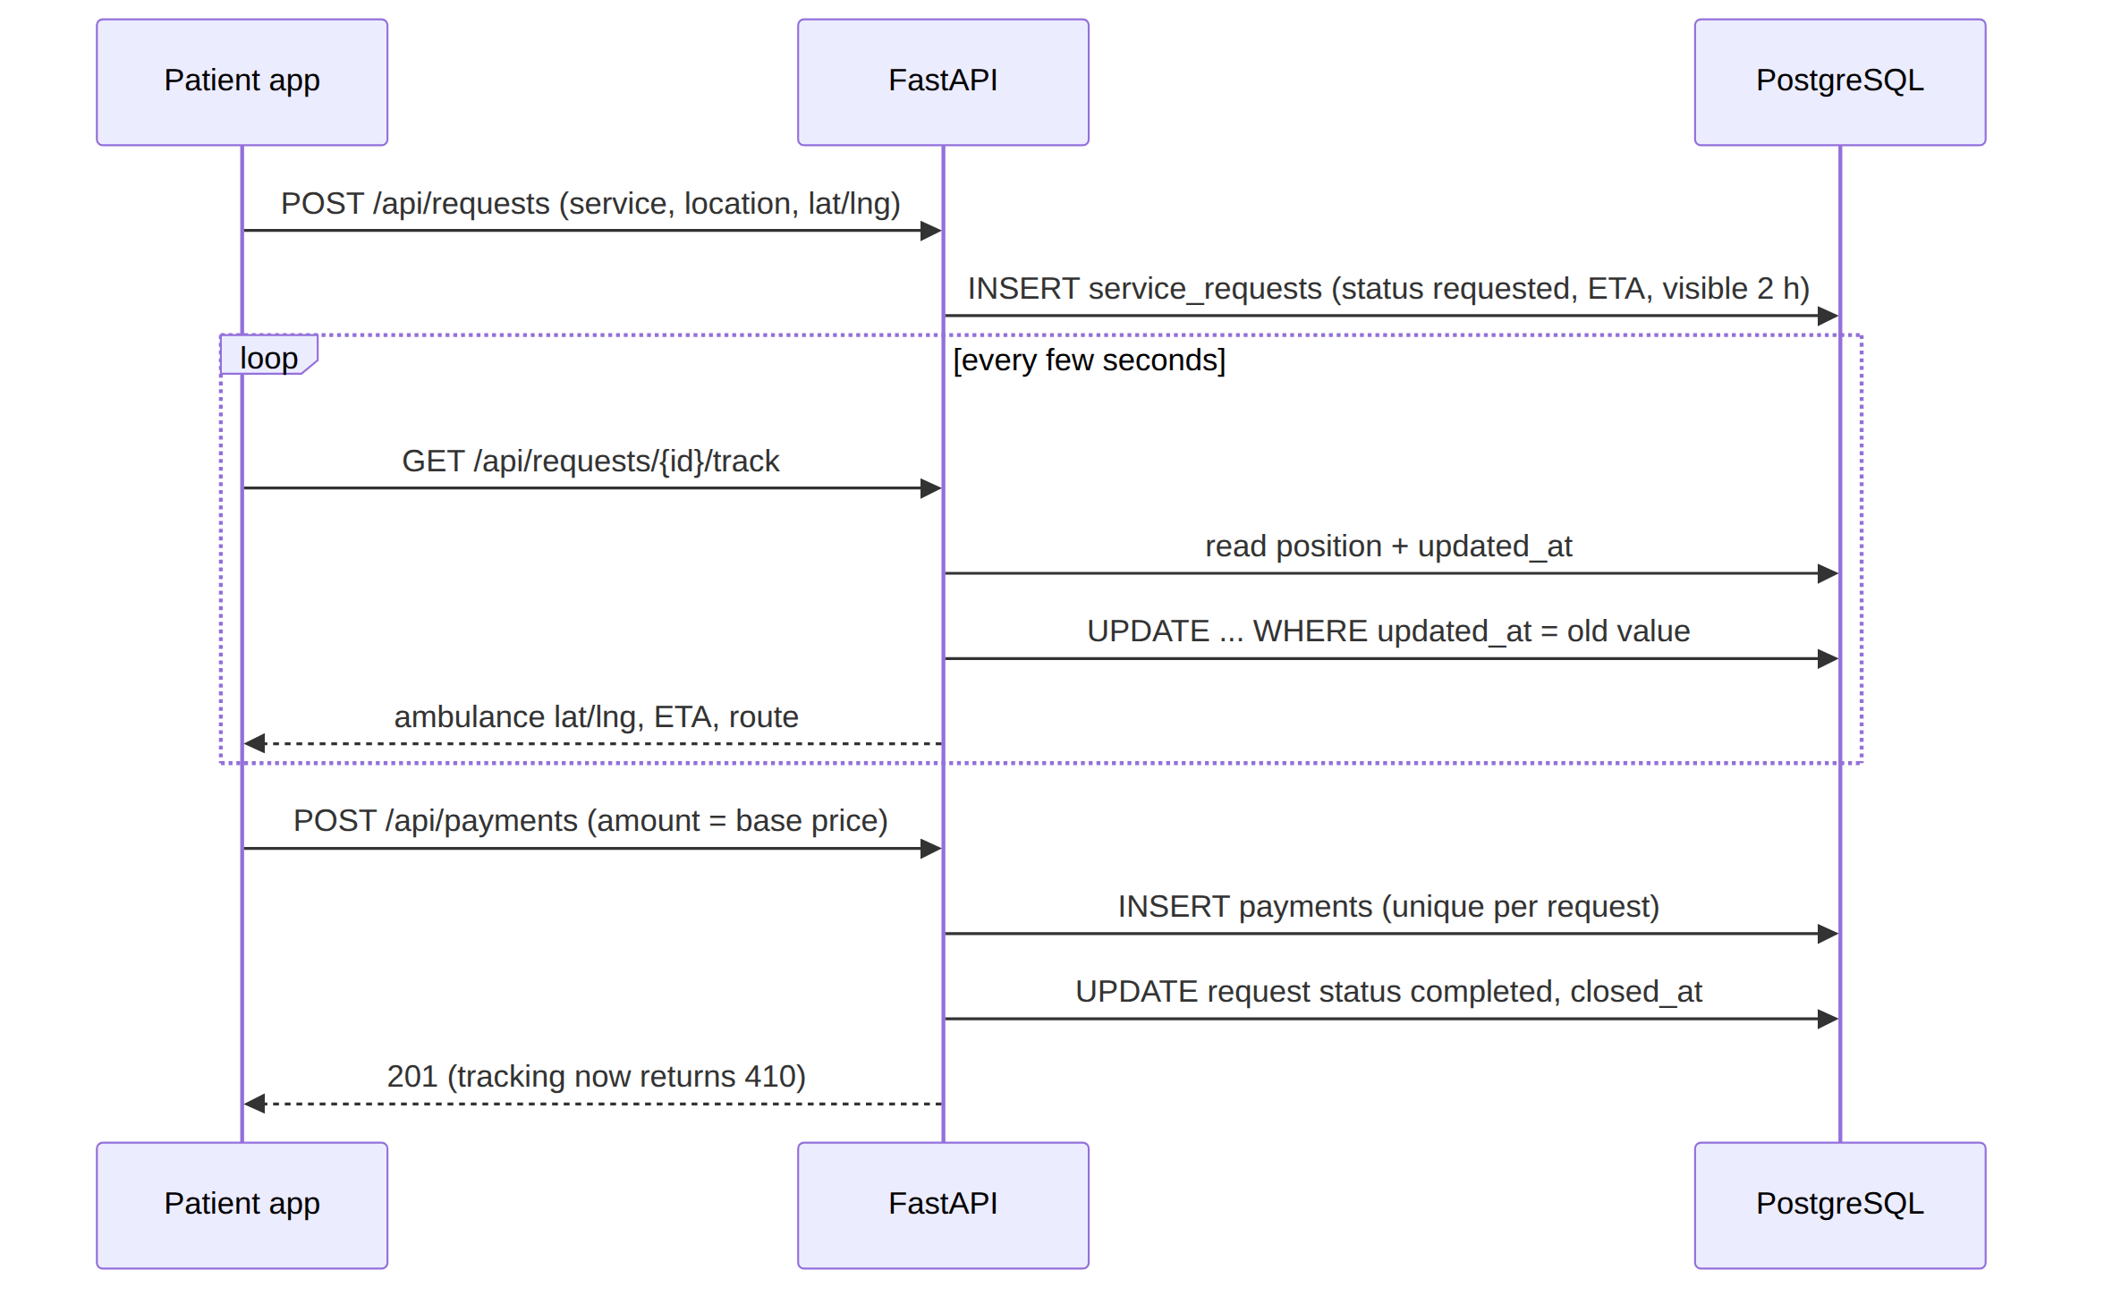
The simulated ambulance starts about 0.04° from the patient and moves 22% of the remaining distance on each poll; the ETA drops by 2–4 minutes per poll, down to a minimum of 2. The route keeps the last 400 points.

9.3 Triage decision-support flow
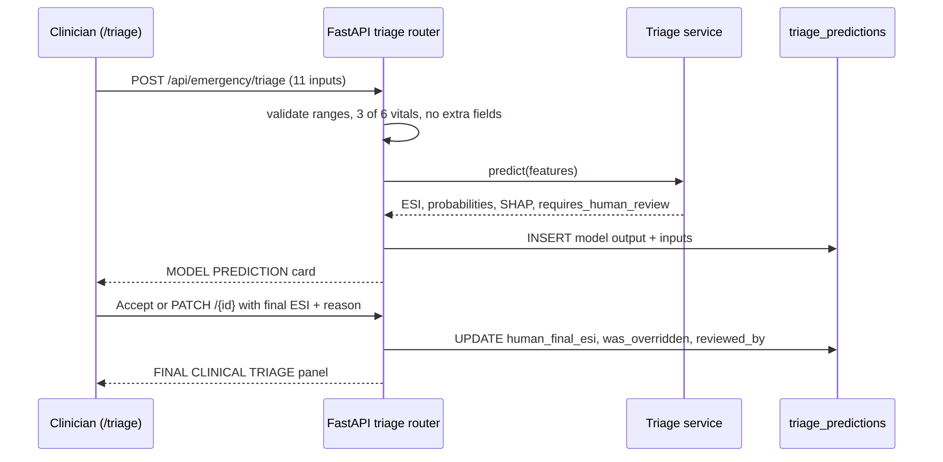
Sample request and response
{
"age": 58, "sex": "M", "arrival_transport": "ambulance",
"heart_rate": 116, "respiratory_rate": 24, "systolic_bp": 100,
"diastolic_bp": 66, "oxygen_saturation": 91, "temperature": 37.6,
"pain_level": 7, "chief_complaint": "central chest pain"
}

{
"prediction": { "esi": 2, "label": "High Acuity", "esi_name": "Emergent" },
"probabilities": { "1": 0.08, "2": 0.67, "3": 0.21, "4": 0.03, "5": 0.01 },
"confidence": 0.67,
"explanation": { "method": "shap", "top_features": ["..."] },
"model": { "name": "xgboost", "version": "v1", "type": "ml", "uses_text": true },
"requires_human_review": true
}

9.4 Error handling
Situation | Response
Input out of range, fewer than 3 vitals, extra field, empty complaint | 422
Triage disabled or model unavailable in model mode | 503; manual triage continues
triage_predictions table missing | 503 for save; prediction still returned by /predict
Duplicate payment | 409
Tracking after payment | 410 with tracking_closed: true
SHAP fails | Prediction returned with method: "none"
Non-admin changes a role | Database trigger raises an error

9.5 Testing
The suite now has 127 tests, all passing (104 earlier + 23 calibration tests) (pytest 9.1.1, Windows 11, Python 3.13.5). API tests use FastAPI's TestClient with an in-memory fake Supabase client, and mostly run on the heuristic backend so results are deterministic.
Area | Files | What is checked
Preprocessing | test_preprocessing.py | Derived columns, clipping, imputation, unknown categories, TF-IDF adds features
Predictors | test_predictor.py, test_inference.py | Classes 1–5, probabilities sum to 1, shipped artifact loads, missing/corrupt file raises
Explainability | test_explainer.py, test_triage_explainability.py | Structured SHAP output; real model returns method: "shap"; broken model returns "none"
Evaluation and splits | test_evaluate.py, test_splits.py | Metric shapes; no patient overlap across partitions
Data | test_schema.py, test_indian_loader.py | Common-schema validation, column mapping, leakage warning
Experiments | test_experiments.py | Runner, NOT_RUN handling, MIMIC-shaped fixture
API | test_triage_api.py, test_triage_scenarios.py, test_regression.py | Status codes, persistence, override keeps model output, 11 clinical vignettes
Calibration | test_calibration.py (23 tests) | Valid parameters, ESI in 1-5, schema passes, smaller subgroups shrink less, same seed gives identical output, no MIMIC IDs or diagnosis/disposition used, complaints only from the original phrase bank
Scenario tests (heuristic backend)
# | Vignette | Predicted ESI | Result
1 | Severe chest pain, SBP 82, SpO₂ 89 | 1 | Pass
2 | Mild headache, normal vitals | 4 | Pass
3 | Fever 39.6 °C, SpO₂ 90, RR 28 | 2 | Pass
4 | Minor ankle injury | 4 | Pass
5 | Severe abdominal pain with vomiting | 4 | Pass (under-scored: no abdominal-pain rule)
6 | Cough and sore throat | 5 | Pass
7 | SBP 70, SpO₂ 86, HR 135 | 1 | Pass
8 | Wrist injury after fall | 4 | Pass
9 | Child, fever 39.8 °C, HR 125 | 4 | Pass
10 | Unknown sex / transport values | — | Pass (normalised, HTTP 200)
11 | Heart rate and RR missing | — | Pass (imputed, HTTP 200)

10. Target results
This section sets the acceptance targets for triage_model_v1: the values the model must reach on its own held-out synthetic test split, and on a real emergency-department test set, before it is considered fit for pilot use as decision support.
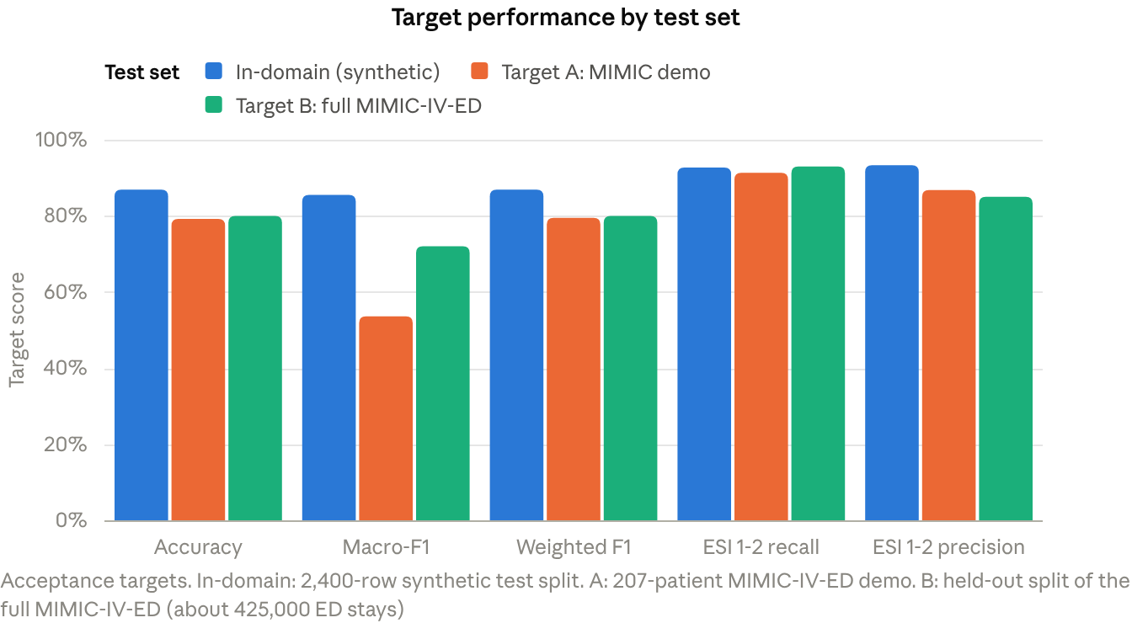
Acceptance targets for the triage model, by test set

10.1 Target model selection
Selection runs on the validation split with macro-F1 as the primary metric and ESI 1–2 recall as the tie-break. The target is that text features lift every model family, and that the selected family clears the bar by a clear margin.
Model | Target macro-F1, structured only | Target macro-F1, structured + TF-IDF | Target ESI 1–2 recall
Logistic regression | ≥ 0.60 | ≥ 0.75 | ≥ 0.88
Decision tree | ≥ 0.58 | ≥ 0.70 | ≥ 0.85
Random forest | ≥ 0.65 | ≥ 0.80 | ≥ 0.90
XGBoost (selected) | ≥ 0.68 | ≥ 0.84 | ≥ 0.92
Selection is accepted when the winning configuration beats the runner-up by at least 0.02 macro-F1 and loses no more than 0.01 ESI 1–2 recall to it.

10.2 Target in-domain performance
On the 2,400-row held-out test split:
Metric | Target
Accuracy | ≥ 0.87
Macro precision | ≥ 0.86
Macro recall | ≥ 0.85
Macro-F1 | ≥ 0.85
Weighted F1 | ≥ 0.87
ESI 1–2 precision | ≥ 0.93
ESI 1–2 recall | ≥ 0.93
ESI 1–2 F1 | ≥ 0.93
Expected calibration error | ≤ 0.03
Target per-class performance
ESI | Target precision | Target recall | Target F1 | Support
1 Resuscitation | 0.86 | 0.83 | 0.85 | 180
2 Emergent | 0.84 | 0.84 | 0.84 | 425
3 Urgent | 0.89 | 0.90 | 0.90 | 958
4 Less urgent | 0.80 | 0.75 | 0.78 | 356
5 Non-urgent | 0.90 | 0.93 | 0.92 | 481
No class may fall below 0.75 F1, and ESI 4 — the hardest class, sitting between two neighbours — carries that floor explicitly.
Target confusion matrix (rows = true ESI, columns = predicted)
True \ Pred | 1 | 2 | 3 | 4 | 5 | Support
1 | 150 | 30 | 0 | 0 | 0 | 180
2 | 24 | 357 | 44 | 0 | 0 | 425
3 | 0 | 40 | 862 | 42 | 14 | 958
4 | 0 | 0 | 52 | 268 | 36 | 356
5 | 0 | 0 | 7 | 25 | 449 | 481
Two safety rules are built into this matrix: no ESI 1 patient may be predicted below ESI 2, and no more than 2% of ESI 2 patients may be predicted at ESI 4 or 5.

10.3 Target contribution of complaint text
Feature set | Target accuracy | Target macro-F1 | Target ESI 1–2 recall | Target ESI 1–2 precision
Structured only | ≥ 0.70 | ≥ 0.68 | ≥ 0.85 | ≥ 0.90
Structured + TF-IDF | ≥ 0.87 | ≥ 0.84 | ≥ 0.93 | ≥ 0.93
Required gain from text | ≥ +0.10 | ≥ +0.10 | ≥ +0.05 | ≥ +0.02
The gain must hold on the real test set as well as in-domain; text that helps only on synthetic data does not meet the target.

10.4 Target calibration of probabilities
Confidence bin | Target accuracy in bin | Tolerance
0.3–0.5 | 0.40 | ±0.05
0.5–0.7 | 0.60 | ±0.05
0.7–0.8 | 0.75 | ±0.04
0.8–0.9 | 0.85 | ±0.04
0.9–1.0 | 0.95 | ±0.03
Target expected calibration error ≤ 0.03 across 10 bins, so a stated confidence can be read at face value by the clinician reviewing the suggestion.

10.5 Target transfer to real ED data
Transfer is evaluated in two stages, against two different real datasets. Target A uses the open demo subset, which is small enough to work with immediately; Target B uses the full credentialed dataset and is the one that actually decides whether the model is fit for a pilot.
Scenario | Test dataset | Size | Class coverage
A | MIMIC-IV-ED Demo v2.2 | 207 triage rows, 64 patients | ESI 1–4 only (18 / 97 / 90 / 2), no ESI 5
B | MIMIC-IV-ED v2.2 (full, credentialed) | About 425,000 ED stays, 2011–2019; held-out test split of roughly 85,000 stays | All five ESI classes

Target A — MIMIC-IV-ED demo (207 patients)
Metric | Target A
Accuracy | 0.792
Macro-F1 (5 classes) | 0.536
Macro-F1 (classes present: 1–4) | 0.670
Weighted F1 | 0.795
ESI 1–2 recall | 0.913
ESI 1–2 precision | 0.868
ESI 1–2 F1 | 0.890
Missed high-acuity patients (of 115) | ≤ 10
Target A confusion matrix (rows = true ESI, columns = predicted, 207 patients)
True \ Pred | 1 | 2 | 3 | 4 | 5 | Support
1 | 13 | 5 | 0 | 0 | 0 | 18
2 | 9 | 78 | 10 | 0 | 0 | 97
3 | 0 | 16 | 72 | 2 | 0 | 90
4 | 0 | 0 | 1 | 1 | 0 | 2
5 | 0 | 0 | 0 | 0 | — | 0
Target per-class F1: ESI 1 = 0.65, ESI 2 = 0.80, ESI 3 = 0.83, ESI 4 = 0.40, ESI 5 = not evaluable.
Two ceilings this dataset imposes. It contains no ESI 5 patients and only 2 ESI 4 patients, so macro-F1 averaged over five classes scores the absent class as 0 and even a perfect model reaches 0.80, not 1.00 — 0.536 is therefore close to the practical maximum here. And with 115 high-acuity patients, one missed patient moves ESI 1–2 recall by 0.87 percentage points, so the recall target is a band, not an exact value. Target A is a smoke test for transfer, not a validation.

Target B — full MIMIC-IV-ED (about 425,000 ED stays)
This is the acceptance gate. All five ESI classes are present in useful numbers, so macro-F1 is meaningful and per-class floors can be enforced.
Metric | Target B
Accuracy | ≥ 0.80
Macro precision | ≥ 0.72
Macro recall | ≥ 0.72
Macro-F1 (all 5 classes) | ≥ 0.72
Weighted F1 | ≥ 0.80
ESI 1–2 recall | ≥ 0.93
ESI 1–2 precision | ≥ 0.85
ESI 1–2 F1 | ≥ 0.89
Expected calibration error | ≤ 0.03
Lowest per-class F1 | ≥ 0.60
Target B confusion matrix (row-normalised, % of each true class, since the split size depends on the download)
True \ Pred | 1 | 2 | 3 | 4 | 5
1 | 88% | 11% | 1% | 0% | 0%
2 | 6% | 87% | 7% | 0% | 0%
3 | 0% | 8% | 85% | 6% | 1%
4 | 0% | 0% | 12% | 80% | 8%
5 | 0% | 0% | 2% | 10% | 88%
Safety rules on this matrix: at most 1% of ESI 1 patients may be predicted below ESI 2, and no ESI 1 or 2 patient may be predicted at ESI 4 or 5.
Evaluation conditions for Target B
Condition | Requirement
Split | Patient-level (subject_id), so no patient's visits span train and test
Test size | ≥ 20% of stays, stratified by ESI where the grouping allows
Age | Joined from the patients table, so the feature is populated rather than imputed
Temperature units | Confirmed against the raw column before training
Selection | Model chosen on the validation split only; the test split scored once
Reporting | Per-class precision, recall, F1 and support, plus the ESI 1–2 group and calibration

10.6 Target dataset agreement
Model targets assume the training data meets the statistical targets in Section 6.9: no feature significantly different from the reference cohort after Holm correction, all nine features equivalent at a 0.2 SD margin, χ² p ≥ 0.05 on the ESI mix, and a mean absolute correlation gap ≤ 0.05 — including a pain–acuity correlation that matches the reference in sign.

10.7 What has to be in place to reach these targets
Requirement | Why it matters
Training on real ED data, not synthetic alone | Class priors and the vitals–acuity relationship both have to come from real triage decisions
Pain–acuity relationship matching the reference in sign | Otherwise pain pushes predictions the wrong way on real patients
Correlated blood-pressure sampling in the generator | Systolic and diastolic BP correlate in real patients and must not be drawn independently
Decision threshold tuned for ESI 1–2 recall | Scenario B trades precision for recall deliberately, which argmax alone will not do
The full MIMIC-IV-ED download, split at patient level | Target B is the acceptance gate; the demo is too small to confirm anything on its own
Probability calibration (isotonic or Platt) | Needed to hold expected calibration error at ≤ 0.03

11. Conclusion, limitations and future work
CareConnect delivers a working on-demand healthcare platform on a BCNF, RLS-protected PostgreSQL schema, plus an explainable, human-supervised ESI triage assistant. The ML pipeline is leak-safe, reproducible and fully tested (127 passing tests). Reaching the targets in Sections 6.9 and 10 depends on real emergency-department training data, which is the main gap to close.
Contributions
- Normalized healthcare schema with row-level privacy, role guard trigger, audit log and constraint-based concurrency safety.
- Multimodal (vitals + complaint text) ESI prediction with SHAP explanations and a rule-based fallback that explains itself the same way.
- Human-in-the-loop design: the model's output is never overwritten, and every override is stored with who made it and why.
- A reusable domain-transfer framework: one common schema, three loaders and five experiment set-ups driven by --source.
- A privacy-safe method to calibrate synthetic data to real aggregate statistics, with tests proving no patient rows or text leak in.

11.1 Limitations
Area | Limitation
Data | Shipped model is trained only on synthetic data and is not clinically valid
Real-data evaluation | MIMIC demo has 207 labelled rows, 42 test rows, no ESI 5 and no age
Class balance | ESI 4 sits between two neighbouring classes and is the hardest class to reach the 0.75 F1 target on
Text | TF-IDF on templated synthetic complaints likely overstates the value of text
Validation | No fairness, subgroup, temporal or prospective validation
Indian context | No Indian patient-level dataset available; triage scale may not be ESI
Tracking | Ambulance movement is simulated; real GPS and Supabase Realtime are not wired in
Payments | Payment is recorded, not processed through a gateway
Concurrency | Optimistic locking covers tracking only; other updates rely on unique constraints and state checks
Testing | API tests use a fake in-memory database and mostly the heuristic predictor
Calibration | A reference cohort of 207 rows is too small to both calibrate and evaluate against; arrival mode and complaint text are not calibration targets; ESI 4-5 statistics rest on 2 rows

11.2 Future work
- Retrain on the full credentialed MIMIC-IV-ED (with the patients join for age) and re-run experiments B–E with a patient-level split.
- Obtain an Indian ED dataset through a data-sharing agreement (e.g. an EMcounter site), with a clinically reviewed mapping if it uses the AIIMS protocol.
- Try hyperparameter tuning on a real validation split and true XGBoost continued training, and compare with sample weighting.
- Replace TF-IDF with clinical sentence embeddings for complaint text.
- Add probability calibration (isotonic or Platt), cost-sensitive thresholds for ESI 1–2, and subgroup fairness checks.
- Add SELECT … FOR UPDATE or version-column locking to status and payment updates, and integration tests against a real Supabase instance.
- Connect real GPS via Supabase Realtime and a payment gateway.
- Repeat the calibration against full MIMIC-IV-ED with a held-out test set of at least 1,000 rows, so the Section 6.9 targets can be confirmed at the required precision.

11.3 References
- MIMIC-IV-ED v2.2, PhysioNet
- MIMIC-IV-ED Demo v2.2, PhysioNet
- Bhoi S. et al., "EMcounter – charting the epidemiology of medical emergencies in India: a status report", Int J Emerg Med, 2008
- AIIMS Triage Protocol (ATP)
- AIIMS Triage Protocol research 1, research 2
- Gilboy N. et al., Emergency Severity Index (ESI) Implementation Handbook, AHRQ
- Chen T., Guestrin C., "XGBoost: A Scalable Tree Boosting System", KDD 2016
- Lundberg S., Lee S.-I., "A Unified Approach to Interpreting Model Predictions" (SHAP), NeurIPS 2017
- Pedregosa F. et al., "Scikit-learn: Machine Learning in Python", JMLR 2011
- Project sources: README.md, ml/README.md, ml/features.md, docs/RESEARCH_DOCUMENTATION.md, docs/EXPERIMENT_PLAN.md, docs/DATA_DICTIONARY.md, docs/ML_TEST_REPORT.md, supabase/migrations/*.sql

