Synthetic vs MIMIC-IV-ED — Statistical Analysis
Sep 18, 2026 · Vinayak Saxena

1. Summary
The synthetic training data differs from the MIMIC-IV-ED demo on 6 of 9 vital-sign features (Welch t-tests, Holm-corrected p < 0.05), on the ESI mix (χ² = 168.9, df = 4, p = 1.8 × 10⁻³⁵) and on arrival transport (χ² = 240.0, p = 7.8 × 10⁻⁵⁰). Sex is the one variable that already matched (p = 0.21).
Calibrating the generator to MIMIC's aggregate statistics helped, and the improvement is statistically supported where it is measured as a distribution shape: paired across the 9 features, the KS distance fell from 0.237 to 0.172 (paired t = −2.84, df = 8, p = 0.022; Wilcoxon p = 0.039; 8 of 9 features improved). The ESI mix went from χ² p = 1.8 × 10⁻³⁵ to p = 0.073, i.e. no longer distinguishable from MIMIC's, and the correlation gap halved (paired t = −2.62, p = 0.034).
Three caveats shape everything below.
- With n = 12,000 vs n = 207, the tests can detect a standardised difference as small as d = 0.20, so tiny, clinically meaningless gaps still come out "significant".
- The two datasets are not naturally paired — no patient appears in both. Paired tests are reported in three explicitly constructed forms (Section 3), each with its own meaning.
- After calibration, most features still fail a 0.2 SD equivalence test, so "no longer significantly different" is not the same as "proven similar".

2. Data and cleaning
Dataset | Source | Rows | Role
synthetic_original | ml/data/generated/synthetic_original.csv, seed 42 | 12,000 | The data the shipped model was trained on
synthetic_mimic_calibrated | ml/data/generated/synthetic_mimic_calibrated.csv, seed 42 | 12,000 | Same generator, parameters tuned to MIMIC aggregates
mimic_demo | mimic-iv-ed-demo-2.2/.../ed/ (triage + edstays) | 207 of 222 stays, 64 patients | Real reference
MIMIC rows are mapped with the project's own loader logic: temperature °F → °C, pain free text → first number clipped to 0–10, acuity → esi, 15 stays without a valid ESI dropped. shock_index and pulse_pressure are derived exactly as FeatureEngineer does.
Cleaning applied before testing. Values outside ml/config.py's FEATURE_RANGES are set to missing, which is what the training pipeline does. This removes exactly two malformed MIMIC values: one diastolic BP of 879 mmHg and one temperature that was recorded in Celsius and then converted again (2.5 °C). Both were reported, not silently dropped, in the project's own domain-shift write-up.
Cleaning matters for the results. With those two values left in, MIMIC's diastolic BP mean is 77.0 (SD 59.3) and pulse pressure 59.9 (SD 63.9); after cleaning they are 73.0 (SD 15.8) and 64.1 (SD 24.7), and the direction of the diastolic difference flips: synthetic BP now looks higher than MIMIC rather than lower. Every test below uses the cleaned values.
Missing data is handled test by test (complete cases per feature), so the MIMIC sample is 189–199 rows depending on the vital. age is 100% missing in MIMIC (the demo has no patients.csv) and is therefore excluded from all tests.

3. Test design
A paired t-test needs matched units — the same patient measured twice, or two measurements that belong together. No patient appears in both datasets, and the synthetic rows are independent draws with no patient linkage at all, so there is no natural pairing. Running a paired test on two unrelated columns of different lengths would be wrong.
So the analysis reports both families, and is explicit about what each answers.
Family | Test | Pairing unit | Question answered
Unpaired | Welch t (unequal variance), Student t, Mann–Whitney U, two-sample KS, Levene | none | Do synthetic and real distributions differ?
Paired (a) | Paired t and Wilcoxon signed-rank on quantile-matched values | the i-th quantile of each dataset | Where along the distribution do they differ, and by how much?
Paired (b) | One-sample t and Wilcoxon on within-ESI mean differences | one ESI class × one feature | Do they still differ once acuity is held constant?
Paired (c) | Paired t, Wilcoxon and sign test on distance-to-MIMIC before vs after calibration | one feature | Did calibration move the data closer to real data?
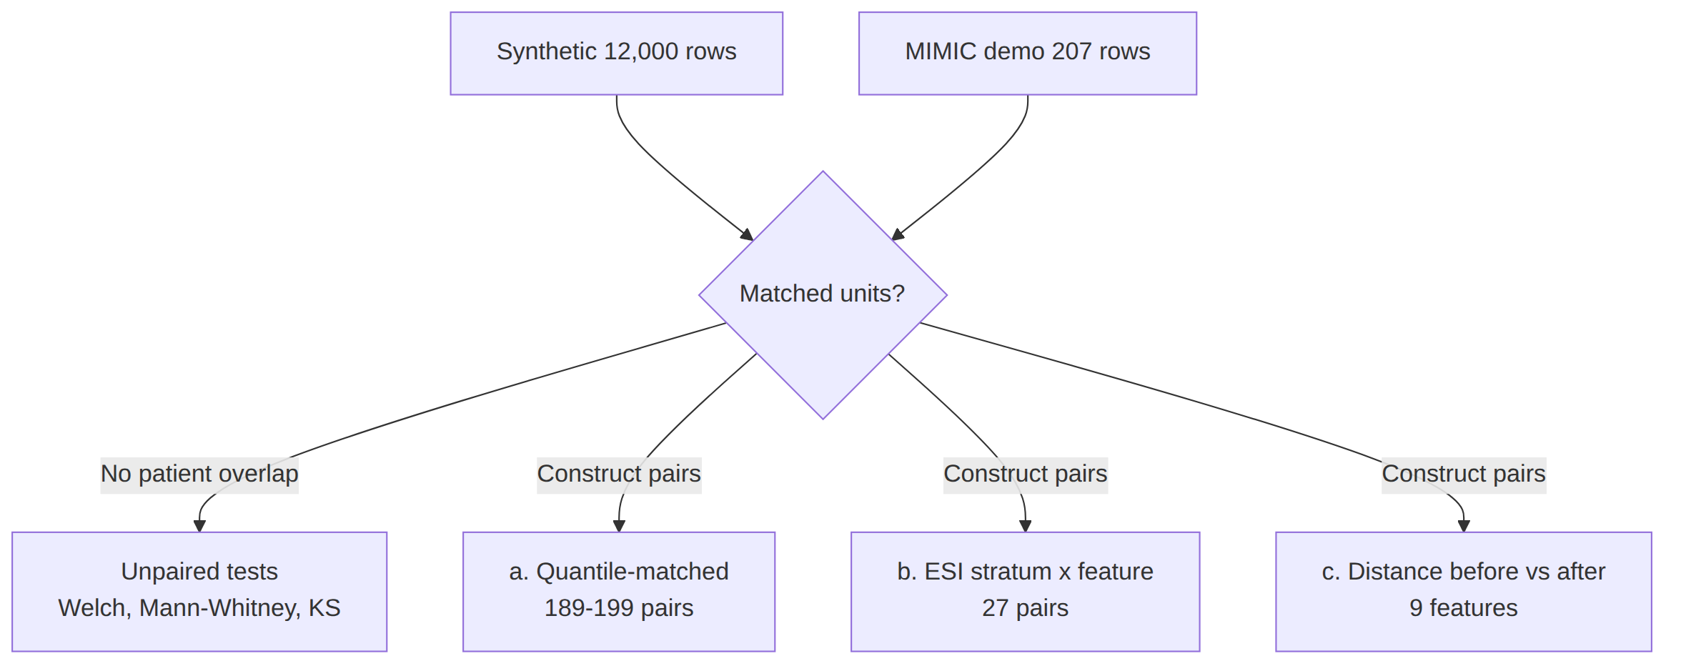
Paired form (a) sorts both samples and pairs the i-th smallest value in each, so the pairs are quantiles rather than patients. This is a legitimate way to test for a distribution shift, but its p-values must not be read as patient-level evidence: the pairing removes the sampling noise an unpaired test has to carry, so the t-values are much larger.
Paired form (b) is the closest thing to a clinically meaningful pairing: within one ESI class, the synthetic mean and the real mean describe the same kind of patient.
Paired form (c) is the standard before/after design, and here the pairing is genuine — each feature contributes one "before" and one "after" measurement of the same quantity.
All p-values in a family are reported raw and corrected with Holm (family-wise) and Benjamini–Hochberg (false discovery rate). Tests are two-sided at α = 0.05.

4. Assumptions and power
Normality. Shapiro–Wilk rejects normality for most features in both datasets, and several MIMIC features are strongly skewed.
Feature | Shapiro p (MIMIC) | Skew (MIMIC) | Excess kurtosis (MIMIC)
Heart rate | 0.128 | 0.32 | 0.01
Respiratory rate | 2.0 × 10⁻¹⁶ | 2.22 | 6.69
Systolic BP | 0.051 | 0.37 | −0.10
Diastolic BP | 0.061 | 0.36 | −0.04
SpO₂ | 2.6 × 10⁻¹⁷ | −2.96 | 15.34
Temperature | 0.0022 | 0.26 | 0.39
Pain | 1.2 × 10⁻¹⁴ | 0.20 | −1.62
Shock index | 0.00020 | 0.63 | 0.06
Pulse pressure | 1.3 × 10⁻⁵ | 0.71 | 0.06
This is why every t-test is reported next to a rank-based test (Mann–Whitney or Wilcoxon). With n = 189–199 on the MIMIC side, the central limit theorem makes the t-test on means reasonably robust anyway, and the two families agree on every feature except respiratory rate and pain, where the means are close but the shapes are not.
Equal variance. Levene's test rejects equal variance for 7 of 9 features (p < 0.05); only heart rate (p = 0.87) and shock index (p = 0.54) pass. Welch's t-test is therefore the primary test; Student's t is reported alongside for completeness.
Power. At α = 0.05 and 80% power with 12,000 vs 207 rows, the smallest detectable standardised difference is Cohen's d = 0.20 — a "small" effect. Anything larger will be flagged as significant, so effect size, not the p-value, is what says whether a difference matters. Effect sizes here use these conventions: d ≈ 0.2 small, 0.5 medium, 0.8 large; Cliff's δ ≈ 0.15 small, 0.33 medium, 0.47 large.
What the small MIMIC sample costs. ESI 4 has 2 rows and ESI 5 has none, so no per-class test is possible for them, and the within-ESI analysis uses classes 1–3 only (18, 97 and 90 rows).

5. Two-sample tests: synthetic vs MIMIC
Six of nine features differ significantly after Holm correction. The largest gaps are pulse pressure (d = −0.71), diastolic BP (d = 0.55) and temperature (d = 0.46).
synthetic_original vs MIMIC demo
Feature | Synthetic mean (SD) | MIMIC mean (SD) | Difference [95% CI] | Welch t (df) | p | Holm p | Cohen's d | Cliff's δ | Mann–Whitney p | KS
Heart rate | 90.76 (20.31) | 91.17 (18.89) | −0.41 [−3.08, 2.26] | −0.30 (205) | 0.76 | 1.00 | −0.02 | 0.03 | 0.47 | 0.095
Respiratory rate | 18.58 (4.51) | 18.14 (3.01) | 0.44 [0.01, 0.87] | 2.04 (214) | 0.043 | 0.13 | 0.10 | −0.03 | 0.59 | 0.218
Systolic BP | 128.47 (19.55) | 136.95 (27.83) | −8.48 [−12.39, −4.58] | −4.28 (201) | 2.9 × 10⁻⁵ | 1.4 × 10⁻⁴ | −0.43 | 0.15 | 1.3 × 10⁻⁴ | 0.198
Diastolic BP | 79.66 (12.04) | 72.99 (15.78) | 6.67 [4.45, 8.90] | 5.92 (201) | 1.4 × 10⁻⁸ | 8.3 × 10⁻⁸ | 0.55 | −0.30 | 7.1 × 10⁻¹³ | 0.277
SpO₂ | 96.27 (3.36) | 97.69 (2.70) | −1.42 [−1.80, −1.04] | −7.31 (208) | 5.7 × 10⁻¹² | 4.0 × 10⁻¹¹ | −0.42 | 0.33 | 1.9 × 10⁻¹⁴ | 0.301
Temperature | 37.11 (0.84) | 36.72 (0.48) | 0.38 [0.31, 0.45] | 10.81 (215) | 4.8 × 10⁻²² | 4.3 × 10⁻²¹ | 0.46 | −0.31 | 2.6 × 10⁻¹⁴ | 0.360
Pain | 4.22 (2.61) | 4.10 (4.01) | 0.12 [−0.46, 0.70] | 0.41 (191) | 0.69 | 1.00 | 0.05 | −0.05 | 0.18 | 0.342
Shock index | 0.73 (0.26) | 0.70 (0.22) | 0.03 [0.00, 0.06] | 2.19 (207) | 0.030 | 0.12 | 0.13 | −0.06 | 0.12 | 0.114
Pulse pressure | 48.75 (21.54) | 64.09 (24.69) | −15.34 [−18.83, −11.86] | −8.69 (202) | 1.3 × 10⁻¹⁵ | 1.0 × 10⁻¹⁴ | −0.71 | 0.32 | 2.5 × 10⁻¹⁵ | 0.228
synthetic_mimic_calibrated vs MIMIC demo
Feature | Difference | Welch t | p | Holm p | Cohen's d | KS
Heart rate | 1.80 | 1.33 | 0.19 | 0.56 | 0.09 | 0.082
Respiratory rate | 0.59 | 2.71 | 0.0074 | 0.044 | 0.15 | 0.282
Systolic BP | −2.11 | −1.06 | 0.29 | 0.58 | −0.08 | 0.050
Diastolic BP | 5.21 | 4.47 | 1.2 × 10⁻⁵ | 1.1 × 10⁻⁴ | 0.16 | 0.129
SpO₂ | −0.83 | −4.28 | 2.8 × 10⁻⁵ | 2.3 × 10⁻⁴ | −0.26 | 0.208
Temperature | −0.03 | −0.75 | 0.45 | 0.58 | −0.01 | 0.251
Pain | 0.44 | 1.50 | 0.14 | 0.54 | 0.14 | 0.286
Shock index | 0.04 | 2.25 | 0.025 | 0.13 | 0.12 | 0.054
Pulse pressure | −7.50 | −4.17 | 4.5 × 10⁻⁵ | 3.1 × 10⁻⁴ | −0.18 | 0.207
Significant differences fall from 6 features to 4, and every effect size except SpO₂ drops below 0.2.
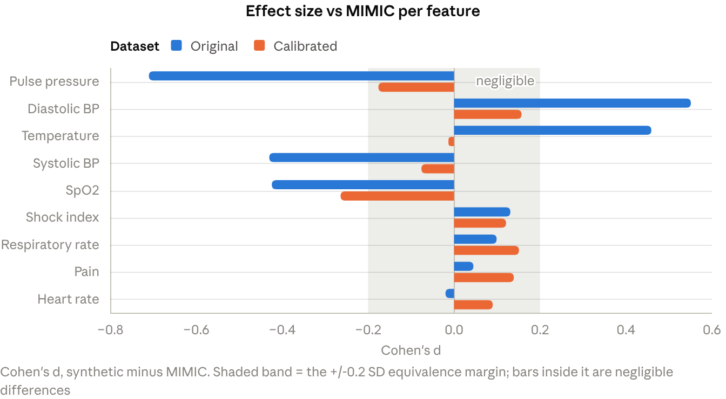
statistical_tests.json · 9 features × 2 synthetic datasets
Two features deserve a note. Temperature has the largest KS distance in the original data (0.360) but the smallest effect size after calibration (d = −0.01), because MIMIC's temperatures are recorded in whole and half degrees Fahrenheit, giving a comb-shaped distribution that no continuous generator can match. Pain shows the opposite pattern: means agree (4.22 vs 4.10, p = 0.69) while shapes do not (KS = 0.342), because real pain scores pile up at 0 and 10.

6. Paired tests

6.1 Quantile-matched pairs (form a)
Each MIMIC value is paired with the synthetic value at the same quantile, giving 189–199 pairs per feature. The mean differences match the unpaired results almost exactly; what changes is precision — the confidence intervals are 3–4 times narrower, so weak differences now reach significance too.
Feature | Pairs | Mean difference [95% CI] | Paired t (df) | p | Holm p | d₂ | Wilcoxon p
Heart rate | 198 | −0.43 [−0.83, −0.04] | −2.16 (197) | 0.032 | 0.063 | −0.15 | 1.0 × 10⁻¹⁰
Respiratory rate | 199 | 0.44 [0.19, 0.68] | 3.50 (198) | 5.7 × 10⁻⁴ | 0.0017 | 0.25 | 0.0021
Systolic BP | 199 | −8.50 [−9.81, −7.19] | −12.75 (198) | 1.4 × 10⁻²⁷ | 6.9 × 10⁻²⁷ | −0.90 | 1.9 × 10⁻²⁴
Diastolic BP | 198 | 6.68 [6.03, 7.32] | 20.40 (197) | 1.8 × 10⁻⁵⁰ | 1.3 × 10⁻⁴⁹ | 1.45 | 3.2 × 10⁻²⁹
SpO₂ | 198 | −1.41 [−1.54, −1.29] | −22.01 (197) | 5.6 × 10⁻⁵⁵ | 4.5 × 10⁻⁵⁴ | −1.56 | 2.7 × 10⁻³²
Temperature | 195 | 0.38 [0.33, 0.43] | 14.81 (194) | 1.1 × 10⁻³³ | 6.4 × 10⁻³³ | 1.06 | 2.4 × 10⁻²⁷
Pain | 189 | 0.13 [−0.15, 0.40] | 0.92 (188) | 0.36 | 0.36 | 0.07 | 0.23
Shock index | 198 | 0.03 [0.02, 0.05] | 4.57 (197) | 8.7 × 10⁻⁶ | 3.5 × 10⁻⁵ | 0.33 | 1.0 × 10⁻¹⁵
Pulse pressure | 198 | −15.35 [−16.18, −14.53] | −36.76 (197) | 3.8 × 10⁻⁹⁰ | 3.4 × 10⁻⁸⁹ | −2.61 | 3.0 × 10⁻³⁴
On the calibrated data the same test still rejects for 8 of 9 features, but the paired effect sizes shrink sharply: pulse pressure d₂ −2.61 → −0.37, diastolic BP 1.45 → 0.29, temperature 1.06 → −0.02. Only SpO₂ stays large (−1.21).
The contrast between the two tables is the point: at the level of means the calibrated data is close to MIMIC, while at the level of whole distributions small systematic gaps remain and this very sensitive test still finds them.

6.2 Within-ESI pairs (form b)
Here each pair is one ESI class × one feature (3 classes × 9 features = 27 pairs), which holds acuity constant.
Dataset | Mean paired difference | t (df = 26) | p | Wilcoxon p
Original vs MIMIC | −0.38 | −0.31 | 0.76 | 0.79
Calibrated vs MIMIC | −0.53 | −0.60 | 0.55 | 0.77
Neither is significant, but that is a weak result rather than evidence of similarity: the differences are in raw units and cancel out (temperature off by +0.4, pulse pressure off by −15). Standardising each difference by the MIMIC subgroup's SD is more informative.
ESI class (MIMIC n) | Mean standardised difference, original | t | p | Mean standardised difference, calibrated
1 (18) | 0.35 | 1.55 | 0.16 | 0.16
2 (97) | 0.22 | 0.94 | 0.37 | 0.04
3 (90) | 0.00 | −0.01 | 0.99 | −0.04
Once acuity is held constant, the synthetic vitals sit within about a third of a standard deviation of the real ones, and calibration halves what remains. The gap is largest at ESI 1, the class with 18 real patients — the acuity level the model most needs to get right, and the one with the least real data to check against.

7. Did calibration help? (form c)
This is the one genuinely paired design: each of the 9 features contributes its distance to MIMIC before calibration and after, and the test asks whether the after-values are smaller.
Distance measure | Mean before | Mean after | Change | Paired t (df = 8) | p | d₂ | Wilcoxon p | Features improved | Sign test p
KS statistic | 0.237 | 0.172 | −0.065 | −2.84 | 0.022 | −0.95 | 0.039 | 8 / 9 | 0.039
|Cohen's d| | 0.319 | 0.132 | −0.187 | −2.26 | 0.054 | −0.75 | 0.13 | 6 / 9 | 0.51
Absolute mean difference | 3.70 | 2.06 | −1.64 | −1.53 | 0.16 | −0.51 | 0.25 | 5 / 9 | 1.00
Wasserstein distance | 4.28 | 3.93 | −0.35 | −0.37 | 0.72 | −0.12 | 0.57 | 6 / 9 | 0.51
Only the KS statistic — the measure of overall distribution shape — improves significantly, and it does so on all three tests (parametric, rank-based and sign), which is as consistent as 9 pairs can be. The effect size is large (d₂ = −0.95).
The measures that are sensitive to a few extreme values (mean difference, Wasserstein) show a big average improvement but fail the test, because the improvement is uneven: heart rate and temperature moved away on Wasserstein while systolic BP moved a long way toward MIMIC. With 9 pairs, that spread swamps the mean.
Reading this honestly: calibration reliably improved distribution shape, showed a large but not statistically confirmed improvement in standardised location (|d| 0.32 → 0.13, p = 0.054), and did not measurably improve outlier-sensitive distance. Nine features is a small sample for a paired test, so p = 0.054 should be read as "underpowered", not "no effect".

8. Categorical variables
Each test is a chi-square goodness-of-fit: the MIMIC counts are the observations, and the synthetic proportions supply the expected counts.
Variable | Dataset | χ² | df | p | Cramér's V | TVD | JS distance
Sex | Original | 1.60 | 1 | 0.21 | 0.088 | 0.044 | 0.037
Sex | Calibrated | 0.04 | 1 | 0.84 | 0.014 | 0.007 | 0.006
Arrival transport | Original | 240.0 | 5 | 7.8 × 10⁻⁵⁰ | 0.482 | 0.444 | 0.510
Arrival transport | Calibrated | 95.8 | 5 | 4.0 × 10⁻¹⁹ | 0.304 | 0.299 | 0.435
ESI | Original | 168.9 | 4 | 1.8 × 10⁻³⁵ | 0.452 | 0.339 | 0.451
ESI | Calibrated | 8.60 | 4 | 0.073 | 0.102 | 0.047 | 0.120
ESI is the headline. The original generator's acuity mix is incompatible with MIMIC's (p = 1.8 × 10⁻³⁵, V = 0.45, a large effect). After calibration the same test no longer rejects (p = 0.073) and the effect size is small — this is the clearest success in the whole comparison.
ESI | MIMIC observed | Expected from original | Expected from calibrated
1 | 18 | 15.5 | 17.6
2 | 97 | 36.6 | 94.2
3 | 90 | 82.7 | 85.5
4 | 2 | 30.7 | 10.1
5 | 0 | 41.5 | 1.4
The residual χ² after calibration comes almost entirely from ESI 4 (2 observed vs 10.1 expected), which is the deliberate 1% floor the calibration applies so that no class disappears.
Arrival transport stays significantly different even after calibration, and this is expected: it was never a calibration target. MIMIC is ambulance-heavy (119 of 207, 57%) where the synthetic generator is walk-in heavy (105.8 expected, 51%), and MIMIC uses unknown (12 rows) and other (1) where the generator uses public and private. Those two categories carry no synthetic probability at all and were excluded from the chi-square, so the reported statistic understates the gap.
Sex already matched before calibration and matches almost perfectly after (V = 0.014).

9. Correlation structure
Fisher's z-test compares each correlation between datasets. Vital–vital pairs use Pearson; anything involving ESI uses Spearman, because ESI is ordinal.
Pair | r synthetic | r calibrated | r MIMIC | z (original vs MIMIC) | p | Holm p | p (calibrated vs MIMIC)
Pain ↔ ESI | −0.498 | −0.082 | +0.203 | −10.17 | 2.8 × 10⁻²⁴ | 2.2 × 10⁻²³ | 9.6 × 10⁻⁵
Systolic ↔ diastolic BP | 0.131 | 0.025 | 0.472 | −5.27 | 1.4 × 10⁻⁷ | 9.8 × 10⁻⁷ | 1.5 × 10⁻¹¹
Heart rate ↔ ESI | −0.491 | −0.250 | −0.167 | −5.11 | 3.2 × 10⁻⁷ | 1.9 × 10⁻⁶ | 0.23
Respiratory rate ↔ ESI | −0.489 | −0.241 | −0.183 | −4.86 | 1.2 × 10⁻⁶ | 6.0 × 10⁻⁶ | 0.40
SpO₂ ↔ ESI | 0.475 | 0.289 | 0.193 | 4.45 | 8.5 × 10⁻⁶ | 3.4 × 10⁻⁵ | 0.16
SpO₂ ↔ respiratory rate | −0.425 | −0.317 | −0.169 | −3.92 | 8.7 × 10⁻⁵ | 2.6 × 10⁻⁴ | 0.029
Heart rate ↔ respiratory rate | 0.373 | 0.219 | 0.234 | 2.13 | 0.033 | 0.066 | 0.83
Heart rate ↔ systolic BP | −0.098 | −0.131 | −0.108 | 0.14 | 0.89 | 0.89 | 0.75
Paired across the 8 pairs, the average gap to MIMIC falls from 0.295 to 0.144 after calibration (paired t = −2.62, df = 7, p = 0.034; Wilcoxon p = 0.039).
Three findings matter for the model.
- Pain points the wrong way. In the synthetic data, higher pain goes with a lower ESI number, i.e. more acute (r = −0.50). In MIMIC the relationship is reversed (r = +0.20): real patients with the highest pain scores are often ESI 3–4, while ESI 1 patients are frequently unresponsive and score 0. A model trained on the synthetic sign will systematically misread pain on real data. Calibration weakens the synthetic correlation (−0.50 → −0.08) but does not flip it, and the gap stays significant.
- Vitals are too predictive of acuity in the synthetic data. Heart rate, respiratory rate and SpO₂ all correlate with ESI 2–3 times more strongly than in MIMIC, because the generator builds ESI from a vitals scorecard. Real triage nurses use judgement, history and appearance, so real correlations are weaker. After calibration these three are no longer significantly different from MIMIC.
- Physiological structure is missing. Systolic and diastolic BP correlate at 0.47 in real patients and only 0.13 in the synthetic data (0.03 after calibration), because the generator samples them independently within a band. This is the one structural gap calibration made slightly worse.

10. Equivalence testing
A non-significant t-test does not show two datasets are similar. Two one-sided tests (TOST) turn the question around and ask whether the difference is small enough to ignore. The margin here is ±0.2 × the MIMIC standard deviation — the same "negligible effect" threshold used above.
Feature | Margin | Difference, original | Equivalent? | Difference, calibrated | TOST p | Equivalent?
Heart rate | ±3.78 | −0.41 | Yes (p = 0.007) | 1.80 | 0.073 | No
Respiratory rate | ±0.60 | 0.44 | No | 0.59 | 0.47 | No
Systolic BP | ±5.57 | −8.48 | No | −2.11 | 0.042 | Yes
Diastolic BP | ±3.16 | 6.67 | No | 5.21 | 0.96 | No
SpO₂ | ±0.54 | −1.42 | No | −0.83 | 0.93 | No
Temperature | ±0.10 | 0.38 | No | −0.03 | 0.054 | No (borderline)
Pain | ±0.80 | 0.12 | Yes (p = 0.010) | 0.44 | 0.11 | No
Shock index | ±0.04 | 0.03 | No | 0.04 | 0.30 | No
Pulse pressure | ±4.94 | −15.34 | No | −7.50 | 0.92 | No
Only 1 of 9 features is statistically equivalent to MIMIC after calibration, and the set even changes: heart rate and pain were equivalent before calibration and are not after, because calibration moved their means while shrinking their gaps elsewhere.
This is the most important corrective in the analysis. Section 5 shows that most calibrated features are no longer significantly different from MIMIC; this section shows that almost none of them are demonstrably similar. With 207 reference rows, the confidence intervals are simply too wide to prove similarity at a 0.2 SD margin — a larger real sample would be needed, not a better generator.

11. Interpretation, limitations and reproduction

11.1 What this means for the triage model
Finding | Consequence for triage_model_v1
ESI mix differs sharply before calibration (χ² p = 1.8 × 10⁻³⁵) | The model's class priors are wrong for a real ED, which is the main reason accuracy drops from 79% to 44% on MIMIC
Pain–acuity correlation has the opposite sign (−0.50 vs +0.20) | Pain is actively misleading as a learned feature; it should be watched in any SHAP review of real-data predictions
Vitals–acuity correlations 2–3× too strong | The model is more confident from vitals alone than real triage data justifies
Systolic–diastolic correlation missing (0.13 vs 0.47) | The generator samples BP components independently; adding a correlated draw would be a cheap, targeted fix
Arrival transport far off (V = 0.30 even after calibration) | A one-hot feature the model sees in proportions no real ED produces
Calibration fixes the ESI mix but not the sign or structure problems | Consistent with the observed result that calibration improved accuracy (0.44 → 0.53) but not macro-F1 or ESI 1–2 recall

11.2 Limitations
- n = 207 real rows, 64 patients. Repeat visits by one patient are not accounted for, so the effective sample is smaller than it looks and p-values are mildly optimistic.
- The demo is not representative. It has no ESI 5 and 2 ESI 4 rows, so all class-conditional conclusions rest on ESI 1–3.
- Constructed pairing. Forms (a) and (b) create pairs that do not exist in the data; their p-values measure distribution differences, not patient-level ones.
- Multiplicity. More than 60 tests are reported. Holm and Benjamini–Hochberg corrections are applied within each family, not across all of them.
- Circularity in one place. The calibrated dataset was tuned using these same 207 rows, so Section 7 measures fit to the reference, not generalisation.
- age untested. It is entirely missing in the demo.
- Statistical similarity is not clinical validity. Nothing here says a model trained on either dataset triages patients correctly.

11.3 Reproducing this
python ml/experiments/run_statistical_tests.py .
The script reads the two generated CSVs and the MIMIC demo files, and writes every number in this document to ml/experiments/results/statistical_tests.json. It changes nothing in the model, the generator or the training pipeline. Fixed inputs: seed 42, cleaning by ml/config.py's FEATURE_RANGES, complete cases per feature, two-sided α = 0.05, Holm and Benjamini–Hochberg corrections within each test family. Libraries: SciPy 1.18, pandas, NumPy.

11.4 Sources
- ml/data/generated/synthetic_original.csv, ml/data/generated/synthetic_mimic_calibrated.csv
- MIMIC-IV-ED Demo v2.2 — edstays.csv.gz, triage.csv.gz
- docs/SYNTHETIC_VS_MIMIC_DOMAIN_SHIFT.md, docs/MIMIC_SYNTHETIC_CALIBRATION.md
- ml/experiments/results/statistical_tests.json (produced by this analysis)

