Credit Risk Pricing Model
A Business Analytics Case Study

Predicting serious delinquency risk and turning it into approve / decline and pricing decisions
Prepared by Joel Kotturi
September 11, 2026

Executive Summary
When a lender receives a loan application, it has to make two decisions: should this person be approved, and if so, what interest rate should they be charged? Both decisions depend on one thing: how likely is this applicant to fall seriously behind on payments? This case study builds a model that estimates that likelihood, and then shows how a bank could turn that estimate into an actual approve, decline, and pricing decision.
The analysis uses a public dataset of 150,000 anonymized U.S. consumer credit records, where about 6.7% of applicants went on to become seriously delinquent (90 or more days past due) within two years. Two prediction models were built and compared: a logistic regression, which is simple and easy to explain, and a gradient boosting model, which is more complex but usually more accurate. The gradient boosting model came out ahead on every metric tested.
The headline result: switching from the logistic regression model to the gradient boosting model reduces estimated cost by $72,556 per 10,000 applicants under the stated cost assumptions, while simultaneously approving more applicants (79.1% approved, versus 76.7%). A better model does not just cut losses. It lets the bank say yes to more people, because it is better at telling good and bad applicants apart.
Beyond the two models, the case study covers four things a real analytics role would touch: cleaning and preparing raw data, hosting and querying that data in a cloud SQL database (Microsoft Azure), translating a model's output into a tiered pricing table in Excel, and communicating the results with charts built for a business audience rather than a technical one.

The Business Problem
Consumer lenders approve millions of credit applications a year, and every approval carries a risk: some share of approved applicants will not pay the money back. A lender that approves everyone loses money on defaults. A lender that declines too aggressively loses good customers and the profit they would have generated. The real decision is not “should we lend to this type of person in general.” It is “what is the risk on this specific applicant, and does that risk justify approval, and at what price.”
This case study treats that as a three-part analytics problem. First, predict each applicant's risk of serious delinquency using the information available at the time they apply. Second, decide on a cutoff: above what predicted risk should an applicant simply be declined. Third, for applicants who are approved, organize them into a small number of pricing tiers, so a higher-risk approved applicant is charged a higher rate to offset the extra risk.

The Data
The dataset is “Give Me Some Credit,” a public dataset of 150,000 anonymized U.S. consumer credit records, originally released for a Kaggle competition. Each row is one applicant, described by ten financial and demographic variables: things like age, monthly income, how many credit lines they have open, how many times they have been late on a payment before, and how much of their available revolving credit they are currently using. The target variable is whether that applicant became seriously delinquent (90 or more days past due) within the following two years.

Cleaning the Data
Raw data is rarely usable as-is, and this dataset was no exception. Four issues were identified and corrected before any modeling began:
- One applicant was recorded with an age of 0, which is not a valid age, so this row was treated as a data error.
- Three columns that count late payments used the placeholder codes 96 and 98 in place of a small number of records, rather than real counts. These were capped and flagged with an indicator column rather than treated as genuine high counts.
- About 20% of applicants had no reported monthly income. Rather than deleting a fifth of the dataset, missing values were filled in with the median income, and a flag column records which rows were imputed this way, so the model can learn that “income not reported” is itself a signal.
- Two columns, debt ratio and revolving utilization, had extreme outlier values (some over 100 times a typical value) that would have distorted the model. These were capped (winsorized) at the 99th percentile, again with a flag column marking which rows were adjusted.
Note: every cleaning decision above is preserved as its own indicator column in the dataset (for example, income_not_reported), rather than silently overwriting the original data. This keeps the cleaning process transparent and lets the model use “was this value estimated” as information in its own right.

Exploratory Analysis: What Actually Predicts Risk
Before building a model, it helps to confirm that the raw data actually contains a usable signal: that the applicants who go delinquent look meaningfully different from the ones who do not. The cleaned dataset (149,999 rows after the one bad record was removed) was loaded into a Microsoft Azure SQL Database, and the two clearest risk patterns were both independently verified using SQL queries run directly against that cloud database, rather than a spreadsheet.

Cloud Database Setup
A SQL Server instance was provisioned on Azure (serverless tier, with auto-pause enabled to control cost when idle), a table named dbo.credit_applicants was created matching the cleaned dataset's structure, and all 149,999 rows were loaded using a Python script with batched inserts. From that point on, the queries below were written and run directly against that cloud table using T-SQL.

Finding 1: Revolving Utilization Is the Strongest Single Signal
Revolving utilization measures how much of an applicant's available credit they are currently using. For example, someone using $9,000 of a $10,000 credit limit has a 90% utilization. The query below groups every applicant into one of four utilization bands using a CASE statement, then computes the delinquency rate within each band using GROUP BY and AVG.
Utilization Band | Applicants | Delinquent | Delinquency Rate
Under 10% | 64,404 | 1,166 | 1.81%
10% to 50% | 44,308 | 1,821 | 4.11%
50% to 100% | 37,949 | 5,798 | 15.28%
Over 100% | 3,338 | 1,241 | 37.18%
Table 1. Delinquency rate by revolving utilization band, computed with a SQL query against the Azure-hosted dataset.
The relationship is dramatic and consistent: applicants using over 100% of their available credit (meaning they have exceeded their limit) go delinquent at more than 20 times the rate of applicants using under 10%. This is the single strongest predictor in the dataset, and it makes intuitive sense: an applicant maxing out their credit is already showing signs of financial strain.

Finding 2: Younger Applicants Carry More Risk
The same technique (a CASE statement to bucket applicants, then GROUP BY and AVG to summarize each bucket) was applied to age instead of utilization.
Age Band | Applicants | Delinquent | Delinquency Rate
Under 30 | 8,820 | 1,035 | 11.73%
30 to 39 | 23,183 | 2,335 | 10.07%
40 to 49 | 34,377 | 2,878 | 8.37%
50 to 59 | 35,301 | 2,278 | 6.45%
60 to 69 | 28,905 | 1,050 | 3.63%
70 and over | 19,413 | 450 | 2.32%
Table 2. Delinquency rate by age band, computed with a SQL query against the Azure-hosted dataset.
The pattern is clean and monotonic: risk falls in every single age band as applicants get older, from 11.73% under 30 down to 2.32% for applicants 70 and older. Age and utilization both turned out to be strong, well-behaved predictors, which is a good sign heading into modeling: a model that cannot find these two patterns would not be worth trusting with more subtle ones.

Finding 3: Late-Payment History Is a Powerful Predictor
Alongside the SQL analysis above, the same dataset was also explored in Excel using COUNTIFS and AVERAGEIFS formulas, grouping applicants by how many times they had previously been 30 to 59 days late on a payment.
Prior Late Payments | Applicants | Delinquency Rate
0 late payments | 119,637 | 2.7%
1 late payment | 17,242 | 12.2%
2 late payments | 5,942 | 24.1%
3 or more late payments | 7,178 | 44.9%
Table 3. Delinquency rate by prior late-payment count, computed in Excel with COUNTIFS and AVERAGEIFS.
This is the most dramatic pattern found anywhere in the dataset: an applicant with three or more prior late payments is over 16 times more likely to become seriously delinquent than one with none (44.9% versus 2.7%). Unlike the two SQL findings above, prior late-payment count is not just correlated with risk; it is close to a direct behavioral record of it, which is why it turns out to be such a strong signal.

Data Quality Check
As a final use of the cloud database, a fourth query confirmed that the cleaning flags described earlier survived the load into Azure correctly, by summing each indicator column across all 149,999 rows.
Cleaning Flag | Rows Flagged | Share of Applicants
Income not reported (imputed) | 29,731 | 19.82%
Placeholder delinquency code capped | 269 | 0.18%
Debt ratio capped (99th percentile) | 1,500 | 1.00%
Revolving utilization capped (99th percentile) | 1,500 | 1.00%
Table 4. Row counts behind each data-cleaning flag, verified with SQL against the Azure-hosted table.
Every figure matches what was documented during the original cleaning step (about 20% income imputation and 1% capping on each winsorized column), confirming the data made it into the cloud database intact.

Predictive Modeling: Comparing Two Approaches
Two models were trained on the same fourteen input columns (the ten original applicant variables plus the four cleaning-flag columns), using a held-out test set of 45,000 applicants the models never saw during training.

Logistic Regression
Logistic regression is a simple, well-understood model that estimates risk as a weighted combination of the input variables. Its main advantage is explainability: it is straightforward to say exactly how much each variable pushes an applicant's risk up or down. It was trained on standardized inputs using a standard scikit-learn pipeline.

Gradient Boosting
Gradient boosting (using XGBoost) builds risk estimates from many small decision trees, each one correcting the mistakes of the trees before it. It can capture interactions between variables, such as “high utilization matters more for younger applicants,” that a logistic regression cannot represent directly. The tradeoff is that it is harder to explain any single prediction.

Calibration: Making the Probabilities Trustworthy
A model's raw output is only useful if a predicted 10% risk actually behaves like a 10% risk in practice. Gradient boosting models are known to be overconfident by default, so a calibration check was run. Platt scaling (sigmoid calibration) actually made the gradient boosting model's calibration slightly worse. Isotonic regression, a more flexible calibration method, fixed this cleanly, improving the calibration error (Brier score) without hurting the model's ability to rank applicants by risk. The isotonic-calibrated gradient boosting model is the one used for every result in the rest of this document.
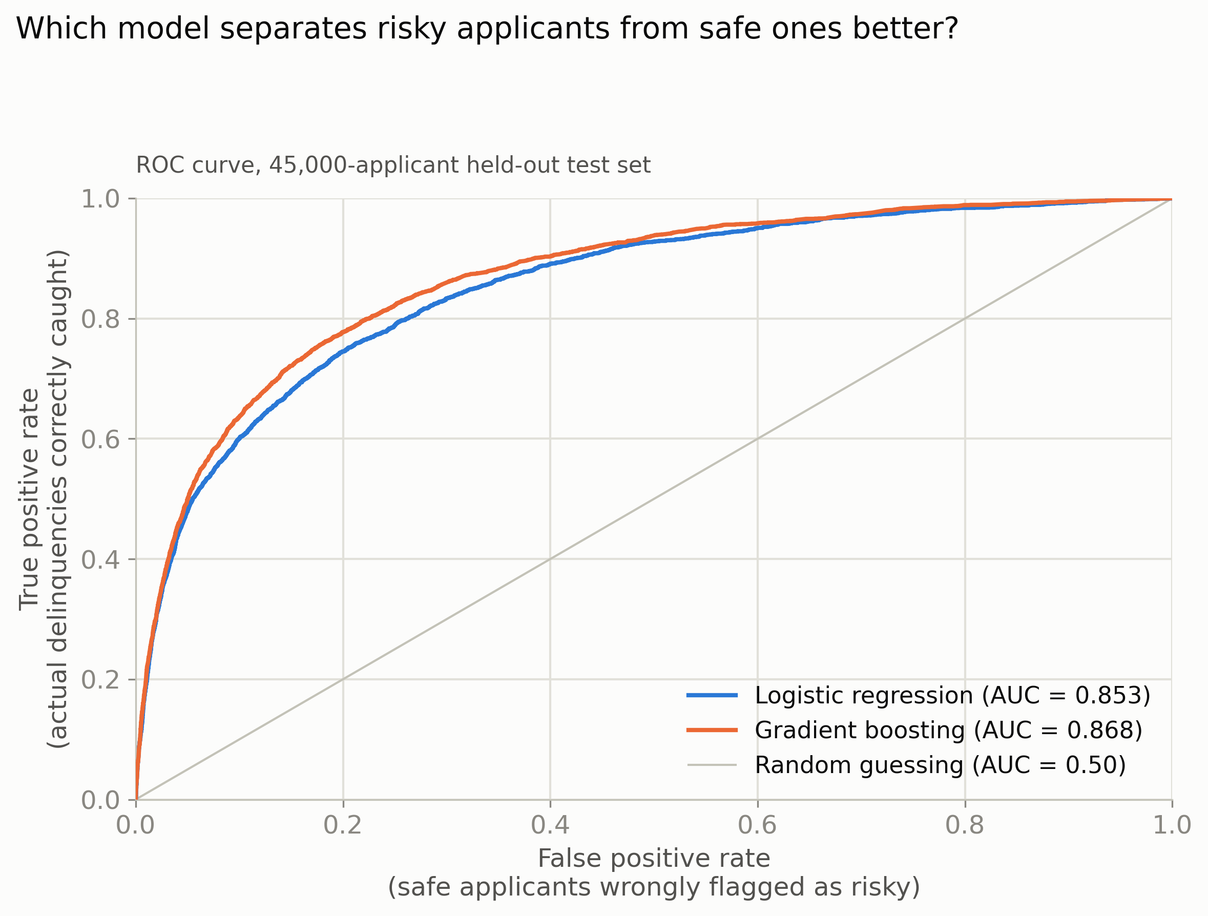
Figure 1. ROC curve comparison: the gradient boosting model dominates the logistic regression model across every threshold.
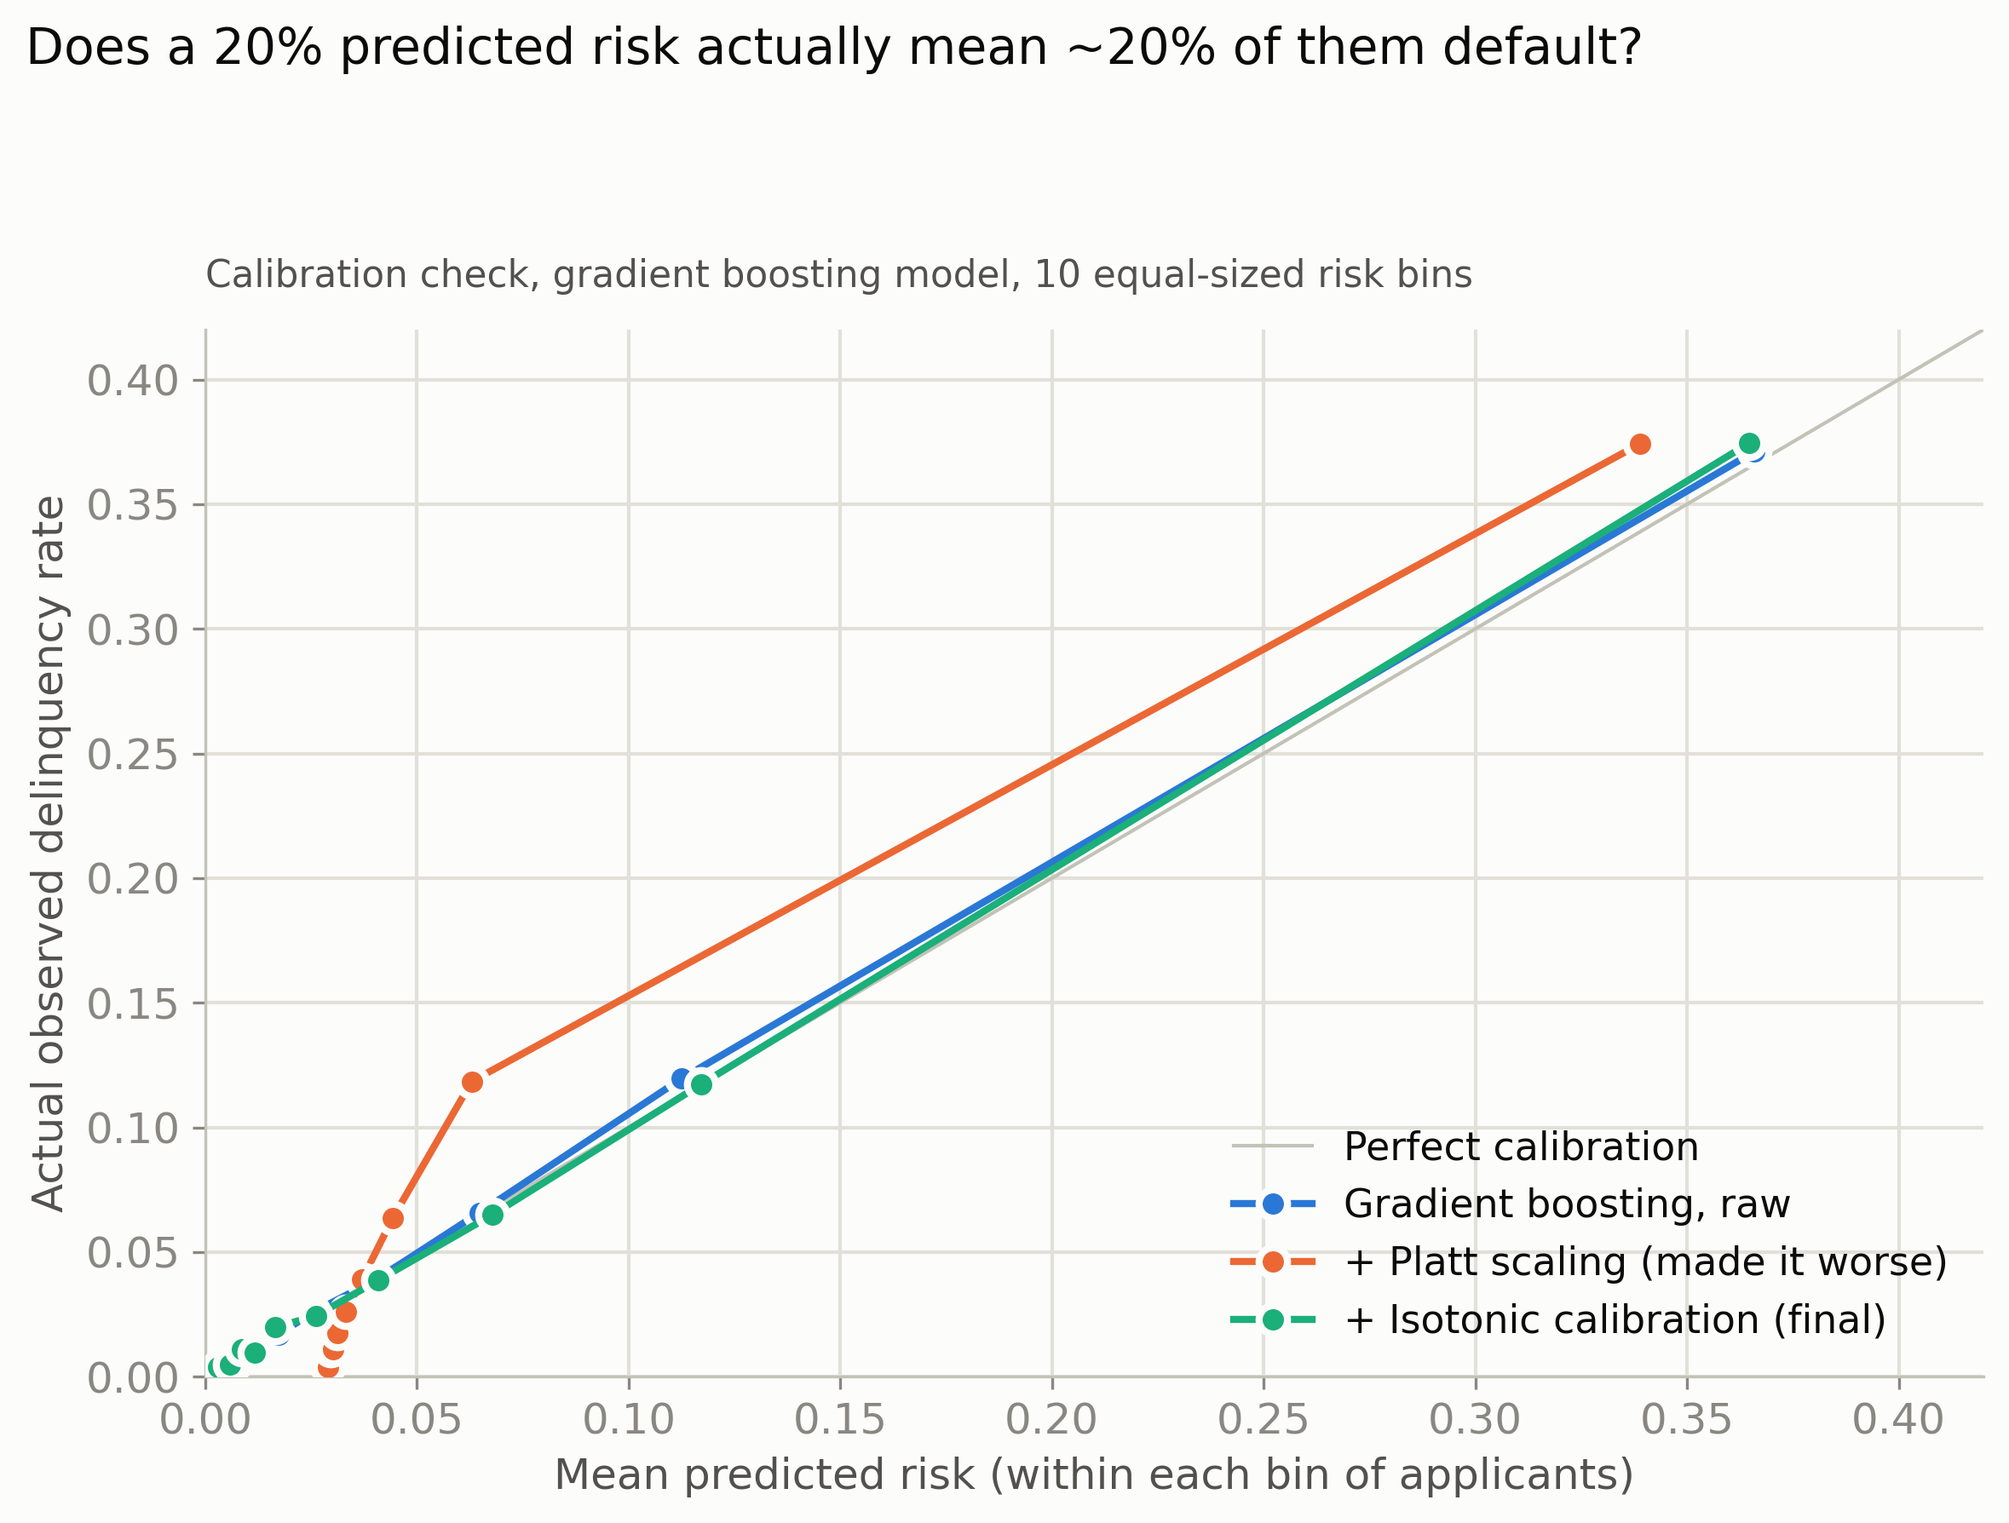
Figure 2. Calibration reliability curve: after isotonic calibration, the gradient boosting model's predicted probabilities closely track actual outcomes.

Performance Comparison
Metric | Logistic Regression | Gradient Boosting (Final)
ROC AUC | 0.853 | 0.868
PR AUC | 0.382 | 0.405
Brier Score (lower is better) | 0.0505 | 0.0486
Table 5. Model performance on the 45,000-applicant held-out test set. ROC AUC and PR AUC measure how well each model ranks risky applicants above safe ones; PR AUC is the more informative of the two here because only 6.7% of applicants actually go delinquent.
Note: accuracy was deliberately not used to judge these models. A model that simply predicted “never delinquent” for every applicant would already be about 93% accurate, since delinquency is rare, so that number would look impressive and mean nothing. ROC AUC, PR AUC, and the calibration check above are what actually show whether a model can tell risky and safe applicants apart.

From Prediction to Decision: A Cost-Based Threshold
A predicted probability is not, by itself, a decision. Turning “this applicant has a 9% predicted risk” into “approve” or “decline” requires a cutoff, and the right cutoff depends on what each type of mistake actually costs the business.

Cost Assumptions
This dataset does not include real loan amounts, interest rates, or recovery data, so a set of illustrative but realistic cost assumptions was used, and is stated plainly here rather than presented as measured fact:
- Average credit exposure per applicant: $5,000
- Loss given default (the share of that exposure lost after collections, if an approved applicant defaults): 60%, making the cost of a missed default (a false negative) $3,000
- Net interest margin the bank would earn on a performing loan: 5% of exposure, making the cost of wrongly declining a good applicant (a false positive) $250
That works out to roughly a 12-to-1 cost ratio between missing a bad loan and turning away a good applicant, which matches how lenders generally think about the tradeoff: losing principal on a default hurts far more than giving up one applicant's margin.
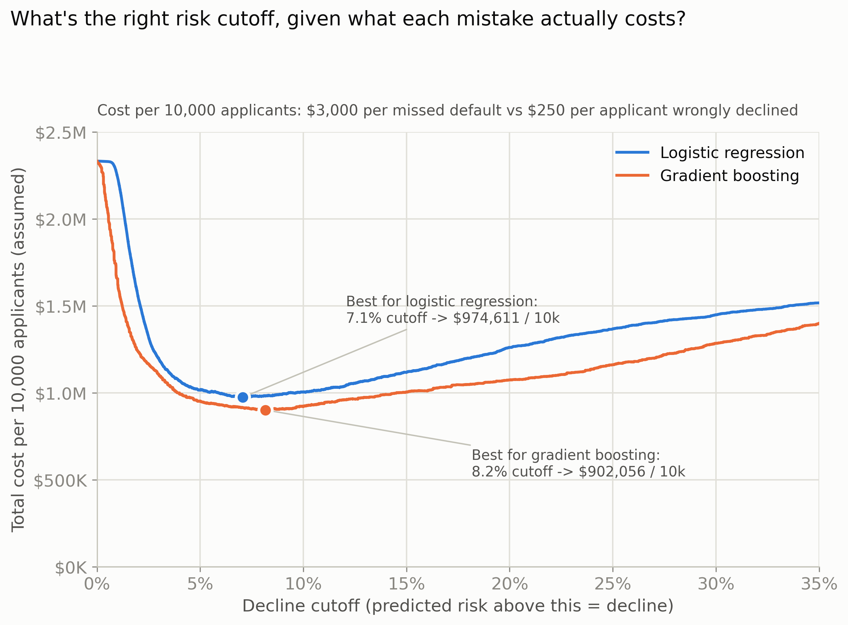
Figure 3. Total cost per 10,000 applicants at every possible decline cutoff, for both models, under the cost assumptions above.

The Optimal Cutoff for Each Model
 | Logistic Regression | Gradient Boosting
Decline cutoff | 7.1% predicted risk | 8.2% predicted risk
Approval rate | 76.7% | 79.1%
Cost per 10,000 applicants | $974,611 | $902,056
Table 6. Cost-minimizing decline cutoff for each model, and the resulting cost and approval rate, under the stated cost assumptions.
Switching from the logistic regression model to the gradient boosting model, and using each model's own optimal cutoff, reduces estimated cost by $72,556 per 10,000 applicants under the stated cost assumptions (about a 7.4% cost reduction) while also approving 2.4 percentage points more applicants. This is the case study's central finding: a more accurate model does not force a tradeoff between being safer and being more generous. Better discrimination between risky and safe applicants lets the bank do both at once.
For context, using a naive, untuned 50% cutoff (a common default) would have cost roughly $1.67 to $1.68 million per 10,000 applicants under either model, nearly double the cost of the properly tuned cutoff. Choosing the right threshold turned out to matter more than which model was used to reach it, though the better model still won on top of that.
Note: every dollar figure in this section depends on the illustrative cost assumptions above. Change the assumed loss-given-default or interest margin, and the optimal cutoff and savings figure both change. Gradient boosting remains the stronger predictive model regardless of those assumptions (it ranks risky and safe applicants better on every metric in the previous section), while the exact financial advantage and optimal cutoff for either model do depend on the assumed cost ratio.

Turning Risk Into Price: A Tiered Pricing Framework
Declining an applicant is not the only lever a lender has. Applicants who are approved can still be charged a rate that reflects their risk, rather than everyone paying the same rate. Rather than inventing a false level of precision (there is no reasonable way to justify a claim like “this specific applicant should be charged exactly 11.7%” from this dataset), applicants were grouped into three risk tiers, each with one illustrative rate.
Risk Tier | Predicted Risk Range | Actual Delinquency Rate | Illustrative Rate
Low risk | Under 3% | 1.1% | 12.9%
Moderate risk | 3% to 8.2% | 4.9% | 19.9%
Decline | 8.2% and above | 24.0% | Not approved
Table 7. The three-tier pricing framework. The 8.2% decline cutoff is the cost-minimizing threshold found above; the 3% split between low and moderate risk is a reasonable illustrative choice, since the dataset does not contain the loan-level rate and margin data needed to optimize that second cutoff the same way.
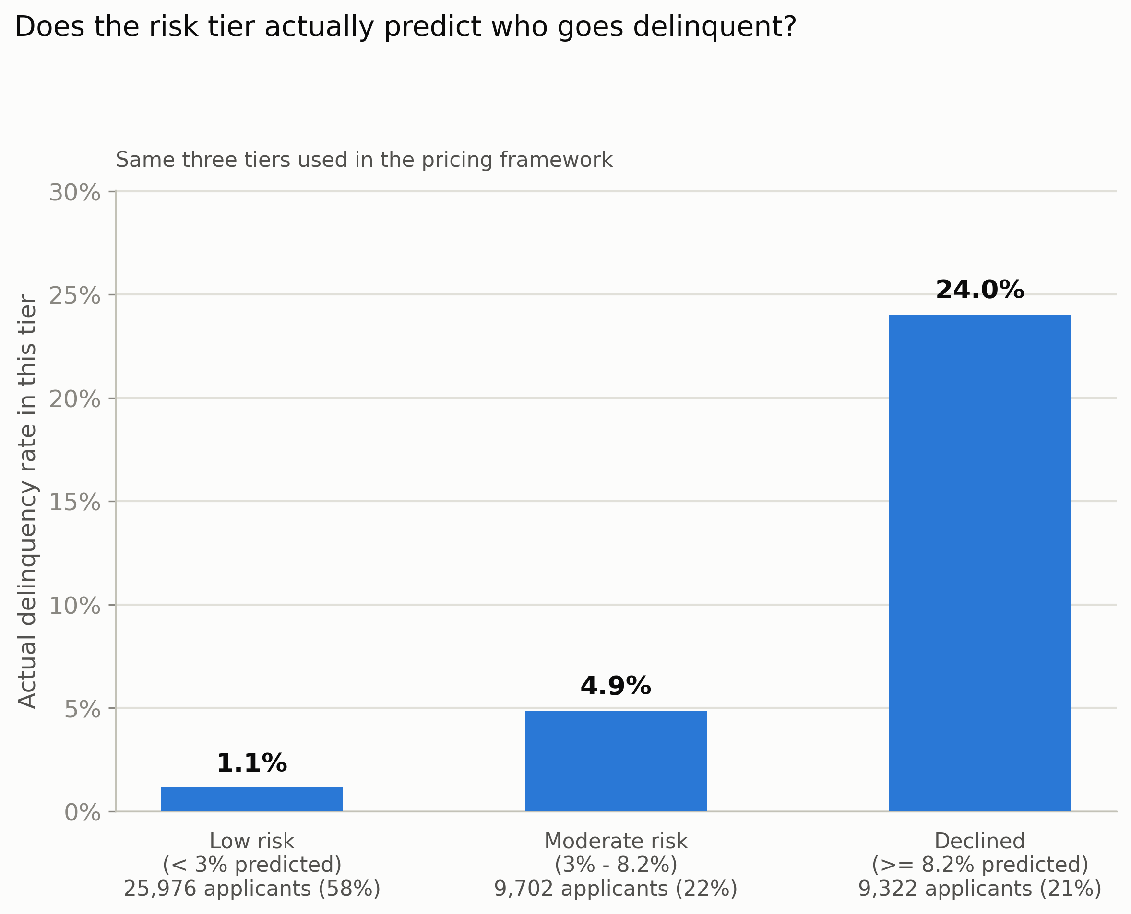
Figure 4. Actual test-set delinquency rate within each of the three tiers, confirming the tiers used for pricing genuinely separate risk.
The actual delinquency rate rises cleanly across the three tiers, from 1.1% in the low-risk tier up to 24.0% in the decline tier, which confirms the tiers are not arbitrary: they track real outcomes. This framework was implemented as a two-sheet Excel workbook. The first sheet holds the cost assumptions and the tier table shown above; the second sheet lists sample applicants with a VLOOKUP formula that looks up each applicant's risk tier and returns the matching rate from the first sheet, so the pricing logic updates automatically if the assumptions or rates ever change.

Key Takeaways
- Revolving utilization and age are both strong, intuitive predictors of delinquency risk on their own, confirmed twice: once through exploratory analysis and again independently through SQL queries against the cloud-hosted dataset.
- A more accurate model (gradient boosting) does not just reduce losses. It lets a lender approve more applicants at the same time, because it is better at separating risky applicants from safe ones.
- Choosing the right decision threshold matters as much as, or more than, choosing the right model: an untuned 50% cutoff cost nearly double what the properly optimized cutoff cost, for either model.
- Model overconfidence is a real, checkable problem. The gradient boosting model needed isotonic calibration to make its probabilities trustworthy, and the naive fix (Platt scaling) actually made things worse, underscoring the value of checking, rather than assuming, that a fix works.
- Every dollar figure in this case study depends on illustrative cost assumptions, since the dataset itself contains no real loan, rate, or recovery data. The relative conclusions (which model is better, and that threshold tuning matters) are robust to those assumptions; the exact dollar amounts are not.

Governance and Fair Lending Considerations
This case study is built for demonstration, not deployment, and using a model like this on real applicants would raise real governance questions. Age is one of the two strongest predictors found here and was included directly as a model input, but in U.S. consumer lending, age is a protected characteristic under the Equal Credit Opportunity Act and Regulation B, and its use in credit scoring is tightly restricted rather than simply a variable that happens to work well. Regulation B also requires lenders to give applicants a specific, understandable reason when they are declined, which is harder for a model like gradient boosting, where a prediction comes from the combined effect of many trees rather than a small set of clearly weighted factors. Before a model like this reached real applicants, it would need a legal and compliance review of which variables are actually permissible to use, an explainability layer (such as SHAP values) so declined applicants can be given a specific reason, and formal bias and disparate-impact testing across protected groups.

Tools and Techniques Used
This case study was built end to end using a mix of tools chosen to match the task rather than to show off a checklist: Python (pandas, scikit-learn, and XGBoost) for data cleaning, modeling, and calibration; Microsoft Azure SQL Database and T-SQL for hosting the cleaned dataset and running the exploratory and data-quality queries shown above; and Microsoft Excel, including a live VLOOKUP formula, for turning the model's output into a pricing table a non-technical reviewer could open and understand.

