Where Should WA Invest Its Next Community Resource Centre?
Facility-location optimization, gravity-model demand decay, equity-weighted objective

Summary
The Western Australian Department of Primary Industries and Regional Development (DPIRD) supports a network of 103 Community Resource Centres (CRCs) across rural, remote and regional WA, the state's primary infrastructure for local engagement, volunteering and civic participation outside Perth. This project asks a concrete allocation question: given a limited budget for new facilities, which of WA's regional communities should be prioritized, and in what order?
Using real 2021 Census population and volunteering data, the ABS Socio-Economic Indexes for Areas (SEIFA), and the actual coordinates of all 103 existing CRCs, this project formulates the problem as a Maximal Covering Location Problem (MCLP), a mixed-integer program solved to full optimality, not a heuristic approximation, with an equity-weighted objective so that disadvantaged, under-engaged communities are prioritized over simply the largest towns.
The headline result: five new facilities (Geraldton, Esperance, Busselton Surrounds, Bayonet Head - Lower King, and Port Hedland) would lift equity-weighted coverage of regional WA from a 69.9% baseline to 98.3%, the highest-return Phase 1 investment. Two further facilities close the remaining gap entirely, reaching 100% coverage at seven new sites total, after which additional facilities add no further measurable benefit under this model.

1. Business Context and Question
DPIRD's Community Resource Network already represents genuine, real-world infrastructure. This project treats it as such rather than inventing hypothetical candidate sites. The business question is: given limited outreach staff and budget, which regional WA communities should be prioritized for the next round of engagement investment, based on population, distance from existing service points, existing activity levels, and social disadvantage?
This mirrors the structure of real public-sector capital planning decisions: a fixed network already exists, funding for expansion is limited, and the goal is to close the largest and most inequitable service gaps first, not simply to serve the most people in absolute terms.

2. Data Sources
Source | What it provides | Provider
2021 Census, Table G01 | Population by SA2 (WA) | Australian Bureau of Statistics
2021 Census, Table G23 | Voluntary work rate by SA2, used as a proxy for existing engagement | Australian Bureau of Statistics
SEIFA 2021, Index of Relative Socio-Economic Disadvantage (IRSD) | Community-level disadvantage score, by SA2 | Australian Bureau of Statistics
ASGS Edition 3 (2021), SA2 digital boundaries | Geographic boundaries and centroids for every SA2 | Australian Bureau of Statistics
Community Resource Centre (CRC) Information | Location, region and type of all 103 real, currently operating CRCs | WA Dept. of Primary Industries and Regional Development

3. Methodology
This section walks through the model in the order it was actually built: what data fed each step, what math was used, and why each decision was made.

3.1 Step 1: Defining the demand points and candidate sites
Data used: SA2 boundaries, Census population, the Greater Perth / Rest-of-WA classification.
WA has 267 SA2s in total. The first job was deciding which of those 267 actually represent communities that a regional engagement program would serve, and which don't belong in the analysis at all. Twenty-four turned out to be national parks, airports, industrial precincts, and two ABS administrative catch-all categories with no fixed population; ABS itself declines to publish a disadvantage score for most of these, since too few people live there for the statistic to be reliable. Excluding them removed only 0.33% of WA's population.
The remaining SA2s were then narrowed to the 76 classified as Rest of WA (outside Greater Perth), matching the CRC network's actual rural and regional mandate. The 103 existing CRCs were kept as fixed, already-open facilities at zero additional cost, and the 76 Rest-of-WA communities became both the demand points (who needs to be served) and the candidate sites (where a new facility could go).
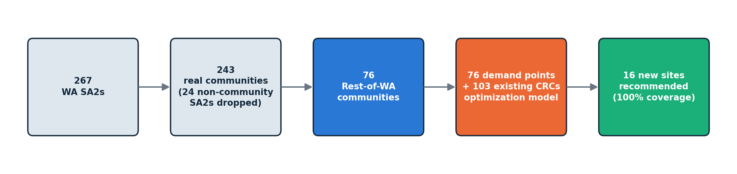
From 267 raw SA2s down to a 7-site recommendation, in four decisions.

3.2 Step 2: Measuring distance, and testing the gravity-model assumption before trusting it
Data used: SA2 centroids, CRC coordinates, Census volunteer rate. Math used: haversine great-circle distance, Pearson correlation.
Distance between every community and every CRC was computed as haversine (great-circle) distance between their coordinates, then scaled up by a circuity factor of 1.3. That factor exists because straight-line distance always understates real travel distance, since roads bend around rivers, ranges and property boundaries. A factor of 1.3 is a standard rural transport-geography approximation for the ratio of real road distance to straight-line distance, used here in place of a live routing API that this project's environment could not reach.
Before relying on distance as a driver of the equity weighting, the assumption behind it was tested rather than simply assumed: is a community's distance from existing engagement infrastructure actually related to how much volunteering already happens there? The Pearson correlation between distance-to-nearest-CRC and Census volunteer rate comes out at -0.19 using the corrected location data described in Section 3.3 (an earlier version of this analysis, before that correction, reported -0.45; that stronger figure was partly an artifact of several communities being measured from the wrong point on the map). A weak negative relationship still points the right way and supports using distance-decay as a real driver of the model rather than a pure assumption, but it is a weaker empirical case than originally reported, and is stated here as such rather than left at the more convenient, less accurate number.

3.3 Step 3: Correcting a real data problem in the location data
Data used: SA2 boundaries (polygon shapes), CRC coordinates. Math used: projected centroid calculation (EPSG:7845, GDA2020 Australian Albers).
A community's location was originally represented by its SA2's geometric centroid: literally the middle point of its polygon shape. That works well for small, city-sized SA2s, but WA also has SA2s the size of small countries, and checking the results turned up a genuine problem: for these huge, sparsely populated shires, the geometric middle of the shape can sit over 100km from where people actually live, simply because the shape is so large and irregular that its center falls in empty land rather than near the town.
Halls Creek is the clearest example, shown below. Its SA2 covers a large stretch of the Kimberley, and the geometric centroid of that shape lands 110km from the actual town of Halls Creek, and from the real CRC already operating there.
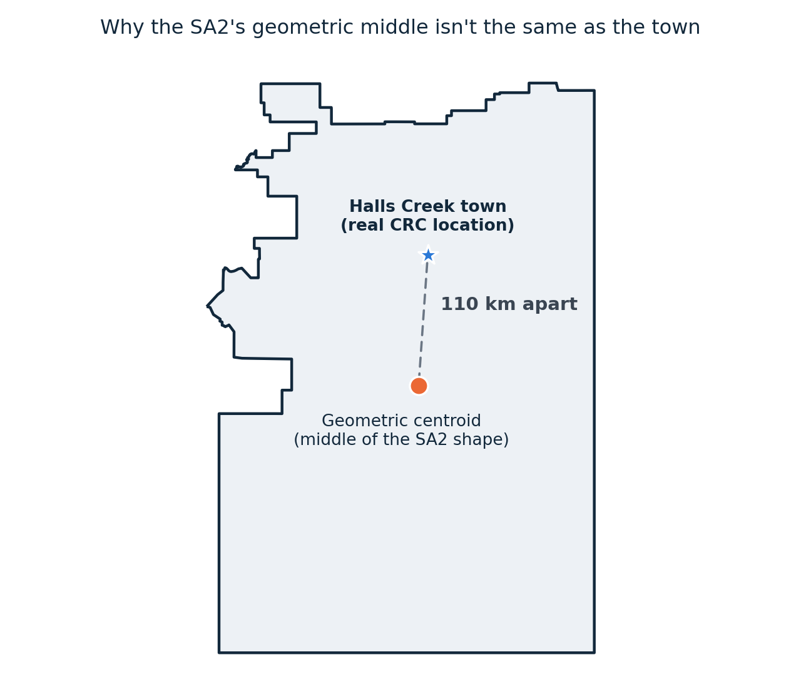
Halls Creek's real SA2 shape: the geometric middle sits 110km from the actual town.
The fix, in two passes. Pass one: wherever an SA2's name exactly matched a real CRC's name, that SA2's location was corrected to the CRC's true coordinates, since the CRC's location is, by definition, where the community actually is. This corrected 22 of the 76 communities, including Halls Creek. Pass one misses cases where the SA2's own name differs from the real town inside it: the SA2 “Leinster - Leonora” does not exactly equal “Leonora”, so pass one skips it, even though the real Leonora CRC sits inside that very SA2's boundary. Pass two catches this: for every large SA2 (over 5,000 sq km) pass one missed, every real CRC whose coordinates fall inside that SA2's actual polygon boundary was located, preferring one that shares part of its name with the SA2 (like “Leonora”), and falling back to the nearest in-boundary facility when no name match exists. This corrected a further 13 communities, including East Pilbara itself, the case that originally prompted this fix (previously showing as 492km from any CRC purely because of an uncorrected centroid), and Kununurra. Together, both passes now give all 26 of WA's geographically large SA2s a real-facility-based location.

3.4 Step 4: Building the equity-weighted demand score
Data used: SEIFA IRSD disadvantage score, Census volunteer rate, Census population. Math used: min-max rescaling to a 1-3x range, simple averaging.
Population alone is not a fair way to rank communities, since it would just point every recommendation at the biggest towns. Instead, each community's population is scaled by an equity multiplier built from two things: how disadvantaged it is (SEIFA IRSD, where a lower score means more disadvantaged) and how under-engaged it already is (Census volunteer rate, where a lower rate means less existing engagement). Each of those two signals is rescaled onto a 1 to 3x range and then averaged, so a highly disadvantaged, under-engaged community can end up counting for up to three times as much in the model as an equally-sized, affluent, already-engaged one. That is the mechanism that stops the model from simply chasing population.

3.5 Step 5: Formulating and solving the optimization model
Data used: equity-weighted demand, distances, a 50km service radius. Math used: Mixed-Integer Programming (Maximal Covering Location Problem), solved via the CBC solver.
With demand weights and distances in hand, the core allocation question becomes a Maximal Covering Location Problem: choose which candidate sites to open, within a fixed budget, to cover as much equity-weighted demand as possible within a 50km service radius, a standard practical catchment for a regional community facility. This was written as a Mixed-Integer Program:
maximize
Σᵢ wᵢ · yᵢ
subject to
yᵢ ≤ covered0ᵢ + Σⱼ∈N(i) xⱼ for every community i
Σⱼ xⱼ ≤ p
xⱼ, yᵢ ∈ {0, 1}
Here xⱼ = 1 if a new facility is opened at candidate site j, yᵢ = 1 if community i ends up within the 50km service radius of any open facility (existing or new), and p is the facility budget. A small secondary penalty on the number of open facilities was added to the objective purely to break ties in favor of opening fewer sites, since the solver would otherwise happily open extra, zero-benefit facilities whenever multiple equally-good solutions exist. The model was solved to proven global optimality, not an approximate or heuristic answer, using the open-source CBC solver via PuLP, for every budget level from 0 to 25 new facilities. Each solve took under 0.1 seconds, reflecting the genuinely small scale of a 76-community, 103-facility problem.

3.6 Step 6: Turning repeated solves into a funding decision
Data used: the same model, solved 26 times, once for each budget from p = 0 to p = 25.
Rather than solving for one arbitrary budget, the model was solved once for every possible budget from 0 to 25 new facilities, and the resulting coverage percentage was tracked at each step. That turns a single answer into a full trade-off curve: how much coverage each additional facility buys, and where the return starts to flatten out. That curve, shown in Section 4, is what actually supports a funding decision, rather than a single number taken in isolation.

4. Results

4.1 Budget sensitivity
The chart below shows equity-weighted demand coverage as a function of the number of new facilities funded. Coverage rises steeply for the first several facilities, then flattens: the classic diminishing-returns signature of a well-posed covering problem, and genuinely useful evidence for a funding decision.

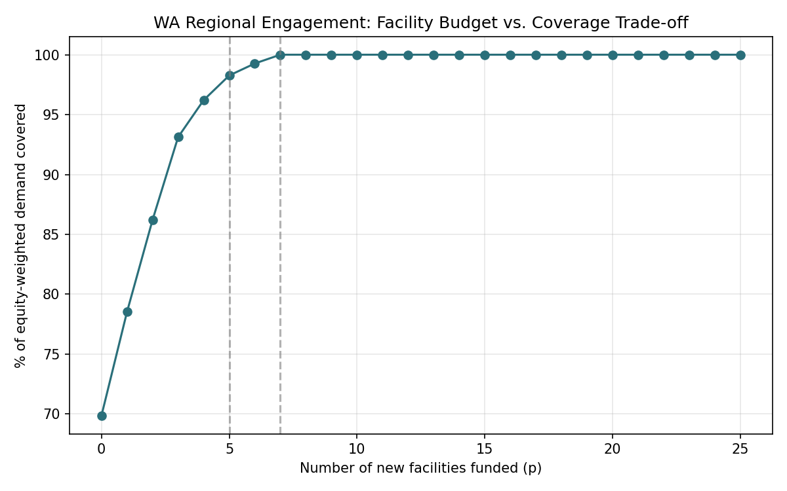

4.2 Phase 1: Quick wins (5 new facilities, 69.9% to 98.3% coverage)
Community | Population | Dist. to nearest CRC (km) | Disadvantage decile | Volunteer rate
Geraldton | 11,888 | 81 | 2 (high disadvantage) | 15.6%
Esperance | 12,003 | 209 | 4 | 23.3%
Busselton Surrounds | 11,900 | 62 | 9 | 23.9%
Bayonet Head - Lower King | 5,211 | 58 | 5 | 21.0%
Port Hedland | 4,253 | 192 | 9 | 16.0%

4.3 Full rollout: remaining 2 facilities (98.3% to 100% coverage)
Community | Population | Dist. to nearest CRC (km) | Disadvantage decile | Volunteer rate
Carnarvon | 4,879 | 156 | 2 | 16.9%
Newman | 4,239 | 277 | 7 | 19.8%

An interactive map showing every community, its coverage status, and the recommended sites is provided alongside this report (Refer to the project portfolio).

5. Limitations
- Road-network distance is approximated via a fixed 1.3x circuity factor applied to straight-line distance, not true routed driving distance. This is defensible and standard for state-scale analysis, but a real routing API (e.g. OSRM) would refine it further, especially in areas with significant natural barriers such as rivers and ranges.
- An earlier version of this analysis left 13 large, sparsely populated SA2s (not six, as originally and incorrectly stated here) on an unadjusted geometric centroid, since no exact-name-matched CRC existed to snap to. That has now been corrected (Section 3.3) by matching each to a real facility located inside its own boundary. A smaller residual limitation remains: where more than one real facility sits inside a single large SA2, the nearest one to the original centroid was used as the best available estimate, which will not always be the single most representative point for such a large, spread-out area.
- Voluntary work rate is a reasonable but imperfect proxy for existing engagement: it captures formal volunteering only, not informal community participation.
- The 50km service radius and 1-3x equity multiplier range are defensible, literature-consistent choices, not the only valid ones. Section 6 now tests both directly, rather than leaving the question open: the site recommendation turns out to be highly sensitive to the radius choice, and largely insensitive to the equity weighting choice.

6. Robustness Checks
Two of the assumptions behind this model are tested directly here, rather than simply asserted as reasonable: the 50km service radius, and the equity weighting formula. Both are re-solved at the same 5-facility budget under a few alternative settings, and the resulting site recommendations are compared against the base case.

6.1 Does the recommendation hold if the equity weighting changes?
Four weighting schemes are compared at the same 5-facility budget and 50km radius: the current 50/50 blend of SEIFA disadvantage and volunteer rate, population alone (no equity adjustment at all), SEIFA disadvantage alone, and volunteer rate alone. All four recommend the exact same 5 communities: Esperance, Busselton Surrounds, Geraldton, Bayonet Head - Lower King, and Port Hedland. This is a genuinely reassuring result. The Phase 1 recommendation is not an artifact of the specific equity formula chosen, these are simply the largest, most under-served communities under almost any reasonable way of counting need.

6.2 Does the recommendation hold if the service radius changes?
The same 5-facility budget is re-solved at 40km and at 60km, instead of the base-case 50km. The result here is different: at 40km, none of the original 5 recommended sites remain in the new top-5 list; at 60km, only 2 of the 5 remain. The recommended sites, in other words, are meaningfully sensitive to the radius assumption, far more so than to the equity weighting.
This is disclosed here as a genuine limitation rather than left untested. The 50km radius is a standard, defensible planning assumption, but it is doing real work in this model, and a funder relying on this recommendation should treat the radius choice as a live parameter worth discussing, not a settled detail.

7. Conclusion
This model turns a genuinely hard combinatorial question, which of 76 real communities should share a limited facility budget, into a mixed-integer program solved to proven optimality in under a second, using entirely real, cited, government data. The five-site Phase 1 recommendation offers the strongest possible first move for a constrained budget; the seven-site full rollout represents the point of total, complete closure of the equity-weighted service gap across regional Western Australia.

