**CHRIST (DEEMED TO BE UNIVERSITY)**

**Department of Computer Science**

**MSc – Artificial Intelligence and Machine Learning**

**Name:** Joel Joseph Motha **Reg. No:** 2448521

**Course:** Java Programming **Lab Program:** 4

**Description**

The code defines an abstract class Robber with methods for different robbing scenarios (RowHouses, RoundHouses, SquareHouse, MultiHouseBuilding). A concrete subclass JAVAProfessionalRobber implements these methods, using a helper function to calculate the maximum money that can be robbed without triggering alarms (by skipping adjacent houses). The program tests these methods with various inputs, calculating and printing the maximum money that can be robbed from a set of houses or buildings.

**Code Screenshots**

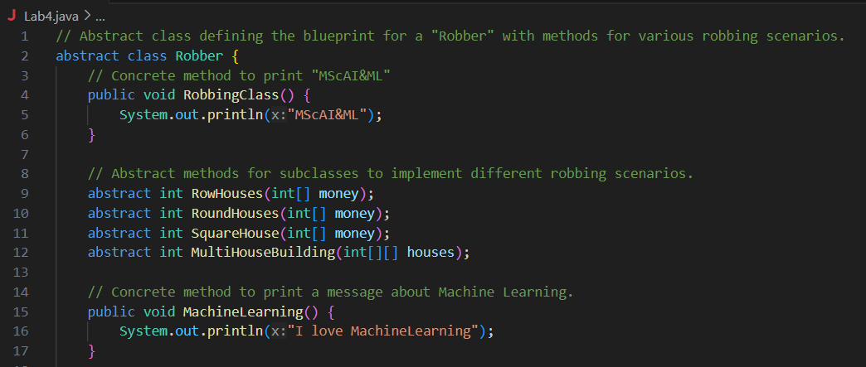

**Output**

MScAI&ML

I love MachineLearning

RowHouses([1,2,3,0]) -> 4

RoundHouses([1,2,3,4]) -> 6

SquareHouse([5,10,2,7]) -> 17

House Money: 13

House Money: 18

House Money: 15

House Money: 15

MultiHouseBuilding([[5,3,8,2],[10,12,7,6],[4,9,11,5],[8,6,3,7]]) -> 61

